Appendix 1 The Cochrane library search strategy on July 25, 2020
Records retrieved | Query | No.
4878 | “Qualitative Research” (qualitative study OR grounded theory OR phenomenology OR lived experience) | #1
10138 | “Palliative Care” (palliative care OR supportive care OR end of life care needs) | #2
2874 | #1 AND #2 | #3
710 | “Hematological Malignancy” (blood cancers OR Leukemia OR lymphoma OR myeloma OR oncology OR cancer OR hematological cancer) | #4
341 | #3 AND #4 | #5
8 | “Hematological Malignancy” (blood cancers OR Leukemia OR lymphoma OR myeloma OR oncology OR cancer OR hematological cancer), AND “Palliative Care” (palliative care OR supportive care OR end of life care needs), AND “Qualitative Research” (qualitative study OR grounded theory OR phenomenology OR lived experience); AND “Patients” | #6

Appendix 2: JBI QARI Data Extraction Tool for Qualitative Research
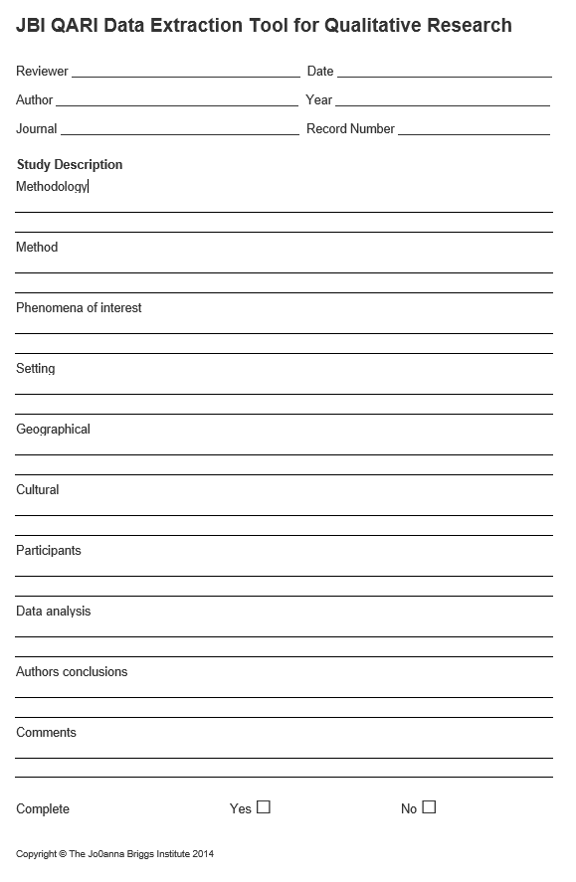
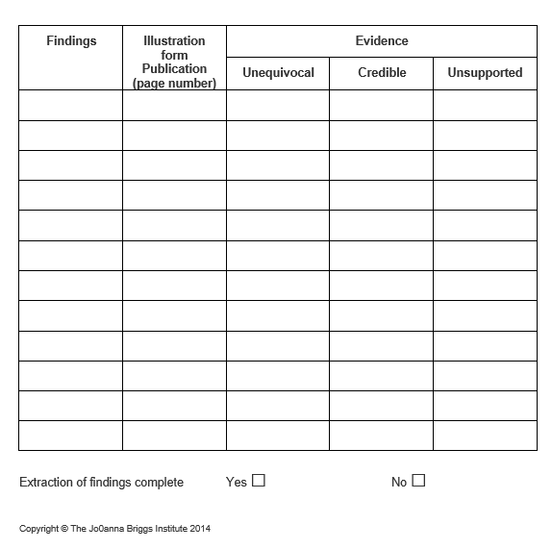
Appendix 3: JBI Critical Appraisal Checklist for Qualitative Research
The Joanna Briggs Institute (JBI) Critical Appraisal Checklist for qualitative research (last amended in 2017). Website: https://joannabriggs.org/critical_appraisal_tools
Major Components | Response options
1. Is there congruity between the stated philosophical perspective and the research methodology? | Yes | No | Unclear | Not applicable
2. Is there congruity between the research methodology and the research question or objectives? | Yes | No | Unclear | Not applicable
3. Is there congruity between the research methodology and the methods used to collect data? | Yes | No | Unclear | Not applicable
4. Is there congruity between the research methodology and the representation and analysis of data? | Yes | No | Unclear | Not applicable
5. Is there congruity between the research methodology and the interpretation of results? | Yes | No | Unclear | Not applicable
6. Is there a statement locating the researcher culturally or theoretically? | Yes | No | Unclear | Not applicable
7. Is the influence of the researcher on the research, and vice-versa, addressed? | Yes | No | Unclear | Not applicable
8. Are participants, and their voices, adequately represented? | Yes | No | Unclear | Not applicable
9. Is the research ethical according to current criteria or, for recent studies, and is there evidence of ethical Approval by an appropriate body? | Yes | No | Unclear | Not applicable
10. Do the conclusions drawn in the research report flow from the analysis, or interpretation, of the data? | Yes | No | Unclear | Not applicable
Overall appraisal: Include □ Exclude □ Seek further info □

