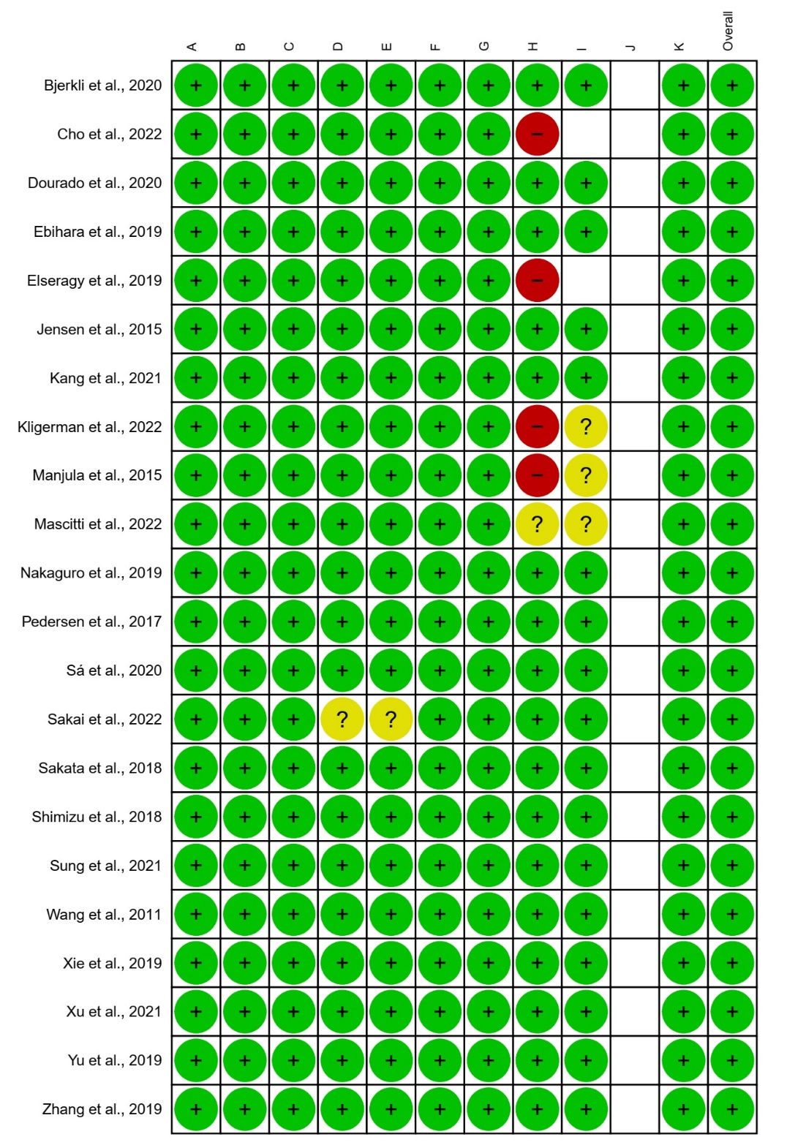
Supplementary Figure 1. Risk of bias within studies. A) Were the two groups similar and recruited from the same population? B) Were the exposures measured similarly to assign people to both exposed and unexposed groups? C) Was the exposure measured in a valid and reliable way? D) Were confounding factors identified? E) Were strategies to deal with confounding factors stated? F) Were the groups/participants free of the outcome at the start of the study (or at the moment of exposure)? G) Were the outcomes measured in a valid and reliable way? H) Was the follow up time reported and sufficient to belong enough for outcomes to occur? I) Was follow up complete, and if not, were the reasons to loss to follow up described and explored? J) Were strategies to address incomplete follow up utilized? K) Was appropriate statistical analysis used?

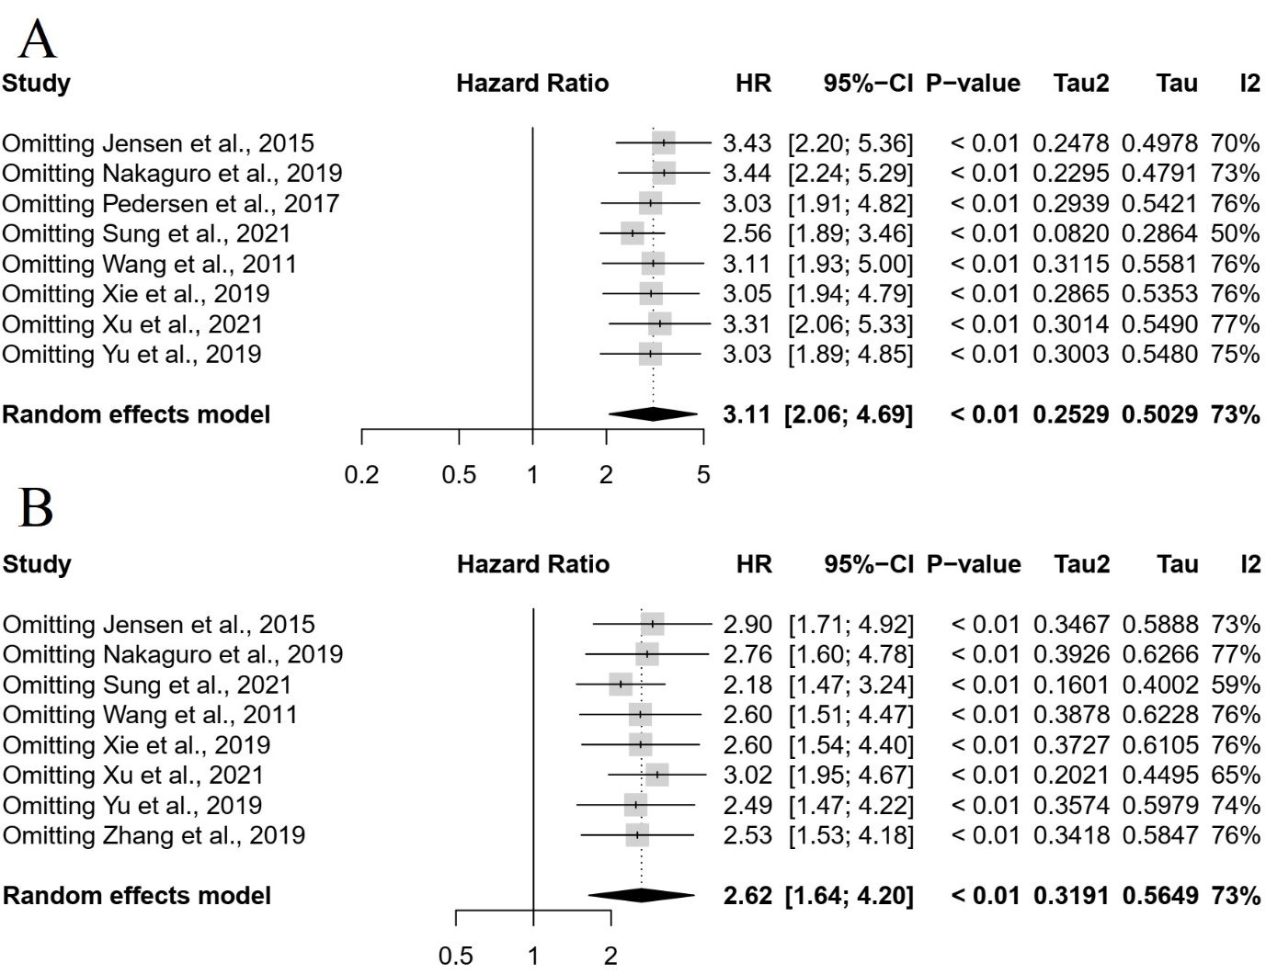

Supplementary Figure 2. Sensitivity analysis for the overall survival meta-analyses. (A) univariate analysis, (B) multivariate analysis

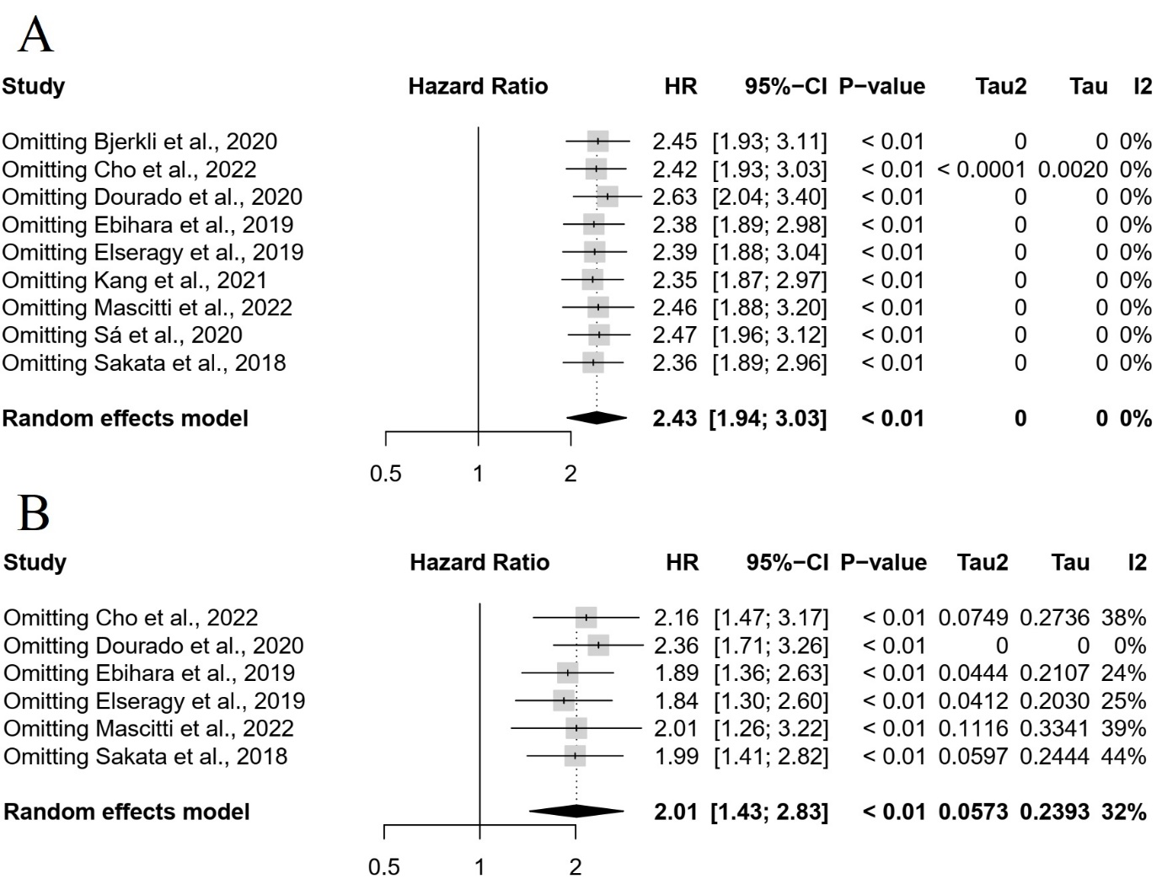

Supplementary Figure 3. Sensitivity analysis for the disease-specific survival meta-analyses. (A) univariate analysis, (B) multivariate analysis

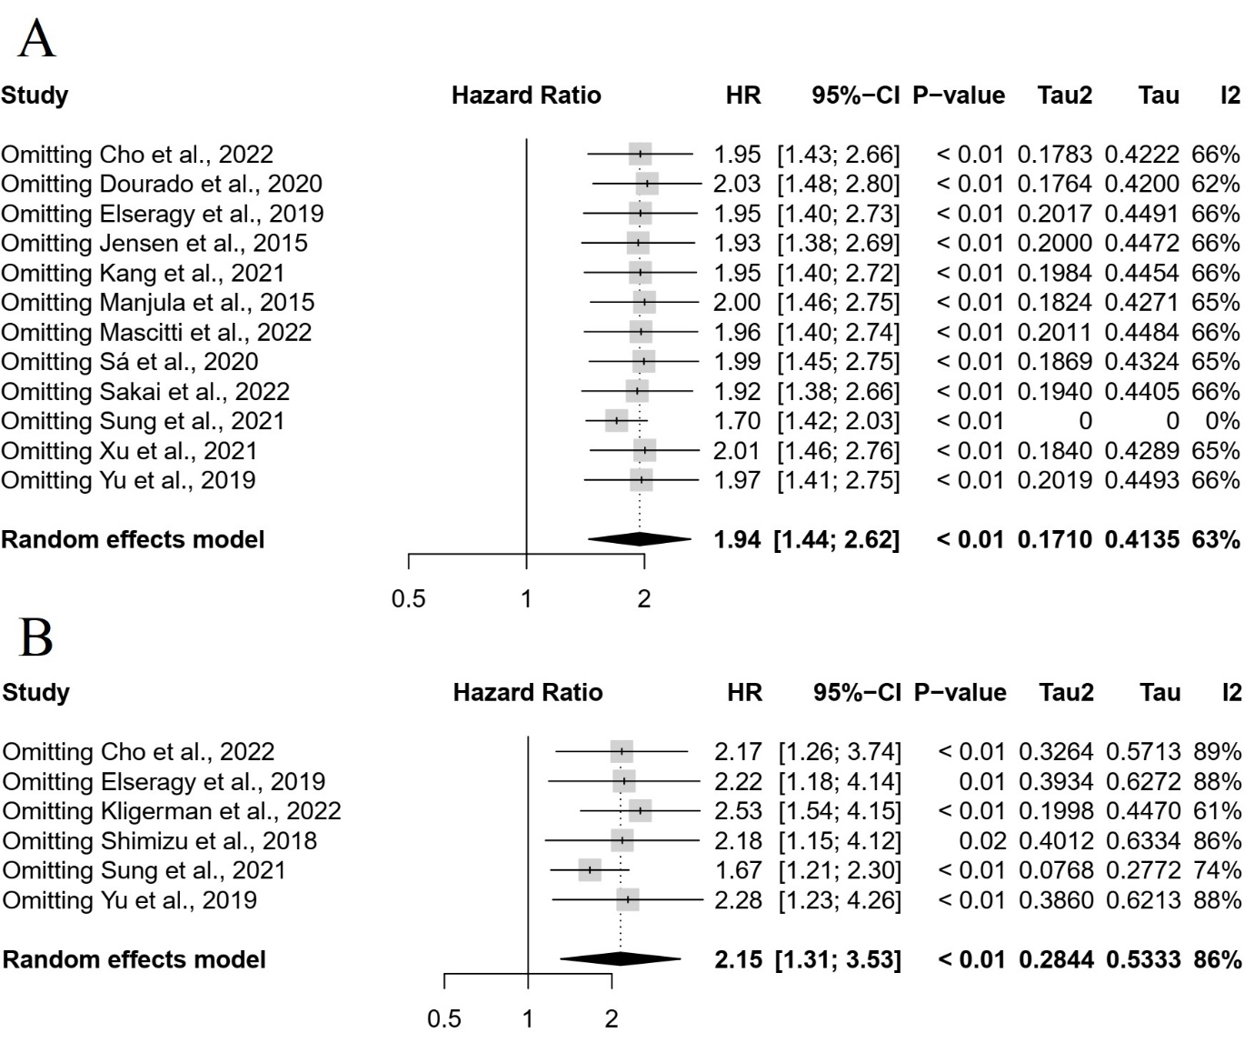 Supplementary Figure 4. Sensitivity analysis for the disease-free survival meta-analyses. (A) univariate analysis, (B) multivariate analysis

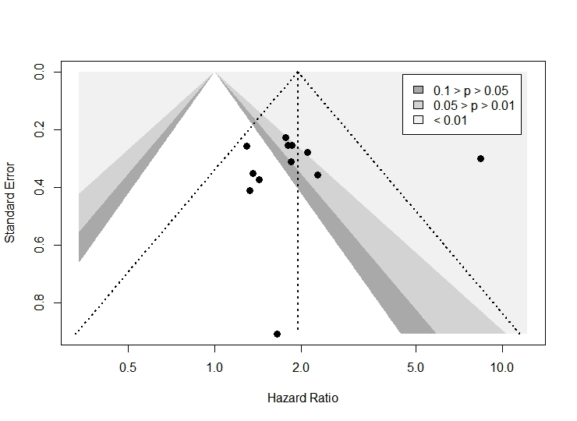 Supplementary Figure 5. Funnel plot of the meta-analysis for DFS in univariate analysis

Supplementary Table 1. Data search strategy
Database | Search | Number of records
PubMed | (“Mouth Neoplasms”[Mesh] OR “Mouth Neoplasms” OR “Mouth Neoplasm” OR “Oral Neoplasm” OR “Oral Neoplasms” OR “Cancer of Mouth” OR “Mouth Cancers” OR “Oral Cancer” OR “Oral Cancers” OR “Cancer of the Mouth” OR “Mouth Cancer” OR “Oral Tongue Squamous Cell Carcinoma” OR “Oral Squamous Cell Carcinoma” OR “Oral Cavity Squamous Cell Carcinoma” OR “Oral Squamous Cell Carcinomas” OR “Squamous Cell Carcinoma of the Mouth”) AND (“tumor budding” OR “tumor-budding” OR “tumour budding” OR “budding”) AND (“Survival”[Mesh] OR “Survival” OR “Prognosis”[Mesh] OR “Prognosis” OR “Prognoses” OR “Prognostic Factors” OR “Prognostic Factor” OR “overall survival” OR “hazard ratio” OR “disease-free survival” OR “Lymphatic Metastasis”[Mesh] OR “Lymphatic Metastasis” OR “Lymphatic Metastases” OR “Lymph Node Metastasis” OR “Lymph Node Metastases”) | 87
EMBASE | #1 (“Mouth Neoplasms” OR “Mouth Neoplasm” OR “Oral Neoplasm” OR “Oral Neoplasms” OR “Cancer of Mouth” OR “Mouth Cancers” OR “Oral Cancer” OR “Oral Cancers” OR “Cancer of the Mouth” OR “Mouth Cancer” OR “Oral Tongue Squamous Cell Carcinoma” OR “Oral Squamous Cell Carcinoma” OR “Oral Cavity Squamous Cell Carcinoma” OR “Oral Squamous Cell Carcinomas” OR “Squamous Cell Carcinoma of the Mouth”)  #2 (“tumor budding” OR “tumor-budding” OR “tumour budding” OR budding)  #3 (Survival OR Prognosis OR Prognoses OR “Prognostic Factors” OR “Prognostic Factor” OR “overall survival” OR “hazard ratio” OR “disease-free survival” OR “Lymphatic Metastasis” OR “Lymphatic Metastases” OR “Lymph Node Metastasis” OR “Lymph Node Metastases”)  #4 (#1 AND #2 AND #3) | 119
SCOPUS | TITLE-ABS-KEY ("Mouth Neoplasms" OR "Mouth Neoplasm" OR "Oral Neoplasm" OR "Oral Neoplasms" OR "Cancer of Mouth" OR "Mouth Cancers" OR "Oral Cancer" OR "Oral Cancers" OR "Cancer of the Mouth" OR "Mouth Cancer" OR "Oral Tongue Squamous Cell Carcinoma" OR "Oral Squamous Cell Carcinoma" OR "Oral Cavity Squamous Cell Carcinoma" OR "Oral Squamous Cell Carcinomas" OR "Squamous Cell Carcinoma of the Mouth" ) AND TITLE-ABS-KEY ( "tumor budding" OR "tumor-budding" OR "tumour budding" OR budding ) AND TITLE-ABS-KEY ( survival OR prognosis OR prognoses OR "Prognostic Factors" OR "Prognostic Factor" OR "overall survival" OR "hazard ratio" OR "disease-free survival" OR "Lymphatic Metastasis" OR "Lymphatic Metastases" OR "Lymph Node Metastasis" OR "Lymph Node Metastases" ) | 71
LIVIVO | (“Mouth Neoplasms” OR “Mouth Neoplasm” OR “Oral Neoplasm” OR “Oral Neoplasms” OR “Cancer of Mouth” OR “Mouth Cancers” OR “Oral Cancer” OR “Oral Cancers” OR “Cancer of the Mouth” OR “Mouth Cancer” OR “Oral Tongue Squamous Cell Carcinoma” OR “Oral Squamous Cell Carcinoma” OR “Oral Cavity Squamous Cell Carcinoma” OR “Oral Squamous Cell Carcinomas” OR “Squamous Cell Carcinoma of the Mouth”) AND (“tumor budding” OR “tumor-budding” OR “tumour budding” OR budding) AND (Survival OR Prognosis OR Prognoses OR “Prognostic Factors” OR “Prognostic Factor” OR “overall survival” OR “hazard ratio” OR “disease-free survival” OR “Lymphatic Metastasis” OR “Lymphatic Metastases” OR “Lymph Node Metastasis” OR “Lymph Node Metastases”) | 112
Web of Science | (“Mouth Neoplasms” OR “Mouth Neoplasm” OR “Oral Neoplasm” OR “Oral Neoplasms” OR “Cancer of Mouth” OR “Mouth Cancers” OR “Oral Cancer” OR “Oral Cancers” OR “Cancer of the Mouth” OR “Mouth Cancer” OR “Oral Tongue Squamous Cell Carcinoma” OR “Oral Squamous Cell Carcinoma” OR “Oral Cavity Squamous Cell Carcinoma” OR “Oral Squamous Cell Carcinomas” OR “Squamous Cell Carcinoma of the Mouth”) AND (“tumor budding” OR “tumor-budding” OR “tumour budding” OR budding) AND (Survival OR Prognosis OR Prognoses OR “Prognostic Factors” OR “Prognostic Factor” OR “overall survival” OR “hazard ratio” OR “disease-free survival” OR “Lymphatic Metastasis” OR “Lymphatic Metastases” OR “Lymph Node Metastasis” OR “Lymph Node Metastases”) | 70
Google Scholar | ((“budding”) AND (“Mouth Neoplasms” OR “Oral Neoplasms” OR “Mouth Cancers” OR “Oral Cancers” OR “Oral Squamous Cell Carcinoma” OR “Oral Squamous Cell Carcinomas”) AND (“Survival”)) filetype:pdf | The first 100 records were selected

Supplementary Table 2. Pooled estimates for demographic and clinicopathological feature of patients

Characteristics | Effect size (%) | 95% CI | Heterogeneity
 |  |  | I² (%) | p
Age (years) | 58.94* | [55.85; 62.04] | 97 | <0.01
Follow-up (months) | 60.14* | [47.83; 72.46] | 100 | 0
Gender
Male | 61.81 | [56.52; 67.10] | 89 | <0.01
Female | 38.19 | [32.90; 43.48] | 89 | <0.01
Site
Tongue | 79.87 | [64.04; 95.69] | 100 | 0
Floor of the mouth | 7.27 | [0.00; 15.23] | 97 | <0.01
Other | 12.81 | [0.00; 28.46] | 100 | 0
Tumor
T1 | 25.88 | [16.37; 35.39] | 98 | <0.01
T2 | 52.17 | [37.93; 66.41] | 99 | <0.01
T3 | 10.41 | [2.97; 17.86] | 95 | <0.01
T4 | 9.97 | [0.46; 19.49] | 95 | <0.01
Lymph node
N0 | 80.80 | [62.55; 99.05] | 98 | <0.01
N1 | 5.21 | [0.00; 11.27] | 91 | <0.01
N2 | 10.55 | [0.00; 23.29] | 97 | <0.01
N3 | 2.18 | [0.00; 6.53] | 89 | <0.01
Metastases
M0 | 99.05 | [96.92; 100,00] | 68 | 0.02
M1 | 0.95 | [0.00; 3.08] | 68 | 0.02
SCC | 95.45 | [86.53; 100] | 100 | 0
Histologic grade
Well-differentiated | 36.19 | [23.23; 49.15] | 98 | <0.01
Moderately differentiated | 53.37 | [41.39; 65.34] | 98 | <0.01
Poorly differentiated | 10.01 | [5.48; 14.55] | 92 | <0.01
Stages
Early | 68.87 | [56.56; 81.17] | 99 | 0
Advanced | 31.04 | [18.80; 43.29] | 99 | <0.01
Tumor budding
Low-grade | 59.12 | [54.01; 64.24] | 88 | <0.01
High-grade | 40.57 | [35.22; 45.92] | 89 | <0.01
*Mean; CI, confidence interval; SCC, squamous cell carcinoma.

Supplementary Table 3. Subgroup analyses for overall survival

Univariate analysis
Subgroup | HR (95% CI) | Heterogeneity
 |  | I² (%) | p
Cut-off (5 buds) | 3.65 (2.39-5.59) | 0 | 0.72
Tongue | 3.04 (2.17-4.26) | 0 | 0.40
China | 3.71 (2.51-5.49) | 0 | 0.92
Multivariate analysis
Asia | 3.52 (2.31-5.34) | 38 | 0.15
China | 3.43 (2.27-5.17) | 0 | 0.94
Cut-off (5 buds) | 3.51 (2.24-5.5) | 0 | 0.84
H&E | 2.76 (1.77-4.31) | 0 | 0.37
CI, confidence interval; H&E, Hematoxylin & Eosin; HR, hazard ratio.

Supplementary Table 4. Subgroup analyses for disease-free survival

Univariate analysis
Subgroup | HR (95% CI) | Heterogeneity
 |  | I² (%) | p
America | 1.34 (0.94-1.91) | 0 | 0.97
Europe | 1.93 (1.33-2.79) | 0 | 0.68
H&E | 1.66 (1.34-2.06) | 0 | 0.95
Cut-off (5 buds) | 1.71 (1.39-2.10) | 0 | 0.94
Tongue | 1.71 (1.37-2.14) | 0 | 0.99
China | 1.79 (1.25-2.56) | 0 | 0.90
Brazil | 1.33 (0.88-2.02) | 0 | 0.82
Multivariate analysis
Cut-off (5 buds) | 1.89 (1.34-2.68) | 0 | 0.93
Tongue | 1.89 (1.34-2.68) | 0 | 0.93
Early-stage | 2.14 (1.58-2.89) | 0 | 0.82
CI, confidence interval; H&E, Hematoxylin & Eosin; HR, hazard ratio.

Supplementary Table 5. Excluded articles and reasons for exclusion (n = 40)
Author | Reasons for exclusion
Acharya et al., 2020 | 2
Alabi et al., 2019 | 1
Almangush et al., 2014 | 4
Almangush et al., 2015 | 4
Almangush et al., 2018a | 3
Almangush et al., 2018b | 2
Angadi et al., 2015 | 1
Arora et al., 2017 | 1
Attramadal et al., 2015 | 1
Bello et al., 2020 | 2
Boxberg et al., 2017 | 1
Chaitra et al., 2020 | 1
Chatterjee et al., 2019 | 1
Da Silva et al., 2019 | 2
Domingueti et al., 2020 | 4
Frare et al., 2016 | 3
Hamada et al., 2020 | 2
Ho et al., 2019 | 2
Hong et al., 2018 | 1
Hori et al., 2017 | 2
Hori et al., 2020 | 3
Joshi et al., 2020 | 3
Mneimneh et al., 2021 | 1
Mohan et al., 2019 | 3
Mohtasham et al., 2021 | 1
Nakashima et al., 2020 | 2
Nandita et al., 2016 | 1
Okuyama et al., 2019 | 2
Parekh et al., 2020 | 3
Sawazaki-Calone et al., 2015 | 3
Seki et al., 2016 | 1
Seki et al., 2017 | 1
Seki‐Soda et al., 2019 | 1
Silva et al., 2021 | 3
Silva et al., 2023 | 4
Sowmya et al., 2020 | 2
Strieder et al., 2017 | 3
Xie et al., 2015 | 4
Yamada et al., 2018 | 1
Yamakawa et al., 2019 | 2
1) Hazard ratio not available; 2) Studies that did not present the outcomes of interest for this review; 3) tumor budding combined with other parameters; 4) the sample reported in another included study.

References

Acharya S, Raj M, Hallikeri K, Desai A (2020). Histological assessment of budding and depth of invasion (BD) model in biopsies of oral squamous cell carcinoma. J Oral Maxillofac Pathol, 24, 1–7.
Alabi RO, Elmusrati M, Sawazaki-Calone I, et al (2019). Machine learning application for prediction of locoregional recurrences in early oral tongue cancer: a Web-based prognostic tool. Virchows Arch, 475, 489–97.
Almangush A, Bello IO, Keski–Säntti H, et al (2014). Depth of invasion, tumor budding, and worst pattern of invasion: Prognostic indicators in early‐stage oral tongue cancer. Head Neck, 36, 811–8.
Almangush A, Coletta RD, Bello IO, et al (2015). A simple novel prognostic model for early stage oral tongue cancer. Int J Oral Max Surg, 44, 143–50.
Almangush A, Heikkinen I, Bakhti N, et al (2018a). Prognostic impact of tumour-stroma ratio in early-stage oral tongue cancers. Histopathology, 72, 1128–35.
Almangush A, Leivo I, Siponen M, et al (2018b). Evaluation of the budding and depth of invasion (BD) model in oral tongue cancer biopsies. Virchows Arch, 472, 231–6.
Angadi PV, Patil PV, Hallikeri K, et al (2015). Tumor Budding Is an Independent Prognostic Factor for Prediction of Lymph Node Metastasis in Oral Squamous Cell Carcinoma. Int J Surg Pathol, 23, 102–10.
Arora A, Husain N, Bansal A, et al (2017). Development of a New Outcome Prediction Model in Early-stage Squamous Cell Carcinoma of the Oral Cavity Based on Histopathologic Parameters With Multivariate Analysis: The Aditi-Nuzhat Lymph-node Prediction Score (ANLPS) System. Am J Surg Pathol, 41, 950–60.
Attramadal CG, Kumar S, Boysen ME, et al (2015). Tumor Budding, EMT and Cancer Stem Cells in T1-2/N0 Oral Squamous Cell Carcinomas. Anticancer Res, 35, 6111–20.
Bello IO, Almangush A, Heikkinen I, et al (2020). Histological characteristics of early‐stage oral tongue cancer in young versus older patients: A multicenter matched‐pair analysis. Oral Dis, 26, 1081–5.
Boxberg M, Jesinghaus M, Dorfner C, et al (2017). Tumour budding activity and cell nest size determine patient outcome in oral squamous cell carcinoma: proposal for an adjusted grading system. Histopathology, 70, 1125–37.
Chaitra B, Burela M, Kasula L, Inuganti R, Vaddatti T (2020). Correlative study of tumor budding, mode of invasion and lymphocytic host response with known clinicopathological prognostic factors in oral squamous cell carcinoma. J Oral Maxillofac Pathol, 24, 484–491.
Chatterjee D, Bansal V, Malik V, et al (2019). Tumor Budding and Worse Pattern of Invasion Can Predict Nodal Metastasis in Oral Cancers and Associated With Poor Survival in Early-Stage Tumors. Ear Nose Throat J, 98, E112–9.
Da Silva KD, Caldeira PC, Alves AM, et al (2019). High CD3+ lymphocytes, low CD66b+ neutrophils, and scarce tumor budding in the invasive front of lip squamous cell carcinomas. Arch Oral Biol, 104, 46–51.
Domingueti CB, Castilho DAQ, De Oliveira CE, et al (2020). Eukaryotic translation elongation factor 1δ, N-terminal propeptide of type I collagen and cancer-associated fibroblasts are prognostic markers of oral squamous cell carcinoma patients. Or Surg Or Med Or Pa, 130, 700-7.
Frare J, Sawazaki-Calone I, Ayroza-Rangel A, et al (2016). Histopathological grading systems analysis of oral squamous cell carcinomas of young patients. Med Oral Patol Oral, e285–98.
Hamada M, Ebihara Y, Nagata K, et al (2020). Podoplanin is an efficient predictor of neck lymph node metastasis in tongue squamous cell carcinoma with low tumor budding grade. Oncol Lett, 19, 2602-8.
Ho Y, Wu T, Cheng H, Yang C, Wu C (2019). The significance of tumor budding in oral cancer survival and its relevance to the eighth edition of the American Joint Committee on Cancer staging system. Head & Neck, 41, 2991–3001.
Hong K-O, Oh K-Y, Shin W-J, et al (2018). Tumor budding is associated with poor prognosis of oral squamous cell carcinoma and histologically represents an epithelial-mesenchymal transition process. Hum Pathol, 80, 123–9.
Hori Y, Kubota A, Yokose T, et al (2020). Association between pathological invasion patterns and late lymph node metastases in patients with surgically treated clinical No early oral tongue carcinoma. Head & Neck, 42, 238–43.
Hori Y, Kubota A, Yokose T, et al (2017). Predictive Significance of Tumor Depth and Budding for Late Lymph Node Metastases in Patients with Clinical N0 Early Oral Tongue Carcinoma. Head and Neck Pathol, 11, 477–86.
Joshi P, Pol J, Chougule M, et al (2020). Tumor budding – A promising prognostic histopathological parameter in oral squamous cell carcinoma – A comparative immunohistochemical study. J Oral Maxillofac Pathol, 24, 1-11.
Mneimneh WS, Xu B, Ghossein C, et al (2021). Clinicopathologic Characteristics of Young Patients with Oral Squamous Cell Carcinoma. Head and Neck Pathol, 15, 1099–108.
Mohan KR, Sharief RM, C. R (2019). Tumor budding and depth of invasion can be used as prognostic risk factors in determining treatment plan for early stage oral squamous cell carcinoma. Int J Res Med Sci, 7, 3854–61.
Mohtasham N, Ghazi N, Anvari K, et al (2021). Evaluation of the Relationship Between the Invasive Front of Oral Squamous Cell Carcinoma and Clinicopathological Parameters. Iran J Pathol, 16, 316–24.
Nakashima C, Kirita T, Yamamoto K, et al (2020). Malic Enzyme 1 Is Associated with Tumor Budding in Oral Squamous Cell Carcinomas. Int J Mol Sci, 21, 1–13.
Nandita KP, Boaz K, Srikant N, Lewis AJ, Manaktala N (2016). Tumour Budding: A Promising Parameter in Oral Squamous Cell Carcinoma. Research Journal of Pharmaceutical, Biological and Chemical Sciences, 7, 2059–63.
Okuyama K, Fukushima H, Naruse T, et al (2019). CD44 Variant 6 Expression and Tumor Budding in the Medullary Invasion Front of Mandibular Gingival Squamous Cell Carcinoma Are Predictive Factors for Cervical Lymph Node Metastasis. Pathol Oncol Res, 25, 603–9.
Parekh D, Kukreja P, Mallick I, Roy P (2020). Worst pattern of invasion – type 4 (WPOI-4) and Lymphocyte host response should be mandatory reporting criteria for oral cavity squamous cell carcinoma: A re-look at the American Joint Committee of Cancer (AJCC) minimum dataset. Indian J Pathol Micr, 63, 527–33.
Sawazaki-Calone I, Rangel A, Bueno A, et al (2015). The prognostic value of histopathological grading systems in oral squamous cell carcinomas. Oral Dis, 21, 755–61.
Seki M, Sano T, Yokoo S, Oyama T (2016). Histologic assessment of tumor budding in preoperative biopsies to predict nodal metastasis in squamous cell carcinoma of the tongue and floor of the mouth: Tumor budding in SCC of the tongue. Head Neck, 38, E1582–90.
Seki M, Sano T, Yokoo S, Oyama T (2017). Tumour budding evaluated in biopsy specimens is a useful predictor of prognosis in patients with cN0 early stage oral squamous cell carcinoma. Histopathology, 70, 869–79.
Seki‐Soda M, Sano T, Koshi H, Yokoo S, Oyama T (2019). Histopathological changes in tumor budding between biopsy and resected specimens from patients treated with preoperative S‐1 chemotherapy for oral cancer. J Oral Pathol Med, 48, 880–7.
Silva GVD, Da Silva Dolens E, Paranaíba LMR, et al (2023). Exploring the combination of tumor‐stroma ratio, tumor‐infiltrating lymphocytes, and tumor budding with WHO histopathological grading on early‐stage oral squamous cell carcinoma prognosis. J Oral Pathol Med, 52, 402–9.
Silva LABD, Lopes MLDDS, Sá MC, et al (2021). Histopathologic grading and its relationship with outcome in oral tongue squamous cell carcinoma. J Oral Pathol Med, 50, 183–90.
Sowmya S, Rao R, Prasad K (2020). Pancytokeratin immunostained tumor buds and cytoplasmic pseudofragments are reliable early predictive variables for regional lymph node metastatic risk assessment of oral squamous cell carcinoma. Indian J Dent Res, 31, 904–10.
Strieder L, Coutinho-Camillo C, Costa V, et al (2017). Comparative analysis of three histologic grading methods for squamous cell carcinoma of the lip. Oral Dis, 23, 120–5.
Xie N, Wang C, Liu X, et al (2015). Tumor budding correlates with occult cervical lymph node metastasis and poor prognosis in clinical early-stage tongue squamous cell carcinoma. J Oral Pathol Med, 44, 266–72.
Yamada S, Otsuru M, Yanamoto S, et al (2018). Progression level of extracapsular spread and tumor budding for cervical lymph node metastasis of OSCC. Clin Oral Invest, 22, 1311–8.
Yamakawa N, Kirita T, Umeda M, et al (2019). Tumor budding and adjacent tissue at the invasive front correlate with delayed neck metastasis in clinical early‐stage tongue squamous cell carcinoma. J Surg Oncol, 119, 370–8.

