Diagnostic accuracy of screening of lip and oral cavity cancers or potentially malignant disorders (PMD) by frontline workers – A systematic review and meta-analysis

Contents of the supplementary material
1. Operational definitions 2
2. Search strategy 2
2a. Study selection criteria 2
2b. Keywords used for PubMed search 3
Table S2. 1 Keyword used for PubMed search 3
2c. Search results 4
Table S2. 2 PubMed search results 4
2d. Keywords used for Embase search 7
Table S2. 3 Keywords used for Embase search with results 7
2e. Keywords used for Scopus search 7
Table S2. 4 Keywords used for Scopus search with results 7
2f. Keywords used for Cochrane Library search 8
Table S2. 5 Keywords used for Cochrane Library search with results 8
2g. Keywords used for Google Scholar search 8
Table S2. 6 Keywords used for Google Scholar search 8
3. Forest Plots 9
Figure S3 1 Forest plot of Sensitivity and Specificity of Indian studies 9
Figure S3 2 Forest plot of Sensitivity and Specificity of Sri Lankan studies 9
Figure S3 3 Forest plot of Sensitivity and Specificity with prevalence less than 50, more than 10 9
Figure S3 4 Forest plot of Sensitivity and Specificity with prevalence more than 10 10
Figure S3 5 Forest plot of Sensitivity and Specificity with prevalence less than 50 10
4. Summary receiver-operating characteristic (SROC) curve 11
Figure S4. 1 SROC curve of Indian studies 11
Figure S4. 2 SROC curve of Sri Lankan studies 12
Figure S4. 3 Prevalence less than 50, more than 10 13
Figure S4. 4 Prevalence more than 10 14
Figure S4. 5 Prevalence less than 50 15
5. List of articles excluded from the review with reasons 16
Table S5. 1 Reason for exclusion – studies conducted among the patient population 16
Table S5. 2 Reason for exclusion – other 20
6. Data from included studies 24
Table S6. 1 Data from the included studies 24
7. Articles included in the review 25

1. Operational definitions

lip and oral cavity cancers: It is a disease in which malignant (cancer) cells form in the lips or mouth.
potentially malignant disorders (PMD): Oral potentially malignant disorders (OPMDs) are conditions that precede the onset of invasive cancers of the oral cavity which includes Leukoplakia, erythroplakia, Proliferative Verrucous Leukoplakia, Erythroplakia, Erythroleukoplakia, Oral Lichen Planus, Oral Lichenoid Lesions, Oral Submucous Fibrosis, palatal lesions.
Frontline health workers: They are those who directly provide nonspecialized basic health service at the community level like Accredited Social Health Activist (ASHA), Auxiliary nurse midwife (ANM), Multipurpose Health Workers (Male/Female), Anganwadi workers (AWW).
Conventional Oral Examination: It is a method of screening to detect the presence of potentially malignant disorders or very early stages of oral cancer with systematic visual inspection of the buccal and labial mucosa, gingivae, bucco-alveolar sulci, tongue, palate, and floor of mouth, under adequate light with disposable instrument.
Toluidine blue staining: It is an adjunct screening technique considered to be sensitive in identifying early oro-pharyngeal premalignant and malignant lesions. In this technique, debris was removed prior to rinsing with 1% acetic acid for 20 sec. Toluidine blue (1% W/W) was applied as an oral rinse for 20 sec and then 1% acetic acid was used for 20 the sec to eliminate the mechanically retained stain. Lesions that showed dark blue staining were positive for premalignant or malignant tissue.
Oral cytology: Oral exfoliative cytology is a non-invasive commonly used adjunct to oral visual inspection. In this technique, oral cells are obtained by brushing, smearing, scraping or lavage of the surface of mucosa which are then sealed on glass slides and evaluated by a pathologist.
Chemiluminescent illumination: It is an oral examination screening aid that is claimed to improve identification, evaluation and monitoring of oral mucosal abnormalities in those with increased risk of oral cancer. In this technique, chemiluminescent light is used to visualize the oral cavity after rinsing the mouth with 1% dilute acetic acid. This highlights dysplastic white lesions as acetowhite regions.

2. Search strategy

2a. Study selection criteria
- Inclusion criteria:
  - Language: Articles in any language.
  - Year of publication: Studies published up to 31st December 2020.
  - Data type: Primary research or secondary data analysis of the available data.
  - Study design: Observational as well as experimental studies
  - Study setting: Community based
  - Study population: Apparently healthy individuals participating in mass screening
  - Study intervention: Examination with Conventional Oral Examination, Toluidine blue staining, Oral cytology/ brush biopsy, and Chemiluminescent illumination conducted by Frontline health workers.
  - Study comparator: examination and clinical evaluation by a physician with specialist knowledge or training, working to the current diagnostic guidelines, or Histopathological confirmation.
  - Outcomes: Sensitivity and Specificity
  - In case of duplicate data or articles based on same study population, article providing the largest sample and most complete appropriate data will be included.
- Exclusion criteria:
  - Studies conducted among the patient population
  - Study where screening was conducted by doctors, dentists, or experts
  - Studies reporting duplicate data
  - Studies that have not reported sensitivity and specificity
  - Studies reported diagnostic accuracy of screening tests other than COE, TBS, OC, and CLI

2b. Keywords used for PubMed search

Table S2. 1 Keyword used for PubMed search
BLOCKS
1 | Oral Cancer/ Premalignant disorders  - mouth neoplasms [MeSH Terms] OR “oral cavity cancer” [tw] OR “oral cavity carcinoma” [tw]  - “oral squamous cell carcinoma” [tw] OR “oral cavity squamous cell carcinoma” [tw]  - “Oral Precancerous conditions” [tw] OR “oral precancerous lesions” [tw]  - “oral premalignant condition” [tw]  - Leukoplakia, oral [MeSH Terms] OR erythroplasia [MeSH Terms] OR erythroplakia [tw] OR erythroleukoplakia [tw] OR “speckled leukoplakia” [tw]  - oral submucous fibrosis [MeSH Terms] OR “oral submucosa fibrosis” [tw]  - “actinic cheilitis” [tw]  - lip neoplasms [MeSH Terms] OR “carcinoma lip” [tw]  - tongue neoplasms [MeSH Terms] OR “carcinoma tongue” [tw]  - gingival neoplasms [MeSH Terms]  - palatal neoplasms [MeSH Terms]  - salivary gland neoplasms [MeSH Terms] OR parotid neoplasms [MeSH Terms] OR sublingual gland neoplasms [MeSH Terms] OR submandibular gland neoplasms [MeSH Terms]  - oropharyngeal neoplasms [MeSH Terms]
2 | Screening  - early detection of cancer [MeSH Terms]  - mass screening [MeSH Terms] OR “community screening” [tw] OR “oral screening” [tw] OR “oral cancer screening” [tw] OR “screening for oral cancer” [tw]  - “Mouth self-examination” [tw] OR “oral self-examination” [tw] OR “Conventional oral examination” [tw]  - tolonium chloride [MeSH Terms] OR coloring agents [MeSH Terms] OR “Toluidine blue staining” [tw] OR “visual diagnostic tool” [tw]  - luminescent measurements [MeSH Terms] OR luminescence [MeSH Terms] OR luminescent agents [MeSH Terms] OR “Chemiluminescent illumination” [tw] OR optical imaging [Mesh Terms] OR staining and labeling [Mesh Terms] OR acetic acid [Mesh Terms] OR “acetic acid wash” [tw] OR ViziLite [tw]  - frozen sections [MeSH Terms] OR “Oral cytology” [tw] OR “brush biopsy” [tw] OR “Oral brush biopsy” [tw] OR “brush cytology” [tw] OR “conventional cytology” [tw] OR “liquid-based cytology” [tw] OR “oral brush cytology” [tw] OR “cytobrush technique” [tw] OR “punch biopsy” [tw]
3 | Diagnostic accuracy  - sensitivity and specificity [MeSH Terms]  - predictive value of tests [MeSH Terms]  - False negative reactions [MeSH Terms]  - False positive reactions [MeSH Terms]  - “true positive” [tw] OR “true positive rate” [tw] OR “false positive” [tw] OR “false positive rate” [tw] OR “true negative” [tw] OR “true negative rate” [tw] OR “false negative” [tw] OR “false negative rate” [tw]  - “diagnostic accuracy” [tw]  - Reproducibility of results [MeSH Terms]  - Data Accuracy [MeSH Terms]  - ROC curve [MeSH Terms]

2c. Search results

Table S2. 2 PubMed search results
Search number | Search query | Results
1 | mouth neoplasms[MeSH Terms] | 70,185
2 | “oral cavity cancer” | 1,053
3 | “oral cavity carcinoma” | 168
4 | “oral squamous cell carcinoma” | 10,561
5 | “oral cavity squamous cell carcinoma” | 678
6 | “Oral Precancerous conditions” | 41
7 | “oral precancerous lesions” | 204
8 | “oral premalignant condition” | 4
9 | Leukoplakia, oral[MeSH Terms] | 3,742
10 | erythroplasia[MeSH Terms] | 471
11 | erythroplakia | 763
12 | erythroleukoplakia | 66
13 | “speckled leukoplakia” | 26
14 | oral submucous fibrosis[MeSH Terms] | 892
15 | “oral submucosa fibrosis” | 5
16 | “actinic cheilitis” | 339
17 | lip neoplasms[MeSH Terms] | 4,220
18 | “carcinoma lip” | 6
19 | tongue neoplasms[MeSH Terms] | 10,235
20 | “carcinoma tongue” | 39
21 | gingival neoplasms[MeSH Terms] | 2,396
22 | palatal neoplasms[MeSH Terms] | 3,013
23 | salivary gland neoplasms[MeSH Terms] | 17,686
24 | parotid neoplasms[MeSH Terms] | 8,878
25 | sublingual gland neoplasms[MeSH Terms] | 139
26 | submandibular gland neoplasms[MeSH Terms] | 1,165
27 | oropharyngeal neoplasms[MeSH Terms] | 8,709
28 | ((((((((((((((((((((((((((mouth neoplasms[MeSH Terms]) OR (“oral cavity cancer”)) OR (“oral cavity carcinoma”)) OR (“oral squamous cell carcinoma”)) OR (“oral cavity squamous cell carcinoma”)) OR (“Oral Precancerous conditions”)) OR (“oral precancerous lesions”)) OR (“oral premalignant condition”)) OR (Leukoplakia, oral[MeSH Terms])) OR (erythroplasia[MeSH Terms])) OR (erythroplakia)) OR (erythroleukoplakia)) OR (“speckled leukoplakia”)) OR (oral submucous fibrosis[MeSH Terms])) OR (“oral submucosa fibrosis”)) OR (“actinic cheilitis”)) OR (lip neoplasms[MeSH Terms])) OR (“carcinoma lip”)) OR (tongue neoplasms[MeSH Terms])) OR (“carcinoma tongue”)) OR (gingival neoplasms[MeSH Terms])) OR (palatal neoplasms[MeSH Terms])) OR (salivary gland neoplasms[MeSH Terms])) OR (parotid neoplasms[MeSH Terms])) OR (sublingual gland neoplasms[MeSH Terms])) OR (submandibular gland neoplasms[MeSH Terms])) OR (oropharyngeal neoplasms[MeSH Terms]) | 81,051
29 | early detection of cancer[MeSH Terms] | 27,247
30 | mass screening[MeSH Terms] | 1,31,375
31 | “community screening” | 680
32 | “oral screening” | 138
33 | “oral cancer screening” | 317
34 | “screening for oral cancer” | 86
35 | “Mouth self-examination” | 16
36 | “oral self-examination” | 15
37 | “Conventional oral examination” | 47
38 | tolonium chloride[MeSH Terms] | 1,819
39 | coloring agents[MeSH Terms] | 1,25,795
40 | “Toluidine blue staining” | 1,186
41 | “visual diagnostic tool” | 3
42 | luminescent measurements[MeSH Terms] | 2,61,493
43 | luminescence[MeSH Terms] | 53,305
44 | luminescent agents[MeSH Terms] | 77,936
45 | “Chemiluminescent illumination” | 6
46 | optical imaging[MeSH Terms] | 50,282
47 | staining and labeling[MeSH Terms] | 1,80,048
48 | acetic acid[MeSH Terms] | 1,49,702
49 | “acetic acid wash” | 32
50 | ViziLite | 25
51 | frozen sections[MeSH Terms] | 4,964
52 | “Oral cytology” | 118
53 | “brush biopsy” | 344
54 | “Oral brush biopsy” | 53
55 | “brush cytology” | 780
56 | “conventional cytology” | 662
57 | “liquid-based cytology” | 1,644
58 | “oral brush cytology” | 14
59 | “cytobrush technique” | 54
60 | “punch biopsy” | 2,341
61 | (((((((((((((((((((((((((((((((early detection of cancer[MeSH Terms]) OR (mass screening[MeSH Terms])) OR (“community screening”)) OR (“oral screening”)) OR (“oral cancer screening”)) OR (“screening for oral cancer”)) OR (“Mouth self-examination”)) OR (“oral self-examination”)) OR (“Conventional oral examination”)) OR (tolonium chloride[MeSH Terms])) OR (coloring agents[MeSH Terms])) OR (“Toluidine blue staining”)) OR (“visual diagnostic tool”)) OR (luminescent measurements[MeSH Terms])) OR (luminescence[MeSH Terms])) OR (luminescent agents[MeSH Terms])) OR (“Chemiluminescent illumination”)) OR (optical imaging[MeSH Terms])) OR (staining and labeling[MeSH Terms])) OR (acetic acid[MeSH Terms])) OR (“acetic acid wash”)) OR (ViziLite)) OR (frozen sections[MeSH Terms])) OR (“Oral cytology”)) OR (“brush biopsy”)) OR (“Oral brush biopsy”)) OR (“brush cytology”)) OR (“conventional cytology”)) OR (“liquid-based cytology”)) OR (“oral brush cytology”)) OR (“cytobrush technique”)) OR (“punch biopsy”) | 9,14,501
62 | sensitivity and specificity[MeSH Terms] | 5,99,299
63 | predictive value of tests[MeSH Terms] | 2,08,481
64 | False negative reactions[MeSH Terms] | 17,966
65 | False positive reactions[MeSH Terms] | 28,033
66 | “true positive” | 6,695
67 | “true positive rate” | 1,022
68 | “false positive” | 66,422
69 | “false positive rate” | 7,629
70 | “true negative” | 2,744
71 | “true negative rate” | 246
72 | “false negative” | 41,083
73 | “false negative rate” | 4,348
74 | “diagnostic accuracy” | 47,332
75 | Reproducibility of results[MeSH Terms] | 4,12,250
76 | Data Accuracy[MeSH Terms] | 2,979
77 | ROC curve[MeSH Terms] | 61,112
78 | ((((((((((((((((sensitivity and specificity[MeSH Terms]) OR (predictive value of tests[MeSH Terms])) OR (False negative reactions[MeSH Terms])) OR (False positive reactions[MeSH Terms])) OR (“true positive”)) OR (“true positive rate”)) OR (“false positive”)) OR (“false positive rate”)) OR (“true negative”)) OR (“true negative rate”)) OR (“false negative”)) OR (“false negative rate”)) OR (“false negative rate”)) OR (“diagnostic accuracy”)) OR (Reproducibility of results[MeSH Terms])) OR (Data Accuracy[MeSH Terms])) OR (ROC curve[MeSH Terms]) | 9,54,425
79 | ((((((((((((((((((((((((((((mouth neoplasms[MeSH Terms]) OR (“oral cavity cancer”)) OR (“oral cavity carcinoma”)) OR (“oral squamous cell carcinoma”)) OR (“oral cavity squamous cell carcinoma”)) OR (“Oral Precancerous conditions”)) OR (“oral precancerous lesions”)) OR (“oral premalignant condition”)) OR (Leukoplakia, oral[MeSH Terms])) OR (erythroplasia[MeSH Terms])) OR (erythroplakia)) OR (erythroleukoplakia)) OR (“speckled leukoplakia”)) OR (oral submucous fibrosis[MeSH Terms])) OR (“oral submucosa fibrosis”)) OR (“actinic cheilitis”)) OR (lip neoplasms[MeSH Terms])) OR (“carcinoma lip”)) OR (tongue neoplasms[MeSH Terms])) OR (“carcinoma tongue”)) OR (gingival neoplasms[MeSH Terms])) OR (palatal neoplasms[MeSH Terms])) OR (salivary gland neoplasms[MeSH Terms])) OR (parotid neoplasms[MeSH Terms])) OR (sublingual gland neoplasms[MeSH Terms])) OR (submandibular gland neoplasms[MeSH Terms])) OR (oropharyngeal neoplasms[MeSH Terms])) AND ((((((((((((((((((((((((((((((((early detection of cancer[MeSH Terms]) OR (mass screening[MeSH Terms])) OR (“community screening”)) OR (“oral screening”)) OR (“oral cancer screening”)) OR (“screening for oral cancer”)) OR (“Mouth self-examination”)) OR (“oral self-examination”)) OR (“Conventional oral examination”)) OR (tolonium chloride[MeSH Terms])) OR (coloring agents[MeSH Terms])) OR (“Toluidine blue staining”)) OR (“visual diagnostic tool”)) OR (luminescent measurements[MeSH Terms])) OR (luminescence[MeSH Terms])) OR (luminescent agents[MeSH Terms])) OR (“Chemiluminescent illumination”)) OR (optical imaging[MeSH Terms])) OR (staining and labeling[MeSH Terms])) OR (acetic acid[MeSH Terms])) OR (“acetic acid wash”)) OR (ViziLite)) OR (frozen sections[MeSH Terms])) OR (“Oral cytology”)) OR (“brush biopsy”)) OR (“Oral brush biopsy”)) OR (“brush cytology”)) OR (“conventional cytology”)) OR (“liquid-based cytology”)) OR (“oral brush cytology”)) OR (“cytobrush technique”)) OR (“punch biopsy”))) AND (((((((((((((((((sensitivity and specificity[MeSH Terms]) OR (predictive value of tests[MeSH Terms])) OR (False negative reactions[MeSH Terms])) OR (False positive reactions[MeSH Terms])) OR (“true positive”)) OR (“true positive rate”)) OR (“false positive”)) OR (“false positive rate”)) OR (“true negative”)) OR (“true negative rate”)) OR (“false negative”)) OR (“false negative rate”)) OR (“false negative rate”)) OR (“diagnostic accuracy”)) OR (Reproducibility of results[MeSH Terms])) OR (Data Accuracy[MeSH Terms])) OR (ROC curve[MeSH Terms])) | 680

2d. Keywords used for Embase search

Table S2. 3 Keywords used for Embase search with results
Blocks
A | ‘mouth cancer’/exp OR ‘precancer’/exp OR ‘leukoplakia’/exp OR ‘erythroplasia’/exp OR ‘lip carcinoma’/exp OR ‘tongue carcinoma’/exp OR ‘gingiva tumor’/exp OR ‘jaw tumor’/exp OR ‘salivary gland tumor’/exp OR ‘parotid gland cancer’/exp OR ‘oropharynx tumor’/exp | 142416
B | ‘cancer screening’/exp OR ‘early cancer diagnosis’/exp | 88781
C | ‘diagnostic accuracy’/exp OR (‘sensitivity’/exp AND ‘specificity’/exp) OR ‘predictive value’/exp OR ‘validity’/exp OR ‘data accuracy’/exp | 557920
 | A AND B AND C | 388

2e. Keywords used for Scopus search

Table S2. 4 Keywords used for Scopus search with results
Search query | Results
((TITLE-ABS-KEY (“mouth cancer”)) OR (TITLE-ABS-KEY (“precancer”)) OR  (TITLE-ABS-KEY (leukoplakia)) OR (TITLE-ABS-KEY (erythroplasia)) OR  (TITLE-ABS-KEY (“lip carcinoma”)) OR (TITLE-ABS-KEY (“tongue carcinoma”))  OR (TITLE-ABS-KEY (“gingiva tumor”)) OR (TITLE-ABS-KEY (“jaw tumor”))  OR (TITLE-ABS-KEY (“salivary gland tumor”)) OR  (TITLE-ABS-KEY (“parotid gland cancer”)) OR (TITLE-ABS-KEY (“oropharynx tumor”)))  AND ((TITLE-ABS-KEY (“Cancer Screening”)) OR (TITLE-ABS-KEY (“early detection”)) OR (TITLE-ABS-KEY (“early cancer diagnosis”))) AND  ((TITLE-ABS-KEY (“diagnostic accuracy”)) OR (TITLE-ABS-KEY (sensitivity))  OR (TITLE-ABS-KEY (specificity)) OR (TITLE-ABS-KEY (“predictive value”))  OR (TITLE-ABS-KEY (validity)) OR (TITLE-ABS-KEY (“Data Accuracy”)))  AND (EXCLUDE (PUBYEAR, 2021)) | 1179

2f. Keywords used for Cochrane Library search

Table S2. 5 Keywords used for Cochrane Library search with results
BLOCKS
1 | Oral Cancer/ Premalignant disorders  mouth neoplasms [MeSH Terms] OR “oral squamous cell carcinoma” [tw] OR “Oral Precancerous conditions” [tw] OR Leukoplakia, oral [MeSH Terms] OR erythroplasia [MeSH Terms] OR oral submucous fibrosis [MeSH Terms] OR lip neoplasms [MeSH Terms] OR tongue neoplasms [MeSH Terms] OR gingival neoplasms [MeSH Terms] OR palatal neoplasms [MeSH Terms] OR salivary gland neoplasms [MeSH Terms] OR parotid neoplasms [MeSH Terms] OR submandibular gland neoplasms [MeSH Terms] OR oropharyngeal neoplasms [MeSH Terms] | 920
2 | Screening  early detection of cancer [MeSH Terms] OR mass screening [MeSH Terms] OR “Conventional oral examination” [tw] OR tolonium chloride [MeSH Terms] OR coloring agents [MeSH Terms] OR luminescent measurements [MeSH Terms] OR luminescence [MeSH Terms] OR luminescent agents [MeSH Terms] OR optical imaging [Mesh Terms] OR staining and labeling [Mesh Terms] OR acetic acid [Mesh Terms] OR frozen sections [MeSH Terms] OR “Oral cytology” [tw] OR “brush biopsy” [tw] OR “brush cytology” [tw] OR “punch biopsy” [tw] | 9890
3 | Diagnostic accuracy  sensitivity and specificity [MeSH Terms] OR predictive value of tests [MeSH Terms] OR False negative reactions [MeSH Terms] OR False positive reactions [MeSH Terms] OR “diagnostic accuracy” [tw] OR Reproducibility of results [MeSH Terms] OR Data Accuracy [MeSH Terms] OR ROC curve [MeSH Terms] | 26241
 | #1 AND #2 AND #3  Cochrane reviews – 3 & Trials — 16 | 19

2g. Keywords used for Google Scholar search

Table S2. 6 Keywords used for Google Scholar search
allintitle: (((Oral cancer) OR (premalignant)) AND ((screening) OR (early detection))) | 140

3. Forest Plots

Figure S3 1 Forest plot of Sensitivity and Specificity of Indian studies
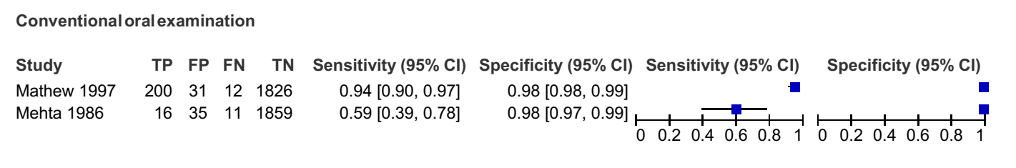

Figure S3 2 Forest plot of Sensitivity and Specificity of Sri Lankan studies
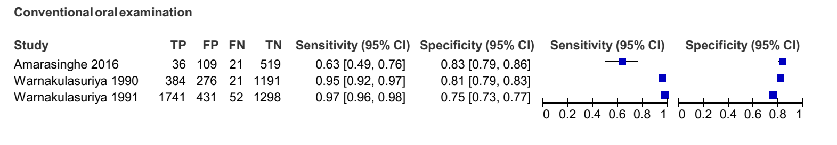

Figure S3 3 Forest plot of Sensitivity and Specificity with prevalence less than 50, more than 10
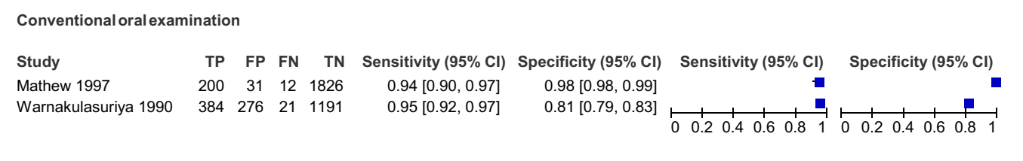

Figure S3 4 Forest plot of Sensitivity and Specificity with prevalence more than 10
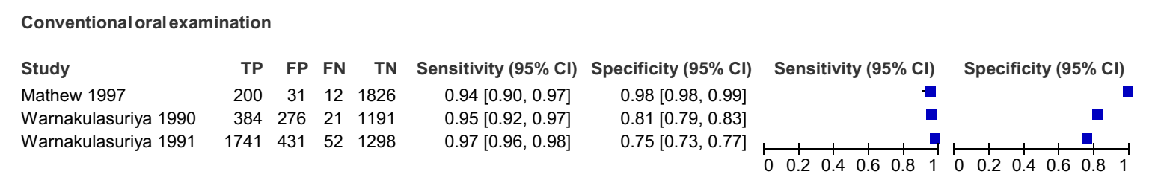

Figure S3 5 Forest plot of Sensitivity and Specificity with prevalence less than 50
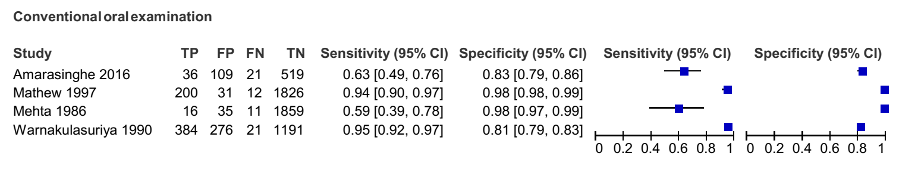

4. Summary receiver-operating characteristic (SROC) curve

Figure S4. 1 SROC curve of Indian studies
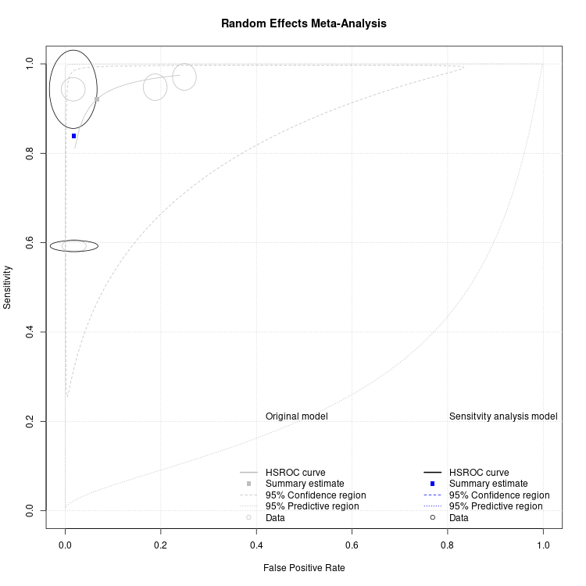

Figure S4. 2 SROC curve of Sri Lankan studies
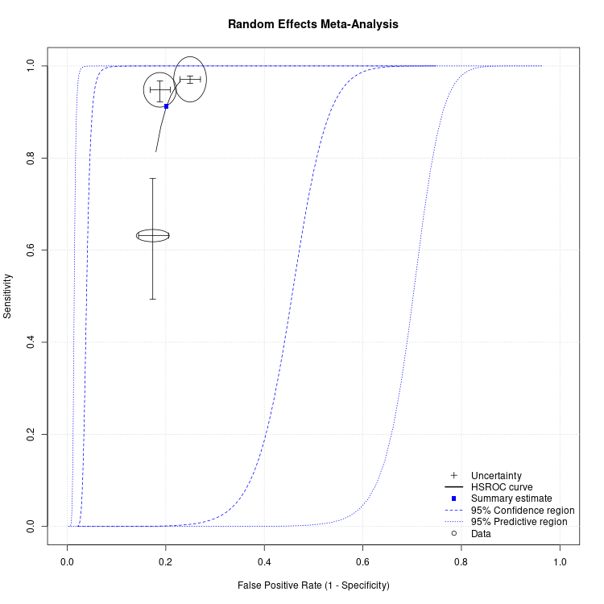

Figure S4. 3 Prevalence less than 50, more than 10
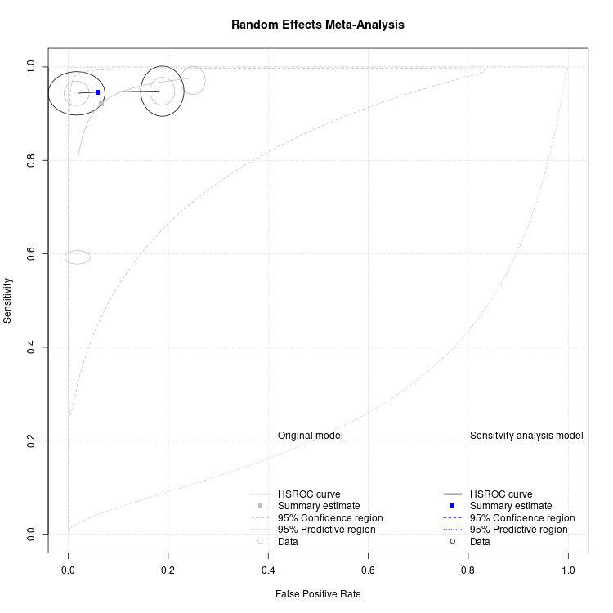

Figure S4. 4 Prevalence more than 10
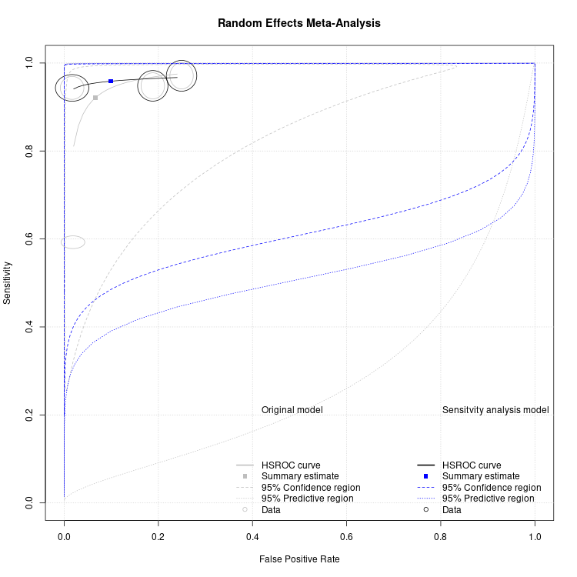

Figure S4. 5 Prevalence less than 50
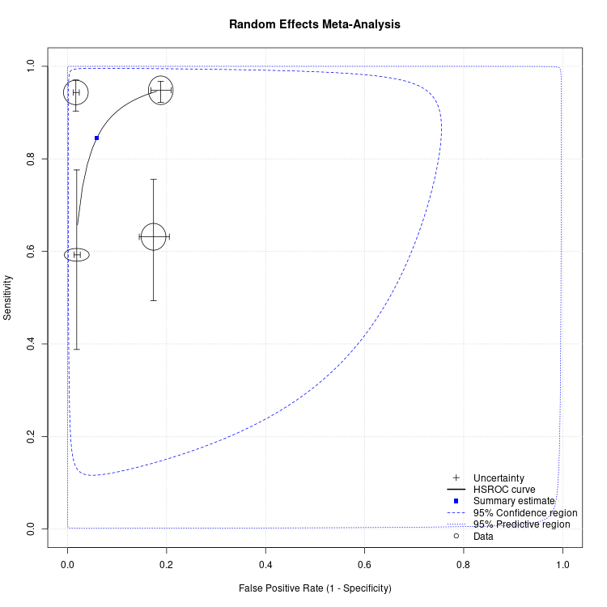

5. List of articles excluded from the review with reasons

Table S5. 1 Reason for exclusion – studies conducted among the patient population
S. No | Authors | Title | Year | Journal
1 | Kujan et al. | Efficacy of oral brush cytology cell block immunocytochemistry in the diagnosis of oral leukoplakia and oral squamous cell carcinoma. | 2020 | Journal of oral pathology & medicine
2 | Velleuer et al. | Diagnostic accuracy of brush biopsy-based cytology for the early detection of oral cancer and precursors in Fanconi anemia. | 2020 | Cancer cytopathology
3 | Hosmani et al. | Comparison of the Efficacy of Sediment Cytology over Oral Brush Cytology in Oral Leukoplakia. | 2020 | Acta cytologica
4 | Morikawa et al. | Image processing analysis of oral cancer, oral potentially malignant disorders, and other oral diseases using optical instruments. | 2020 | International journal of oral and maxillofacial surgery
5 | Shi et al. | Potential role of autofluorescence imaging in determining biopsy of oral potentially malignant disorders: A large prospective diagnostic study. | 2019 | Oral oncology
6 | Kujan et al. | CDK4, CDK6, cyclin D1 and Notch1 immunocytochemical expression of oral brush liquid-based cytology for the diagnosis of oral leukoplakia and oral cancer. | 2019 | Journal of oral pathology & medicine
7 | Sadullahoğlu et al. et al. | The risk of malignancy according to Milan reporting system of salivary gland fine-needle aspiration with Becton Dickinson SurePath liquid-based processing. | 2019 | Diagnostic cytopathology
8 | Osaka et al. | Evaluation of Liquid Based Cytology for Tongue Squamous Cell Carcinoma: Comparison with Conventional Cytology. | 2019 | The Bulletin of Tokyo Dental College
9 | Saini et al. | Efficacy of Fluorescence Technology vs Conventional Oral Examination for the Early Detection of Oral Pre-Malignant Lesions. A Clinical Comparative Study. | 2019 | Endocrine, metabolic & immune disorders drug targets
10 | Chiang et al. | Comparative evaluation of autofluorescence imaging and histopathological investigation for oral potentially malignant disorders in Taiwan. | 2019 | Clinical oral investigations
11 | Alsarraf et al. | Liquid-based oral brush cytology in the diagnosis of oral leukoplakia using a modified Bethesda Cytology system. | 2018 | Journal of oral pathology & medicine
12 | Yamamoto et al. | Detection accuracy for epithelial dysplasia using an objective autofluorescence visualization method based on the luminance ratio. | 2017 | International journal of oral science
13 | Ganga et al. | Evaluation of the diagnostic efficacy and spectrum of autofluorescence of benign, dysplastic and malignant lesions of the oral cavity using VELscope. | 2017 | Oral oncology
14 | Amirchaghmaghi et al. | The diagnostic value of the native fluorescence visualization device for early detection of premalignant/malignant lesions of the oral cavity. | 2018 | Photodiagnosis and photodynamic therapy
15 | Goodson et al. | Efficacy of oral brush biopsy in potentially malignant disorder management. | 2017 | Journal of oral pathology & medicine
16 | Yan et al. | Portable LED-induced autofluorescence spectroscopy for oral cancer diagnosis. | 2017 | Journal of biomedical optics
17 | Sekine et al. | Diagnostic accuracy of oral cancer cytology in a pilot study. | 2017 | Diagnostic pathology
18 | Jajodia et al. | Brush Cytology and AgNOR in the Diagnosis of Oral Squamous Cell Carcinoma. | 2017 | Acta cytologica
19 | Lalla et al. | Assessment of oral mucosal lesions with autofluorescence imaging and reflectance spectroscopy. | 2016 | Journal of the American Dental Association (1939)
20 | Kaur et al. | Evaluation of brush cytology and DNA image cytometry for the detection of cancer of the oral cavity. | 2016 | Diagnostic cytopathology
21 | Moro et al. | The GOCCLESÂ® medical device is effective in detecting oral cancer and dysplasia in dental clinical setting. Results from a multicentre clinical trial. | 2015 | Acta otorhinolaryngologica Italica
22 | Nanayakkara et al. | Comparison of spatula and cytobrush cytological techniques in early detection of oral malignant and premalignant lesions: a prospective and blinded study. | 2016 | Journal of oral pathology & medicine
23 | Chainani-Wu et al. | Toluidine blue aids in detection of dysplasia and carcinoma in suspicious oral lesions. | 2015 | Oral diseases
24 | Awan et al. | Assessing the accuracy of autofluorescence, chemiluminescence and toluidine blue as diagnostic tools for oral potentially malignant disorders—a clinicopathological evaluation. | 2015 | Clinical oral investigations
25 | Sahebjamee et al. | Conventional versus Papanicolaou-stained cytobrush biopsy in the diagnosis of oral squamous cell carcinoma. | 2014 | Oral health and dental management
26 | Petruzzi et al. | Evaluation of autofluorescence and toluidine blue in the differentiation of oral dysplastic and neoplastic lesions from non-dysplastic and neoplastic lesions: a cross-sectional study. | 2014 | Journal of biomedical optics
27 | Hanken et al. | The detection of oral pre- malignant lesions with an autofluorescence based imaging system (VELscope™) — a single blinded clinical evaluation. | 2013 | Head & face medicine
28 | Junaid et al. | Toluidine blue: yet another low-cost method for screening oral cavity tumour margins in third world countries. | 2013 | JPMA. The Journal of the Pakistan Medical Association
29 | Kolokythas et al. | A prototype tobacco-associated oral squamous cell carcinoma classifier using RNA from brush cytology. | 2013 | Journal of oral pathology & medicine
30 | Kämmerer et al. | Prospective, blinded comparison of cytology and DNA-image cytometry of brush biopsies for early detection of oral malignancy. | 2013 | Oral oncology
31 | Rana et al. | Clinical evaluation of an autofluorescence diagnostic device for oral cancer detection: a prospective randomized diagnostic study. | 2012 | European journal of cancer prevention
32 | Marzouki et al. | Use of fluorescent light in detecting malignant and premalignant lesions in the oral cavity: a prospective, single-blind study. | 2012 | Journal of otolaryngology - head & neck surgery
33 | Afrogheh et al. | An evaluation of the Shandon Papspin liquid-based oral test using a novel cytologic scoring system. | 2012 | Oral surgery, oral medicine, oral pathology and oral radiology
34 | Awan et al. | Utility of toluidine blue as a diagnostic adjunct in the detection of potentially malignant disorders of the oral cavity—a clinical and histological assessment. | 2012 | Oral diseases
35 | Junaid et al. | A comparative analysis of toluidine blue with frozen section in oral squamous cell carcinoma. | 2012 | World journal of surgical oncology
36 | Mojsa et al. | Value of the ViziLite Plus System as a diagnostic aid in the early detection of oral cancer/premalignant epithelial lesions. | 2012 | The Journal of craniofacial surgery
37 | Jeng et al. | Novel quantitative analysis using optical imaging (Velscope) and spectroscopy (raman) techniques for oral cancer detection | 2020 | Cancers
38 | Morikawa et al. | Non-invasive early detection of oral cancers using fluorescence visualization with optical instruments | 2020 | Cancers
39 | Jabbar et al. | The diagnostic efficacy of visually enhanced lesion scope (Velscope) in identifying benign, dysplastic and cancerous oral lesions | 2020 | Indian J. Forensic Med. Toxicol.
40 | Leuci et al. | May velscope be deemed an opportunistic oral cancer screening by general dentists? A pilot study | 2020 | J. Clin. Med.
41 | Rahman et al. | A study to evaluate the efficacy of toluidine blue and cytology in detecting oral cancer and dysplastic lesions. | 2012 | Quintessence international (Berlin, Germany : 1985)
42 | Farah et al. | Efficacy of tissue autofluorescence imaging (VELScope) in the visualization of oral mucosal lesions. | 2012 | Head & neck
43 | Sweeny et al. | Assessment of tissue autofluorescence and reflectance for oral cavity cancer screening. | 2011 | Otolaryngology head and neck surgery
44 | Matsumoto K | Detection of potentially malignant and malignant lesions of oral cavity using autofluorescence visualization device. | 2011 | Kokubyo Gakkai zasshi. The Journal of the Stomatological Society, Japan
45 | Pérez-Sayáns et al. | Non-computer-assisted liquid-based cytology for diagnosis of oral squamous cell carcinoma. | 2012 | Biotechnic & histochemistry
46 | Paderni et al. | Direct visualization of oral-cavity tissue fluorescence as novel aid for early oral cancer diagnosis and potentially malignant disorders monitoring. | 2011 | International journal of immunopathology and pharmacology
47 | Cancela-Rodríguez et al. | The use of toluidine blue in the detection of pre-malignant and malignant oral lesions. | 2011 | Journal of oral pathology & medicine
48 | Awan et al. | Evaluation of an autofluorescence based imaging system (VELscopeâ„¢) in the detection of oral potentially malignant disorders and benign keratoses. | 2011 | Oral oncology
49 | Scheer et al. | Autofluorescence imaging of potentially malignant mucosa lesions. | 2011 | Oral surgery, oral medicine, oral pathology, oral radiology, and endodontics
50 | Upadhyay et al. | Reliability of toluidine blue vital staining in detection of potentially malignant oral lesions —time to reconsider. | 2011 | Asian Pacific journal of cancer prevention : APJCP
51 | Güneri et al. | The utility of toluidine blue staining and brush cytology as adjuncts in clinical examination of suspicious oral mucosal lesions. | 2011 | International journal of oral and maxillofacial surgery
52 | Moro et al. | Autofluorescence and early detection of mucosal lesions in patients at risk for oral cancer. | 2010 | The Journal of craniofacial surgery
53 | Morikawa et al. | The utility of optical instrument “ORALOOK®” in the early detection of high-risk oral mucosal lesions | 2019 | Anticancer Res.
54 | Delavarian et al. | Evaluation of the diagnostic value of a Modified Liquid-Based Cytology using OralCDx Brush in early detection of oral potentially malignant lesions and oral cancer. | 2010 | Medicina oral, patologia oral y cirugia bucal
55 | Koch et al. | Effectiveness of autofluorescence to identify suspicious oral lesions—a prospective, blinded clinical trial. | 2011 | Clinical oral investigations
56 | Koch et al. | Diagnostic efficiency of differentiating small cancerous and precancerous lesions using mucosal brush smears of the oral cavity—a prospective and blinded study. | 2011 | Clinical oral investigations
57 | Nagaraju et al. | Diagnostic efficiency of toluidine blue with Lugol’s iodine in oral premalignant and malignant lesions. | 2010 | Indian journal of dental research
58 | Mehrotra et al. | A cross-sectional study evaluating chemiluminescence and autofluorescence in the detection of clinically innocuous precancerous and cancerous oral lesions. | 2010 | Journal of the American Dental Association (1939)
59 | Jayaprakash et al. | Autofluorescence-guided surveillance for oral cancer. | 2009 | Cancer prevention research (Philadelphia, Pa.)
60 | McIntosh et al. | The assessment of diffused light illumination and acetic acid rinse (Microlux/DL) in the visualization of oral mucosal lesions. | 2009 | Oral oncology
61 | Allegra et al. | The usefulness of toluidine staining as a diagnostic tool for precancerous and cancerous oropharyngeal and oral cavity lesions. | 2009 | Acta otorhinolaryngologica Italica : organo ufficiale della Societa italiana di otorinolaringologia e chirurgia cervico-facciale
62 | Bhoopathi et al. | Low positive predictive value of the oral brush biopsy in detecting dysplastic oral lesions. | 2009 | Cancer
63 | Navone R | Cytology of the oral cavity: a re-evaluation. | 2009 | Pathologica
64 | Adil et al. | Comparative study on the efficacy of Tissue Autofluorescence (Visually Enhanced Lesion Scope) and Toluidine Blue as a screening method in oral potentially malignant and malignant lesions | 2017 | J. Med. Sci.
65 | Mehrotra et al. | The use of an oral brush biopsy without computer-assisted analysis in the evaluation of oral lesions: a study of 94 patients. | 2008 | Oral surgery, oral medicine, oral pathology, oral radiology, and endodontics
66 | Bhalang et al. | The application of acetic acid in the detection of oral squamous cell carcinoma. | 2008 | Oral surgery, oral medicine, oral pathology, oral radiology, and endodontics
67 | Mallia et al. | Laser-induced autofluorescence spectral ratio reference standard for early discrimination of oral cancer. | 2008 | Cancer
68 | Driemel et al. | Performance of conventional oral brush biopsies. | 2008 | HNO
69 | Navone et al. | The impact of liquid-based oral cytology on the diagnosis of oral squamous dysplasia and carcinoma. | 2007 | Cytopathology
70 | Epstein et al. | Analysis of oral lesion biopsies identified and evaluated by visual examination, chemiluminescence and toluidine blue. | 2008 | Oral oncology
71 | Remmerbach et al. | Minimally invasive brush-biopsy: innovative method for early diagnosis of oral squamous cell carcinoma. | 2007 | Schweizer Monatsschrift fur Zahnmedizin
72 | Lane et al. | Simple device for the direct visualization of oral-cavity tissue fluorescence. | 2006 | Journal of biomedical optics
73 | Chang et al. | Topical application of photofrin for photodynamic diagnosis of oral neoplasms. | 2005 | Plastic and reconstructive surgery
74 | Hayama et al. | Liquid-based preparations versus conventional cytology: specimen adequacy and diagnostic agreement in oral lesions. | 2005 | Medicina oral, patologia oral y cirugia bucal
75 | Poate et al. | An audit of the efficacy of the oral brush biopsy technique in a specialist Oral Medicine unit. | 2004 | Oral oncology
76 | Maraki et al. | Cytologic and DNA-cytometric very early diagnosis of oral cancer. | 2004 | Journal of oral pathology & medicine
77 | Zheng et al. | The use of digitized endoscopic imaging of 5-ALA-induced PPIX fluorescence to detect and diagnose oral premalignant and malignant lesions in vivo. | 2004 | International journal of cancer
78 | Navone et al. | [Usefulness of oral exfoliative cytology for the diagnosis of oral squamous dysplasia and carcinoma]. | 2004 | Minerva stomatologica
79 | Svistun et al. | Vision enhancement system for detection of oral cavity neoplasia based on autofluorescence. | 2004 | Head & neck
80 | Epstein et al. | The utility of tolonium chloride rinse in the diagnosis of recurrent or second primary cancers in patients with prior upper aerodigestive tract cancer. | 2003 | Head & neck
81 | Betz et al. | A comparative study of normal inspection, autofluorescence and 5-ALA-induced PPIX fluorescence for oral cancer diagnosis. | 2002 | International journal of cancer
82 | Onofre et al. | Reliability of toluidine blue application in the detection of oral epithelial dysplasia and in situ and invasive squamous cell carcinomas. | 2001 | Oral surgery, oral medicine, oral pathology, oral radiology, and endodontics
83 | Leunig et al. | Detection of squamous cell carcinoma of the oral cavity by imaging 5-aminolevulinic acid-induced protoporphyrin IX fluorescence. | 2000 | The Laryngoscope
84 | Zenk et al. | [Visualizing carcinomas of the mouth cavity by stimulating synthesis of fluorescent protoporphyrin IX]. | 1999 | Mund-, Kiefer- und Gesichtschirurgie : MKG
85 | Wang et al. | Diagnosis of oral cancer by light-induced autofluorescence spectroscopy using double excitation wavelengths. | 1999 | Oral oncology
86 | Betz et al. | Autofluorescence imaging and spectroscopy of normal and malignant mucosa in patients with head and neck cancer. | 1999 | Lasers in surgery and medicine
87 | Martin et al. | The application of toluidine blue as a diagnostic adjunct in the detection of epithelial dysplasia. | 1998 | Oral surgery, oral medicine, oral pathology, oral radiology, and endodontics
88 | Kulapaditharom et al. | Laser-induced fluorescence imaging in localization of head and neck cancers. | 1998 | The Annals of otology, rhinology, and laryngology
89 | Epstein et al. | The utility of toluidine blue application as a diagnostic aid in patients previously treated for upper oropharyngeal carcinoma. | 1997 | Oral surgery, oral medicine, oral pathology, oral radiology, and endodontics
90 | Ingrams et al. | Autofluorescence characteristics of oral mucosa. | 1997 | Head & neck
91 | Warnakulasuriya et al. | Sensitivity and specificity of OraScan toluidine blue mouthrinse in the detection of oral cancer and precancer. | 1996 | Journal of oral pathology & medicine
92 | Amorin et al. | [White lesions of the oral mucosa. Auxiliary diagnostic methods]. | 1990 | Anales de la Facultad de Odontologia
93 | Mashberg et al. | Screening for oral and oropharyngeal squamous carcinomas. | 1984 | CA: a cancer journal for clinicians
94 | Mashberg A | Reevaluation of toluidine blue application as a diagnostic adjunct in the detection of asymptomatic oral squamous carcinoma: a continuing prospective study of oral cancer III. | 1980 | Cancer
95 | Reddy et al. | Correlative study of exfoliative cytology and histopathology of oral carcinomas. | 1975 | Journal of oral surgery (American Dental Association : 1965)
96 | Vahidy et al. | Toludine blue test for detection of carcinoma of the oral cavity: an evaluation. | 1972 | Journal of surgical oncology
97 | Dabelsteen et al. | The limitations of exfoliative cytology for the detection of epithelial atypia in oral leukoplakias. | 1971 | British journal of cancer
98 | Kameyama et al. | Clinico stastical observation of squamous cell cancer in oral cavity for past 10 years (1973-1982) and a trial for early detection of oral cancer | 1988 | Japanese Journal of Oral and Maxillofacial Surgery
99 | Deuerling et al. | Evaluation of the accuracy of liquid-based oral brush cytology in screening for oral squamous cell carcinoma | 2019 | Cancers
100 | Jain et al. | Role of Chemiluminescence examination as non-invasive diagnostic tool in early detection of Leukoplakia | 2018 | Journal of Oral Biology and Craniofacial Research
101 | Chaudhry et al. | Comparison of chemiluminescence and toluidine blue in the diagnosis of dysplasia in leukoplakia: a cross-sectional study | 2016 | Journal of investigative and clinical dentistry
102 | Casparis et al. | Transepithelial brush biopsy - Oral CDxÂ® - A noninvasive method for the early detection of precancerous and cancerous lesions | 2014 | Journal of Clinical and Diagnostic Research
103 | Gupta et al. | Clinical correlative study on early detection of oral cancer and precancerous lesions by modified oral brush biopsy and cytology followed by histopathology | 2014 | Journal of Cancer Research and Therapeutics
104 | Ujaoney et al. | Evaluation of chemiluminescence, toluidine blue and histopathology for detection of high-risk oral precancerous lesions: A cross-sectional study | 2012 | BMC Clinical Pathology
105 | Seijas-Naya et al. | Applications of OralCDx Â® methodology in the diagnosis of oral leukoplakia | 2012 | Medicina Oral, Patologia Oral y Cirugia Bucal
106 | Sharma et al. | Non -invasive diagnostic tools in early detection of oral epithelial dysplasia | 2011 | Journal of Clinical and Experimental Dentistry
107 | Gupta et al. | Utility of toluidine blue staining and brush biopsy in precancerous and cancerous oral lesions | 2007 | Acta Cytologica
108 | Field et al. | Oral mucosal screening as an integral part of routine dental care. | 1995 | British dental journal

Table S5. 2 Reason for exclusion – other
S. No | Authors | Title | Year | Journal | Reason for exclusion
1 | Huang et al. | Two-channel autofluorescence analysis for oral cancer. | 2018 | Journal of biomedical optics | Study population with multiple sub-groups
2 | Yang et al. | In Vivo Multimodal Optical Imaging: Improved Detection of Oral Dysplasia in Low-Risk Oral Mucosal Lesions. | 2018 | Cancer prevention research (Philadelphia, Pa.) | Study population with multiple sub-groups
3 | Olms et al. | Clinical comparison of liquid-based and conventional cytology of oral brush biopsies: a randomized controlled trial. | 2018 | Head & face medicine | wrong outcome
4 | Cânjău et al. | Fluorescence influence on screening decisions for oral malignant lesions. | 2018 | Romanian journal of morphology and embryology | Study population with multiple sub-groups
5 | Pandey et al. | Oral Brush Liquid-Based Cytology: A Study of Concordance between a Cytotechnologist and a Cytopathologist. | 2018 | Acta cytologica | Agreement was assessed, not validation
6 | Sharbatdaran et al. | Assessment of oral cytological features in smokers and nonsmokers after application of toluidine blue. | 2017 | Diagnostic cytopathology | wrong outcome
7 | Remmerbach et al. | Liquid-based versus conventional cytology of oral brush biopsies: a split-sample pilot study. | 2017 | Clinical oral investigations | Agreement was assessed, not validation
8 | Brands et al. | The prognostic value of GLUT-1 staining in the detection of malignant transformation in oral mucosa. | 2017 | Clinical oral investigations | Study population with multiple sub-groups
9 | Liu et al. | Quantitative risk stratification of oral leukoplakia with exfoliative cytology. | 2015 | PloS one | Study population with multiple sub-groups
10 | Higgins et al. | Design and characterization of a handheld multimodal imaging device for the assessment of oral epithelial lesions. | 2014 | Journal of biomedical optics | wrong outcome
11 | Gonzalez et al. | Exfoliative cytology as a tool for monitoring pre-malignant and malignant lesions based on combined stains and morphometry techniques. | 2015 | Journal of oral pathology & medicine | Study population with multiple sub-groups
12 | Monteiro et al. | Outcomes of invitational and opportunistic oral cancer screening initiatives in Oporto, Portugal. | 2015 | Journal of oral pathology & medicine | Screened by Dental students, Values not given clearly
13 | Francisco et al. | Fluorescence spectroscopy for the detection of potentially malignant disorders and squamous cell carcinoma of the oral cavity. | 2014 | Photodiagnosis and photodynamic therapy | Study population with multiple sub-groups
14 | Klatt et al. | Fractal dimension of time-resolved autofluorescence discriminates tumour from healthy tissues in the oral cavity. | 2014 | Journal of cranio-maxillo-facial surgery | Study population with multiple sub-groups
15 | Chaudhari et al. | Comparison of different screening methods in estimating the prevalence of precancer and cancer amongst male inmates of a jail in Maharashtra, India. | 2013 | Asian Pacific journal of cancer prevention : APJCP | Screened by an expert
16 | Bhoopathi et al. | Utility of oral cancer diagnostic adjuncts in the adult US populations. | 2013 | Journal of oral pathology & medicine | Secondary data analysis
17 | Ebenezar et al. | Noninvasive fluorescence excitation spectroscopy for the diagnosis of oral neoplasia in vivo. | 2012 | Journal of biomedical optics | Study population with multiple sub-groups
18 | Macaulay et al. | High throughput image cytometry for detection of suspicious lesions in the oral cavity. | 2012 | Journal of biomedical optics | Study population with multiple sub-groups
19 | Qaiser et al. | Novel use of fluorescein dye in detection of oral dysplasia and oral cancer | 2020 | Photodiagn. Photodyn. Ther. | Study population with multiple sub-groups
20 | Sartori et al. | Accuracy of screening for potentially malignant disorders of the oral mucosa by dentists in primary care. | 2012 | Oral health & preventive dentistry | Screened by general dental practitioner
21 | Awan et al. | Utility of chemiluminescence (ViziLiteâ„¢) in the detection of oral potentially malignant disorders and benign keratoses. | 2011 | Journal of oral pathology & medicine | Study population with multiple sub-groups
22 | Balevi B | Assessing the usefulness of three adjunctive diagnostic devices for oral cancer screening: a probabilistic approach. | 2011 | Community dentistry and oral epidemiology | Secondary data analysis
23 | Scott et al. | Pilot study to estimate the accuracy of mouth self-examination in an at-risk group. | 2010 | Head & neck | Moth self examination
24 | Mallia et al. | Clinical grading of oral mucosa by curve-fitting of corrected autofluorescence using diffuse reflectance spectra. | 2010 | Head & neck | Study population with multiple sub-groups
25 | Huber MA | Assessment of the VELscope as an adjunctive examination tool. | 2009 | Texas dental journal | wrong outcome
26 | Roblyer et al. | Objective detection and delineation of oral neoplasia using autofluorescence imaging. | 2009 | Cancer prevention research (Philadelphia, Pa.) | Study population with multiple sub-groups
27 | Schwarz et al. | Noninvasive evaluation of oral lesions using depth-sensitive optical spectroscopy. | 2009 | Cancer | Study population with multiple sub-groups
28 | Huff et al. | Sensitivity of direct tissue fluorescence visualization in screening for oral premalignant lesions in general practice. | 2009 | General dentistry | wrong outcome
29 | Moyer et al. | Screening for oral cancer: U.S. Preventive Services Task Force recommendation statement | 2014 | Ann. Intern. Med. | Review article
30 | Mallia et al. | Laser-induced autofluorescence spectral ratio reference standard for early discrimination of oral cancer. | 2008 | Cancer | Population-patient,Study population with multiple sub-groups
31 | Schwarz et al. | Autofluorescence and diffuse reflectance spectroscopy of oral epithelial tissue using a depth-sensitive fiber-optic probe. | 2008 | Applied optics | Study population with multiple sub-groups
32 | Saini et al. | Oral cancer: Initial diagnosis influences final prognosis | 2014 | Pravara Med. Rev. | Letter to editor
33 | Kao et al. | Screening for oral cancers-Which method is most effective? | 2011 | J. Chin. Med. Assoc. | Editorial
34 | Mehrotra et al. | The efficacy of oral brush biopsy with computer-assisted analysis in identifying precancerous and cancerous lesions | 2011 | Head Neck Oncol. | Screened by specialists and residents-in-training, Patient inclusion criteria
35 | Hirata K | Discusson of adjunctive diagnostic modalities available for screening of oral leukoplakia. | 2006 | Hawaii dental journal | Review article
36 | Majumder et al. | Relevance vector machine for optical diagnosis of cancer. | 2005 | Lasers in surgery and medicine | Study population with multiple sub-groups
37 | Ram et al. | Chemiluminescence as a diagnostic aid in the detection of oral cancer and potentially malignant epithelial lesions. | 2005 | International journal of oral and maxillofacial surgery | Study population with multiple sub-groups
38 | de Veld et al. | Clinical study for classification of benign, dysplastic, and malignant oral lesions using autofluorescence spectroscopy. | 2004 | Journal of biomedical optics | Study population with multiple sub-groups
39 | Huber et al. | Acetic acid wash and chemiluminescent illumination as an adjunct to conventional oral soft tissue examination for the detection of dysplasia: a pilot study. | 2004 | Quintessence international (Berlin, Germany : 1985) | Pilot study, Irrelevant abstract
40 | Sweeny et al. | Assessment of autofluorescence for oral cancer screening | 2011 | Otolaryngol. Head Neck Surg. | Study population with multiple sub-groups
41 | Remmerbach et al. | Oral brush biopsy analysis by matrix assisted laser desorptionizationi on- time of flight mass spectrometry profiling - A pilot study | 2011 | Oral Oncol. | Study population with multiple sub-groups
42 | Ramadas et al. | Interim results from a cluster randomized controlled oral cancer screening trial in Kerala, India. | 2003 | Oral oncology | Same population study already included, duplication
43 | Drinnan AJ | Screening for oral cancer and precancer--a valuable new technique. | 2000 | General dentistry | Review article
44 | Gillenwater et al. | Noninvasive diagnosis of oral neoplasia based on fluorescence spectroscopy and native tissue autofluorescence. | 1998 | Archives of otolaryngology--head & neck surgery | Study population with multiple sub-groups
45 | Burzynski et al. | Evaluation of oral cancer screening. | 1997 | Journal of cancer education | wrong outcome
46 | Dhingra et al. | Early diagnosis of upper aerodigestive tract cancer by autofluorescence. | 1996 | Archives of otolaryngoloy--head & neck surgery | Study population with multiple sub-groups
47 | Mashberg et al. | Early diagnosis of asymptomatic oral and oropharyngeal squamous cancers. | 1995 | CA: a cancer journal for clinicians | Review article
48 | Mashberg A | Tolonium (toluidine blue) rinse--a screening method for recognition of squamous carcinoma. Continuing study of oral cancer IV. | 1981 | JAMA | wrong outcome
49 | Pizer et al. | An assessment of toluidine blue for the diagnosis of lip lesions. | 1979 | Virginia medical | No Abstract & Full text available
50 | Bánóczy J | Exfoliative cytologic examinations in the early diagnosis of oral cancer. | 1976 | International dental journal | Review article
51 | Reddy et al. | Toluidine blue staining of oral cancer and precancerous lesions. | 1973 | The Indian journal of medical research | No Abstract & Full text available
52 | Rosen et al. | Detection of early oral cancer by toluidine blue. | 1971 | Journal of the Canadian Dental Association | No Abstract & Full text available
53 | Jaber et al. | Oral cancer prevention and early detection | 2012 | International journal of health care quality assurance | wrong outcome
54 | Eckert et al. | A review of oral cancer screening and detection in the metropolitan Detroit cancer control program. | 1982 | Progress in clinical and biological research | Review article
55 | Warnakulasuriya et al. | Utilization of primary health care workers for early detection of oral cancer and precancer cases in Sri Lanka | 1984 | Bulletin of the World Health Organization | wrong outcome
56 | Clark Alison | Oral cancer prevention and early detection | 1999 | Nursing Standard (through 2013) | Discussion
57 | Kaleem et al. | Reliability and validity of light-based screening techniques in detection of oral premalignant lesions | 2018 | King Khalid University Journal of Health Sciences | Screened by researcher and specialist dental surgeon
58 | Simonato et al. | Fluorescence visualization improves the detection of oral, potentially malignant, disorders in population screening | 2019 | Photodiagnosis and Photodynamic Therapy | Screened by General practice dentist
59 | Huang et al. | Novel quantitative analysis of autofluorescence images for oral cancer screening | 2017 | Oral Oncology | Study population with multiple sub-groups
60 | Charanya et al. | Adjunctive aids for the detection of oral premalignancy | 2016 | Journal of Pharmacy and Bioallied Sciences | Review article
61 | Bhatia et al. | Assessment of a decision making protocol to improve the efficacy of VELscopeâ„¢ in general dental practice: A prospective evaluation | 2014 | Oral Oncology | Screened by general dental practitioner
62 | Sambandham et al. | The application of Vizilite in oral cancer | 2013 | Journal of Clinical and Diagnostic Research | Review article
63 | Ali et al. | Diagnostic test for cancer detection in dental & ent clinics: The toluidine blue test | 2012 | JK Practitioner | Review article
64 | Chang et al. | Visual screening of oral cavity cancer in a male population: Experience from a medical center | 2011 | Journal of the Chinese Medical Association | Screened by an experienced otolaryngologists or dentists
65 | Elango et al. | Mouth self-examination to improve oral cancer awareness and early detection in a high-risk population | 2011 | Oral Oncology | Moth self examination
66 | Rahman et al. | Evaluation of a low-cost, portable imaging system for early detection of oral cancer | 2010 | Head and Neck Oncology | Study population with multiple sub-groups
67 | Sankaranarayanan et al. | Early findings from a community-based, cluster-randomized, controlled oral cancer screening trial in Kerala, India | 2000 | Cancer | Same population study already included, duplication
68 | Macey et al. | Diagnostic tests for oral cancer and potentially malignant disorders in patients presenting with clinically evident lesions | 2015 | Cochrane Database of Systematic Reviews | Review article
69 | Jullien et al. | Attendance and compliance at an oral cancer screening programme in a general medical practice. | 1995 | European journal of cancer. Part B, Oral oncology | wrong outcome
70 | Su et al. | A community-based RCT for oral cancer screening with toluidine blue. | 2010 | Journal of dental research | wrong outcome
71 | Frenández et al. | An evaluation of the oral cancer control program in Cuba. | 1995 | Epidemiology (Cambridge, Mass.) | wrong outcome
72 | Ikeda et al. | Epidemiological study of oral leukoplakia based on mass screening for oral mucosal diseases in a selected Japanese population. | 1991 | Community dentistry and oral epidemiology | wrong outcome

6. Data from included studies

Table S6. 1 Data from the included studies
Study ID | True  Positive | False  Positive | False  Negative | True  Negative | Sensitivity | Sensitivity  (95% CI) | Specificity | Specificity  (95% CI) | Sample size | Prevalence  (%) | Compliance on referral centre (%) | Training duration of health workers
Mathew 1997 | 200 | 31 | 12 | 1826 | 0.943 | 0.903 - 0.970 | 0.983 | 0.976 - 0.989 | 2069 | 10.3 | 100 | 6 weeks
Mehta 1986 | 16 | 35 | 11 | 1859 | 0.593 | 0.388 - 0.776 | 0.982 | 0.974 - 0.987 | 1921 | 1.4 | 72 | 5 days; 2 days
Warnakulasuriya 1990 | 384 | 276 | 21 | 1191 | 0.948 | 0.922 - 0.968 | 0.812 | 0.791 - 0.832 | 1872 | 21.6 | 54.1 | 2 days
Warnakulasuriya 1991 | 1741 | 431 | 52 | 1298 | 0.971 | 0.962 - 0.978 | 0.751 | 0.730 - 0.771 | 3522 | 50.7 | 62 | 2 days
Amarasinghe 2016 | 36 | 109 | 21 | 519 | 0.63 | 0.49 - 0.76 | 0.83 | 0.79 - 0.86 | 685 | 8.3 | 67 | 2 days

7. Articles included in the review
1. Mathew B, Sankaranarayanan R, Sunilkumar KB, Kuruvila B, Pisani P, Krishnan Nair M. Reproducibility and validity of oral visual inspection by trained health workers in the detection of oral precancer and cancer. BR J CANCER. 1997;76(3):390-4.
2. Mehta FS, Gupta PC, Bhonsle RB, Murti PR, Daftary DK, Pindborg JJ. Detection of oral cancer using basic health workers in an area of high oral cancer incidence in India. Cancer Detect Prev. 1986;9(3-4):219-25.
3. Warnakulasuriya KA, Nanayakkara BG. Reproducibility of an oral cancer and precancer detection program using a primary health care model in Sri Lanka. Cancer Detect Prev. 1991;15(5):331-4.
4. Warnakulasuriya S, Pindborg JJ. Reliability of oral precancer screening by primary health care workers in Sri Lanka. Community dental health. 1990;7(1):73-9.
5. Amarasinghe AA, Usgodaarachchi US, Johnson NW. Evaluation of the utilization of primary healthcare staff for control of oral cancer: A Sri Lankan experience. Translational Research in Oral Oncology. 2016 Dec 21;1:2057178X16682544.

