**Supplementary Appendix**

**FIGURES**

**Supplemental Figure S1.** Physician’s caseload

**Supplemental Figure S2.** Physician’s perception of importance of JAK2 V617F mutation testing and bone marrow biopsy for diagnosing MPN

**Supplemental Figure S3.** Physician’s perception of proportion of symptomatic MPN patients that undergo diagnostic testing

**Supplemental Figure S4.** Physician’s perception of top reasons why symptomatic MPN patients do not undergo JAK2 V617F testing

**Supplemental Figure S5.** Physician’s perception of top reasons why symptomatic MPN patients do not undergo bone marrow biopsy testing

**Supplemental Figure S6.** Physician perception of MF disease burden

**Supplemental Figure S7.** Physician perception of MF patient’s symptoms at first visit vs currently

**Supplemental Figure S8.** Physician perception of top MF symptoms

**Supplemental Figure S9.** Physician perception of MF symptoms’ impact on quality of life

**Supplemental Figure S10.** Physician perception of MF patient concerns – functional and financial well-being

**Supplemental Figure S11.** Physician perception ofMF patient concerns – physical, social/ family well-being

**Supplemental Figure S12.** Physician perception of MF disease progression

**Supplemental Figure S13.** Physician perception of patient involvement in treatment decisions

**Supplemental Figure S14.** Physician perception of patient and physician alignment on treatment goals

**Supplemental Figure S15.** Physician perception of factors used to assess MF progression

**Supplemental Figure S16.** Physician perception of MF symptoms most likely to be recommended a drug

**Supplemental Figure S17.** Physician perception of treatment goals for MF patients

**Supplemental Figure S18.** Physician perception for patient reasons for changing drug therapy of MF patients

**Supplemental Figure S19.** Physician perception of solutions to overcoming unmet needs in MF

Physician’s caseload

**S****upplemental Figure S1.** Physician’s caseload

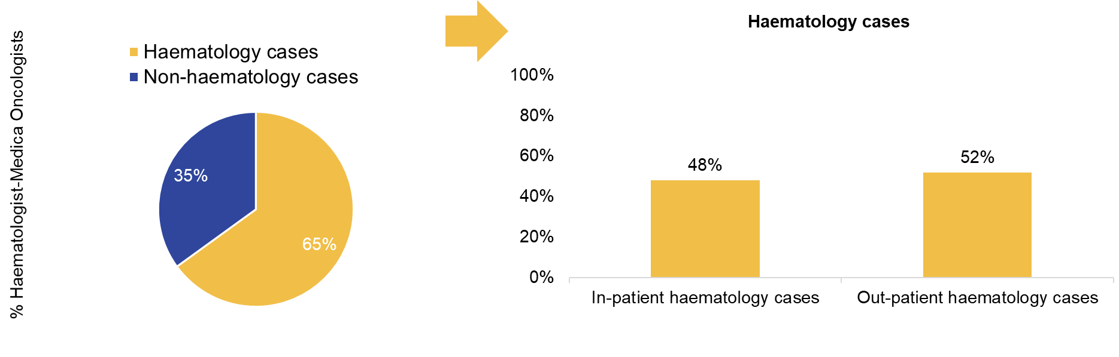

Diagnostic challenges of MPN

**Supplemental Figure S2.** Physician’s perception of importance of JAK2 V617F mutation testing and bone marrow biopsy for diagnosing MPN

**Supplemental Figure S3.** Physician’s perception of proportion of symptomatic MPN patients that undergo diagnostic testing

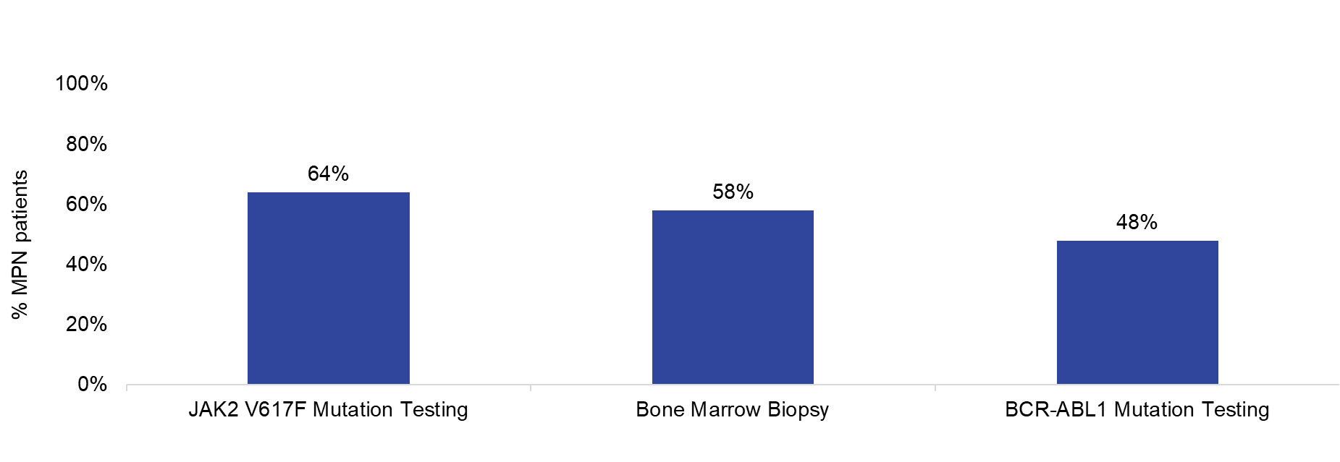

**Supplemental Figure S4.** Physician’s perception of top reasons why symptomatic MPN patients do not undergo JAK2 V617F testing

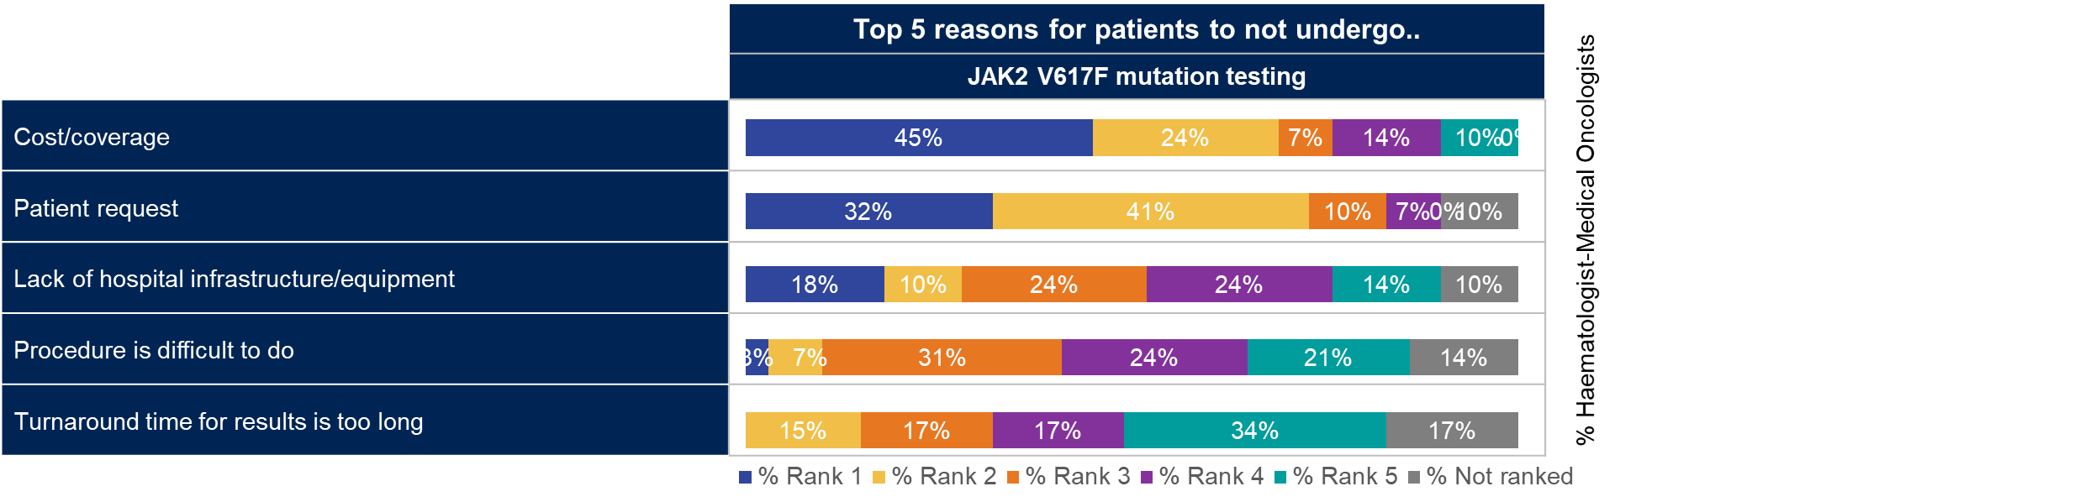

**Supplemental Figure S5.** Physician’s perception of top reasons why symptomatic MPN patients do not undergo bone marrow biopsy testing

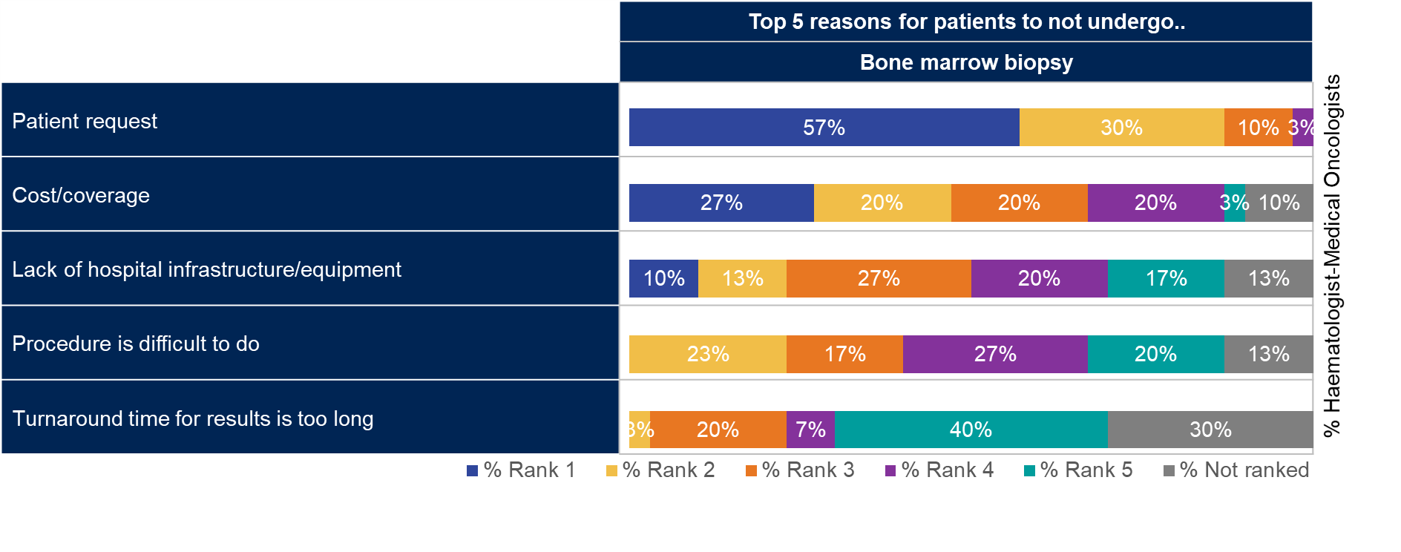

MF disease burden

**Supplemental Figure S6.** Physician perception of MF disease burden

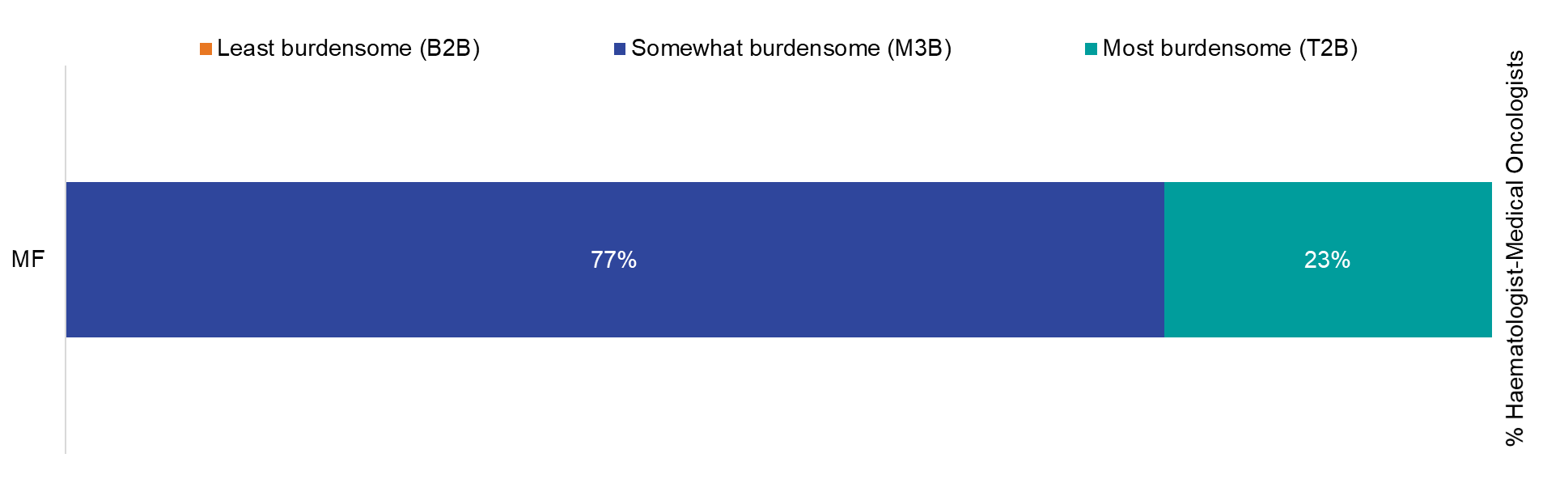

**Supplemental Figure S7.** Physician perception of MF patient’s symptoms at first visit vs currently

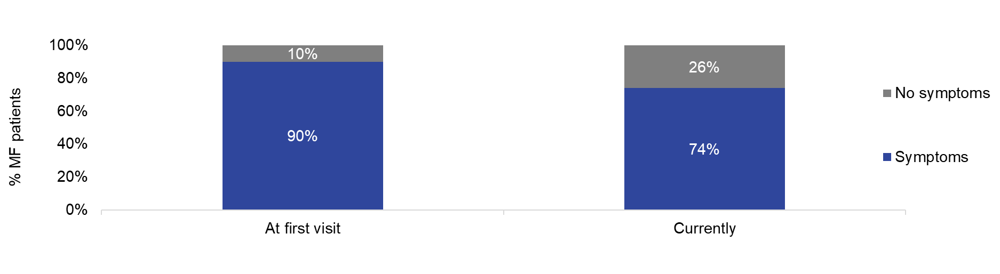

**Supplemental Figure S8.** Physician perception of top MF symptoms

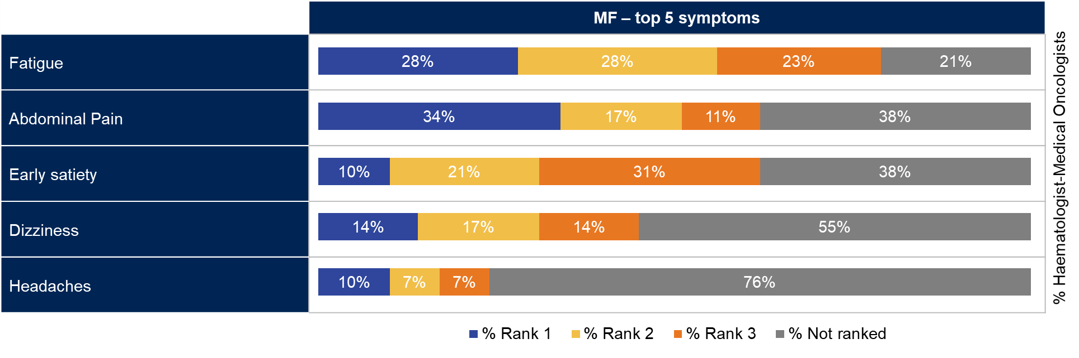**Supplemental Figure S9.** Physician perception of MF symptoms’ impact on quality of life

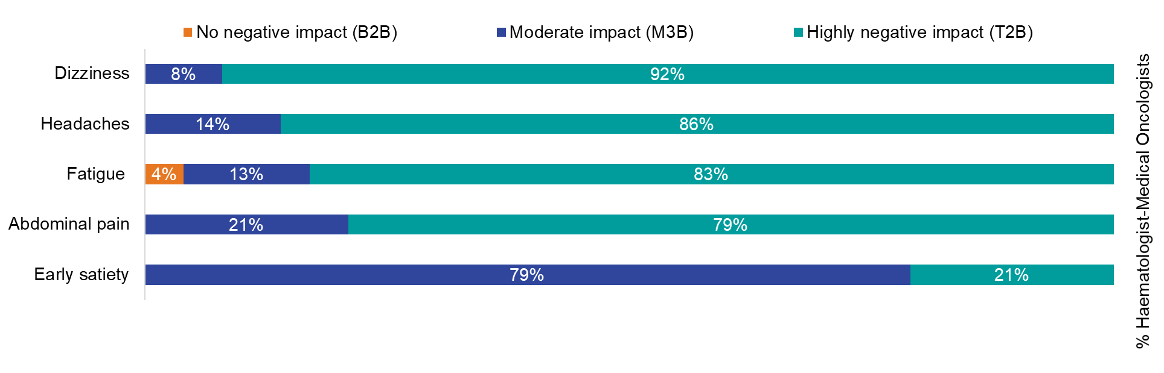

**Supplemental Figure S10.** Physician perception of MF patient concerns – functional and financial well-being

% Haematologist-Medical Oncologists

% Haematologist-Medical Oncologists

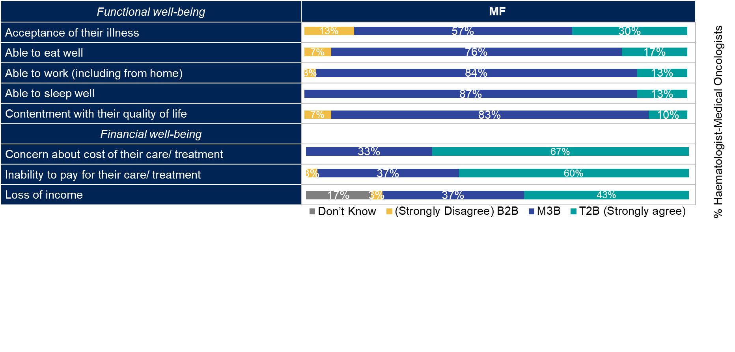

**Supplemental Figure S11.** Physician perception ofMF patient concerns – physical, social/ family well-being

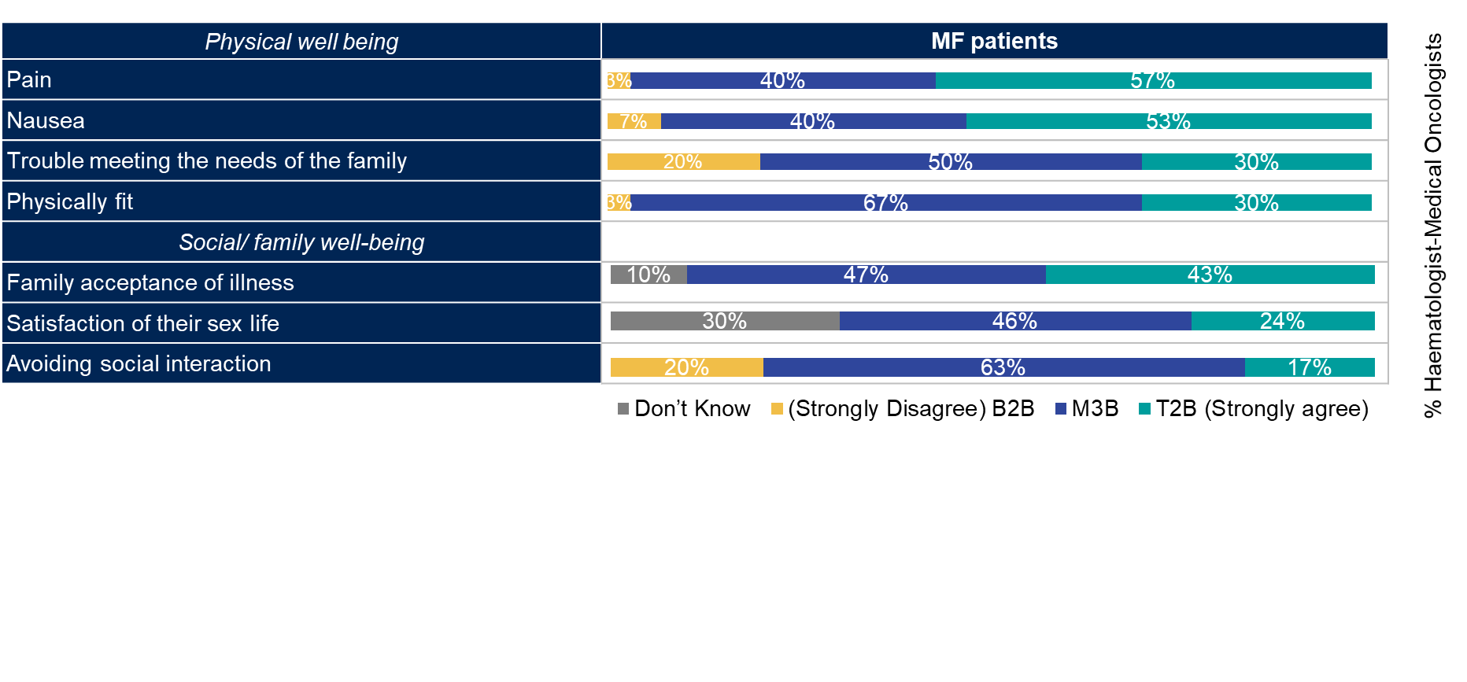

**Supplemental Figure S12.** Physician perception of MF disease progression

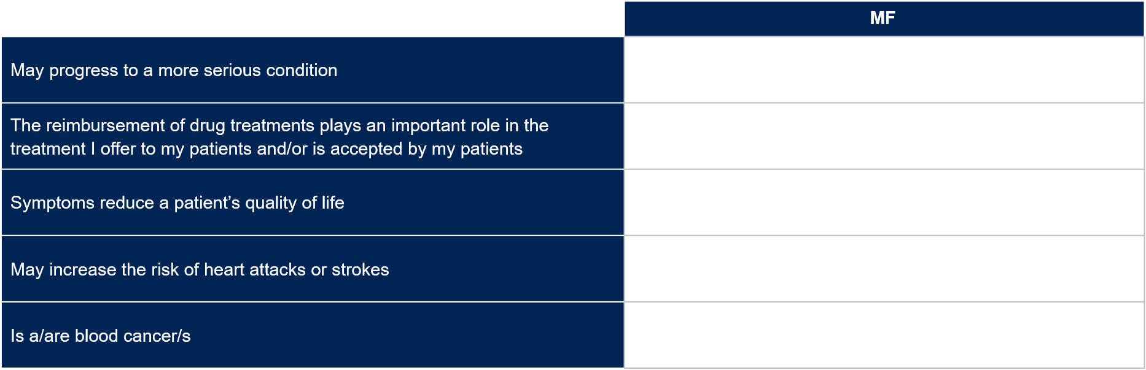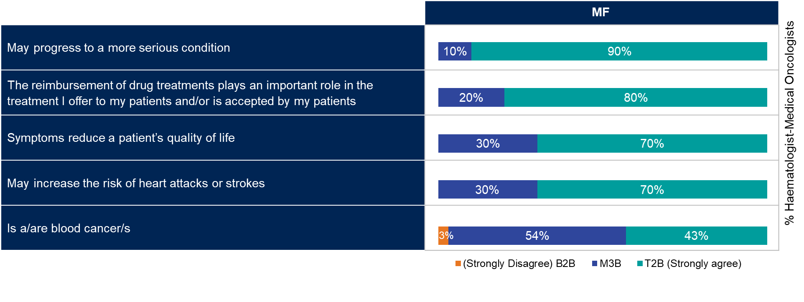

Shared decision making

**Supplemental Figure S13.** Physician perception of patient involvement in treatment decisions

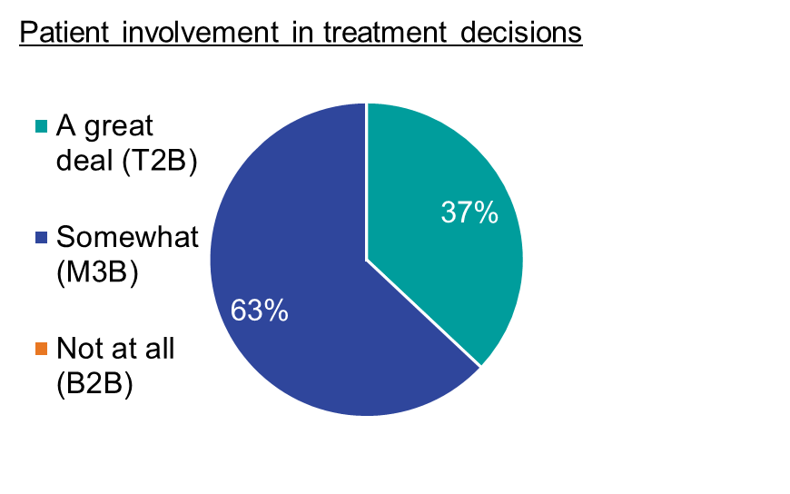

**Supplemental Figure S14.** Physician perception of patient and physician alignment on treatment goals

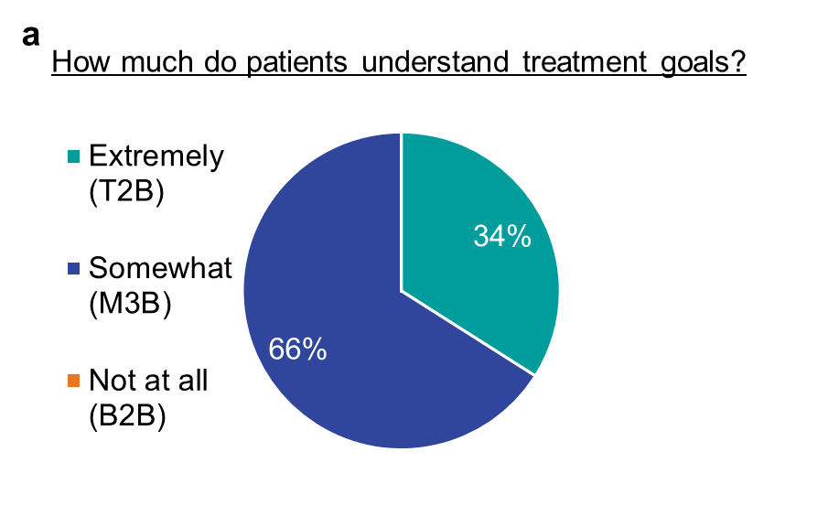

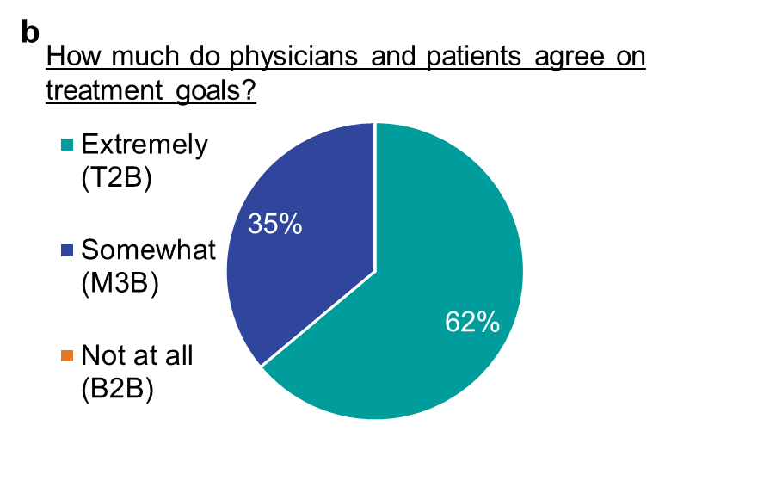

% Haematologist-Medical Oncologists

MF treatment

**Supplemental Figure S15.** Physician perception of factors used to assess MF progression

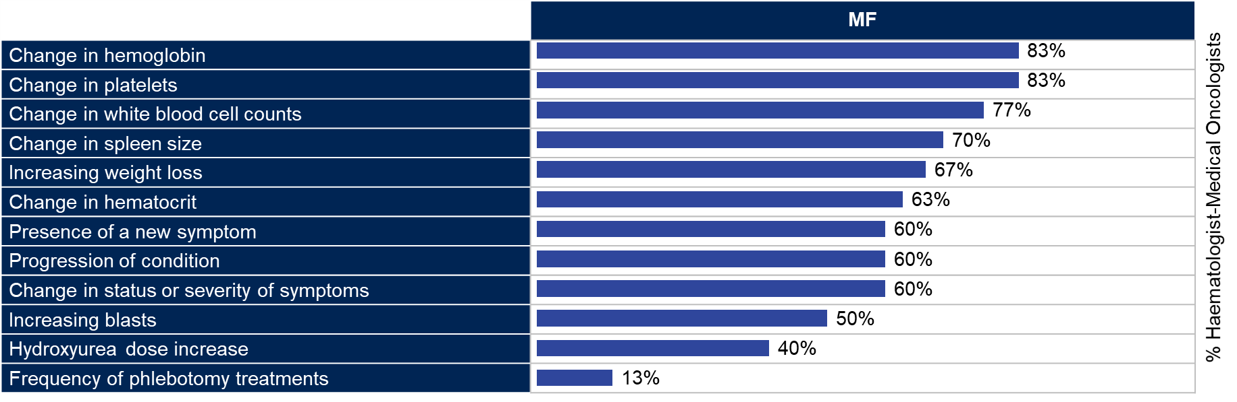

**Supplemental Figure S16.** Physician perception of MF symptoms most likely to be recommended a drug 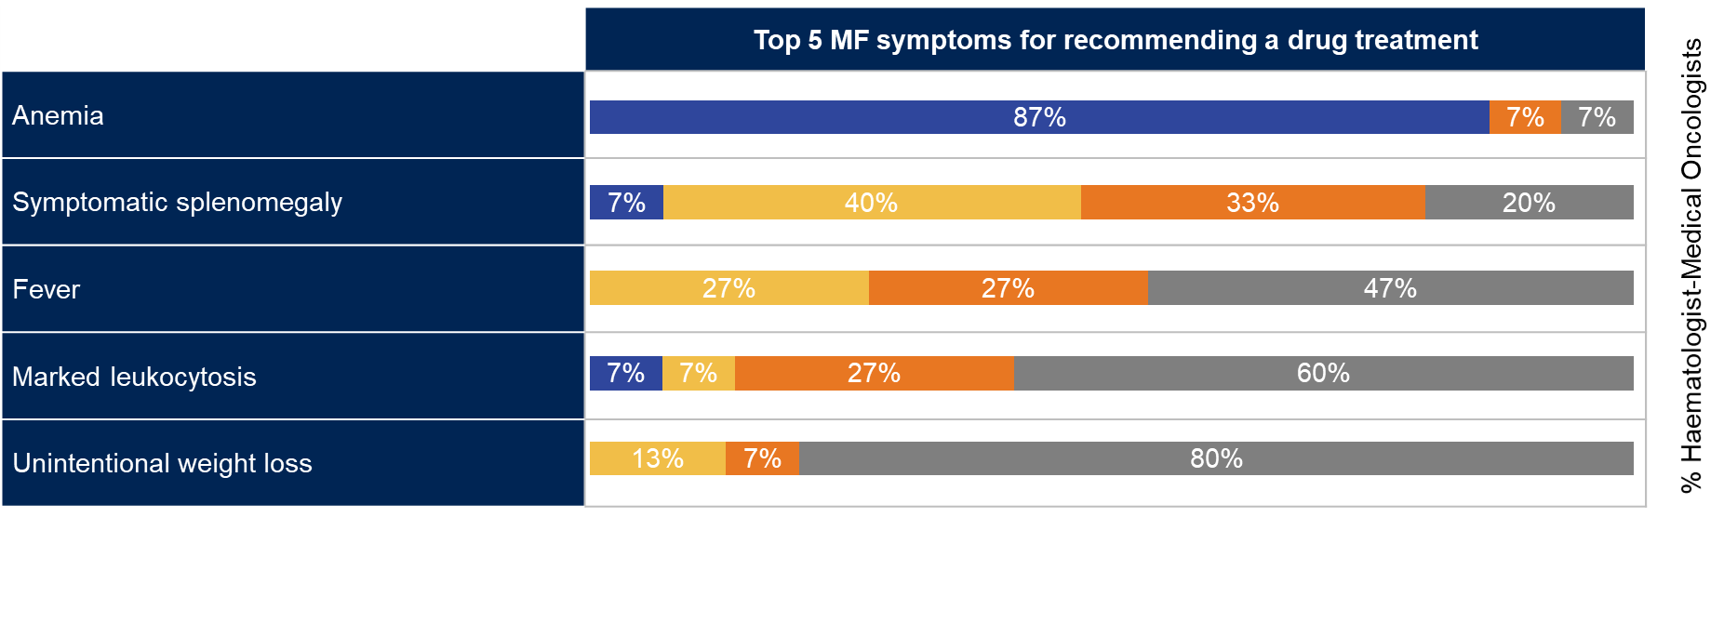

**Supplemental Figure S17.** Physician perception of treatment goals for MF patients 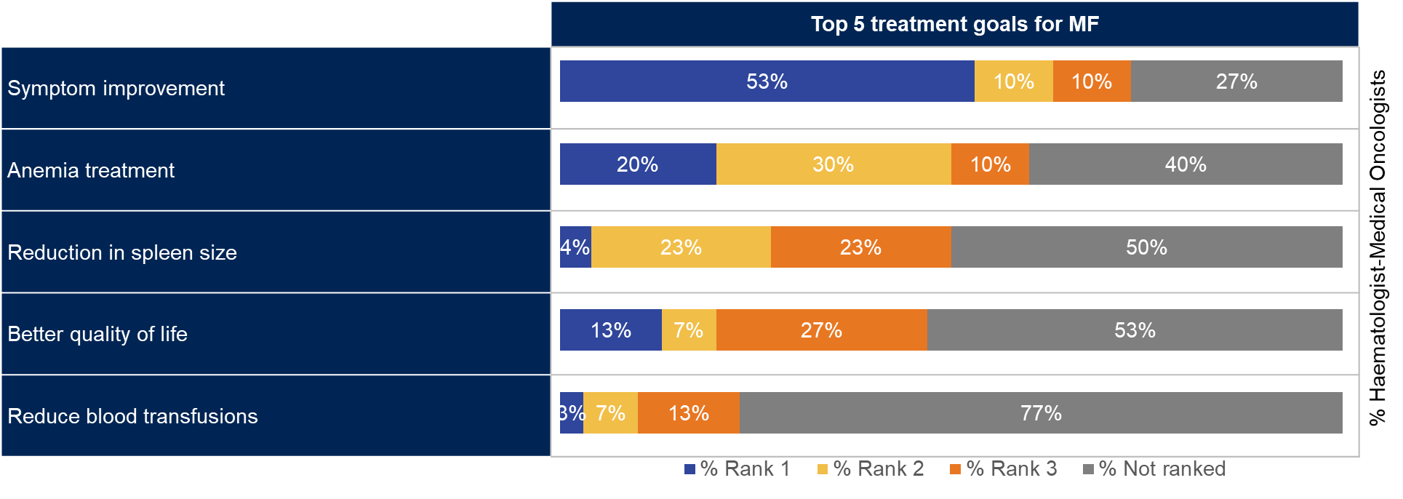

% Haematologist-Medical Oncologists

**Supplemental Figure S18.** Physician perception for patient reasons for changing drug therapy of MF patients

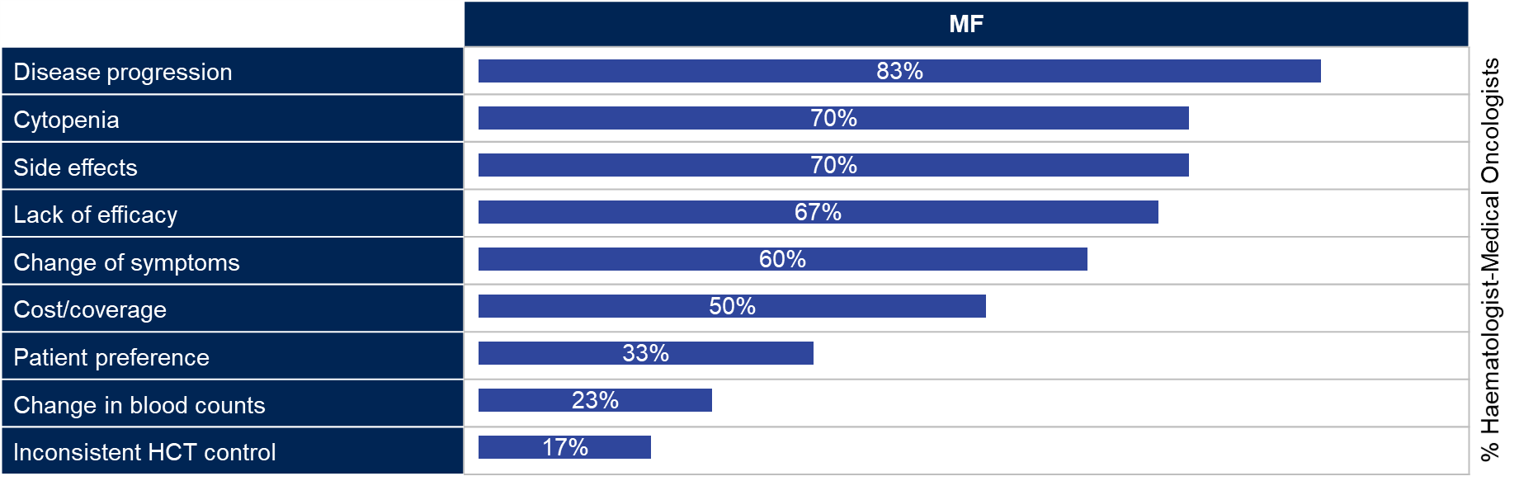

Unmet needs

**Supplemental Figure S19.** Physician perception of solutions to overcoming unmet needs in MF

