**Supplementary material:**

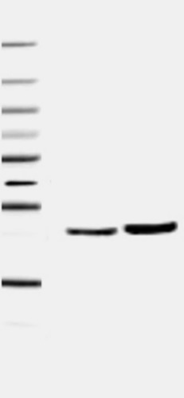

Western blot CD 63

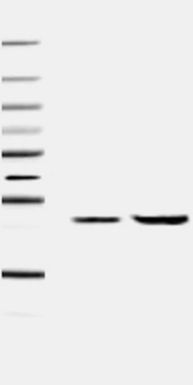

Western blot CD 81

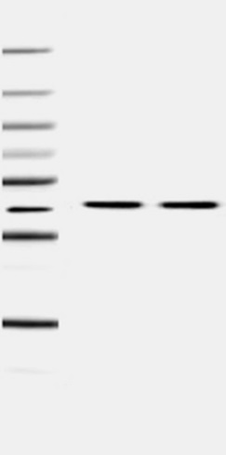

Western blot b-actin



Western blot Cleaved caspase-3



Western blot Beta- actin