SUPPLEMENTARY MATERIALS
FIGURES
Fig S1 (A)
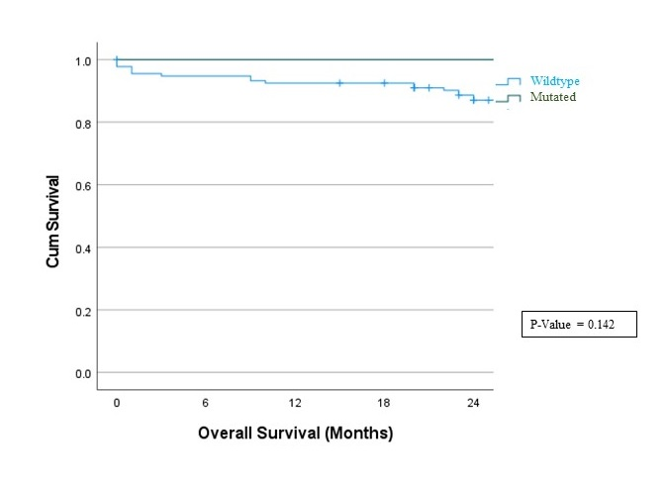

Fig S1 (A) OS B-ALL with NOTCH1 Exon-26

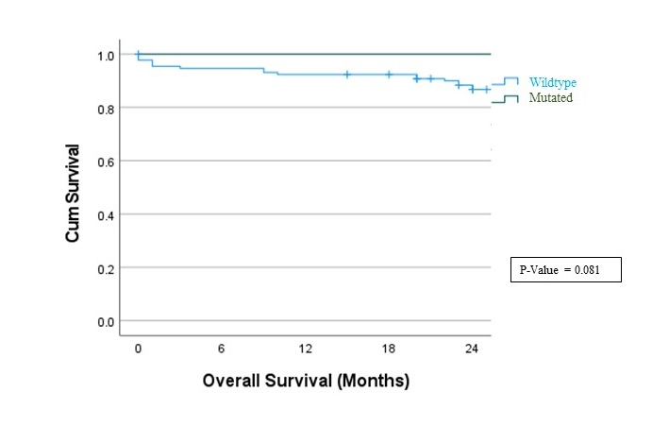
Fig S1 (B)

Fig S1 (B) OS B-ALL with NOTCH1 Exon-34

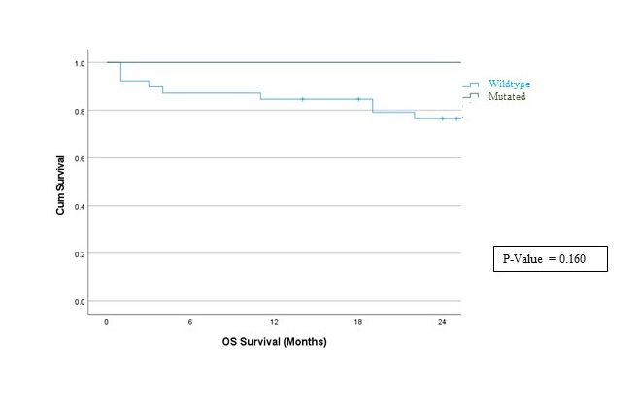
Fig S2 (A)

Fig S2 (A) OS T-ALL NOTCH1 Exon-26

Fig S2 (B)
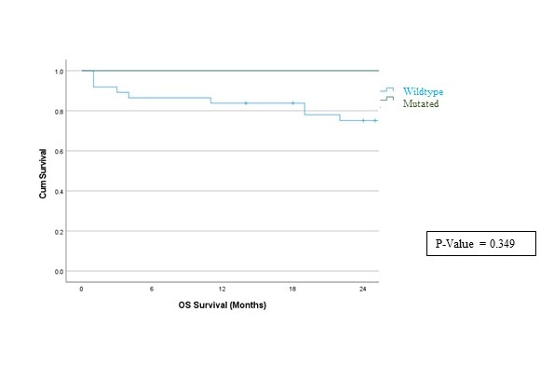

Fig S2 (B) OS T-ALL NOTCH1 Exon-34

Fig S3 (A)
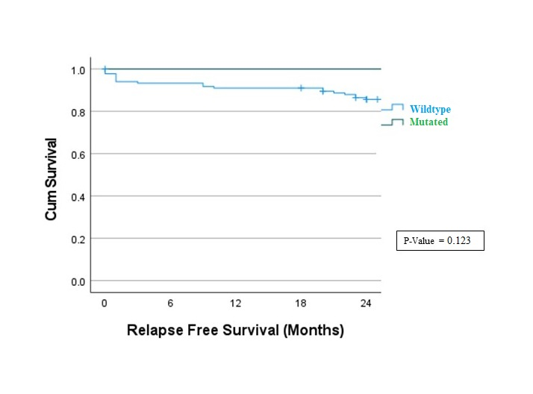

Fig S3 (A) RFS B-ALL NOTCH1 Exon-26

Fig S3 (B)
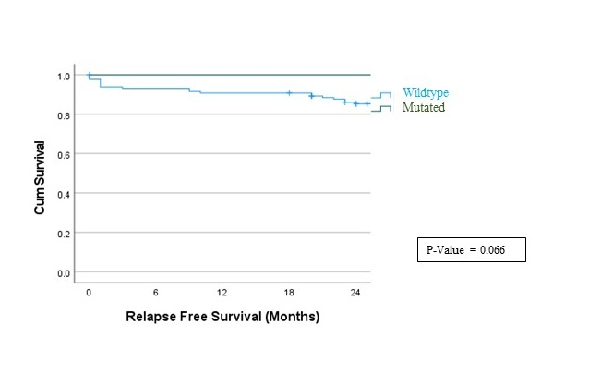

Fig S3 (A) RFS B-ALL NOTCH1 Exon-34

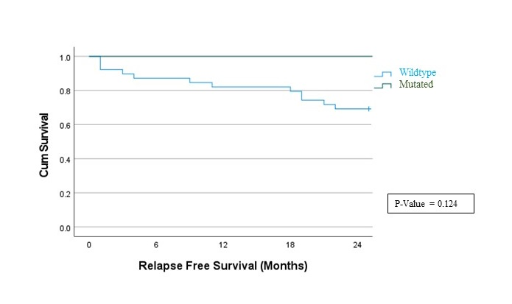
Fig S4 (A)

Fig S4 (A) RFS T-ALL NOTCH1 Exon-26

Fig S4 (B)
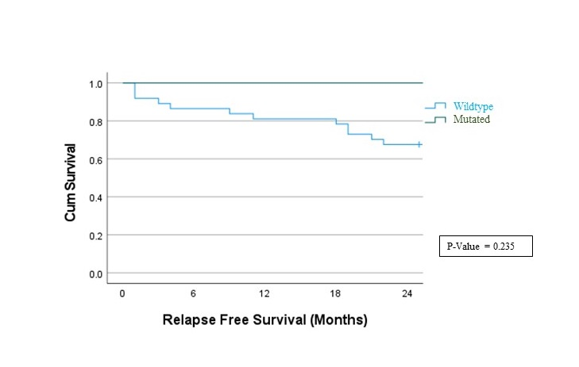

Fig S4 (B) RFS T-ALL NOTCH1 Exon-34

