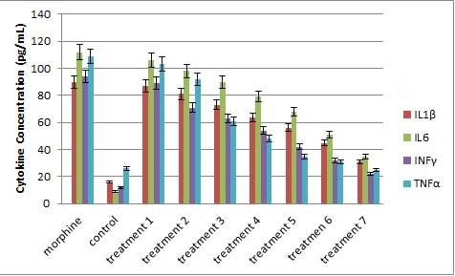

Supplementary Figure 1. Production of IL-1β, IL-6, INF-γ, and TNF-α inflammatory cytokines morphine and Prunus amygdalus var. amara essential oil in cells after 48h. Morphine cell culture: 100 mM morphine added to the cell culture, Control: PC12 cell culture; Treatment-1: 100 mM morphine and 2.5 μg of Prunus amygdalus var. amara essential oil added to the cell culture; Treatment-2: 100mM morphine and 5 μg of Prunus amygdalus var. amara essential oil added to the cell culture; Treatment-3: 100 mM morphine and 10μg of Prunus amygdalus var. amara essential oil added to the cell culture; Treatment-4: 100mM morphine and 20 μg of Prunus amygdalus var. amara essential oil added to the cell culture; Treatment-5: 100 mM morphine and 40 μg of Prunus amygdalus var. amara essential oil added to the cell culture; Treatment-6: 100 mM morphine and 80 μg of Prunus amygdalus var. amara essential oil added to the cell culture; and Treatment-7: 100 mM morphine and 160 μg of Prunus amygdalus var. amara essential oil added to the cell culture.

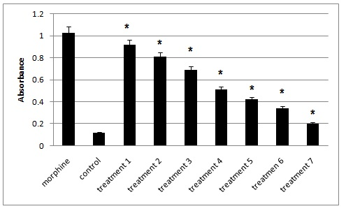
Supplementary Figure 2. Mitochondrial membrane potential of the cells after 48 h treated by morphine and Prunus amygdalus var. amara essential oil. Morphine cell culture: 100 mM morphine added to the cell culture, Control: PC12 cell culture; Treatment-1: 100 mM morphine and 2.5 μg of Prunus amygdalus var. amara essential oil added to the cell culture; Treatment-2: 100 mM morphine and 5 μg of Prunus amygdalus var. amara essential oil added to the cell culture; Treatment-3: 100 mM morphine and 10 μg of Prunus amygdalus var. amara essential oil added to the cell culture; Treatment-4: 100mM morphine and 20 μg of Prunus amygdalus var. amara essential oil added to the cell culture; Treatment-5: 100 mM morphine and 40 μg of Prunus amygdalus var. amara essential oil added to the cell culture; Treatment-6: 100 mM morphine and 80 μg of Prunus amygdalus var. amara essential oil added to the cell culture; and Treatment-7: 100 mM morphine and 160 μg of Prunus amygdalus var. amara essential oil added to the cell culture.

