Deciphering Candida’s Genomic Influence on Oral Squamous Cell Carcinoma: A Bioinformatics Approach

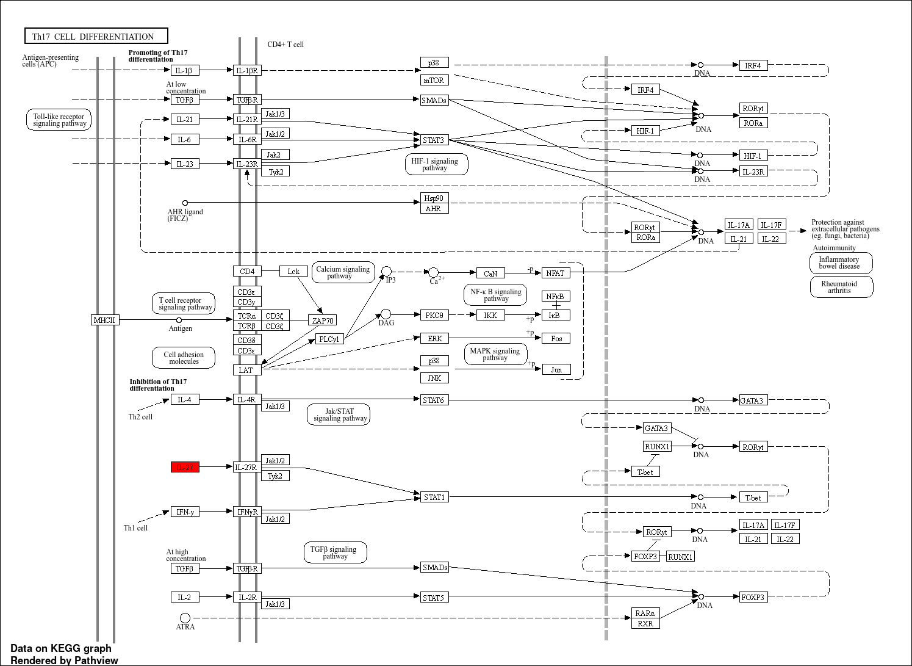
Th17 cell differentiation pathway promoted by candida in OSCC

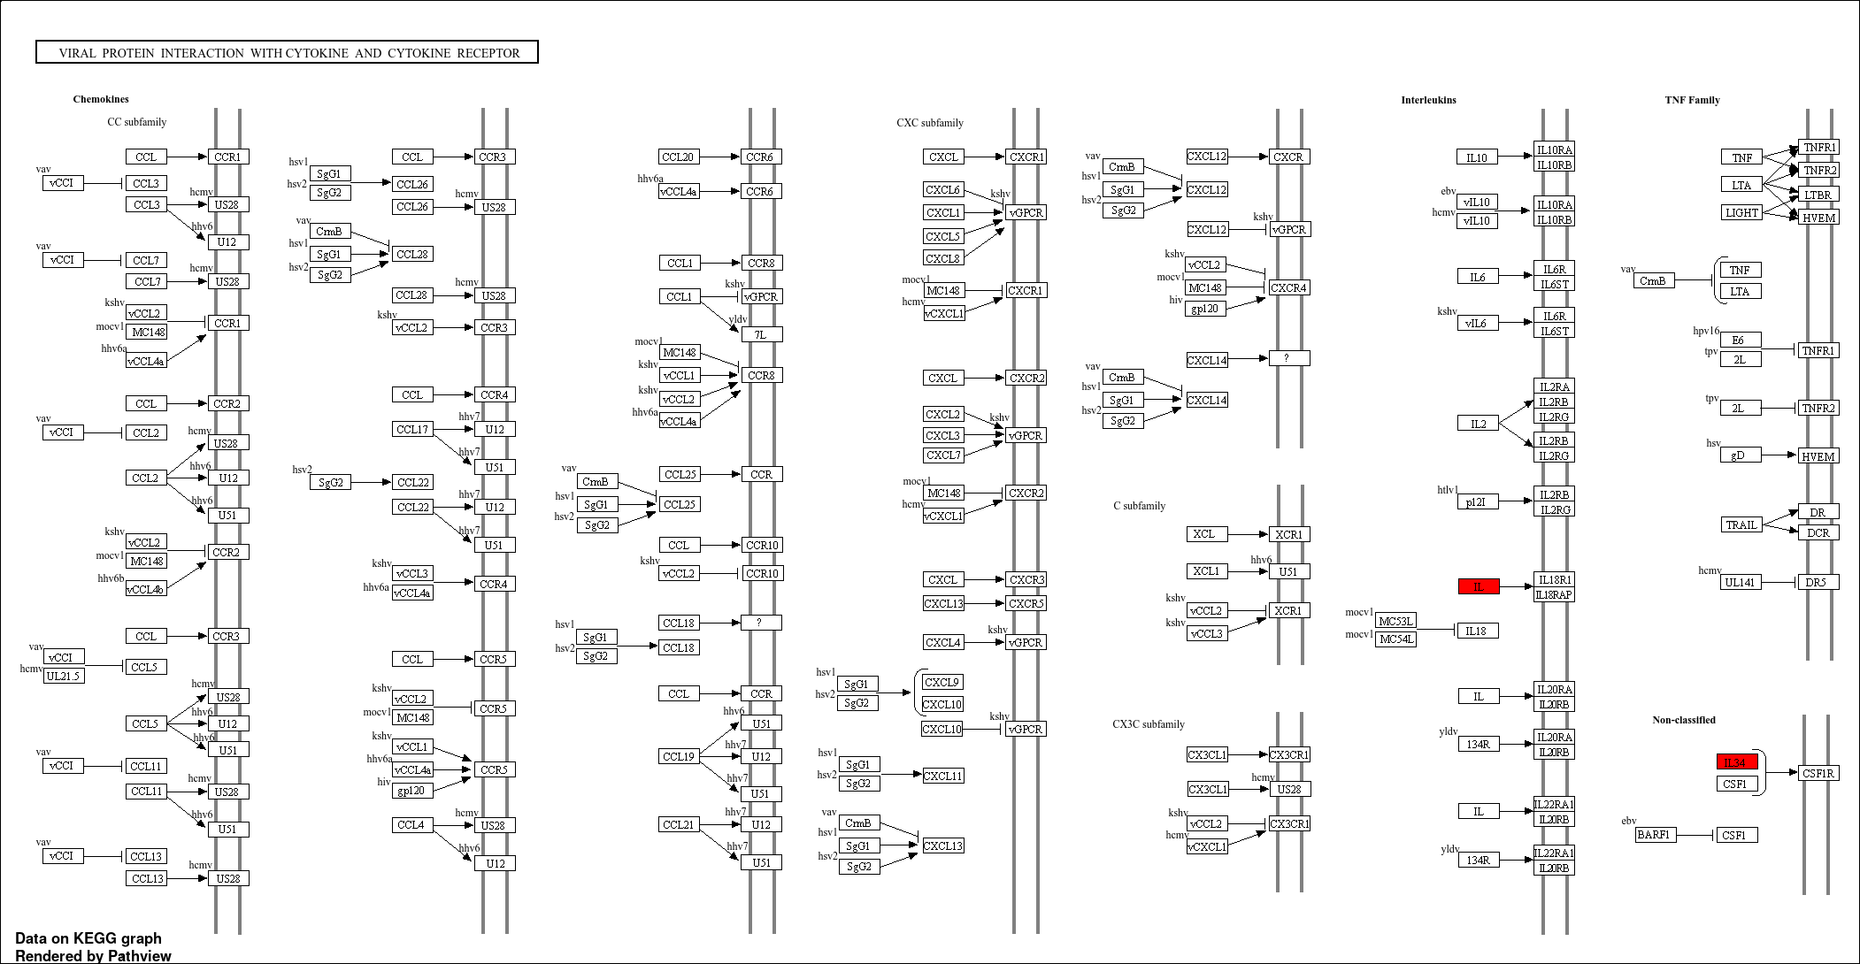
Viral protein interaction with cytokine and cytokine receptor

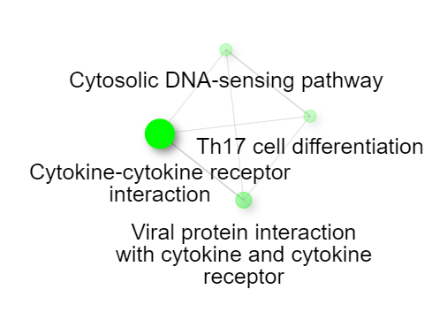
Static signaling plot showing the pathways influenced by Candida in progression of OSCC

