S1 Table. Grouping of the variables followed for the data analysis
Parameter | Group 1 | Group 2
Age at diagnosis | ≤ 50 years | > 50 years
Histological type | IBC-NST | Other (all other types including DCIS)
Tumor grade/ differentiation | G1/ well-differentiated | G2 or G3/ moderately or poorly differentiated
Tumor size | ≤ 2 cm | > 2 cm
Pathological tumor stage | Early stage (pT1/pT2) | Late stage (pT3/pT4)
Lymph node Metastasis | Negative | Positive
ER status | ER+ (includes positive and equivocal data) | ER-
PR status | PR+ (includes positive and equivocal data) | PR-
SHR status | SHR+ (includes positive and equivocal data) | SHR-
HER2 status | HER2+ (includes positive and equivocal data) | HER2-
Receptor based subtype | SHR+/HER2- | Other (includes SHR+/HER2+, SHR-/HER2+ and SHR-/HER2)
Ki67 Proliferation index | <20% | ≥20%
IHC-based molecular subtype | Luminal (includes both Luminal A & Luminal B) | HER2/TNBC
Ancestry | Indo-Aryan Ancestry (Sinhalese and Burghers) | Dravidian Ancestry (Tamils & Moors/Muslims)

S2 Table. Distribution of Ki67 proliferative index according to age and clinicopathological characteristics
Parameter | Ki67  < 20% (Low) | Ki67  ≥ 20% (High) | Total | p-value
All | 30 | 28 | 58
Age at diagnosis (N=58; 100%)
≤50 years | 7 | 7 | 14
>50 years | 23 | 21 | 44 | 1.000
Histological type (N=58; 100%)
IBC-NST | 23 | 27 | 50
Other | 7 | 1 | 8 | 0.053
Tumor grade/ differentiation (N=57; 98.3%)
G1/ well-differentiated | 14 | 5 | 19
G2 or G3/ moderately or poorly differentiated | 15 | 23 | 38 | *0.024
Tumor size (N=42; 72.4%)
≤ 2 cm | 5 | 5 | 10
> 2 cm | 20 | 12 | 32 | 0.714
Mean (cm) (95% CI) | 3.3 (2.5-4.2) | 3.4 (2.3-4.5)
Median (cm) (Range) | 3.0 (1.2-12.0) | 3.3 (0.7-9.3) |  | 0.884
Pathological tumor stage (N=40; 68.9%)
Early stage (pT1/pT2) | 21 | 14 | 35
Late stage (pT3/pT4) | 2 | 3 | 5 | 0.634
Lymph node metastasis (N=42; 72.4%)
Negative | 17 | 9 | 26
Positive | 8 | 8 | 16 | 0.353
ER status (N=58; 100%)
ER+ | 27 | 26 | 53
ER- | 3 | 2 | 5 | 1.000
PR status (N=58; 100%)
PR+ | 23 | 18 | 41
PR- | 7 | 10 | 17 | 0.390
SHR status (N=58; 100%)
SHR+ | 27 | 26 | 53
SHR- | 3 | 2 | 5 | 1.000
HER2 status (N=57; 98.3%)
HER2+ | 3 | 3 | 6
HER2- | 26 | 25 | 51 | 1.000
Receptor based subtype (N=58; 100%)
SHR+/HER2- | 24 | 24 | 48
Other | 6 | 4 | 10 | 0.732
IHC-based molecular subtype (N=57; 98.3%)
Luminal | 24 | 24 | 48
HER2/TNBC | 5 | 4 | 9 | 1.000
*: association is significant at 5% level, OR 4.293, 95% CI 1.279-14.408
CI: confidence interval, ER: estrogen receptor, HER2: human epidermal growth factor receptor 2, IBC-NST: invasive breast carcinoma of no special type, IHC: immunohistochemical, LN: Lymph Node, N: number of samples analysed with percentage, OR: odds ratio, PR: progesterone receptor, pT: pathological tumor stage, SHR: steroid hormone receptor, TNBC: triple-negative breast cancer

S3 Table. Status of lymph node (LN) metastasis in selected clinical and histopathological groups
Parameter | LN Status |  |  | p-value
 | Node Positive (n) | Node Negative (n) | Total  (n)
All | 21 | 29 | 50
Histological type (N=50; 100%)
IBC-NST | 16 | 26 | 42
Other | 5 | 3 | 8 | 0.255
Tumor grade/ differentiation (N=48; 96%)
G1/ well-differentiated | 8 | 8 | 16
G2 or G3/ moderately or poorly differentiated | 12 | 20 | 32 | 0.537
Tumor size (N=50; 100%)
≤ 2 cm | 4 | 9 | 13
>2 cm | 17 | 20 | 37 | 0.515
Mean (cm) (95% CI) | 4.2 (2.9-5.4) | 2.9 (2.4-3.3)
Median (cm) (Range) | 3.5 (1.1-12.0) | 2.8 (0.7-6.5) |  | 0.058
Pathological tumor stage (N=47; 94%)
Early stage (pT1/pT2) | 15 | 26 | 41
Late stage (pT3/pT4) | 5 | 1 | 6 | 0.070

ER status (N=50; 100%)
ER+ | 19 | 25 | 44
ER- | 2 | 4 | 6 | 1.000
PR Status (N=50; 100%)
PR+ | 13 | 22 | 35
PR- | 8 | 7 | 15 | 0.356
SHR Status (N=50; 100%)
SHR+ | 19 | 25 | 44
SHR- | 2 | 4 | 6 | 1.000
HER2 status (N=49; 98%)
HER2+ | 12 | 15 | 27
HER2- | 9 | 13 | 22 | 1.000
Receptor based subtype (N=50; 100%)
SHR+/HER2- | 17 | 22 | 39
Others | 4 | 7 | 11 | 0.741
IHC-based molecular subtype (N=39; 78%)
Luminal | 17 | 22 | 29
HER2/TNBC | 4 | 6 | 10 | 1.000
CI: confidence interval, ER: estrogen receptor, HER2: human epidermal growth factor receptor 2, IBC-NST: invasive breast carcinoma of no special type, IHC: immunohistochemical, LN: Lymph Node, N: number of samples analysed with percentage, OR: odds ratio, PR: progesterone receptor, pT: pathological tumor stage, SHR: steroid hormone receptor, TNBC: triple-negative breast cancer

S4 Table. Status of patient age in selected clinical and histopathological groups
Parameter | Younger patients (age at diagnosis ≤ 50 years) | Older patients (age at diagnosis > 50 years) | Total | p-value
All | 16 | 50 | 66
Histological type (N=66; 100%)
IBC-NST | 14 | 43 | 57
Other | 2 | 7 | 9 | 1.000
Tumor grade/ differentiation (N=64; 96.9%)
G1/ well-differentiated | 7 | 15 | 22
G2 or G3/ moderately or poorly differentiated | 9 | 33 | 42 | 0.379
Tumor size (N=49; 74.2%)
≤ 2 cm | 4 | 8 | 12
> 2 cm | 9 | 28 | 37 | 0.708
Mean (cm) (95% CI) | 2.9 (2.0-3.7) | 3.6 (2.9-4.3)
Median (cm) (Range) | 2.6 (1.1-6.5) | 3.3 (0.7-12.0) |  | 0.244
Pathological tumor stage (N=46; 69.7%)
Early stage (pT1/pT2) | 11 | 29 | 40
Late stage (pT3/pT4) | 1 | 5 | 6 | 1.000
Lymph node metastasis (N=50; 75.8%)
Negative | 8 | 21 | 29
Positive | 5 | 16 | 21 | 1.000
ER status (N=66; 100%)
ER+ | 14 | 46 | 60
ER- | 2 | 4 | 6 | 0.627
PR status (N=66; 100%)
PR+ | 12 | 34 | 46
PR- | 4 | 16 | 20 | 0.758
SHR status (N=66; 100%)
SHR+ | 14 | 46 | 60
SHR- | 2 | 4 | 6 | 0.627
HER2 status (N=65; 98.5%)
HER2+ | 2 | 4 | 6
HER2- | 14 | 45 | 59 | 0.631
Receptor based subtype (N=66; 100%)
SHR+/HER2- | 12 | 43 | 55
Other | 4 | 7 | 11 | 0.440
IHC-based molecular subtype (N=65; 98.5%)
Luminal | 12 | 43 | 55
HER2/TNBC | 4 | 6 | 10 | 0.245
CI: confidence interval, ER: estrogen receptor, HER2: human epidermal growth factor receptor 2, IBC-NST: invasive breast carcinoma of no special type, IHC: immunohistochemical, LN: Lymph node, N: number of samples analysed with percentage, PR: progesterone receptor, pT: pathological tumor stage, SHR: steroid hormone receptor, TNBC: triple-negative breast cancer
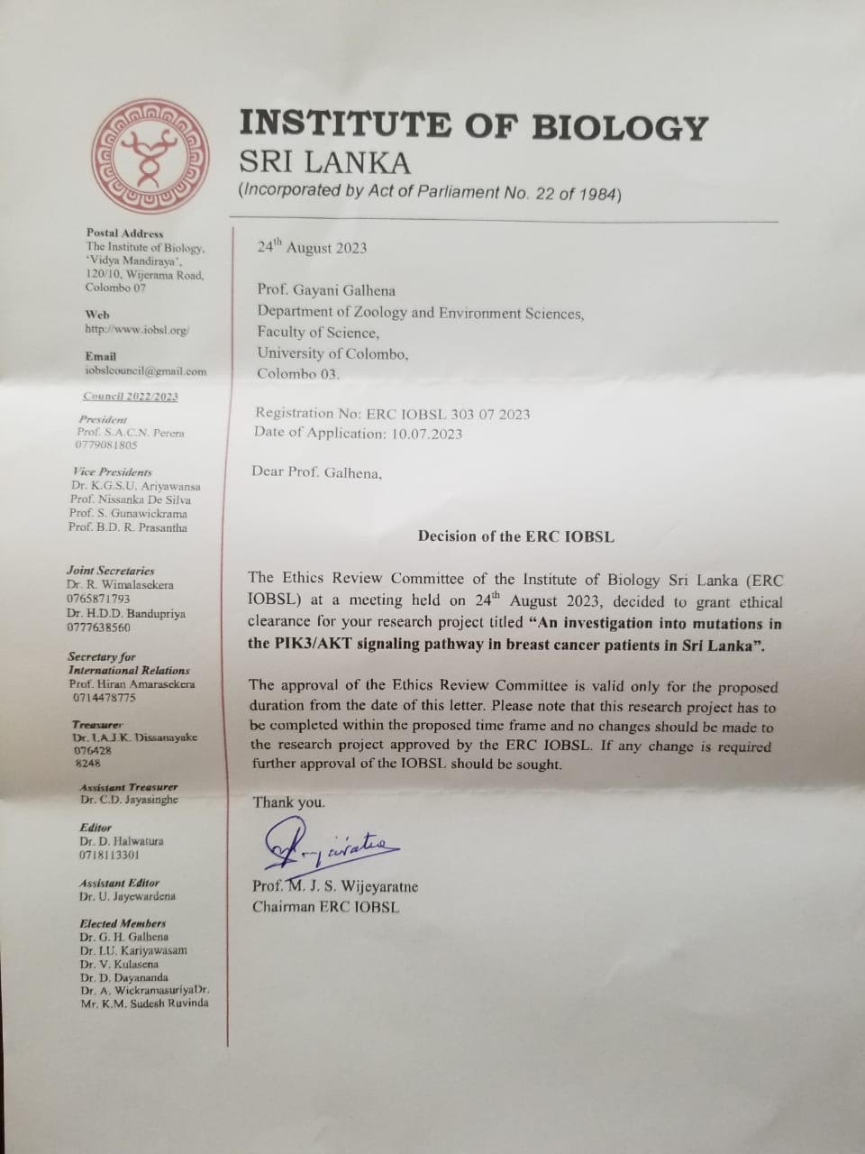

S1 Fig. Ethical approval for the study granted by the Ethics Review Committee of the Institute of Biology, Sri Lanka (ERC IOBSL 303 07 2023)
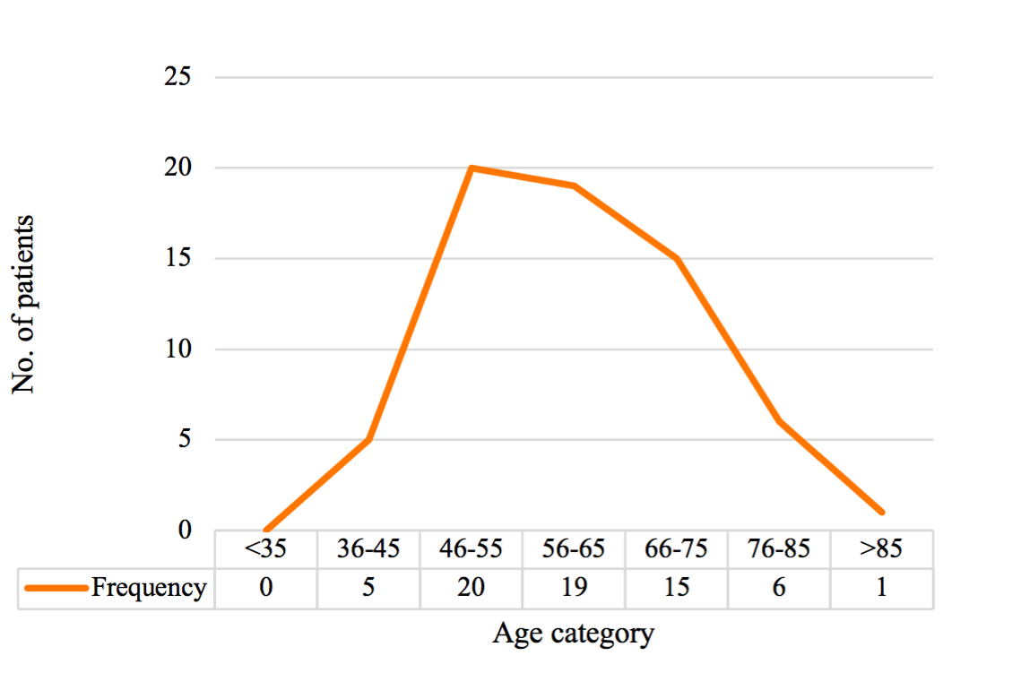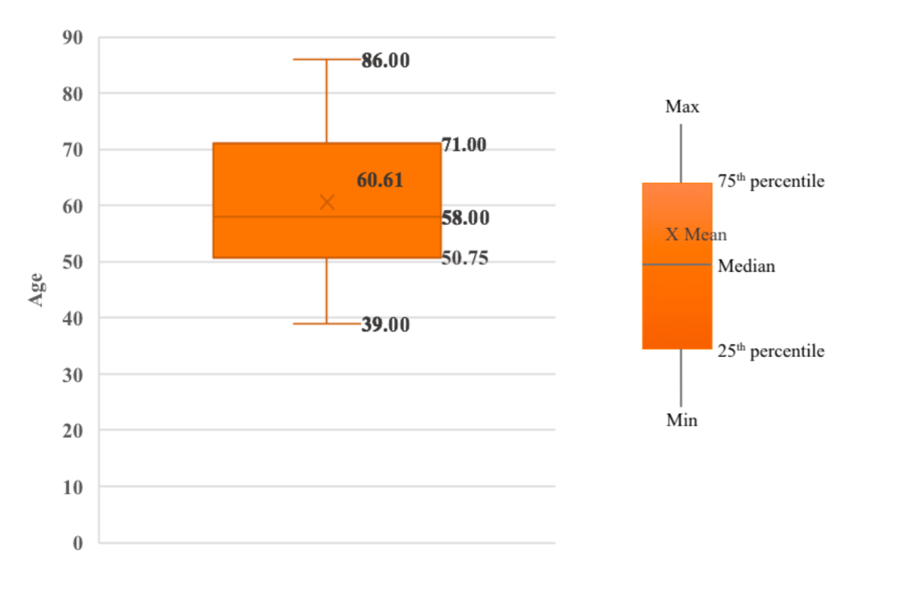
S2 Fig. Age distribution of the cohort
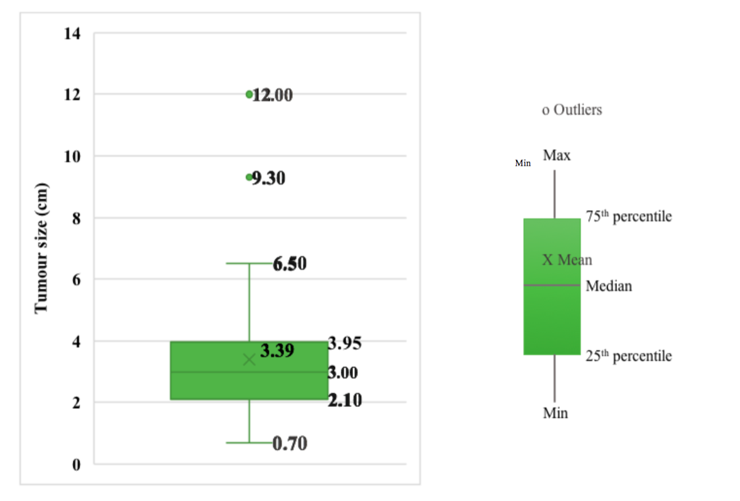
S3 Fig. Distribution of tumor size (cm) in the cohort

