Comprehensive Molecular Docking and Molecular Dynamic Reveal Inhibitor of HER2 L755S, T798I, and T798M based on Large Database of Curcumin Derivatives
Mantiqa Syafa Duvadillan Gusrin^{1,2}, Yonika Arum Larasati³, Rohmad Yudi Utomo^{2,4}
¹Graduate School of Master of Pharmaceutical Sciences, Faculty of Pharmacy, Universitas Gadjah Mada, Sekip Utara, Sleman, Yogyakarta Indonesia 55281;
²Cancer Chemoprevention Research Center, Faculty of Pharmacy, Universitas Gadjah Mada, Sekip Utara, Sleman, Yogyakarta Indonesia 55281;
³Translational Research Center in Oncohaematology, Department of Cell Physiology and Metabolism, Faculty of Medicine, University of Geneva, Geneva, Switzerland;
⁴Laboratory of Medicinal Chemistry, Department of Pharmaceutical Chemistry, Faculty of Pharmacy, Universitas Gadjah Mada, Sekip Utara, Sleman, Yogyakarta Indonesia 55281
*Corresponding author
Email: rohmad.yudi.utomo@ugm.ac.id

Content
Supplementary Table 1. Lipinski rule of five profile of curcumin derivatives.............. 2
Supplementary Table 2. Top-100 curcumin derivatives with lower docking score toward HER2 WT.................................................................................................................................. 13
Supplementary Figure 1. ............................................................................................... 26
Supplementary Figure 2. ................................................................................................ 27
Supplementary Figure 3. ................................................................................................ 28
Supplementary Figure 4. ................................................................................................ 29
Supplementary Figure 5. ................................................................................................ 30
Supplementary Figure 6. ................................................................................................ 31
Supplementary Figure 7. ................................................................................................ 32
Supplementary Figure 8. ................................................................................................ 33
Supplementary Figure 9. ................................................................................................ 34

Supplementary Table 1. Lipinski rule of five profile of curcumin derivatives
No | Smiles | SlogP | ExactMW | NumHBD | NumHBA
1 | COc1cc(/C=C/C(=O)CC(=O)/C=C/c2ccc(O)cc2)ccc1F | 3.7948 | 340.1111 | 1 | 4
2 | O=C(/C=C/c1ccc(O)cc1Cl)CC(=O)/C=C/c1ccc(O)cc1Cl | 4.6595 | 376.0269 | 2 | 4
3 | COc1ccc(/C=C/C(=O)CC(=O)/C=C/c2ccc3[nH]ccc3c2)cc1O | 4.137 | 361.1314 | 2 | 4
4 | COc1cc(/C=C/C(=O)CC(=O)/C=C/c2ccc(O)c(C[N+](C)(C)C)c2)ccc1O.[I-] | 0.5715 | 537.1012 | 2 | 5
5 | COc1cc(/C=C/C(=O)C(C)(C)C(=O)/C=C/c2ccc(O)c(OC)c2)ccc1O | 4.006 | 396.1573 | 2 | 6
6 | COc1ccc(/C=C/C(=O)CC(=O)/C=C/c2cc(O)ccc2[N+](=O)[O-])cc1O | 3.2695 | 383.1005 | 2 | 7
7 | NCCOc1ccc(/C=C/C(=O)CC(=O)/C=C/c2ccc(OCCN)c(OCCN)c2)cc1OCCN | 1.2915 | 512.2635 | 4 | 10
8 | COc1cc(/C=C/C(=O)CC(=O)/C=C/c2ccc(OCCCCC[n+]3ccccc3)c(OC)c2)ccc1O.[Br-] | 2.2051 | 595.1569 | 1 | 6
9 | O=C(/C=C/c1ccc(O)c(OC(F)(F)F)c1)CC(=O)/C=C/c1ccc(O)c(OC(F)(F)F)c1 | 5.1499 | 476.0695 | 2 | 6
10 | COc1ccc(/C=C/C(=O)CC(=O)/C=C/c2ccc(OC)cc2)cc1 | 3.9587 | 336.1362 | 0 | 4
11 | O=C(/C=C/c1ccccc1C(F)(F)F)CC(=O)/C=C/c1ccccc1C(F)(F)F | 5.9791 | 412.0898 | 0 | 2
12 | O=C(/C=C/c1cccc(O)c1)CC(=O)/C=C/c1cccc(O)c1 | 3.3527 | 308.1049 | 2 | 4
13 | COc1cc(C=C(C(=O)/C=C/c2ccc(N(C)C)cc2)C(=O)/C=C/c2ccc(N(C)C)cc2)ccc1O | 5.4812 | 496.2362 | 1 | 6
14 | COc1cc(/C=C/C(=O)CC(=O)/C=C/c2ccco2)ccc1O | 3.2487 | 312.0998 | 1 | 5
15 | COc1cccc(/C=C/C(=O)C(C)(C)C(=O)/C=C/c2cccc(OC)c2)c1 | 4.5948 | 364.1675 | 0 | 4
16 | COc1cc(/C=C/C(=O)CC(=O)/C=C/c2ccc(OCCN)c(OC)c2)ccc1OCCN | 2.6337 | 454.2104 | 2 | 8
17 | COc1ccccc1/C=C/C(=O)CC(=O)/C=C/c1ccccc1OC | 3.9587 | 336.1362 | 0 | 4
18 | COc1cc(/C=C/C(=O)CC(=O)/C=C/c2ccc(OCCC[P+](c3ccccc3)(c3ccccc3)c3ccccc3)c(OC)c2)ccc1O.[Cl-] | 4.4313 | 706.2251 | 1 | 6
19 | NCCOc1ccc(/C=C/C(=O)CC(=O)/C=C/c2ccc(OCCN)cc2)cc1 | 2.6165 | 394.1893 | 2 | 6
20 | COc1ccc(/C=C/C(=O)CC(=O)/C=C/c2c[nH]c3cccc([N+](=O)[O-])c23)cc1O | 4.0452 | 406.1165 | 2 | 6
21 | COc1cc(C=CC(=O)CC(=O)C=Cc2ccc(O)c(OC)c2)ccc1O | 3.3699 | 368.126 | 2 | 6
22 | COc1ccc(/C=C/C(=O)CC(=O)/C=C/c2ccc(N(C)C)cc2Cl)cc1O | 4.3751 | 399.1237 | 1 | 5
23 | CCOc1ccc(/C=C/C(=O)C(C)(C)C(=O)/C=C/c2ccc(OCC)c(OC)c2)cc1OC | 5.3922 | 452.2199 | 0 | 6
24 | O=C(/C=C/c1ccc(O)cc1)CC(=O)/C=C/c1cc(C(F)(F)F)ccc1F | 4.805 | 378.0879 | 1 | 3
25 | COc1cc(/C=C/C(=O)CC(=O)/C=C/c2ccc(OCCCCC[n+]3ccccc3)c(OC)c2)ccc1OCCCCC[n+]1ccccc1.[Br-].[Br-] | 1.0403 | 822.1879 | 0 | 6
26 | COc1cc(/C=C/C(=O)CC(=O)/C=C/c2ccc(OCCO)c(OC)c2)ccc1O | 3.0354 | 412.1522 | 2 | 7
27 | COc1cc(/C=C/C(=O)C(=Cc2ccc(N(C)C)cc2)C(=O)/C=C/c2ccc(O)c(OC)c2)ccc1O | 5.1294 | 499.1995 | 2 | 7
28 | COc1ccc(/C=C/C(=O)C(C)(C)C(=O)/C=C/c2ccc(OC)c(OC)c2)cc1OC | 4.612 | 424.1886 | 0 | 6
29 | COc1cc(/C=C/C(=O)CC(=O)/C=C/c2ccc(O)cc2)ccc1OC(C)=O | 3.581 | 380.126 | 1 | 6
30 | COc1cc(/C=C/C(=O)CC(=O)/C=C/c2ccc3[nH]ccc3c2)ccc1O | 4.137 | 361.1314 | 2 | 4
31 | COc1ccc(/C=C/C(=O)CC(=O)/C=C/c2ccc(O)c(OC)c2)cc1O | 3.3699 | 368.126 | 2 | 6
32 | COc1cc(/C=C/C(=O)CC(=O)/C=C/c2ccc(OC(=O)c3ccccc3OC(C)=O)c(OC)c2)ccc1O | 4.8088 | 530.1577 | 1 | 9
33 | O=C(/C=C/c1ccc(O)cc1)CC(=O)/C=C/c1cc(O)ccc1Br | 4.1152 | 386.0154 | 2 | 4
34 | COc1cccc(/C=C/C(=O)CC(=O)/C=C/c2ccc(O)cc2)c1O | 3.3613 | 338.1154 | 2 | 5
35 | CCN(CC)c1ccc(/C=C/C(=O)CC(=O)/C=C/c2ccc(O)cc2)c(OCOC)c1 | 4.476 | 423.2046 | 1 | 6
36 | COc1cc(/C=C/C(=O)CC(=O)/C=C/c2ccc3ccccc3c2)ccc1O | 4.8089 | 372.1362 | 1 | 4
37 | COc1cc(/C=C/C(=O)CC(=O)/C=C/c2ccc(O)c(C[N+](C)(C)C)c2)ccc1O | 3.5675 | 410.1962 | 2 | 5
38 | COc1cc(/C=C/C(=O)CC(=O)/C=C/c2ccc(CN(C)C)cc2)ccc1O | 3.7173 | 379.1784 | 1 | 5
39 | COc1ccc(OC)c(/C=C/C(=O)CC(=O)/C=C/c2cc(OC)ccc2OC)c1 | 3.9759 | 396.1573 | 0 | 6
40 | COc1ccc(/C=C/C(=O)C(C)(C)C(=O)/C=C/c2ccc(OC)cc2)cc1 | 4.5948 | 364.1675 | 0 | 4
41 | COc1cc(/C=C/C(=O)CC(=O)/C=C/c2ccc(OCCN)c(OC)c2)ccc1OCCN.Cl.Cl | 3.4773 | 526.1637 | 2 | 8
42 | COC(=O)/C=C/C(C(=O)/C=C/c1ccc(OC)c(OC)c1)C(=O)/C=C/c1ccc(OC)c(OC)c1 | 3.9312 | 480.1784 | 0 | 8
43 | COc1cc(/C=C/C(=O)CC(=O)/C=C/c2ccc(OC(=O)CNCCCl)c(OC)c2)ccc1OC(=O)CNCCCl | 3.4263 | 606.1536 | 2 | 10
44 | COc1cc(/C=C/C(=O)CC(=O)/C=C/c2ccc(O)cc2)ccc1OCCCCC[n+]1ccccc1 | 5.1925 | 486.2275 | 1 | 5
45 | COc1cc(/C=C/C(=O)CC(=O)/C=C/c2cccnc2)ccc1O | 3.0507 | 323.1158 | 1 | 5
46 | O=C(/C=C/c1ccc(O)cc1)CC(=O)/C=C/c1cc(OCc2ccccc2)ccc1Br | 5.9886 | 476.0623 | 1 | 4
47 | O=C(/C=C/c1ccc(O)cc1)CC(=O)/C=C/c1cccc(Br)c1 | 4.4096 | 370.0205 | 1 | 3
48 | COCOc1c(O)cccc1/C=C/C(=O)CC(=O)/C=C/c1ccc(O)cc1 | 3.3354 | 368.126 | 2 | 6
49 | CCOc1cc(/C=C/C(=O)CC(=O)/C=C/c2ccc(O)c(OCC)c2)ccc1O | 4.1501 | 396.1573 | 2 | 6
50 | COc1cc(/C=C/C(=O)CC(=O)/C=C/c2ccc(O)c(O)c2)ccc1O | 3.0669 | 354.1103 | 3 | 6
51 | COc1cc(/C=C/C(=O)CC(=O)/C=C/c2ccc(OC)c(OC)c2)ccc1O | 3.6729 | 382.1416 | 1 | 6
52 | C#CCOc1ccc(/C=C/C(=O)CC(=O)/C=C/c2ccc(OCC#C)c(OC)c2)cc1OC | 3.9827 | 444.1573 | 0 | 6
53 | COc1cc(/C=C/C(=O)CC(=O)/C=C/c2ccc(OC(=O)c3ccccc3O)c(OC)c2)ccc1O | 4.5891 | 488.1471 | 2 | 8
54 | CCOc1cc(/C=C/C(=O)CC(=O)/C=C/c2ccc(OC(=O)CNCCCl)c(OCC)c2)ccc1OC(=O)CNCCCl | 4.2065 | 634.1849 | 2 | 10
55 | CN(C)c1ccc(/C=C/C(=O)CC(=O)/C=C/c2ccc(N(C)C)cc2)cc1 | 4.0735 | 362.1994 | 0 | 4
56 | COc1c(O)cc(/C=C/C(=O)CC(=O)/C=C/c2ccc(O)c(O)c2)cc1O | 2.7725 | 370.1053 | 4 | 7
57 | COc1cc(/C=C/C(=O)CC(=O)/C=C/c2ccc(OCCCCC[n+]3ccccc3)cc2)ccc1O.[Br-] | 2.1965 | 565.1464 | 1 | 5
58 | COc1cc(/C=C/C(=O)CC(=O)/C=C/c2ccc(OCCOCCN)c(OC)c2)ccc1OCCOCCN | 2.6669 | 542.2628 | 2 | 10
59 | COc1cc(/C=C/C(=O)CC(=O)/C=C/c2ccc(OCC(=O)N[C@@H](CCCCN)C(=O)O)c(OC)c2)ccc1O | 2.7415 | 554.2264 | 4 | 9
60 | O=C(/C=C/c1ccc(O)cc1)CC(=O)/C=C/c1cn(Cc2ccccc2)c2ccccc12 | 5.6501 | 421.1678 | 1 | 4
61 | COc1ccc(OC)c(/C=C/C(=O)C(C)(C)C(=O)/C=C/c2cc(OC)ccc2OC)c1 | 4.612 | 424.1886 | 0 | 6
62 | COc1cc(/C=C/C(=O)CC(=O)/C=C/c2ccc(OCCOCCN)c(OC)c2)ccc1OCCOCCN.Cl.Cl | 3.5105 | 614.2162 | 2 | 10
63 | O=C(/C=C/c1ccc(O)cc1)CC(=O)/C=C/c1cc(O)ccc1[N+](=O)[O-] | 3.2609 | 353.0899 | 2 | 6
64 | COc1cc(/C=C/C(=O)CC(=O)/C=C/c2ccc(O)c(OC)c2)cc(OC)c1 | 3.6729 | 382.1416 | 1 | 6
65 | COCOc1cccc(O)c1/C=C/C(=O)CC(=O)/C=C/c1ccc(OC)c(O)c1 | 3.344 | 398.1366 | 2 | 7
66 | COc1cccc(/C=C/C(=O)CC(=O)/C=C/c2cccc(OC)c2OC)c1OC | 3.9759 | 396.1573 | 0 | 6
67 | COc1cc(/C=C/C(=O)C(=Cc2ccncc2)C(=O)/C=C/c2ccc(O)c(OC)c2)ccc1O | 4.4584 | 457.1525 | 2 | 7
68 | COc1ccc(/C=C/C(=O)C(C)(F)C(=O)/C=C/c2ccc(OC)c(OC)c2)cc1OC | 4.314 | 428.1635 | 0 | 6
69 | O=C(/C=C/c1ccc(O)cc1)CC(=O)/C=C/c1c[nH]c2ccccc12 | 4.1284 | 331.1208 | 2 | 3
70 | O=C(/C=C/c1ccc(O)cc1)CC(=O)/C=C/c1ccc(O)c(Cl)c1 | 4.0061 | 342.0659 | 2 | 4
71 | Cc1cc(/C=C/C(=O)CC(=O)/C=C/c2ccc(OCCN)c(C)c2)ccc1OCCN | 3.23334 | 422.2206 | 2 | 6
72 | O=C(/C=C/c1ccc(O)cc1)CC(=O)/C=C/c1ccccc1C(F)(F)F | 4.6659 | 360.0973 | 1 | 3
73 | COC(=O)c1ccccc1/C=C/C(=O)CC(=O)/C=C/c1ccc(O)cc1 | 3.4337 | 350.1154 | 1 | 5
74 | CSc1ccccc1/C=C/C(=O)CC(=O)/C=C/c1ccc(O)cc1 | 4.369 | 338.0977 | 1 | 4
75 | O=C(/C=C/c1ccc(O)cc1)CC(=O)/C=C/c1cc(O)ccc1-c1ccccc1 | 5.0197 | 384.1362 | 2 | 4
76 | O=C(/C=C/c1ccc(O)cc1)CC(=O)/C=C/c1ccc(OC(=O)c2ccccc2)cc1 | 4.8663 | 412.1311 | 1 | 5
77 | Cc1cc(/C=C/C(=O)CC(=O)/C=C/c2ccc(OCCN)c(C)c2)ccc1OCCN.Cl.Cl | 4.07694 | 494.1739 | 2 | 6
78 | COC(=O)C(C(=O)/C=C/c1ccc(O)c(OC)c1)C(=O)/C=C/c1ccc(O)c(OC)c1 | 2.769 | 426.1315 | 2 | 8
79 | COc1cc(/C=C/C(=O)CC(=O)/C=C/c2ccc(O)cc2)ccc1OC(=O)c1ccccc1 | 4.8749 | 442.1416 | 1 | 6
80 | [2H]c1c([2H])c(/C=C/C(=O)CC(=O)/C=C/c2ccc(O)c(OC)c2)c([2H])c([2H])c1O | 3.3613 | 342.1405 | 2 | 5
81 | COc1cc(/C=C/C(=O)CC(=O)/C=C/c2ccc(OC(C)=O)cc2)ccc1O | 3.581 | 380.126 | 1 | 6
82 | COc1cc(C=C(C(=O)/C=C/c2ccc(O)c(OC)c2)C(=O)/C=C/c2ccc(O)c(OC)c2)ccc1O | 4.7776 | 502.1628 | 3 | 8
83 | CC(C)(C(=O)/C=C/c1ccc(O)c(O)c1)C(=O)/C=C/c1ccc(O)c(O)c1 | 3.4 | 368.126 | 4 | 6
84 | O=C(/C=C/c1ccc(O)c(O)c1)CC(=O)/C=C/c1cc(O)c(O)c(O)c1 | 2.4695 | 356.0896 | 5 | 7
85 | COc1cc(/C=C/C(=O)CC(=O)/C=C/c2ccc(OC(=O)CCNCCCl)c(OC)c2)ccc1OC(=O)CCNCCCl | 4.2065 | 634.1849 | 2 | 10
86 | CN(C)c1ccc(/C=C/C(=O)CC(=O)/C=C/c2ccc(O)cc2)c([N+](=O)[O-])c1 | 3.6213 | 380.1372 | 1 | 6
87 | O=C(/C=C/c1ccc(O)cc1)CC(=O)/C=C/c1ccc(O)cc1 | 3.3527 | 308.1049 | 2 | 4
88 | COc1cc(/C=C/C(=O)C(=CO)C(=O)/C=C/c2ccc(OC(C)=O)c(OC)c2)ccc1OC(C)=O | 3.8611 | 480.142 | 1 | 9
89 | CS(=O)(=O)n1ccc2ccc(/C=C/C(=O)CC(=O)/C=C/c3ccc(O)cc3)cc21 | 3.4095 | 409.0984 | 1 | 6
90 | COc1cc(/C=C/C(=O)CC(=O)/C=C/c2ccc(OCC(=O)O)c(OC)c2)ccc1O | 3.1277 | 426.1315 | 2 | 7
91 | COc1cc(/C=C/C(=O)CC(=O)/C=C/c2ccc(OCC=C(C)C)cc2)ccc1OCC=C(C)C | 6.6401 | 474.2406 | 0 | 5
92 | COc1cc(/C=C/C(=O)C(=NNc2ccccc2)C(=O)/C=C/c2ccc(O)c(OC)c2)ccc1O | 4.4479 | 472.1634 | 3 | 8
93 | Cl.Cl.Cl.Cl.NCCOc1ccc(/C=C/C(=O)CC(=O)/C=C/c2ccc(OCCN)c(OCCN)c2)cc1OCCN | 2.9787 | 656.1702 | 4 | 10
94 | CO/C(O)=C/C=C(C(=O)/C=C/c1ccc(OC)c(OC)c1)C(=O)/C=C/c1ccc(OC)c(OC)c1 | 4.558 | 480.1784 | 1 | 8
95 | COc1cccc(/C=C/C(=O)CC(=O)/C=C/c2cccc(OC)c2)c1 | 3.9587 | 336.1362 | 0 | 4
96 | O=C(/C=C/c1ccc(O)c(O)c1)CC(=O)/C=C/c1ccc(O)c(O)c1 | 2.7639 | 340.0947 | 4 | 6
97 | CCOC(=O)C(C(=O)/C=C/c1ccc(O)c(OC(F)(F)F)c1)C(=O)/C=C/c1ccc(O)c(OC(F)(F)F)c1 | 4.9391 | 548.0906 | 2 | 8
98 | CC(C)(C(=O)/C=C/c1ccc(O)cc1)C(=O)/C=C/c1ccc(O)cc1 | 3.9888 | 336.1362 | 2 | 4
99 | O=C(/C=C/c1ccc(C(F)(F)F)cc1)CC(=O)/C=C/c1ccc(C(F)(F)F)cc1 | 5.9791 | 412.0898 | 0 | 2
100 | COc1cc(/C=C/C(=O)CC(=O)/C=C/c2ccc(O)c(OC)c2)ccc1O | 3.3699 | 368.126 | 2 | 6
101 | COc1ccc(O)c(/C=C/C(=O)CC(=O)/C=C/c2ccc(O)cc2)c1 | 3.3613 | 338.1154 | 2 | 5
102 | COc1ccc(/C=C/C(=O)C(C)C(=O)/C=C/c2ccc(OC)c(OC)c2)cc1OC | 4.2219 | 410.1729 | 0 | 6
103 | COc1cc(O)cc(/C=C/C(=O)CC(=O)/C=C/c2ccc(O)c(OC)c2)c1 | 3.3699 | 368.126 | 2 | 6
104 | O=C(/C=C/c1ccc(O)cc1)CC(=O)/C=C/c1ccccc1-c1cccc2ccccc12 | 6.4673 | 418.1569 | 1 | 3
105 | COc1cc(OCCN)ccc1/C=C/C(=O)CC(=O)/C=C/c1ccc(OCCN)cc1OC | 2.6337 | 454.2104 | 2 | 8
106 | COc1cc(/C=C/C(=O)CC(=O)/C=C/c2ccc3c(c2)OCO3)ccc1O | 3.3844 | 366.1103 | 1 | 6
107 | CC(C)(C)[Si](C)(C)OCc1ccccc1/C=C/C(=O)CC(=O)/C=C/c1ccc(O)cc1 | 6.1689 | 436.207 | 1 | 4
108 | O=C(/C=C/c1ccc(Cl)cc1)CC(=O)/C=C/c1ccc(Cl)cc1 | 5.2483 | 344.0371 | 0 | 2
109 | COc1cc(/C=C/C(=O)CC(=O)/C=C/c2ccc(N(C)C)cc2Cl)ccc1O | 4.3751 | 399.1237 | 1 | 5
110 | COc1cc(/C=C/C(=O)CC(=O)/C=C/c2ccc(O)cc2)c(Br)cc1O | 4.1238 | 416.0259 | 2 | 5
111 | Cl.Cl.NCCOc1ccc(/C=C/C(=O)CC(=O)/C=C/c2ccc(OCCN)cc2)cc1 | 3.4601 | 466.1426 | 2 | 6
112 | COc1cc(/C=C/C(=O)CC(=O)/C=C/c2ccc(OC)c3ccccc23)ccc1O | 4.8175 | 402.1467 | 1 | 5
113 | N[C@@H](Cc1ccccc1)C(=O)Nc1ccc(/C=C/C(=O)CC(=O)/C=C/c2ccc(O)cc2)cc1 | 4.1556 | 454.1893 | 3 | 5
114 | COc1cc(/C=C/C(=O)C(C)(C)C(=O)/C=C/c2cc(OC)c(OC)c(OC)c2)cc(OC)c1OC | 4.6292 | 484.2097 | 0 | 8
115 | COc1cc(/C=C/C(=O)CC(=O)/C=C/c2ccc(O)cc2)cc(OC)c1OC | 3.6729 | 382.1416 | 1 | 6
116 | COc1cc(/C=C/C(=O)C(=Cc2ccc3c(c2)C(=O)N(C2CCC(=O)NC2=O)C3=O)C(=O)/C=C/c2ccc(O)c(OC)c2)ccc1O | 3.4646 | 636.1744 | 3 | 10
117 | COc1ccc(O)c(/C=C/C(=O)CC(=O)/C=C/c2ccc(O)c(OC)c2)c1 | 3.3699 | 368.126 | 2 | 6
118 | COC(=O)C(C(=O)/C=C/c1ccc(O)cc1)C(=O)/C=C/c1ccc(O)cc1 | 2.7518 | 366.1103 | 2 | 6
119 | COC(=O)COc1ccc(/C=C/C(=O)CC(=O)/C=C/c2ccc(O)c(OC)c2)cc1OC | 3.2161 | 440.1471 | 1 | 8
120 | O=C(/C=C/c1ccc(O)cc1)CC(=O)/C=C/c1cc(O)c(Br)cc1Br | 4.8777 | 463.9259 | 2 | 4
121 | O=C(/C=C/c1ccc(O)c(O)c1)CC(=O)/C=C/c1cccc(O)c1O | 2.7639 | 340.0947 | 4 | 6
122 | O=C(/C=C/c1ccc(O)cc1)CC(=O)/C=C/c1ccc(O)cc1O | 3.0583 | 324.0998 | 3 | 5
123 | COc1cc(/C=C\C(=O)CC(=O)/C=C\c2ccc(O)c(OC)c2)ccc1O | 3.3699 | 368.126 | 2 | 6
124 | COc1cc(/C=C/C(=O)CC(=O)/C=C/c2ccc(OCC=C(C)C)c(OC)c2)ccc1O | 5.0093 | 436.1886 | 1 | 6
125 | COc1cc(N(C)C)ccc1/C=C/C(=O)CC(=O)/C=C/c1ccc(O)cc1 | 3.7217 | 365.1627 | 1 | 5
126 | COc1cc(/C=C/C(=O)CC(=O)/C=C/c2ccc(O)c(CO)c2)ccc1O | 2.8536 | 368.126 | 3 | 6
127 | O=C(/C=C/c1ccc(O)cc1)C(C(=O)/C=C/c1ccc(O)cc1)C(=O)Nc1ccccc1 | 4.2175 | 427.142 | 3 | 5
128 | COc1cc(/C=C/C(=O)CC(=O)/C=C/c2ccc(OC(=O)[C@@H](N)C(C)C)c(OC)c2)ccc1OC(=O)[C@@H](N)C(C)C | 3.7361 | 566.2628 | 2 | 10
129 | CN1CCN(c2ccc(/C=C/C(=O)CC(=O)/C=C/c3ccc(N4CCN(C)CC4)cc3)cc2)CC1 | 3.4451 | 472.2838 | 0 | 6
130 | CN(C)Cc1ccc(/C=C/C(=O)C(C(=O)/C=C/c2ccc(N(C)C)cc2)C(=O)Nc2ccccc2)cc1 | 4.9339 | 495.2522 | 1 | 5
131 | COc1cc(O)ccc1/C=C/C(=O)CC(=O)/C=C/c1ccc(O)cc1OC | 3.3699 | 368.126 | 2 | 6
132 | COc1ccc([N+](=O)[O-])c(/C=C/C(=O)CC(=O)/C=C/c2ccc(O)cc2)c1 | 3.5639 | 367.1056 | 1 | 6
133 | Cc1cc(/C=C/C(=O)CC(=O)/C=C/c2ccc(O)cc2)ccc1O | 3.66112 | 322.1205 | 2 | 4
134 | O=C(/C=C/c1ccc(O)cc1)CC(=O)/C=C/c1ccc2cc[nH]c2c1 | 4.1284 | 331.1208 | 2 | 3
135 | COc1ccc(/C=C/C(=O)CC(=O)/C=C/c2ccc(OCC(=O)N[C@@H](CCCCN)C(=O)O)c(OC)c2)cc1OC | 3.0445 | 568.2421 | 3 | 9
136 | CC(C)(C(=O)/C=C/c1ccc(O)c(Br)c1)C(=O)/C=C/c1ccc(O)c(Br)c1 | 5.5138 | 491.9572 | 2 | 4
137 | COc1cc(/C=C/C(=O)CC(=O)/C=C/c2c[nH]c3ccccc23)ccc1O | 4.137 | 361.1314 | 2 | 4
138 | O=C(/C=C/c1cccc(O)c1)CC(=O)/C=C/c1cccc(O)c1O | 3.0583 | 324.0998 | 3 | 5
139 | O=C(/C=C/c1cccc(O)c1O)CC(=O)/C=C/c1cccc(O)c1O | 2.7639 | 340.0947 | 4 | 6
140 | COc1ccc(/C=C/C(=O)CC(=O)/C=C/c2ccc(N(C)C)c3ccccc23)cc1O | 4.8749 | 415.1784 | 1 | 5
141 | O=C(/C=C/c1ccc(O)cc1)CC(=O)/C=C/c1cccc2cccnc12 | 4.1953 | 343.1208 | 1 | 4
142 | COc1ccc(/C=C/C(=O)CC(=O)/C=C/c2ccc(O)c(OC)c2)cc1 | 3.6643 | 352.1311 | 1 | 5
143 | COc1ccc2ccccc2c1/C=C/C(=O)CC(=O)/C=C/c1ccc(O)cc1 | 4.8089 | 372.1362 | 1 | 4
144 | CCN(CC)c1ccc(/C=C/C(=O)CC(=O)/C=C/c2ccc(O)cc2)c(OCC=C(C)C)c1 | 5.8383 | 447.241 | 1 | 5
145 | COc1ccc(/C=C/C(=O)CC(=O)/C=C/c2ccc(O)cc2)c(OC)c1 | 3.6643 | 352.1311 | 1 | 5
146 | COc1cc(/C=C/C(=O)C(=Cc2ccc(F)cc2)C(=O)/C=C/c2ccc(O)c(OC)c2)ccc1O | 5.2025 | 474.1479 | 2 | 6
147 | CC(CO)(CO)C(=O)Oc1ccc(/C=C/C(=O)C(C)(C)C(=O)/C=C/c2ccc(OC(=O)C(C)(CO)CO)cc2)cc1 | 2.3702 | 568.2308 | 4 | 10
148 | CC(=O)O[C@H]1C2=C(C([N+]#N)=C3C(=O)C4C(=O)C=CC=C4C([O-])=C32)[C@@H](OC(C)=O)[C@@](C)(O)[C@@H]1OC(C)=O | -0.15792 | 496.1118 | 1 | 11
149 | C=CCOc1ccc(/C=C/C(=O)CC(=O)/C=C/c2ccc(OCC=C)c(OC)c2)cc1OC | 5.0883 | 448.1886 | 0 | 6
150 | O=C(/C=C/c1c[nH]c2ccccc12)CC(=O)/C=C/c1c[nH]c2ccccc12 | 4.9041 | 354.1368 | 2 | 2
151 | COc1cccc(OC)c1/C=C/C(=O)C(C)(C)C(=O)/C=C/c1c(OC)cccc1OC | 4.612 | 424.1886 | 0 | 6
152 | COc1cc(/C=C/C(=O)CC(=O)/C=C/c2cccc(OC)c2O)ccc1O | 3.3699 | 368.126 | 2 | 6
153 | COc1cc(/C=C/C(=O)CC(=O)/C=C/c2ccc(OC(C)=O)cc2)ccc1OC(C)=O | 3.8007 | 422.1366 | 0 | 7
154 | O=C(/C=C/c1ccco1)C(C(=O)/C=C/c1ccco1)=C1SCCCS1 | 4.8191 | 372.049 | 0 | 6
155 | COc1cc(/C=C/C(=O)CC(=O)/C=C/c2ccc(C(C)=O)c(OC)c2)ccc1C(C)=O | 4.3639 | 420.1573 | 0 | 6
156 | O=C(/C=C/c1ccc(O)cc1)CC(=O)/C=C/c1ccccc1-c1ccccc1 | 5.3141 | 368.1412 | 1 | 3
157 | O=C(/C=C/c1ccc(O)cc1)CC(=O)/C=C/c1ccccc1[N+](=O)[O-] | 3.5553 | 337.095 | 1 | 5
158 | O=C(/C=C/c1cc(O)ccc1[N+](=O)[O-])CC(=O)/C=C/c1cc(O)ccc1[N+](=O)[O-] | 3.1691 | 398.075 | 2 | 8
159 | CC1(C)C(=O)/C=C\C(=O)C(C)(C)C(=O)/C=C\C(=O)C(C)(C)c2ccc(o2)C(C)(C)C(=O)/C=C\C1=O | 3.984 | 480.2148 | 0 | 7
160 | COc1ccccc1/C=C/C(=O)C(C)(C)C(=O)/C=C/c1ccccc1OC | 4.5948 | 364.1675 | 0 | 4
161 | COc1ccc(/C=C/C(=O)CC(=O)/C=C/c2ccc(OC)c(OC)c2)cc1OC | 3.9759 | 396.1573 | 0 | 6
162 | CCCOc1ccc(/C=C/C(=O)CC(=O)/C=C/c2ccc(OCCC)c(OC)c2)cc1OC | 5.5363 | 452.2199 | 0 | 6
163 | N[C@H](Cc1ccccc1)C(=O)Nc1ccc(/C=C/C(=O)CC(=O)/C=C/c2ccc(O)cc2)cc1 | 4.1556 | 454.1893 | 3 | 5
164 | COc1ccc(/C=C/C(=O)CC(=O)/C=C/c2ccc(OC)c(O)c2)cc1O | 3.3699 | 368.126 | 2 | 6
165 | COc1cc(/C=C/C(=O)CC(=O)/C=C/c2ccc(OCCO)c(OC)c2)ccc1OCCO | 2.7009 | 456.1784 | 2 | 8
166 | O=C(/C=C/c1ccccc1O)CC(=O)/C=C/c1cccc(O)c1O | 3.0583 | 324.0998 | 3 | 5
167 | O=C(/C=C/c1cccc(O)c1)CC(=O)/C=C/c1cc(O)ccc1O | 3.0583 | 324.0998 | 3 | 5
168 | COC(=O)CCC(C(=O)/C=C/c1ccc([O-])c(OC(F)(F)F)c1)C(=O)/C=C/c1ccc([O-])c(OC(F)(F)F)c1.[Na+].[Na+] | -1.9268 | 606.0701 | 0 | 8
169 | CC(C)(C(=O)/C=C/c1ccccc1)C(=O)/C=C/c1ccccc1 | 4.5776 | 304.1463 | 0 | 2
170 | COc1cc(/C=C/C(=O)CC(=O)/C=C/c2ccc(O)cc2)ccc1O | 3.3613 | 338.1154 | 2 | 5
171 | COc1cc(OCC2CCCO2)ccc1/C=C/C(=O)CC(=O)/C=C/c1ccc2cc[nH]c2c1 | 4.9892 | 445.1889 | 1 | 5
172 | COc1cc(/C=C/C(=O)CC(=O)/C=C/c2ccc(OC(C)=O)c(OC)c2)ccc1O | 3.5896 | 410.1366 | 1 | 7
173 | COc1cc(O)ccc1/C=C/C(=O)CC(=O)/C=C/c1ccc2cc[nH]c2c1 | 4.137 | 361.1314 | 2 | 4
174 | COc1ccc(/C=C/C(=O)CC(=O)/C=C/c2ccc(N(C)C)cc2[N+](=O)[O-])cc1O | 3.6299 | 410.1478 | 1 | 7
175 | CO[13c]1[13cH][13c](/C=C/C(=O)CC(=O)/C=C/[13c]2[13cH][13cH][13c](O)[13c](OC)[13cH]2)[13cH][13cH][13c]1O | 3.3699 | 380.1662 | 2 | 6
176 | O=C(/C=C/c1cc(O)c(O)c(O)c1)CC(=O)/C=C/c1ccccc1O | 2.7639 | 340.0947 | 4 | 6
177 | O=C(/C=C/c1ccc(O)c(O)c1)CC(=O)/C=C/c1cc(O)ccc1O | 2.7639 | 340.0947 | 4 | 6
178 | COc1cc(/C=C/C(=O)CC(=O)/C=C/c2ccc(O)c(C(F)(F)F)c2)ccc1O | 4.3801 | 406.1028 | 2 | 5
179 | COc1ccc(/C=C/C(=O)C(=Cc2ccc(OC)c(OC)c2)C(=O)/C=C/c2ccc(OC)cc2)cc1 | 5.6694 | 484.1886 | 0 | 6
180 | COc1cc(/C=C/C(=O)C(=Cc2cccc(F)c2)C(=O)/C=C/c2ccc(O)c(OC)c2)ccc1O | 5.2025 | 474.1479 | 2 | 6
181 | O=C(/C=C/c1cccc(O)c1)CC(=O)/C=C/c1ccc(O)c(O)c1 | 3.0583 | 324.0998 | 3 | 5
182 | COc1ccc(/C=C/C(=O)CC(=O)/C=C/c2ccc(OC)c(OC)c2)cc1 | 3.9673 | 366.1467 | 0 | 5
183 | COc1cc(/C=C/C(=O)CC(=O)/C=C/c2ccc(OC(=O)c3ccccc3)c(OC)c2)ccc1O | 4.8835 | 472.1522 | 1 | 7
184 | O=C(/C=C/c1ccc(O)cc1)CC(=O)/C=C/c1ccccc1-c1ccc2ccccc2c1 | 6.4673 | 418.1569 | 1 | 3
185 | COc1cc(/C=C/C(=O)CC(=O)/C=C/c2ccc(O)c(O)c2)cc(OC)c1OC | 3.3785 | 398.1366 | 2 | 7
186 | COc1cc(/C=C/C(=O)CC(=O)/C=C/c2ccc(O)cc2)ccc1OCCCCC[n+]1ccccc1.[Br-] | 2.1965 | 565.1464 | 1 | 5
187 | COc1cc(/C=C/C(=O)C(Cc2ccc(O)c(OC)c2)C(=O)/C=C/c2ccc(O)c(OC)c2)ccc1O | 4.5529 | 504.1784 | 3 | 8
188 | O=C(/C=C/c1cccc([N+](=O)[O-])c1)CC(=O)/C=C/c1ccc(O)c(O)c1 | 3.2609 | 353.0899 | 2 | 6
189 | CC1(C)C(=O)/C=C\C(=O)C(C)(C)C(=O)/C=C\C(=O)C(C)(C)C(=O)/C=C\C(=O)C(C)(C)C(=O)/C=C\C1=O | 2.8824 | 496.2097 | 0 | 8
190 | CCO/C(O)=C/C=C(C(=O)/C=C/c1ccc(OC)c(OC)c1)C(=O)/C=C/c1ccc(OC)c(OC)c1 | 4.9481 | 494.1941 | 1 | 8
191 | CN(C)Cc1ccc(/C=C/C(=O)CC(=O)/C=C/c2ccc(N(C)C)cc2)cc1 | 4.0691 | 376.2151 | 0 | 4
192 | O=C(/C=C/c1ccc(O)cc1)CC(=O)/C=C/c1cc(F)cc(F)c1 | 3.9253 | 328.0911 | 1 | 3
193 | COc1cc(/C=C/C(=O)CC(=O)/C=C/c2cc(O)ccc2OC)ccc1O | 3.3699 | 368.126 | 2 | 6
194 | COc1cc(/C=C/C(=O)CC(=O)/C=C/c2ccc(OC(C)=O)c(OC)c2)ccc1OC(C)=O | 3.8093 | 452.1471 | 0 | 8
195 | COc1cc(/C=C/C(=O)CC(=O)/C=C/c2ccccc2)ccc1O | 3.6557 | 322.1205 | 1 | 4
196 | COc1cc(/C=C/C(=O)CC(=O)/C=C/c2ccc3cc[nH]c3c2)ccc1O | 4.137 | 361.1314 | 2 | 4
197 | COc1ccc(/C=C/C(=O)CC(=O)/C=C/c2ccc3cc[nH]c3c2)c(OC)c1 | 4.44 | 375.1471 | 1 | 4
198 | COc1cc(/C=C/C(=O)CC(=O)/C=C/c2ccc(OC(=O)CCl)c(OC)c2)ccc1OC(=O)CCl | 4.2471 | 520.0692 | 0 | 8
199 | CC(C)(C(=O)/C=C/c1ccccc1O)C(=O)/C=C/c1ccccc1O | 3.9888 | 336.1362 | 2 | 4
200 | CCN(CC)c1ccc(/C=C/C(=O)CC(=O)/C=C/c2ccc(O)cc2)c(OC(C)C)c1 | 5.2805 | 421.2253 | 1 | 5
201 | COc1ccc(/C=C/C(=O)CC(=O)/C=C/c2cccc(O)c2OC)cc1O | 3.3699 | 368.126 | 2 | 6
202 | COc1ccc(/C=C/C(=O)CC(=O)/C=C/c2ccc(O)c(OC)c2)c(O)c1 | 3.3699 | 368.126 | 2 | 6
203 | COc1cc(/C=C/C(=O)CC(=O)/C=C/c2ccc(O)cc2OC)ccc1O | 3.3699 | 368.126 | 2 | 6
204 | COc1cc(OCc2ccccc2)ccc1/C=C/C(=O)CC(=O)/C=C/c1ccc2cc[nH]c2c1 | 6.0104 | 451.1784 | 1 | 4
205 | COc1cc(OCc2ccccn2)ccc1/C=C/C(=O)CC(=O)/C=C/c1ccc2cc[nH]c2c1 | 5.4054 | 452.1736 | 1 | 5
206 | CCc1ccc(C=C(C(=O)/C=C/c2ccc(O)c(OC)c2)C(=O)/C=C/c2ccc(O)c(OC)c2)cc1 | 5.6258 | 484.1886 | 2 | 6
207 | COc1ccc(/C=C/C(=O)CC(=O)/C=C/c2cc(O)ccc2O)cc1O | 3.0669 | 354.1103 | 3 | 6
208 | CC1=C(/C=C/C(=O)/C(=C\c2ccc(O)cc2)C(=O)/C=C/c2ccc(O)cc2)C(C)(C)CCC1 | 6.4156 | 442.2144 | 2 | 4
209 | COc1ccccc1/C=C/C(=O)CC(=O)/C=C/c1ccc(O)c(O)c1 | 3.3613 | 338.1154 | 2 | 5
210 | CCOc1cc(/C=C/C(=O)C(=Cc2ccccc2)C(=O)/C=C/c2ccc(O)c(OCC)c2)ccc1O | 5.8436 | 484.1886 | 2 | 6
211 | O=C(/C=C/c1cc(O)ccc1O)CC(=O)/C=C/c1cc(O)ccc1O | 2.7639 | 340.0947 | 4 | 6
212 | CCCCCOc1ccc(/C=C/C(=O)CC(=O)/C=C/c2ccc(O)c(OC)c2)cc1OC | 5.2333 | 438.2042 | 1 | 6
213 | COc1cc(/C=C/C(=O)CC(=O)/C=C/c2c(O)cccc2OC)ccc1O | 3.3699 | 368.126 | 2 | 6
214 | COC(=O)COc1ccc(/C=C/C(=O)CC(=O)/C=C/c2ccc(OC)c(OC)c2)cc1OC | 3.5191 | 454.1628 | 0 | 8
215 | O=C(/C=C/c1ccc(O)cc1)CC(=O)/C=C/c1cc(OCc2ccccc2)ccc1[N+](=O)[O-] | 5.1343 | 443.1369 | 1 | 6
216 | O=C(/C=C/c1ccc(O)c(O)c1)CC(=O)/C=C/c1ccccc1O | 3.0583 | 324.0998 | 3 | 5
217 | COc1cc(/C=C/C(=O)C(=Cc2ccccc2O)C(=O)/C=C/c2ccc(O)c(OC)c2)ccc1O | 4.769 | 472.1522 | 3 | 7
218 | COc1cc(/C=C/C(=O)CC(=O)/C=C/c2ccc(OCCCCC[n+]3ccccc3)cc2)ccc1O | 5.1925 | 486.2275 | 1 | 5
219 | O=C(/C=C/c1ccccc1O)CC(=O)/C=C/c1ccccc1O | 3.3527 | 308.1049 | 2 | 4
220 | CC1(C)C(=O)C=CC(=O)C(C)(C)C(=O)C=CC(=O)C(C)(C)c2ccc(o2)C(C)(C)C(=O)C=CC1=O | 3.984 | 480.2148 | 0 | 7
221 | COc1ccc(/C=C/C(=O)CC(=O)/C=C/c2ccc(O)cc2Cl)cc1O | 4.0147 | 372.0765 | 2 | 5
222 | CC(C)(C(=O)/C=C/c1ccc(Cl)cc1)C(=O)/C=C/c1ccc(Cl)cc1 | 5.8844 | 372.0684 | 0 | 2
223 | O=C(/C=C/c1ccc(O)cc1)CC(=O)/C=C/c1cc(Cl)cc(Cl)c1O | 4.6595 | 376.0269 | 2 | 4
224 | CCN(CC)c1ccc(/C=C/C(=O)CC(=O)/C=C/c2ccc(O)cc2)c(OCc2ccccc2)c1 | 6.0723 | 469.2253 | 1 | 5
225 | O=C(/C=C/c1ccc(O)cc1)CC(=O)/C=C/c1cc(Cl)ccc1[N+](=O)[O-] | 4.2087 | 371.0561 | 1 | 5
226 | O=C(/C=C/c1ccc(Br)cc1)CC(=O)/C=C/c1ccc(Br)cc1 | 5.4665 | 431.9361 | 0 | 2
227 | COc1cc(/C=C/C(=O)C(=Cc2ccccc2)C(=O)/C=C/c2ccc(O)c(OC)c2)ccc1O | 5.0634 | 456.1573 | 2 | 6
228 | COc1ccc(/C=C/C(=O)CC(=O)/C=C/c2ccc(O)cc2OC)cc1O | 3.3699 | 368.126 | 2 | 6
229 | COc1cc(OCCN)ccc1/C=C/C(=O)CC(=O)/C=C/c1ccc(OCCN)cc1OC.Cl.Cl | 3.4773 | 526.1637 | 2 | 8
230 | COc1cc(/C=C/C(=O)C(C(=O)/C=C/c2ccc(O)c(OC)c2)C(=O)Nc2ccccc2)ccc1O | 4.2347 | 487.1631 | 3 | 7
231 | O=C(/C=C/c1ccc(O)cc1)CC(=O)/C=C/c1ccc2ccn(Cc3ccccc3)c2c1 | 5.6501 | 421.1678 | 1 | 4
232 | COc1cc(/C=C/C(=O)CC(=O)/C=C/c2ccc(O)c(CN(C)C)c2)ccc1O | 3.4229 | 395.1733 | 2 | 6
233 | O=C(/C=C/c1ccc(O)cc1)CC(=O)/C=C/c1c[nH]c2cccc([N+](=O)[O-])c12 | 4.0366 | 376.1059 | 2 | 5
234 | COc1cc(/C=C/C(=O)CC(=O)/C=C/c2ccc(F)c(OC)c2)ccc1O | 3.8034 | 370.1217 | 1 | 5
235 | COc1cc(/C=C/C(=O)CC(=O)/C=C/c2cc(OC)c(O)c(OC)c2)cc(OC)c1O | 3.3871 | 428.1471 | 2 | 8
236 | COc1cc(/C=C/C(=O)CC(=O)/C=C/c2cc(F)c(O)c(OC)c2)cc(F)c1O | 3.6481 | 404.1071 | 2 | 6
237 | COc1cc(/C=C/C(=O)C(=Cc2ccc(O)cc2)C(=O)/C=C/c2ccc(O)c(OC)c2)ccc1O | 4.769 | 472.1522 | 3 | 7
238 | CC(=O)Oc1ccc(/C=C/C(=O)CC(=O)/C=C/c2ccc(O)cc2)cc1 | 3.5724 | 350.1154 | 1 | 5
239 | COc1cc(/C=C/C(=O)CC(=O)/C=C/c2cc(OC)c(O)c([N+](=O)[O-])c2)ccc1O | 3.2781 | 413.1111 | 2 | 8
240 | COCOc1cc(O)ccc1/C=C/C(=O)CC(=O)/C=C/c1ccc(O)cc1 | 3.3354 | 368.126 | 2 | 6
241 | COc1cc(/C=C/C(=O)CC(=O)/C=C/c2ccc(OCCO)cc2)ccc1O | 3.0268 | 382.1416 | 2 | 6
242 | COc1ccc(/C=C/C(=O)CC(=O)/C=C/c2ccc(O)cc2)cc1 | 3.6557 | 322.1205 | 1 | 4
243 | COc1cc(/C=C/C(=O)CC(=O)/C=C/c2ccc(OC(=O)c3ccccc3)cc2)ccc1O | 4.8749 | 442.1416 | 1 | 6
244 | CC(=O)Oc1ccc(/C=C/C(=O)CC(=O)/C=C/c2ccc(OC(C)=O)c(O)c2)cc1 | 3.4977 | 408.1209 | 1 | 7
245 | O=C(/C=C/c1ccc(O)cc1)CC(=O)/C=C/c1ccc(O)c(O)c1 | 3.0583 | 324.0998 | 3 | 5
246 | COCOc1ccc(OC)cc1/C=C/C(=O)CC(=O)/C=C/c1cc(OC)ccc1O | 3.647 | 412.1522 | 1 | 7
247 | O=C(/C=C/c1ccccc1O)CC(=O)/C=C/c1cc(O)ccc1O | 3.0583 | 324.0998 | 3 | 5
248 | COc1ccc(/C=C/C(=O)CC(=O)/C=C/c2c(O)cccc2OC)cc1O | 3.3699 | 368.126 | 2 | 6
249 | O=C(/C=C/c1cccc2cc[nH]c12)CC(=O)/C=C/c1cccc2cc[nH]c12 | 4.9041 | 354.1368 | 2 | 2
250 | COc1cccc(/C=C/C(=O)CC(=O)/C=C/c2ccc(O)c(O)c2)c1 | 3.3613 | 338.1154 | 2 | 5
251 | COc1cc(/C=C/C(=O)CC(=O)/C=C/c2ccc(OC(=O)C(N)CC[Se]C)c(OC)c2)ccc1O | 3.4577 | 547.1109 | 2 | 8
252 | O=C(/C=C/c1ccc(O)cc1)CC(=O)/C=C/c1ccc(O)cc1Cl | 4.0061 | 342.0659 | 2 | 4
253 | COc1ccc(/C=C/C(=O)CC(=O)/C=C/c2cccc(Oc3ccccc3)c2)cc1O | 5.448 | 414.1467 | 1 | 5
254 | COc1ccc(/C=C/C(=O)C(=CO)C(=O)/C=C/c2ccc(OC)cc2)cc1 | 4.0105 | 364.1311 | 1 | 5
255 | O=C(/C=C/c1ccc(OCc2ccccc2)cc1)CC(=O)/C=C/c1ccc(OCc2ccccc2)cc1 | 7.0995 | 488.1988 | 0 | 4
256 | COCOc1cccc(O)c1/C=C/C(=O)CC(=O)/C=C/c1ccc(O)c(OC)c1 | 3.344 | 398.1366 | 2 | 7
257 | COc1ccc(NN=C(C(=O)/C=C/c2ccc(O)c(OC)c2)C(=O)/C=C/c2ccc(O)c(OC)c2)cc1 | 4.4565 | 502.174 | 3 | 9
258 | COc1cc(/C=C/C(=O)CC(=O)/C=C/c2ccc(OC(=O)[C@@H](N)C(C)C)c(OC)c2)ccc1O | 3.553 | 467.1944 | 2 | 8
259 | O=C(/C=C/c1ccc2c(c1)OCO2)CC(=O)/C=C/c1ccc2c(c1)OCO2 | 3.3989 | 364.0947 | 0 | 6
260 | COc1ccc(/C=C/C(=O)CC(=O)/C=C/c2ccc(O)c(O)c2)cc1 | 3.3613 | 338.1154 | 2 | 5
261 | COc1cc(/C=C/C(=O)CC(=O)/C=C/c2ccc(O)cc2Cl)ccc1O | 4.0147 | 372.0765 | 2 | 5
262 | O=C(/C=C/c1ccccc1)CC(=O)/C=C/c1ccccc1 | 3.9415 | 276.115 | 0 | 2
263 | C=CC(=O)NC(c1ccccc1)C(C(=O)/C=C/c1cccc(O)c1)C(=O)/C=C/c1cccc(O)c1 | 4.6223 | 467.1733 | 3 | 5
264 | O=C(/C=C/c1ccc(O)cc1)CC(=O)/C=C/c1cccc(O)c1O | 3.0583 | 324.0998 | 3 | 5
265 | O=C(/C=C/c1ccc(O)cc1)CC(=O)/C=C/c1cc(O)ccc1O | 3.0583 | 324.0998 | 3 | 5
266 | COc1cc(/C=C/C(=O)CC(=O)/C=C/c2cccc(O)c2OC)ccc1O | 3.3699 | 368.126 | 2 | 6
267 | O=C(/C=C/c1ccc(O)c([N+](=O)[O-])c1)CC(=O)/C=C/c1ccc(O)c([N+](=O)[O-])c1 | 3.1691 | 398.075 | 2 | 8
268 | COc1cccc(C=C(C(=O)/C=C/c2ccc(O)c(OC)c2)C(=O)/C=C/c2ccc(O)c(OC)c2)c1 | 5.072 | 486.1679 | 2 | 7
269 | COc1ccc(/C=C/C(=O)C2(C(=O)/C=C/c3ccc(OC)c(OC)c3)CCCCC2)cc1OC | 5.5363 | 464.2199 | 0 | 6
270 | COc1cc(/C=C/C(=O)CC(=O)/C=C/c2cc(C)c(O)c(OC)c2)cc(C)c1O | 3.98674 | 396.1573 | 2 | 6
271 | CCCN(CCC)C(=O)c1cccc(/C=C/C(=O)CC(=O)/C=C/c2ccc(O)cc2)c1 | 4.9093 | 419.2097 | 1 | 4
272 | COc1cc(/C=C/C(=O)CC(=O)/C=C/c2cc(O)ccc2[N+](=O)[O-])ccc1O | 3.2695 | 383.1005 | 2 | 7
273 | O=C(/C=C/c1ccc(O)c(Br)c1)CC(=O)/C=C/c1ccc(O)c(Br)c1 | 4.8777 | 463.9259 | 2 | 4
274 | COc1cc(/C=C/C(=O)CC(=O)/C=C/c2cccc3ccccc23)ccc1O | 4.8089 | 372.1362 | 1 | 4
275 | CCOC(=O)CCC(F)(C(=O)/C=C/c1ccc(O)c(OC)c1)C(=O)/C=C/c1ccc(O)c(OC)c1 | 4.0314 | 486.169 | 2 | 8
276 | COc1cc(O)cc(/C=C/C(=O)CC(=O)/C=C/c2cc(O)cc(OC)c2)c1 | 3.3699 | 368.126 | 2 | 6
277 | COc1ccc(/C=C/C(=O)C(=CO)C(=O)/C=C/c2ccc(OC)c(OC)c2)cc1OC | 4.0277 | 424.1522 | 1 | 7
278 | Cc1ccc(/C=C/C(=O)CC(=O)/C=C/c2ccc(C)cc2)cc1 | 4.55834 | 304.1463 | 0 | 2
279 | COc1cc(/C=C/C(=O)CC(=O)/C=C/c2ccc(OC(=O)CN)c(OC)c2)ccc1OC(=O)CN | 1.6869 | 482.1689 | 2 | 10
280 | C=CCOc1ccc(/C=C/C(=O)CC(=O)/C=C/c2ccc(O)c(OC)c2)cc1OC | 4.2291 | 408.1573 | 1 | 6
281 | O=C(/C=C/c1cccc([N+](=O)[O-])c1)CC(=O)/C=C/c1cccc([N+](=O)[O-])c1 | 3.7579 | 366.0852 | 0 | 6
282 | O=C(/C=C/c1cc(O)ccc1O)CC(=O)/C=C/c1cccc(O)c1O | 2.7639 | 340.0947 | 4 | 6
283 | O=C(/C=C/c1ccc(O)c(OC(F)(F)F)c1)C(CCOCCO)C(=O)/C=C/c1ccc(O)c(OC(F)(F)F)c1 | 4.775 | 564.1219 | 3 | 8
284 | O=C(/C=C/c1cc(O)c(O)c(O)c1)CC(=O)/C=C/c1cc(O)c(O)c(O)c1 | 2.1751 | 372.0845 | 6 | 8
285 | CC(=O)Oc1ccc(/C=C/C(=O)CC(=O)/C=C/c2ccc(OC(C)=O)cc2)cc1 | 3.7921 | 392.126 | 0 | 6
286 | COc1ccc(/C=C/C(=O)CC(=O)/C=C/c2cc(OC)c(OC)c(OC)c2)cc1O | 3.6815 | 412.1522 | 1 | 7
287 | O=C(/C=C/c1ccc(O)cc1)CC(=O)/C=C/c1cc(OCc2ccccc2)ccc1-c1ccccc1 | 6.8931 | 474.1831 | 1 | 4
288 | O=C(/C=C/c1ccccc1)C(Cc1ccccc1)(Cc1ccccc1)C(=O)/C=C/c1ccccc1 | 7.0232 | 456.2089 | 0 | 2
289 | COc1cc(/C=C/C(=O)CC(=O)/C=C/c2cc(OC)cc(OC)c2)cc(OC)c1 | 3.9759 | 396.1573 | 0 | 6
290 | O=C(/C=C/c1ccco1)CC(=O)/C=C/c1ccco1 | 3.1275 | 256.0736 | 0 | 4
291 | CNc1ccc(/C=C/C(=O)CC(=O)/C=C/c2ccc(NC)c(C(F)(F)F)c2)cc1C(F)(F)F | 6.0625 | 470.1429 | 2 | 4
292 | CN(C)c1ccc(/C=C/C(=O)CC(=O)/C=C/c2ccc(O)cc2)c(Cl)c1 | 4.3665 | 369.1132 | 1 | 4
293 | COc1ccc(/C=C/C(=O)C(F)(F)C(=O)/C=C/c2ccc(OC)c(OC)c2)cc1OC | 4.2211 | 432.1384 | 0 | 6
294 | COc1ccc(/C=C/C(=O)C(=Cc2ccc(C)o2)C(=O)/C=C/c2ccc(OC)c(OC)c2)cc1OC | 5.57082 | 488.1835 | 0 | 7
295 | COC(=O)CC(C(=O)/C=C/c1ccc(O)c(OC(F)(F)F)c1)C(=O)/C=C/c1ccc(O)c(OC(F)(F)F)c1 | 4.9391 | 548.0906 | 2 | 8
296 | COc1cc(/C=C/C(=O)C(=Cc2ccc(O)c(O)c2)C(=O)/C=C/c2ccc(O)c(OC)c2)ccc1O | 4.4746 | 488.1471 | 4 | 8
297 | CCOC(=O)CCC(C(=O)/C=C/c1ccc(O)c(OC)c1)C(=O)/C=C/c1ccc(O)c(OC)c1 | 3.9393 | 468.1784 | 2 | 8
298 | CCOC(=O)/C=C/C(C(=O)/C=C/c1ccc(OC)c(OC)c1)C(=O)/C=C/c1ccc(OC)c(OC)c1 | 4.3213 | 494.1941 | 0 | 8
299 | COc1ccc(/C=C/C(=O)C(/C=C/C(N)=O)C(=O)/C=C/c2ccc(OC)c(OC)c2)cc1OC | 3.2435 | 465.1788 | 1 | 7
300 | N#Cc1cccc(/C=C/C(=O)CC(=O)/C=C/c2ccc(O)c(O)c2)c1 | 3.22438 | 333.1001 | 2 | 5
301 | CC(C(=O)/C=C/c1ccc(O)c(OC(F)(F)F)c1)C(=O)/C=C/c1ccc(O)c(OC(F)(F)F)c1 | 5.3959 | 490.0851 | 2 | 6
302 | CCCOc1ccc(/C=C/C(=O)CC(=O)/C=C/c2ccc(O)c(OC)c2)cc1OC | 4.4531 | 410.1729 | 1 | 6
303 | COc1cc(/C=C/C(=O)CC(=O)/C=C/c2ccc(N(C)C)cc2[N+](=O)[O-])ccc1O | 3.6299 | 410.1478 | 1 | 7
304 | COc1ccc(/C=C/C(=O)CC(=O)/C=C/c2ccc(OC)cc2OC)c(OC)c1 | 3.9759 | 396.1573 | 0 | 6
305 | CCOC(O)=C(C(=O)/C=C/c1ccc(O)c(OC)c1)C(=O)/C=C/c1ccc(O)c(OC)c1 | 3.7859 | 440.1471 | 3 | 8
306 | COc1cc(/C=C/C(=O)CC(=O)/C=C/c2cncc(C(F)(F)F)c2)ccc1O | 4.0695 | 391.1031 | 1 | 5
307 | COc1cc(/C=C/C(=O)CC(=O)/C=C/c2ccc(OC(=O)CN)c(OC)c2)ccc1O | 2.5284 | 425.1475 | 2 | 8
308 | COc1ccc(O)cc1/C=C/C(=O)CC(=O)/C=C/c1cc(O)ccc1OC | 3.3699 | 368.126 | 2 | 6
309 | CCOC(=O)CCC(C(=O)/C=C/c1ccc(OC)c(OC)c1)C(=O)/C=C/c1ccc(OC)c(OC)c1 | 4.5453 | 496.2097 | 0 | 8
310 | O=C(/C=C/c1cccc(C(F)(F)F)c1)CC(=O)/C=C/c1cccc(C(F)(F)F)c1 | 5.9791 | 412.0898 | 0 | 2
311 | CCO/C(O)=C/C=C(C(=O)/C=C/c1ccc(O)c(OC)c1)C(=O)/C=C/c1ccc(O)c(OC)c1 | 4.3421 | 466.1628 | 3 | 8
312 | COc1ccc(/C=C/C(=O)C(/C=C/CO)C(=O)/C=C/c2ccc(OC)c(OC)c2)cc1OC | 3.7505 | 452.1835 | 1 | 7
313 | COc1cc(/C=C/C(=O)C(=NNc2ccc(C)cc2)C(=O)/C=C/c2ccc(O)c(OC)c2)ccc1O | 4.75632 | 486.1791 | 3 | 8
314 | CC(C)(C(=O)/C=C/c1ccccc1C(F)(F)F)C(=O)/C=C/c1ccccc1C(F)(F)F | 6.6152 | 440.1211 | 0 | 2
315 | COc1ccc(/C=C/C(=O)C(=Cc2ccc(O)c(OC)c2)C(=O)/C=C/c2ccc(OC)cc2)cc1 | 5.3664 | 470.1729 | 1 | 6
316 | COC(=O)CCC(C(=O)/C=C/c1ccc(O)c(OC(F)(F)F)c1)C(=O)/C=C/c1ccco1 | 4.318 | 452.1083 | 1 | 7
317 | COc1cc(/C=C/C(=O)C(=NNc2ccc([N+](=O)[O-])cc2)C(=O)/C=C/c2ccc(O)c(OC)c2)ccc1O | 4.3561 | 517.1485 | 3 | 10

Supplementary table 2. Top-100 curcumin derivatives with lower docking score toward HER2 WT
No | Chembl ID | SMILES | Docking Score
1 | CHEMBL1077035 | O=C(O)C(NC(=O)c1ccc(NCc2nc3C(=O)NC(N)=Nc3nc2)cc1)CCC(=O)OCCC(C(=O)/C=C/c1cc(OC)c(O)cc1)C(=O)/C=C/c1cc(OC)c(O)cc1 | -11.464
2 | CHEMBL3598000 | O=C(/C=C/c1cc(OC)c(OC(=O)c2c(Nc3c(C)c(C)ccc3)cccc2)cc1)CC(=O)/C=C/c1cc(OC)c(O)cc1 | -8.9509
3 | CHEMBL450381 | O=C(/C=C/c1cc(O)c(O[C@H]2[C@H](O)[C@@H](O)[C@H](O)[C@@H](CO)O2)cc1)CC(=O)/C=C/c1cc(O)c(O[C@H]2[C@H](O)[C@@H](O)[C@H](O)[C@@H](CO)O2)cc1 | -9.70886
4 | CHEMBL3598016 | O=C(Oc1c(OC)cc(/C=C/C(=O)CC(=O)/C=C/c2cc(OC)c(OC(=O)CCc3oc(c(-c4ccccc4)n3)-c3ccccc3)cc2)cc1)CCc1oc(c(-c2ccccc2)n1)-c1ccccc1 | -8.70176
5 | CHEMBL3598018 | O=C(/C=C/c1cc(OC)c(OC(=O)c2c(OC(=O)c3c(O)cccc3)cccc2)cc1)CC(=O)/C=C/c1cc(OC)c(OC(=O)c2c(OC(=O)c3c(O)cccc3)cccc2)cc1 | -10.6294
6 | CHEMBL3558376 | O=C(/C=C/c1cc(OC)c(OCCCCC[n+]2ccccc2)cc1)CC(=O)/C=C/c1cc(OC)c(O)cc1 | -9.15451
7 | CHEMBL4802943 | [P+](CCCOc1c(OC)cc(/C=C/C(=O)CC(=O)/C=C/c2cc(OC)c(O)cc2)cc1)(c1ccccc1)(c1ccccc1)c1ccccc1 | -8.94341
8 | CHEMBL3597993 | O=C(/C=C/c1cc(OC)c(OC(=O)c2c(OC(=O)C)cccc2)cc1)CC(=O)/C=C/c1cc(OC)c(O)cc1 | -8.87415
9 | CHEMBL3758528 | O=C(/C=C/c1cc(OC)c(OC/C=C(\C)/C)cc1)C(C(=O)/C=C/c1cc(OC)c(OC/C=C(\C)/C)cc1)C/C=C(\C)/C | -9.10491
10 | CHEMBL2064003 | O=C(/C(/C(=O)/C=C/c1c(OC)ccc(OC)c1)=C\c1cc(OC)c(O)c(OC)c1)/C=C/c1c(OC)ccc(OC)c1 | -8.96421
11 | CHEMBL2260090 | ClCCNCC(=O)Oc1c(OC)cc(/C=C/C(=O)CC(=O)/C=C/c2cc(OC)c(OC(=O)CNCCCl)cc2)cc1 | -9.33683
12 | CHEMBL3758791 | O=C(/C=C/c1cc(OC)c(OC/C=C(\CC/C=C(\C)/C)/C)cc1)CC(=O)/C=C/c1cc(OC)c(O)cc1 | -9.13588
13 | CHEMBL2260076 | O=C(Oc1c(OC)cc(/C=C/C(=O)CC(=O)/C=C/c2cc(OC)c(OC(=O)CCNc3sc(C)nn3)cc2)cc1)CCNc1sc(C)nn1 | -10.1987
14 | CHEMBL3598015 | O=C(Oc1c(OC)cc(/C=C/C(=O)CC(=O)/C=C/c2cc(OC)c(OC(=O)[C@H](C)c3cc4c(cc(OC)cc4)cc3)cc2)cc1)[C@H](C)c1cc2c(cc(OC)cc2)cc1 | -9.37912
15 | CHEMBL2063999 | O=C(/C(/C(=O)/C=C/c1c(OC)ccc(OC)c1)=C\c1cc(OC)c(O)cc1)/C=C/c1c(OC)ccc(OC)c1 | -9.05625
16 | CHEMBL2064107 | Brc1c(O)c(OC)cc(/C=C(\C(=O)/C=C/c2c(OC)cc(OC)cc2OC)/C(=O)/C=C/c2c(OC)cc(OC)cc2OC)c1 | -9.42508
17 | CHEMBL2260081 | ClCCNCC(=O)Oc1c(OCC)cc(/C=C/C(=O)CC(=O)/C=C/c2cc(OCC)c(OC(=O)CNCCCl)cc2)cc1 | -9.54031
18 | CHEMBL1088293 | O=C(/C=C/c1ccc(OC(=O)c2ccccc2)cc1)CC(=O)/C=C/c1ccc(OC(=O)c2ccccc2)cc1 | -8.97708
19 | CHEMBL4300150 | O=C(/C=C/c1cc(OC)c(OCCOCCN)cc1)CC(=O)/C=C/c1cc(OC)c(OCCOCCN)cc1 | -9.18416
20 | CHEMBL2259878 | O=C(Oc1c(OC)cc(/C=C/C(=O)CC(=O)/C=C/c2cc(OC)c(OC(=O)CCCCCC)cc2)cc1)CCCCCC | -9.12757
21 | CHEMBL3827917 | O=C(O)[C@@H](NC(=O)COc1c(OC)cc(/C=C/C(=O)CC(=O)/C=C/c2cc(OC)c(O)cc2)cc1)CCCCN | -8.92006
22 | CHEMBL3759749 | O=C(/C=C/c1cc(OC)c(OC/C=C(\CC/C=C(\CC/C=C(\C)/C)/C)/C)cc1)CC(=O)/C=C/c1cc(OC)c(OC/C=C(\CC/C=C(\CC/C=C(\C)/C)/C)/C)cc1 | -9.45939
23 | CHEMBL1077099 | O=C(/C=C/c1cc(OC)c(OC(=O)c2ccccc2)cc1)CC(=O)/C=C/c1cc(OC)c(OC(=O)c2ccccc2)cc1 | -9.06118
24 | CHEMBL4098212 | O=C(Oc1c(OC)cc(/C=C/C(=O)C(C(=O)/C=C/c2cc(OC)c(OC(=O)C(CO)(CO)C)cc2)(CC)CC)cc1)C(CO)(CO)C | -9.75226
25 | CHEMBL2064002 | Brc1c(O)c(OC)cc(/C=C(\C(=O)/C=C/c2c(OC)ccc(OC)c2)/C(=O)/C=C/c2c(OC)ccc(OC)c2)c1 | -8.91475
26 | CHEMBL2064106 | Fc1c(O)ccc(/C=C(\C(=O)/C=C/c2c(OC)cc(OC)cc2OC)/C(=O)/C=C/c2c(OC)cc(OC)cc2OC)c1 | -9.81097
27 | CHEMBL3598007 | Clc1c(Nc2c(CC(=O)Oc3c(OC)cc(/C=C/C(=O)CC(=O)/C=C/c4cc(OC)c(OC(=O)Cc5c(Nc6c(Cl)cccc6Cl)cccc5)cc4)cc3)cccc2)c(Cl)ccc1 | -10.7538
28 | CHEMBL3598002 | O=C(Oc1c(OC)cc(/C=C/C(=O)CC(=O)/C=C/c2cc(OC)c(O)cc2)cc1)CCc1oc(c(-c2ccccc2)n1)-c1ccccc1 | -9.44806
29 | CHEMBL3827366 | O=C(O)[C@@H](NC(=O)COc1c(OC)cc(/C=C/C(=O)CC(=O)/C=C/c2cc(OC)c(O)cc2)cc1)CCCCNC(=O)[C@@H](NC(=O)[C@@H](NC(=O)[C@@H]1CNCC1)C)CCCCN | -10.3758
30 | CHEMBL4299939 | O=C(/C=C/c1cc(OCc2ccccc2)c(OCCCN)cc1)CC(=O)/C=C/c1cc(OCc2ccccc2)c(OCCCN)cc1 | -9.2898
31 | CHEMBL2260082 | ClCCN(CC(=O)Oc1c(OCC)cc(/C=C/C(=O)CC(=O)/C=C/c2cc(OCC)c(OC(=O)CN(CCCl)CCCl)cc2)cc1)CCCl | -9.56722
32 | CHEMBL2064000 | O=C(/C(/C(=O)/C=C/c1c(OC)ccc(OC)c1)=C\c1cc(OC)c(OC)cc1)/C=C/c1c(OC)ccc(OC)c1 | -9.47049
33 | CHEMBL2260092 | O=C(Oc1c(OC)cc(/C=C/C(=O)CC(=O)/C=C/c2cc(OC)c(OC(=O)CNCCN(C)C)cc2)cc1)CNCCN(C)C | -10.2721
34 | CHEMBL2260072 | O=C(/C=C/c1cc(OCC)c(OC(=O)c2sccc2)cc1)CC(=O)/C=C/c1cc(OCC)c(OC(=O)c2sccc2)cc1 | -9.70894
35 | CHEMBL2260079 | O=C(Oc1c(OCC)cc(/C=C/C(=O)CC(=O)/C=C/c2cc(OCC)c(OC(=O)CNc3sc4c(n3)ccc(OC)c4)cc2)cc1)CNc1sc2c(n1)ccc(OC)c2 | -9.6858
36 | CHEMBL2063994 | O=C(/C(/C(=O)/C=C/c1c(OC)c(OC)ccc1)=C\c1c(OC)c(OC)ccc1)/C=C/c1c(OC)c(OC)ccc1 | -8.89896
37 | CHEMBL2260077 | ClCCNCCC(=O)Oc1c(OC)cc(/C=C/C(=O)CC(=O)/C=C/c2cc(OC)c(OC(=O)CCNCCCl)cc2)cc1 | -9.43085
38 | CHEMBL3597997 | FC(F)(F)c1cc(Nc2c(C(=O)Oc3c(OC)cc(/C=C/C(=O)CC(=O)/C=C/c4cc(OC)c(O)cc4)cc3)cccc2)ccc1 | -9.28529
39 | CHEMBL2260089 | O=C(Oc1c(OC)cc(/C=C/C(=O)CC(=O)/C=C/c2cc(OC)c(OC(=O)CNc3sc(C)nn3)cc2)cc1)CNc1sc(C)nn1 | -10.1299
40 | CHEMBL2259875 | O=C(Oc1c(OCC)cc(/C=C/C(=O)CC(=O)/C=C/c2cc(OCC)c(OC(=O)CCNCCN(CC)CC)cc2)cc1)CCNCCN(CC)CC | -9.80431
41 | CHEMBL212610 | O=C(/C(/C(=O)/C=C/c1cc(OC)c(OC2OCCCC2)cc1)=C\C=C(/OCC)\O)/C=C/c1cc(OC)c(OC2OCCCC2)cc1 | -10.2018
42 | CHEMBL508738 | O=C(/C=C/c1ccc(O[C@H]2[C@H](O)[C@@H](O)[C@H](O)[C@@H](CO)O2)cc1)CC(=O)/C=C/c1ccc(O[C@H]2[C@H](O)[C@@H](O)[C@H](O)[C@@H](CO)O2)cc1 | -9.16657
43 | CHEMBL4537307 | O=C(/C=C/c1cc(OC)c(O[C@H]2[C@H](O)[C@@H](O)[C@H](O)[C@@H](CO)O2)cc1)CC(=O)/C=C/c1cc(OC)c(O[C@H]2[C@H](O)[C@@H](O)[C@H](O)[C@@H](CO)O2)cc1 | -9.68433
44 | CHEMBL3598008 | Fc1c(-c2cc(O)c(C(=O)Oc3c(OC)cc(/C=C/C(=O)CC(=O)/C=C/c4cc(OC)c(OC(=O)c5c(O)cc(-c6c(F)cc(F)cc6)cc5)cc4)cc3)cc2)ccc(F)c1 | -9.94333
45 | CHEMBL3598010 | FC(F)(F)c1cc(Nc2c(C(=O)Oc3c(OC)cc(/C=C/C(=O)CC(=O)/C=C/c4cc(OC)c(OC(=O)c5c(Nc6cc(C(F)(F)F)ccc6)cccc5)cc4)cc3)cccc2)ccc1 | -10.6145
46 | CHEMBL2260088 | O=C(Oc1c(OC)cc(/C=C/C(=O)CC(=O)/C=C/c2cc(OC)c(OC(=O)CNc3sc4c(n3)ccc(OC)c4)cc2)cc1)CNc1sc2c(n1)ccc(OC)c2 | -10.033
47 | CHEMBL2260080 | O=C(Oc1c(OCC)cc(/C=C/C(=O)CC(=O)/C=C/c2cc(OCC)c(OC(=O)CNc3sc(C)nn3)cc2)cc1)CNc1sc(C)nn1 | -9.56871
48 | CHEMBL2064108 | O=C(/C(/C(=O)/C=C/c1c(OC)cc(OC)cc1OC)=C\c1cc(OC)c(O)c(OC)c1)/C=C/c1c(OC)cc(OC)cc1OC | -9.50885
49 | CHEMBL3758656 | O=C(/C=C/c1cc(OC)c(OC/C=C(\CC/C=C(\C)/C)/C)cc1)C(C(=O)/C=C/c1cc(OC)c(OC/C=C(\CC/C=C(\C)/C)/C)cc1)C/C=C(\CC/C=C(\C)/C)/C | -11.5176
50 | CHEMBL1800975 | O=C(/C(/C(=O)/C=C/c1cc(OC)c(OC)c(OC)c1)=C\c1cc(OC)c(OC)cc1)/C=C/c1cc(OC)c(OC)c(OC)c1 | -9.37018
51 | CHEMBL3746241 | O=C(/C(/C(=O)/C=C/c1cc(OC)c(O)cc1)=C\c1cc2C(=O)N(C(=O)c2cc1)C1C(=O)NC(=O)CC1)/C=C/c1cc(OC)c(O)cc1 | -9.18674
52 | CHEMBL3598014 | O=C(/C=C/c1cc(OC)c(OC(=O)c2c(Nc3c(C)c(C)ccc3)cccc2)cc1)CC(=O)/C=C/c1cc(OC)c(OC(=O)c2c(Nc3c(C)c(C)ccc3)cccc2)cc1 | -10.0827
53 | CHEMBL455159 | O=C(Oc1c(OC)cc(/C=C/C(=O)CC(=O)/C=C/c2cc(OC)c(OC(=O)[C@@H](N)C(C)C)cc2)cc1)[C@@H](N)C(C)C | -8.86642
54 | CHEMBL3827698 | O=C(O)[C@@H](NC(=O)COc1c(OC)cc(/C=C/C(=O)CC(=O)/C=C/c2cc(OC)c(OC)cc2)cc1)CCCCN | -8.87809
55 | CHEMBL3759699 | O=C(C(C(=O)/C=C/c1cc(OC)c(OC/C=C(\CC/C=C(\C)/C)/C)cc1)(C/C=C(\CC/C=C(\C)/C)/C)C/C=C(\CC/C=C(\C)/C)/C)/C=C/c1cc(OC)c(OC/C=C(\CC/C=C(\C)/C)/C)cc1 | -10.9522
56 | CHEMBL3759699 | O=C(/C=C/c1cc(C(C)(C)C)c(O)c(C(C)(C)C)c1)CC(=O)/C=C/c1cc(C(C)(C)C)c(O)c(C(C)(C)C)c1 | -9.19664
57 | CHEMBL2259872 | O=C(Oc1c(OCC)cc(/C=C/C(=O)CC(=O)/C=C/c2cc(OCC)c(OC(=O)CNCCN(CC)CC)cc2)cc1)CNCCN(CC)CC | -11.4745
58 | CHEMBL3558372 | O=C(/C=C/c1cc(OC)c(OCCCCC[n+]2ccccc2)cc1)CC(=O)/C=C/c1cc(OC)c(OCCCCC[n+]2ccccc2)cc1 | -10.0854
59 | CHEMBL3598011 | O=C(Oc1c(OC)cc(/C=C/C(=O)CC(=O)/C=C/c2cc(OC)c(OC(=O)C(C)c3ccc(CC(C)C)cc3)cc2)cc1)C(C)c1ccc(CC(C)C)cc1 | -9.70746
60 | CHEMBL4444656 | O=C(/C(/C(=O)/C=C/c1cc(OC)c(O)cc1)=C\C1CCN(C(OC(C)(C)C)=O)CC1)/C=C/c1cc(OC)c(O)cc1 | -8.88335
61 | CHEMBL3765149 | O=C(/C=C/c1cc(OC)c(OCCN2CCN(Cc3ccc(-c4oc(-c5cc(Nc6nc(-c7cnccc7)ccn6)c(C)cc5)nn4)cc3)CC2)cc1)CC(=O)/C=C/c1cc(OC)c(O)cc1 | -10.1332
62 | CHEMBL2063997 | O=C(/C(/C(=O)/C=C/c1c(OC)c(OC)ccc1)=C\c1c(OC)c(OC)c(OC)cc1)/C=C/c1c(OC)c(OC)ccc1 | -9.27672
63 | CHEMBL4300045 | O=C(/C=C/c1cc(OCCN)c(OCCN)c(OCCN)c1)CC(=O)/C=C/c1cc(OCCN)c(OCCN)c(OCCN)c1 | -9.54523
64 | CHEMBL3598019 | Clc1c(C)c(Nc2c(C(=O)Oc3c(OC)cc(/C=C/C(=O)CC(=O)/C=C/c4cc(OC)c(OC(=O)c5c(Nc6c(C)c(Cl)ccc6)cccc5)cc4)cc3)cccc2)ccc1 | -9.40117
65 | CHEMBL1077036 | O=C(O)C(NC(=O)c1ccc(NCc2nc3C(=O)NC(N)=Nc3nc2)cc1)CCC(=O)OCCOc1c(OC)cc(/C=C/C(=O)CC(=O)/C=C/c2cc(OC)c(O)cc2)cc1 | -9.39491
66 | CHEMBL2397422 | O=[N+]([O-])c1cc(-c2c(/C=C(\C(=O)/C=C/c3cc(OC)c(O)cc3)/C(=O)/C=C/c3cc(OC)c(O)cc3)cn(-c3ccccc3)n2)ccc1 | -9.1872
67 | CHEMBL1800964 | O=C(/C(/C(=O)/C=C/c1cc(OC)c(OC)cc1)=C\c1cc(OC)c(OC)c(OC)c1)/C=C/c1cc(OC)c(OC)cc1 | -9.27477
68 | CHEMBL3827416 | O=C(O)[C@@H](NC(=O)COc1c(OC)cc(/C=C/C(=O)CC(=O)/C=C/c2cc(OC)c(OC)cc2)cc1)CCCCNC(=O)[C@@H](NC(=O)[C@@H](NC(=O)[C@@H]1CNCC1)C)CCCCN | -10.2491
69 | CHEMBL541222 | O=C(/C(/C(=O)/C=C/C=1C(C)(C)CCCC=1C)=C\c1cc(OCC)c(OCC)cc1)/C=C/c1cc(OCC)c(OCC)cc1 | -9.44678
70 | CHEMBL2260091 | ClCCN(CC(=O)Oc1c(OC)cc(/C=C/C(=O)CC(=O)/C=C/c2cc(OC)c(OC(=O)CN(CCCl)CCCl)cc2)cc1)CCCl | -9.07722
71 | CHEMBL3598012 | Clc1ccc(C(=O)n2c(C)c(CC(=O)Oc3c(OC)cc(/C=C/C(=O)CC(=O)/C=C/c4cc(OC)c(OC(=O)Cc5c(C)n(C(=O)c6ccc(Cl)cc6)c6c5cc(OC)cc6)cc4)cc3)c3c2ccc(OC)c3)cc1 | -9.14394
72 | CHEMBL2397432 | O=C(/C(/C(=O)/C=C/c1cc(OC)c(O)cc1)=C\c1c(-c2c(O)cccc2)nn(-c2ccccc2)c1)/C=C/c1cc(OC)c(O)cc1 | -9.26866
73 | CHEMBL3598006 | O=C(/C=C/c1cc(OC)c(OC(=O)c2c(OC(=O)C)cccc2)cc1)CC(=O)/C=C/c1cc(OC)c(OC(=O)c2c(OC(=O)C)cccc2)cc1 | -9.25243
74 | CHEMBL2063996 | Brc1c(O)c(OC)cc(/C=C(\C(=O)/C=C/c2c(OC)c(OC)ccc2)/C(=O)/C=C/c2c(OC)c(OC)ccc2)c1 | -9.08231
75 | CHEMBL558067 | O=C(/C(/C(=O)/C=C/C=1C(C)(C)CCCC=1C)=C\c1cc(OC)c(O)c(OC)c1)/C=C/c1cc(OC)c(O)c(OC)c1 | -9.28434
76 | CHEMBL3598009 | O=C(Oc1c(OC)cc(/C=C/C(=O)CC(=O)/C=C/c2cc(OC)c(OC(=O)CC3(CC)OCCc4c5c(c(CC)ccc5)[nH]c34)cc2)cc1)CC1(CC)OCCc2c3c(c(CC)ccc3)[nH]c12 | -9.66999
77 | CHEMBL4088696 | O=C(Oc1c(OC)cc(/C=C/C(=O)C(C(=O)/C=C/c2cc(OC)c(OC(=O)C(CO)(CO)C)cc2)(C)C)cc1)C(CO)(CO)C | -9.10242
78 | CHEMBL444980 | O=C(Oc1c(OC)cc(/C=C/C(=O)CC(=O)/C=C/c2cc(OC)c(OC(=O)[C@@H](N)CCC(=O)O)cc2)cc1)[C@@H](N)CCC(=O)O | -10.2566
79 | CHEMBL4087450 | O=C(/C(/C(=O)/C=C/c1cc(OCC)c(O)cc1)=C\c1cc(OCC)c(O)cc1)/C=C/c1cc(OCC)c(O)cc1 | -9.12395
80 | CHEMBL3667025 | FC(F)(F)Oc1c(O)ccc(/C=C/C(=O)C(C(=O)/C=C/c2cc(OC(F)(F)F)c(O)cc2)CCC(=O)OC(C)(C)C)c1 | -8.91507
81 | CHEMBL1800974 | O=C(/C(/C(=O)/C=C/c1cc(OC)c(OC)cc1)=C\c1c(OC)c(OC)ccc1)/C=C/c1cc(OC)c(OC)cc1 | -9.37714
82 | CHEMBL2259876 | S(=O)(=O)(N)c1ccc(NCC(=O)Oc2c(OC)cc(/C=C/C(=O)CC(=O)/C=C/c3cc(OC)c(OC(=O)CNc4ccc(S(=O)(=O)N)cc4)cc3)cc2)cc1 | -10.2654
83 | CHEMBL1091724 | O=C(Oc1c(OC)cc(/C=C/C(=O)CC(=O)/C=C/c2cc(OC)c(OC(=O)[C@@H](N)CC(=O)O)cc2)cc1)[C@@H](N)CC(=O)O | -8.97903
84 | CHEMBL3758432 | O=C(C(C(=O)/C=C/c1cc(OC)c(OC/C=C(\C)/C)cc1)(C/C=C(\C)/C)C/C=C(\C)/C)/C=C/c1cc(OC)c(OC/C=C(\C)/C)cc1 | -9.49989
85 | CHEMBL1253958 | O=C(/C=C/c1cc(OC)c(OCCCCC)cc1)CC(=O)/C=C/c1cc(OC)c(OCCCCC)cc1 | -9.59552
86 | CHEMBL4079269 | O=C(Oc1c(OC)cc(/C=C/C(=O)C(C#CCO)(C#CCO)C(=O)/C=C/c2cc(OC)c(OC(=O)C(CO)(CO)C)cc2)cc1)C(CO)(CO)C | -9.74854
87 | CHEMBL4640876 | O=C(O[C@H]1[C@H](C)[C@H]2[C@@]34OO[C@@](C)(O[C@H]3O1)CC[C@H]4[C@H](C)CC2)CCC(=O)Oc1c(OC)cc(/C=C/C(=O)CC(=O)/C=C/c2cc(OC)c(O)cc2)cc1 | -9.49036
88 | CHEMBL2259874 | O=C(Oc1c(OCC)cc(/C=C/C(=O)CC(=O)/C=C/c2cc(OCC)c(OC(=O)CCNCCN(C)C)cc2)cc1)CCNCCN(C)C | -10.0948
89 | CHEMBL4639879 | O=C(C(C(=O)/C=C/c1cc(OC)c(OCC(=O)OC)cc1)(CC(=O)OC)CC(=O)OC)/C=C/c1cc(OC)c(OCC(=O)OC)cc1 | -9.06458
90 | CHEMBL4165877 | O=C(/C=C/c1cc(OC)c(OCc2c(C)nc(C)c(C)n2)cc1)CC(=O)/C=C/c1cc(OC)c(OCc2c(C)nc(C)c(C)n2)cc1 | -9.05718
91 | CHEMBL2392187 | O=C(/C=C/c1cc(OC)c(O)c(C/C=C(\C)/C)c1)CC(=O)/C=C/c1cc(OC)c(O)c(C/C=C(\C)/C)c1 | -9.33403
92 | CHEMBL2260073 | O=C(Oc1c(OC)cc(/C=C/C(=O)CC(=O)/C=C/c2cc(OC)c(OC(=O)CNCCN(CC)CC)cc2)cc1)CNCCN(CC)CC | -9.39647
93 | CHEMBL2260075 | O=C(Oc1c(OC)cc(/C=C/C(=O)CC(=O)/C=C/c2cc(OC)c(OC(=O)CCNc3sc4c(n3)ccc(OC)c4)cc2)cc1)CCNc1sc2c(n1)ccc(OC)c2 | -9.42579
94 | CHEMBL1800976 | O=C(/C(/C(=O)/C=C/c1cc(OC)c(OC)cc1)=C\c1c(OC)ccc(OC)c1)/C=C/c1cc(OC)c(OC)cc1 | -8.938
95 | CHEMBL211812 | FC(C(=O)/C=C/c1cc(OC)c(OC2OCCCC2)cc1)(C(=O)/C=C/c1cc(OC)c(OC2OCCCC2)cc1)CCC(=O)OCC | -9.82298
96 | CHEMBL448824 | O=C(Oc1c(OC)cc(/C=C/C(=O)CC(=O)/C=C/c2cc(OC)c(OC(=O)/C=C/C=C/c3cc(O)c(O)cc3)cc2)cc1)/C=C/C=C/c1cc(O)c(O)cc1 | -9.24333
97 | CHEMBL3597995 | Fc1c(-c2cc(O)c(C(=O)Oc3c(OC)cc(/C=C/C(=O)CC(=O)/C=C/c4cc(OC)c(O)cc4)cc3)cc2)ccc(F)c1 | -9.50089
98 | CHEMBL473041 | O=C(/C=C/c1cc(OC)c(O)c(C(/C=C/c2cc(OC)c(OC)cc2)C)c1)CC(=O)/C=C/c1cc(OC)c(O)cc1 | -8.94995
99 | CHEMBL450047 | O=C(/C=C/c1cc(OC)c(O)c(C(/C=C/c2c(OC)cc(OC)c(OC)c2)C)c1)CC(=O)/C=C/c1cc(OC)c(O)cc1 | -9.37303
100 | CHEMBL378846 | O=C(/C(/C(=O)/C=C/c1cc(OC)c(O)cc1)=C\C=C(/OCC)\O)/C=C/c1cc(OC)c(O)cc1 | -9.11455

Supplementary table 3. Selected RMSD, RMSF, Rg, and SASA value of Lapatinib and Curcumin Derivatives in complex with HER2 L755S, HER2 T798I, and HER2 T798M
HER2 L755S*
Compound | RMSD** | RMSF*** | Rg** | SASA**
HER2 L755S | 2.5963 ± 0.5146 | 2.5421 ± 0.5272 | 31.1379 ± 0.4037 | 397.5591 ± 31.4130
HER2 L755S+CHEMBL3758656 | 3.7323 ± 0.5287 | 1.7435 ± 0.6670 | 31.8764 ± 0.3236 | 377.8879 ± 28.0848
HER2 L755S+CHEMBL3827366 | 2.7127 ± 0.4358 | 2.2223 ± 0.6418 | 31.8068 ± 0.2527 | 338.5619 ± 18.0597
HER2 L755S+Lapatinib | 3.8734 ± 0.5335 | 1.7489 ± 0.6290 | 31.9469 ± 0.3813 | 424.0151 ± 46.6045
HER2 T798I*
Compound | RMSD** | RMSF*** | Rg** | SASA**
HER2 T798I | 3.5471 ± 0.6026 | 1.9927 ± 0.5325 | 31.5545 ± 0.2847 | 370.3534 ± 31.0325
HER2 T798I+CHEMBL3758656 | 4.3060 ± 0.6329 | 1.2665 ± 0.6417 | 30.8208 ± 0.2307 | 344.0984 ± 23.4107
HER2 T798I+CHEMBL3827366 | 4.8675 ± 0.9201 | 1.9309 ± 0.4972 | 32.4446 ± 0.4332 | 366.7163 ± 21.3381
HER2 T798I+Lapatinib | 3.8610 ± 0.5799 | 1.6654 ± 0.6493 | 31.2615 ± 0.2359 | 385.9371 ± 27.9364
HER2 T798M*
Compound | RMSD** | RMSF*** | Rg** | SASA**
HER2 T798M | 2.9399 ± 0.5049 | 1.5769 ± 0.4454 | 31.7918 ± 0.2452 | 317.3796 ± 25.2859
HER2 T798M+CHEMBL3758656 | 4.2836 ± 0.4868 | 2.2466 ± 0.4751 | 31.9298 ± 0.2576 | 385.2948 ± 29.9294
HER2 T798M+CHEMBL3827366 | 3.8428 ± 0.5072 | 1.6453 ± 0.5231 | 32.5311 ± 0.3189 | 428.1876 ± 40.0778
HER2 T798M+Lapatinib | 4.8196 ± 0.5435 | 1.6654 ± 0.6494 | 31.2615 ± 0.2359 | 385.9371 ± 27.9364
*Data was expressed in mean ± SD
**The value was obtained at 10 ns simulation
***The value was obtained at amino acid Val750

Supplementary Figure 1. Curation and analysis of curcumin derivatives database. (A) KNIME workflow for filtering curcumin derivatives. (B) PMI analysis of retrieved curcumin derivatives from the database

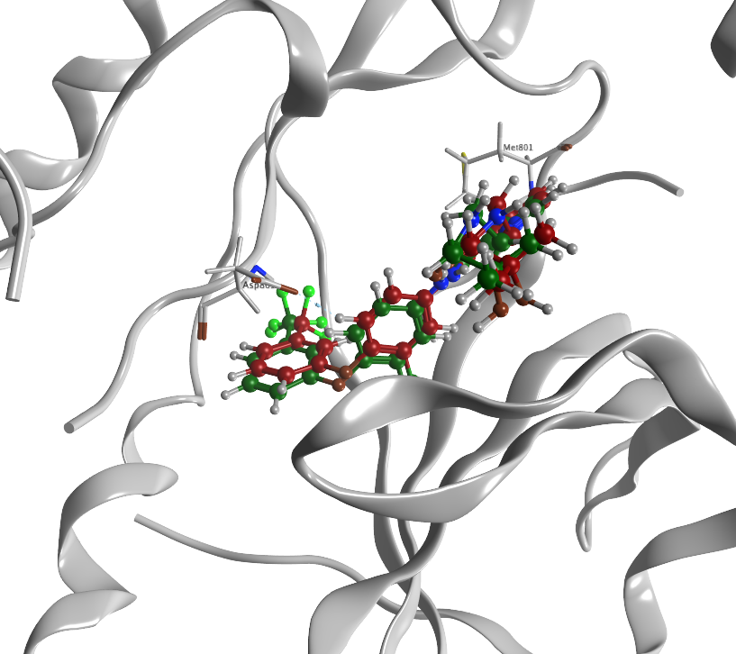
Supplementary Figure 2. The crystal structure of the redocking study used TAK-285 as the native ligand. Protein was illustrated as a grey ribbon while compounds and interacting amino acids were demonstrated as ball stick color.

Supplementary Figure 3. Structural and conformational analysis of HER2 mutations (L755S, T798I, and T798M) and their Ramachandran plot. (A) Overal structure of kinase domain highlighting the mutation site. (B) Ramachandran plots for mutated residues. The green dots represent the conformational spaces of the Phi-Psi angles for mutated residues. Deviations from typically allowed regions (orange outlines) suggest changes in backbone conformational preferences.

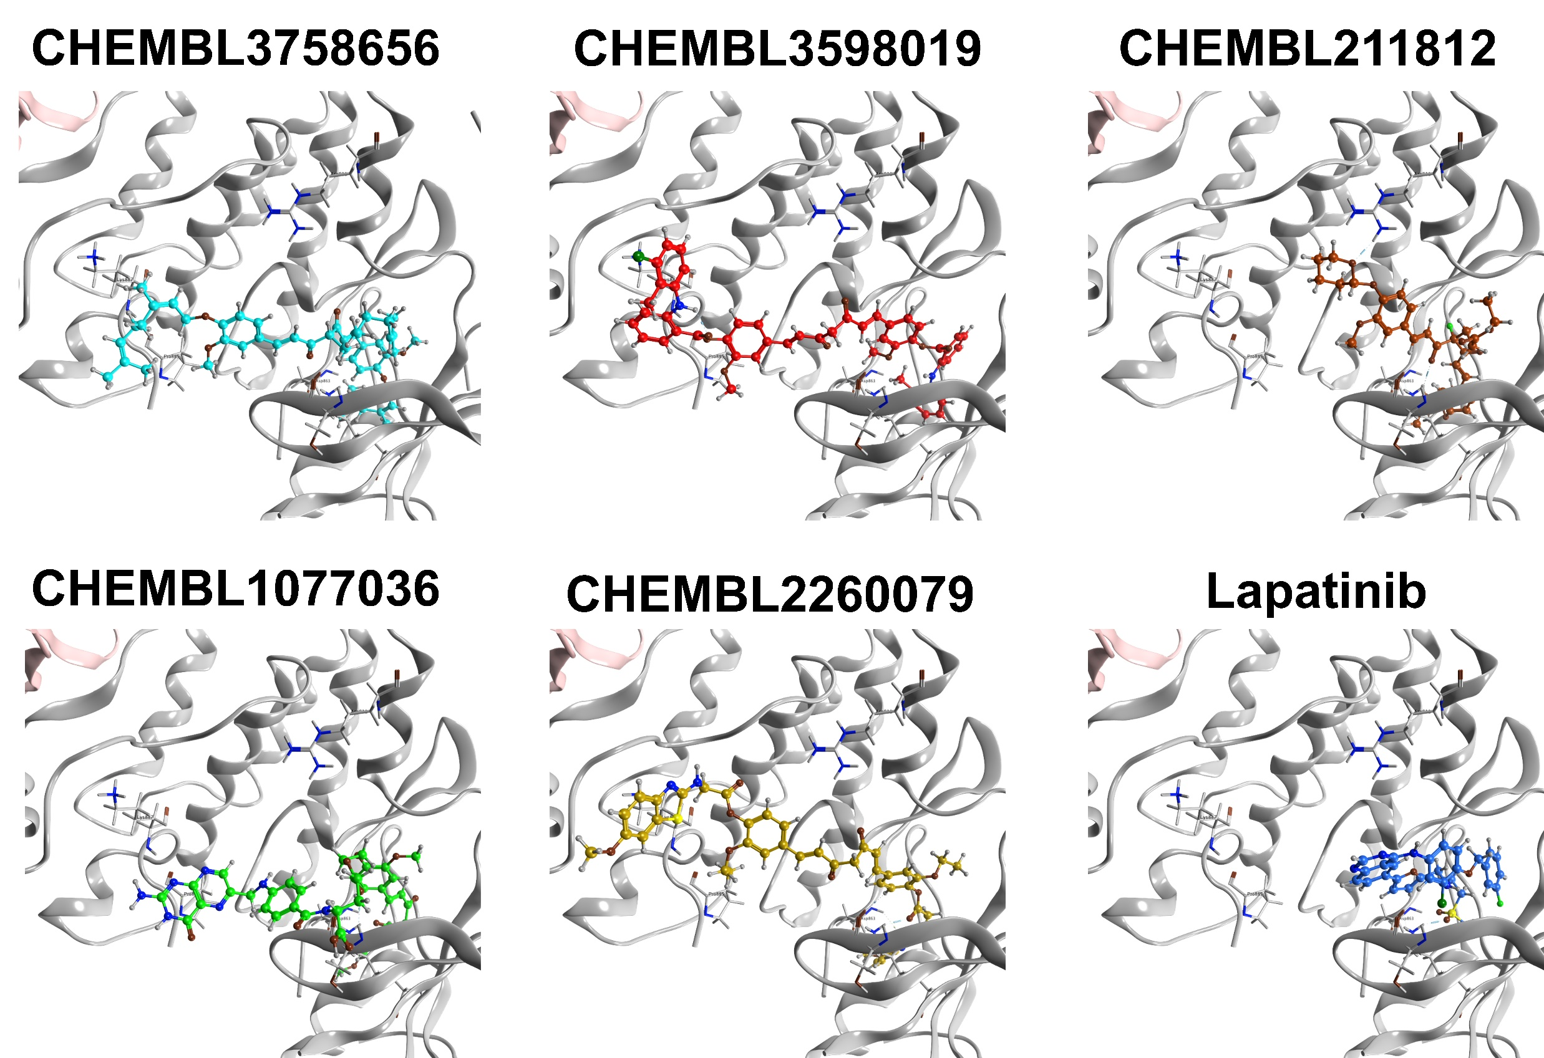
Supplementary Figure 4. Binding interaction of Lapatinib and top five Curcumin Derivatives against HER2 L755S in 3D Visualization

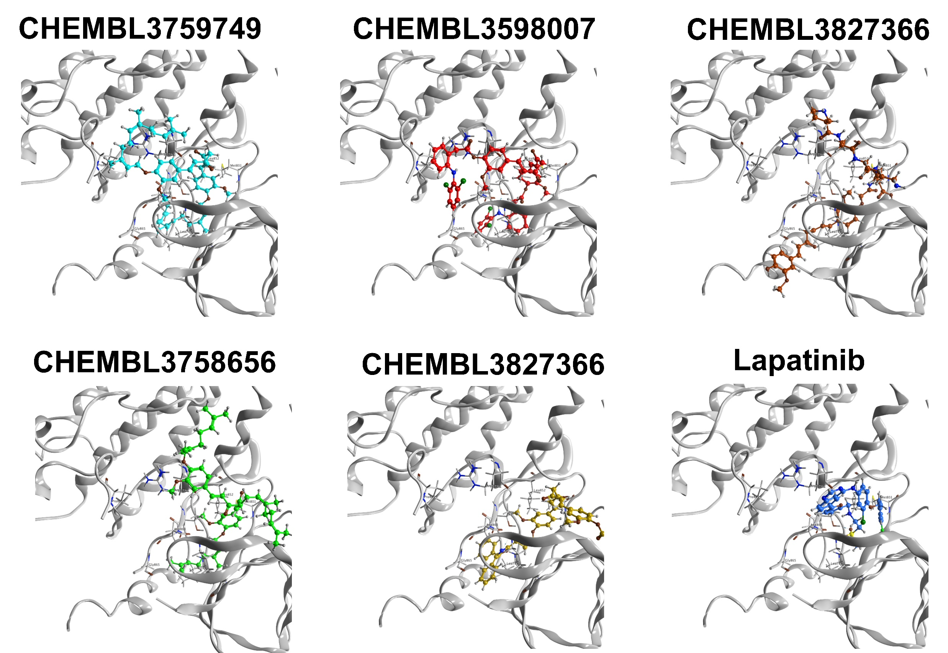

Supplementary Figure 5. Binding interaction of Lapatinib and top five Curcumin Derivatives against HER2 T798I in 3D Visualization

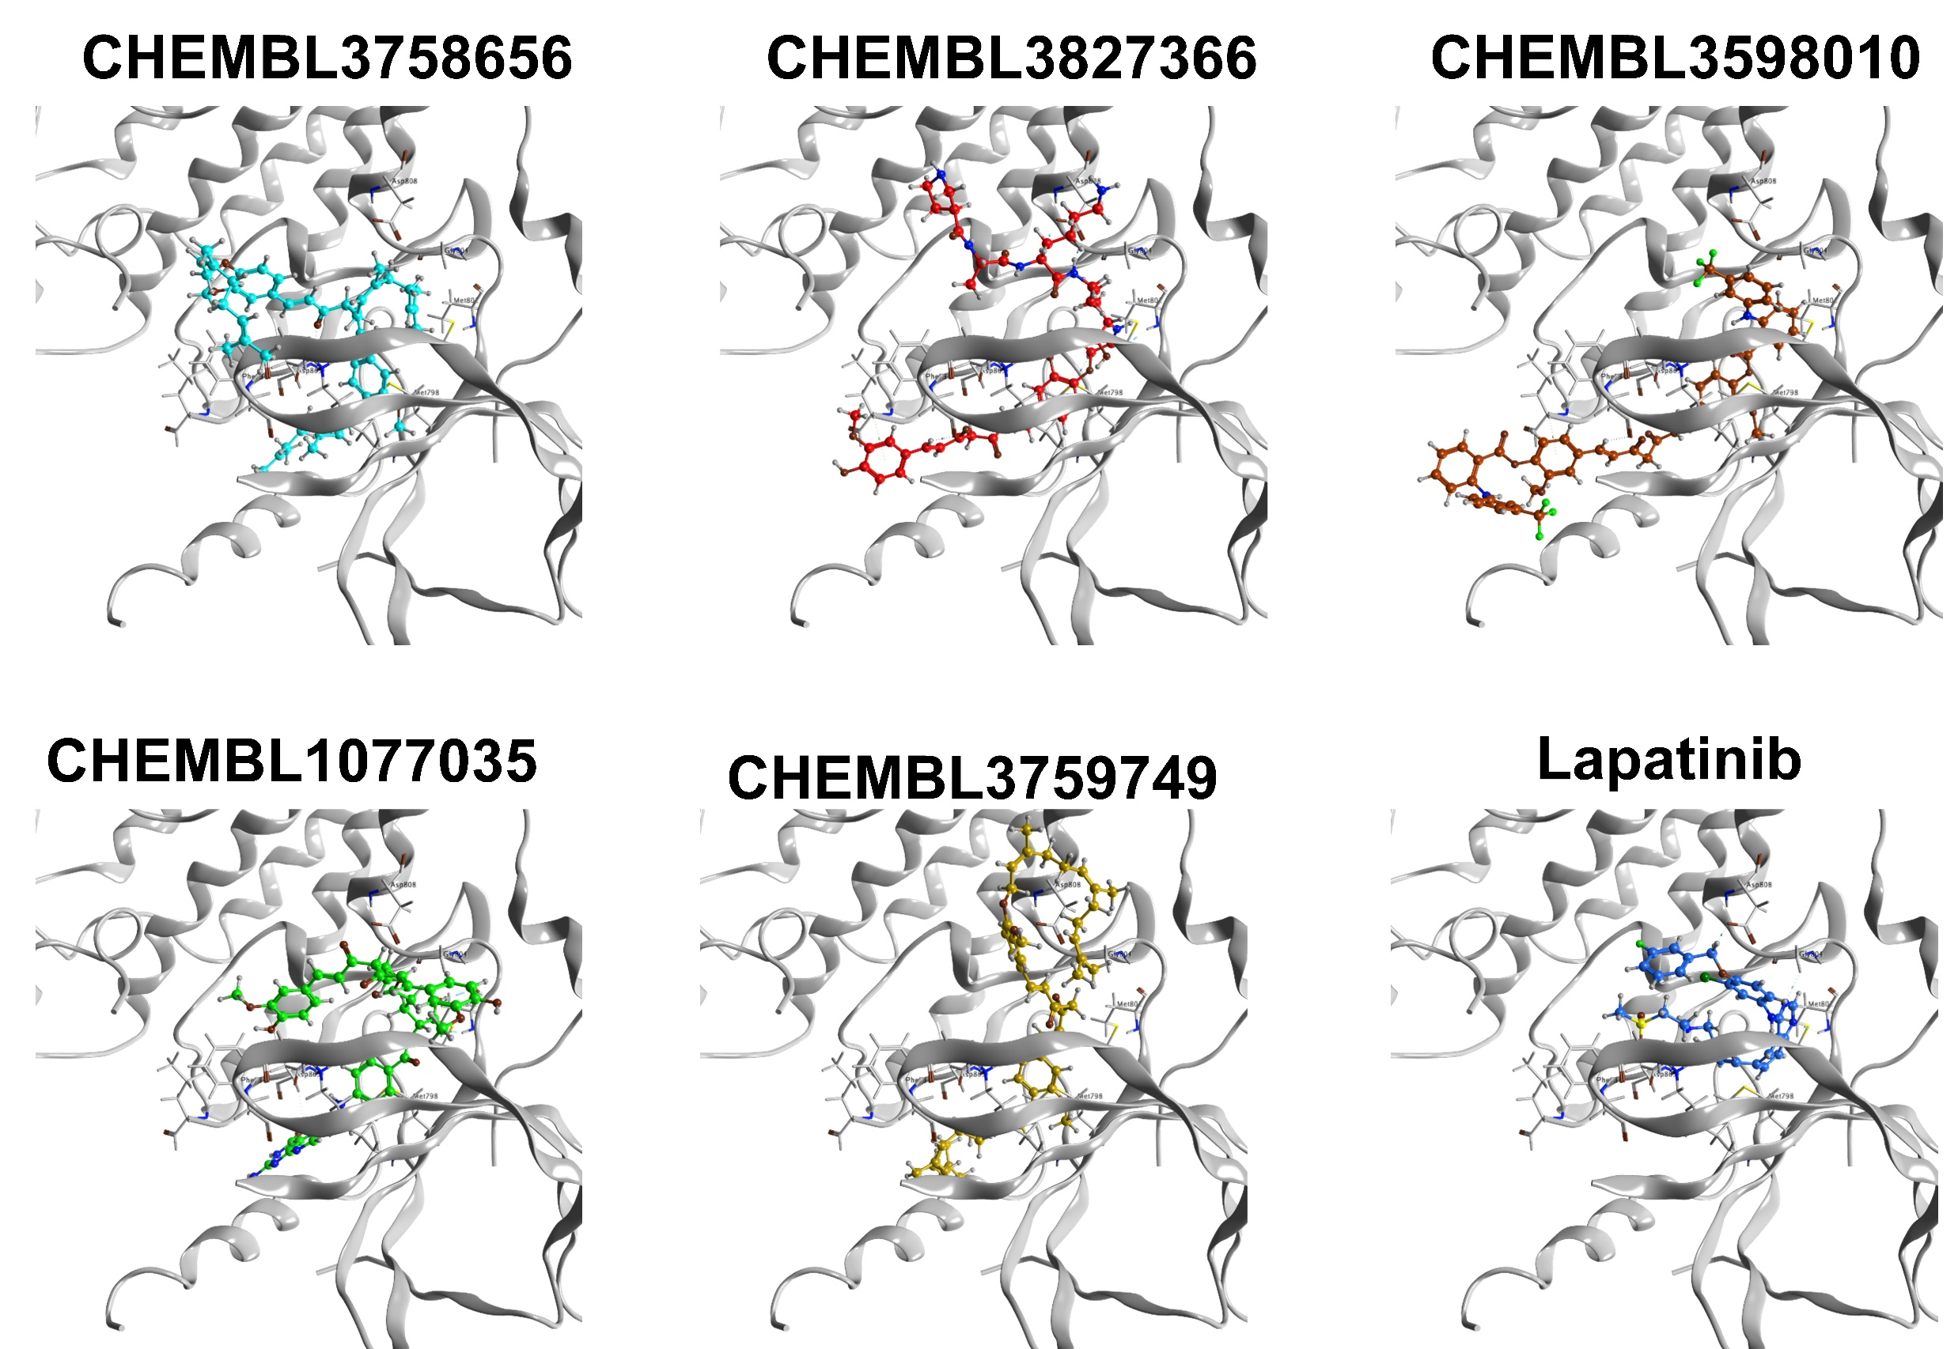
Supplementary Figure 6. Binding interaction of Lapatinib and top five Curcumin Derivatives against HER2T798M in 3D Visualization

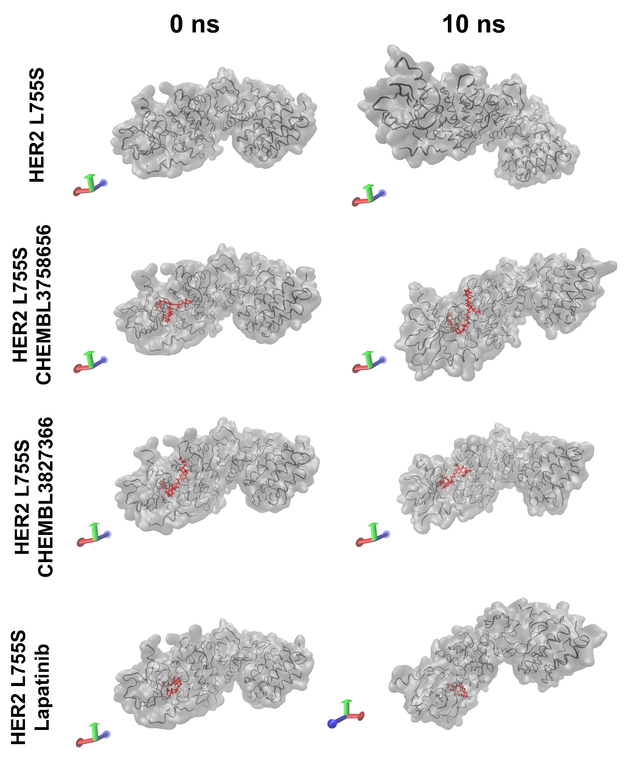
Supplementary Figure 7. Visualization of the binding interaction of curcumin derivatives againts HER2 L755S
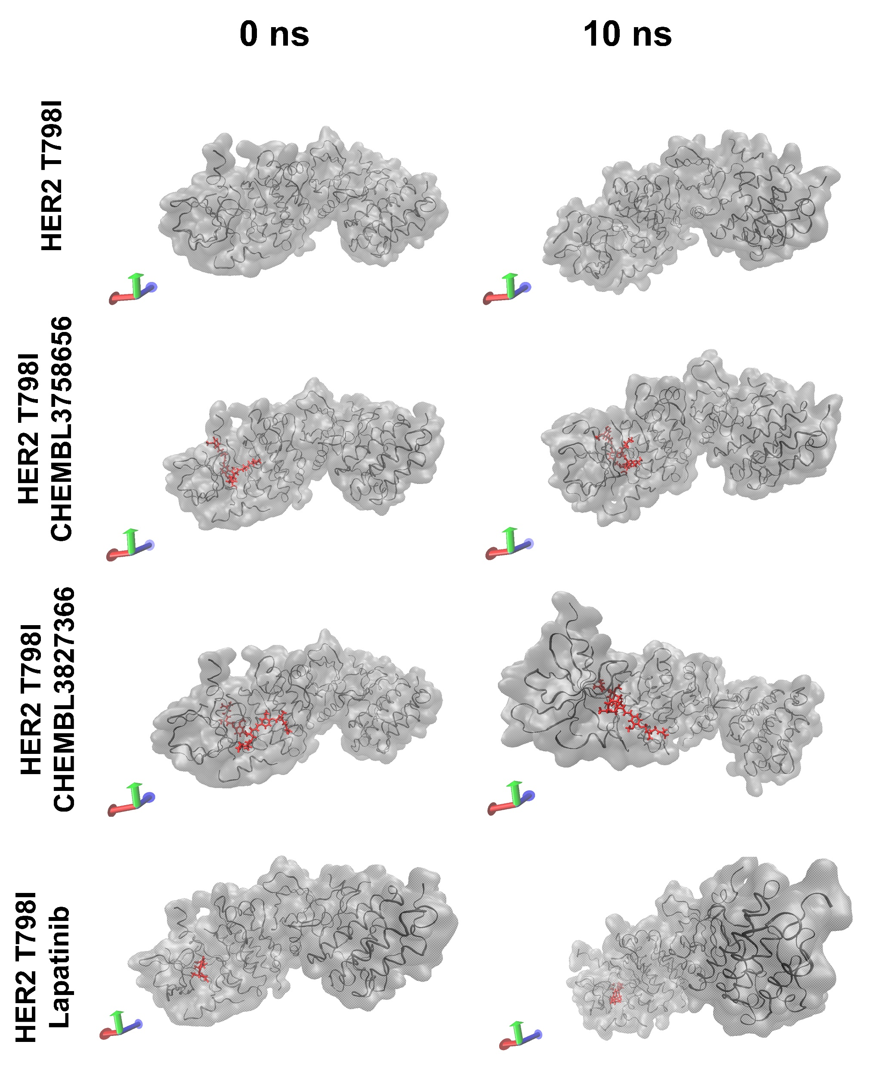
Supplementary Figure 8. Visualization of the binding interaction of curcumin derivatives againts HER2 T798I.
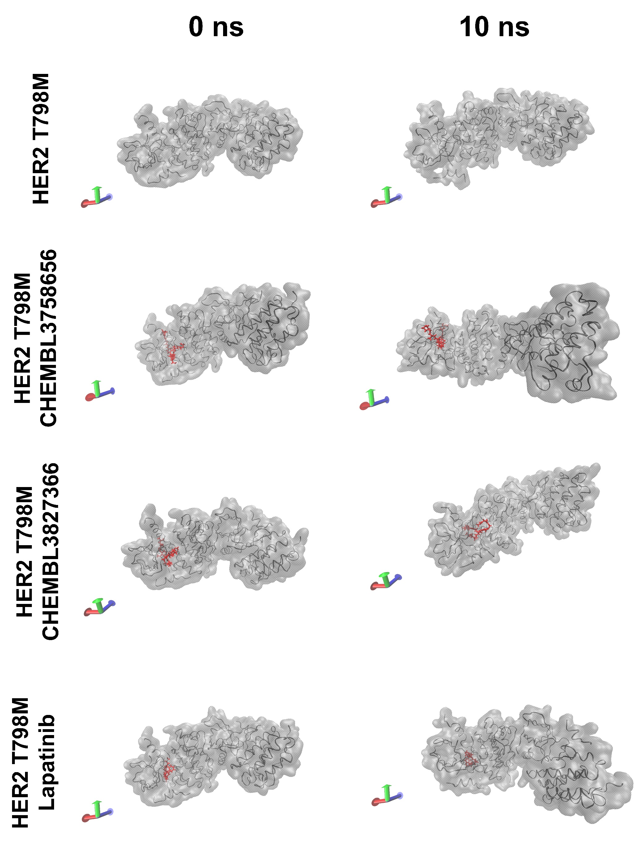
Supplementary Figure 9. Visualization of the binding interaction of curcumin derivatives againts HER2 T798M.

