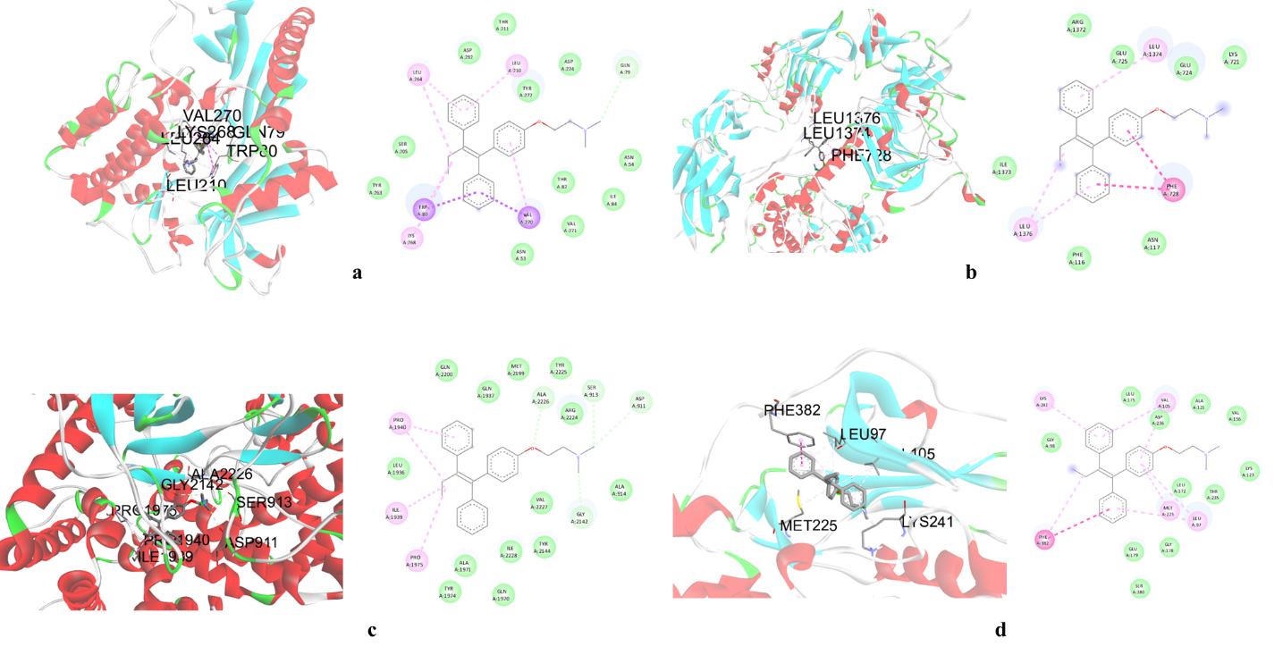
Supplementary Figure.1 Molecular docking analysis of Tamoxifen with BC target genes
Binding association of Tamoxifen with BC key targets by molecular docking analysis. Analysis by PyRx software illustrates the binding complexes formed between tamoxifen and the following proteins including AKT-1, MTOR, RPS6KB1 and INSR (a-d)

