Supplementary Figure 4A JC-1 assay
detects fluorescence shifts from green to red, corresponding to changes in Δψm.

- Representative JC-1 fluorescence images showing the red and green signals at 3 hours after treatment with Chamuangone (0.75, 1.5, and 3.0 μg/mL).

control
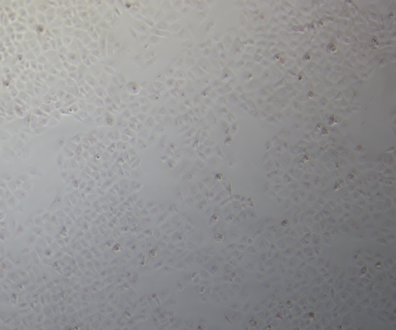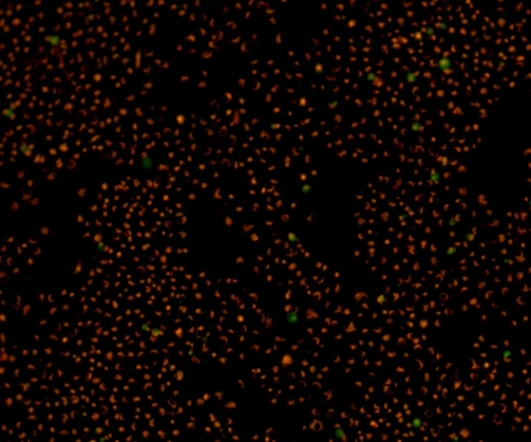

Chamuangone 0.75 μg/mL
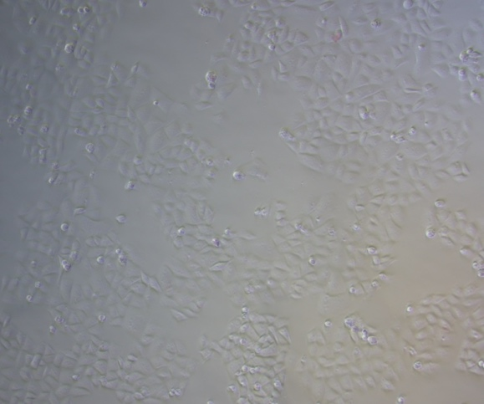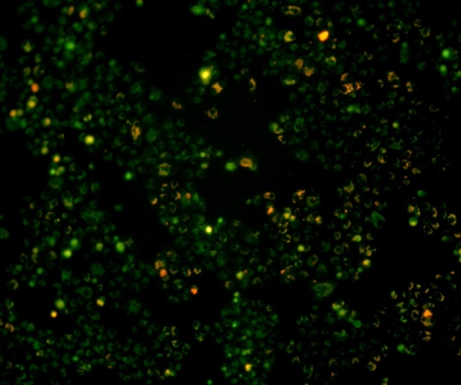

Chamuangone 1.5 μg/mL
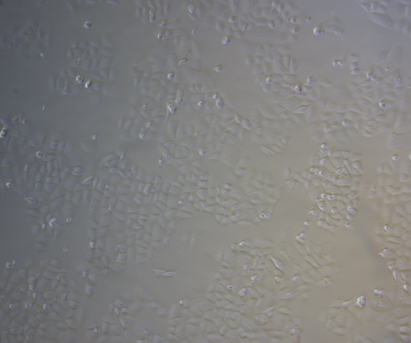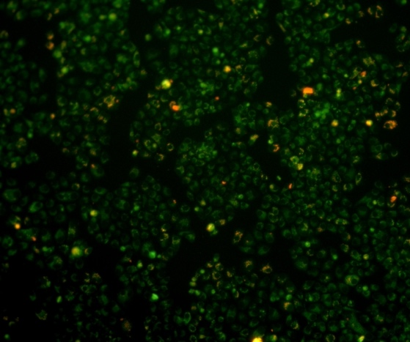

Chamuangone 3 μg/mL
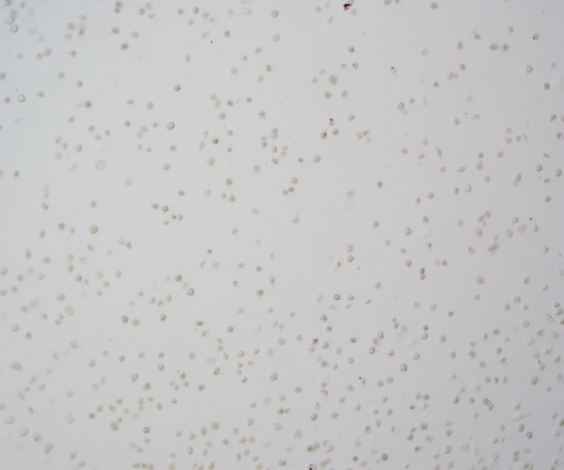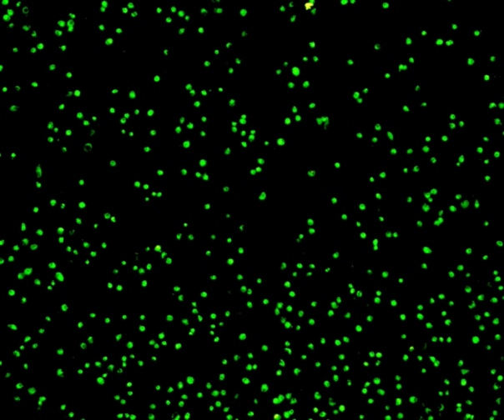

- Representative JC-1 fluorescence images showing the red and green signals at 6 hours after treatment with Chamuangone (0.75, 1.5, and 3.0 μg/mL).

control
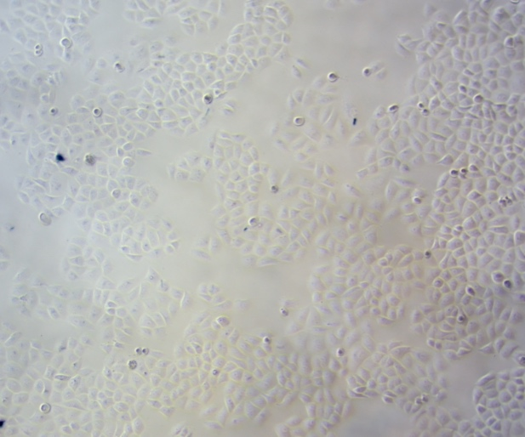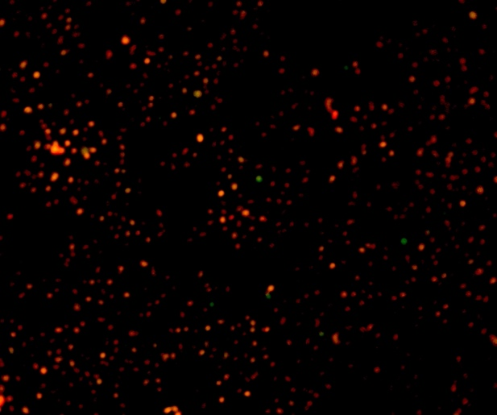

Chamuangone 0.75 μg/mL
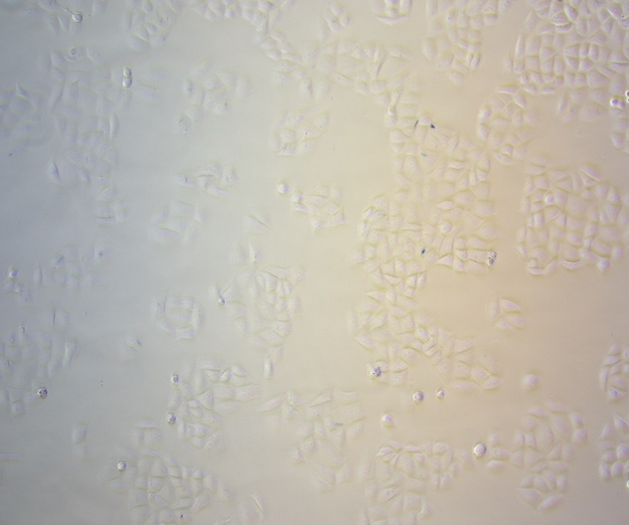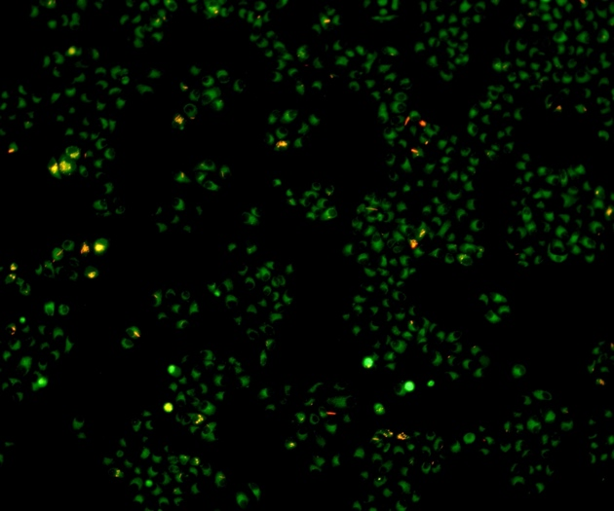

Chamuangone 1.5 μg/mL
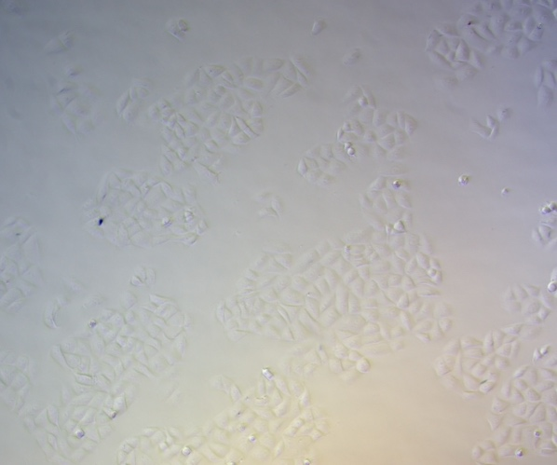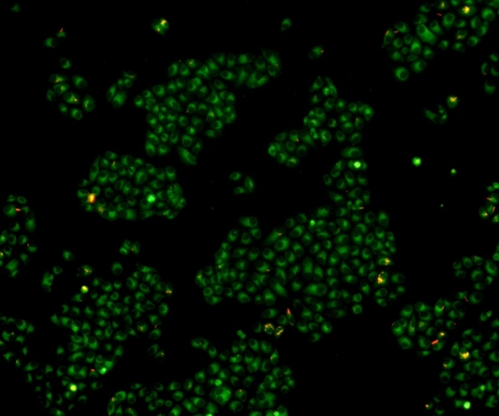

Chamuangone 3 μg/mL
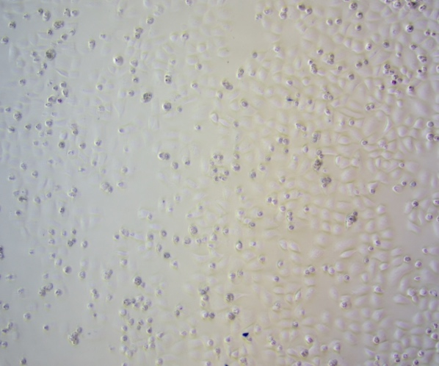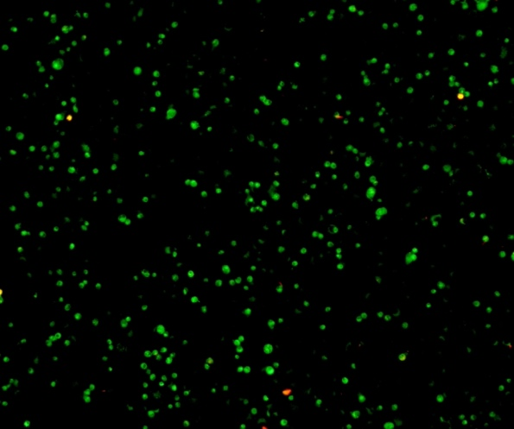

- Representative JC-1 fluorescence images showing the red and green signals at 24 hours after treatment with Chamuangone (0.75, 1.5, and 3.0 μg/mL).

control
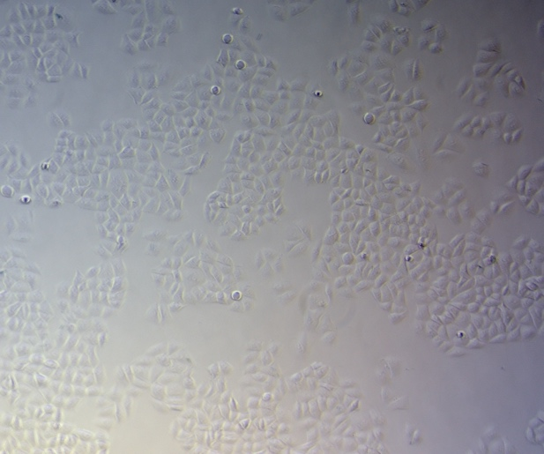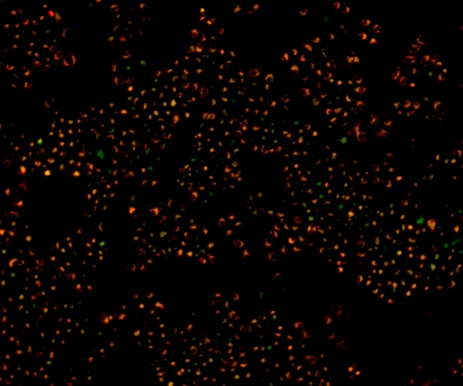

Chamuangone 0.75 μg/mL
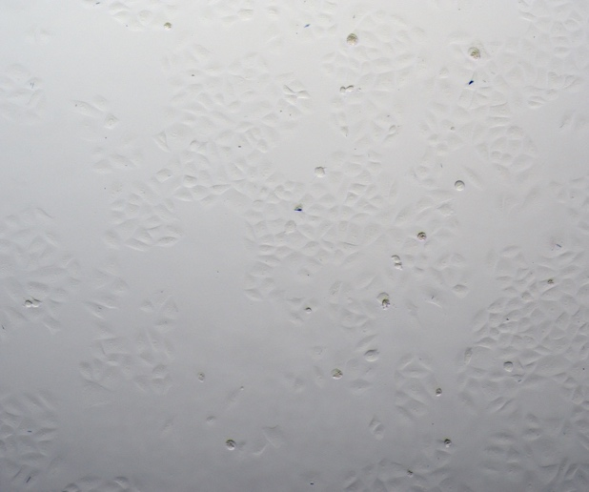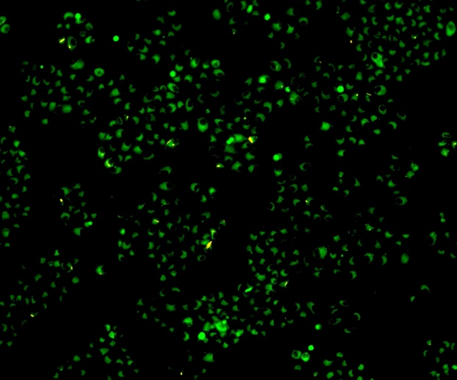

Chamuangone 1.5 μg/mL
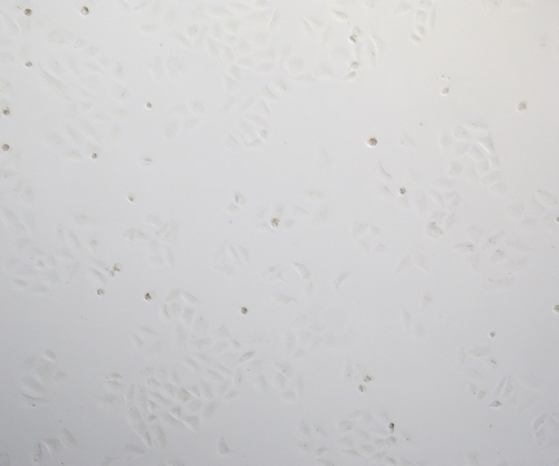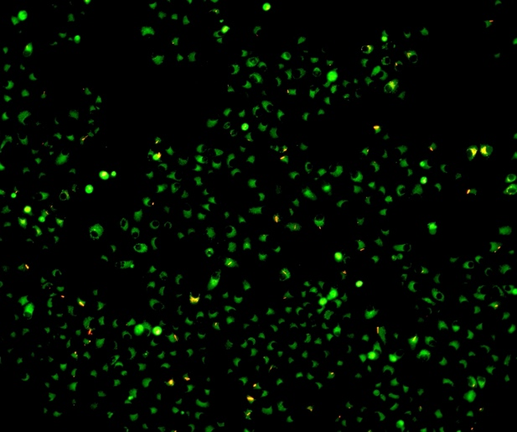

Chamuangone 3 μg/mL
