Supplementary Figure 6A - RayBio® Human XL Oncology Array
Full-length blots: multiple human cancer-related
proteins in KKU-100 cells

- Blot1: KKU-100 Chamuangone 3 ug-ml 24h Oncology Array with label

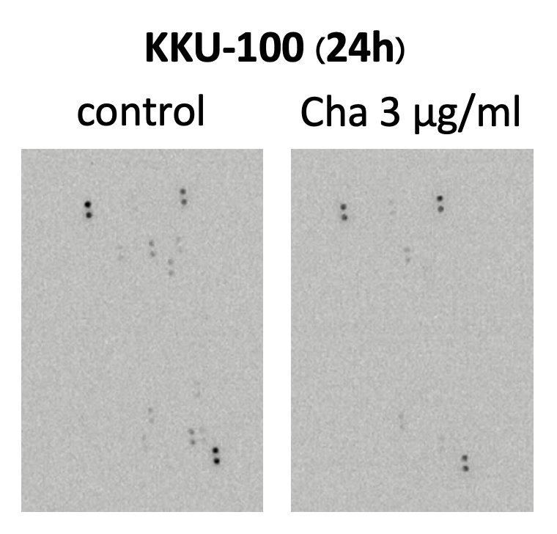

"In the manuscript, the image shown in Figure 6A was cropped from the original blots, Full Blot 1."
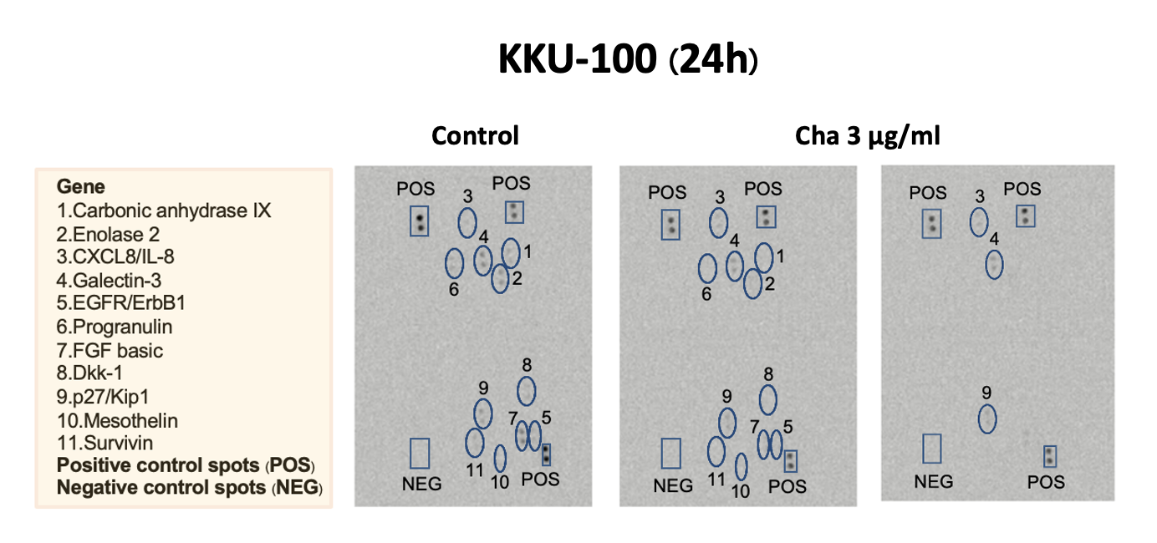
The middle panel shows all detected protein spots compared with the control, while the right panel highlights only the proteins expressed after treatment.

