Supplementary Figure
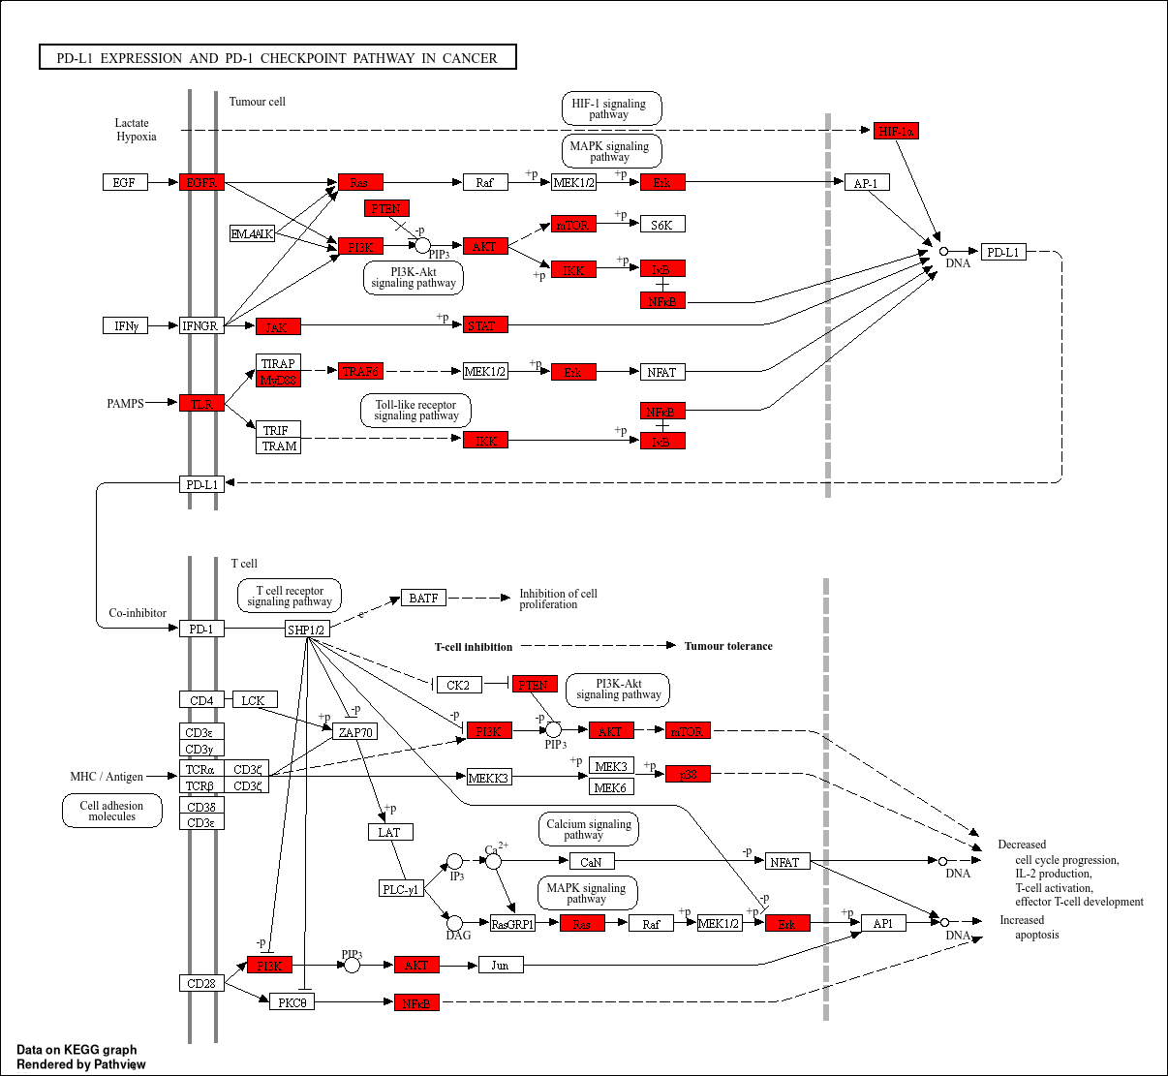
Supplementary Figure 1. KEGG Pathway Mapping Reveals Molecular Mechanisms of PD-L1/PD-1 Checkpoint Regulation Specific Signaling

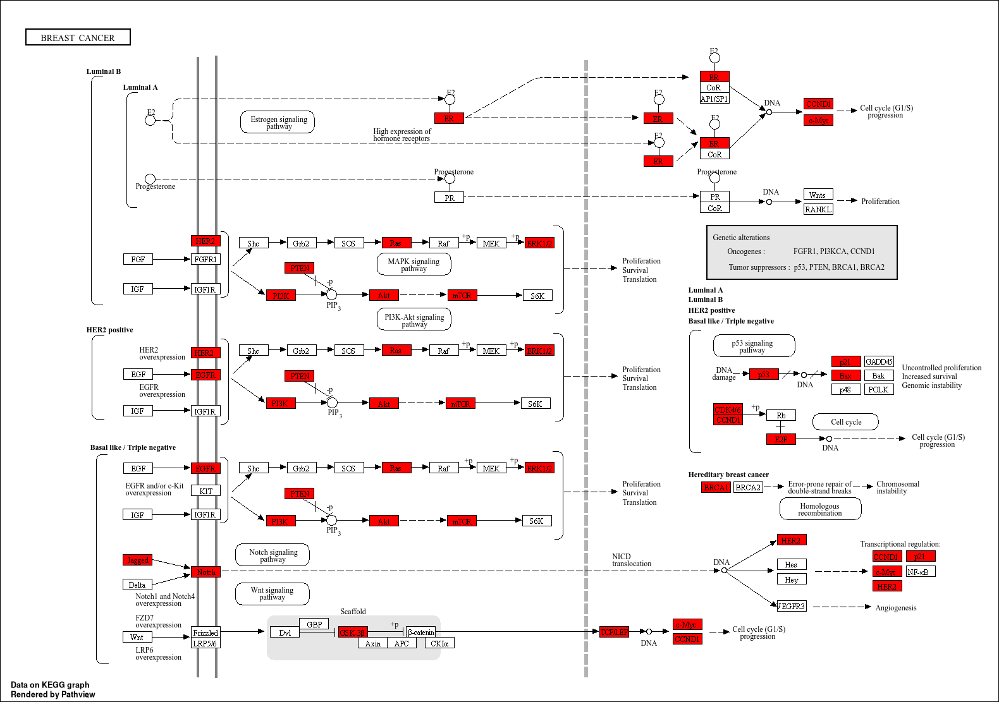
Supplementary Figure 2. KEGG Pathway Mapping Reveals Molecular Mechanisms of Breast Cancer Specific Signaling

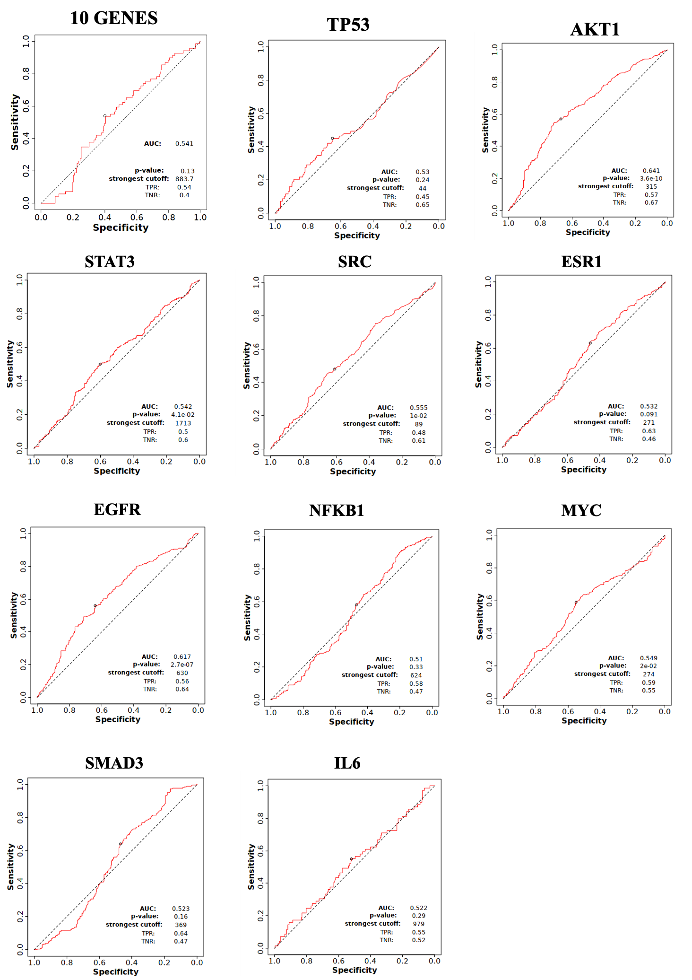
Supplementary Figure 3. Receiver Operating Characteristic Analysis Demonstrates Diagnostic Performance of BCSC-Related Gene Signatures. ROC curves evaluating the discriminatory power of individual genes and a combined 10-gene signature in distinguishing malignant from normal breast tissue.

