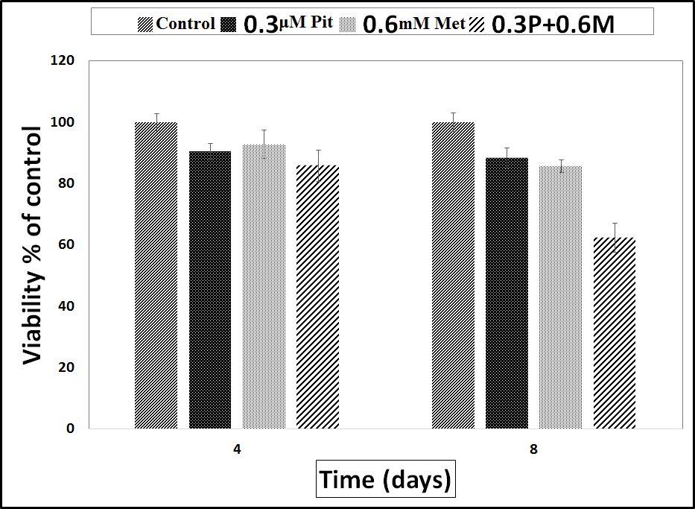
Supplementary Figure (1): Combined treatment increases cell death.
The death rate of MDA-MB-468 cells treated with either Metformin and Pitavastatin alone or in combination is shown in the preceding figure. After 24 and 48 hours of treatment, the trypan blue assay was used to detect the mortality of these cells. The findings show the average % SEM of at least two double-replicated studies.

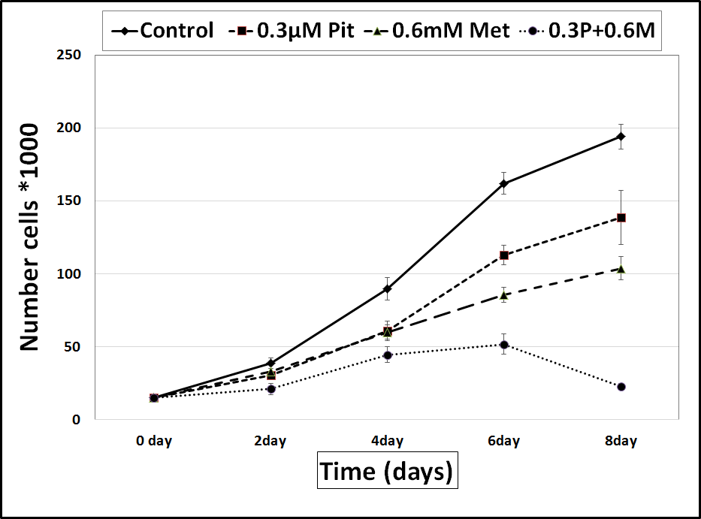
Supplementary Figure (2): The impact of Metformin and Pitavastatin, either separately or in combination, on MDA-MB-468 cell growth.
The curve showed the proliferation of control MDA-MB-468 cells compared to cells treated with Metformin and Pitavastatin alone or by combining both of them. The results were presented as the control's mean percentage ± SEM from at least two experiments that were repeated twice.
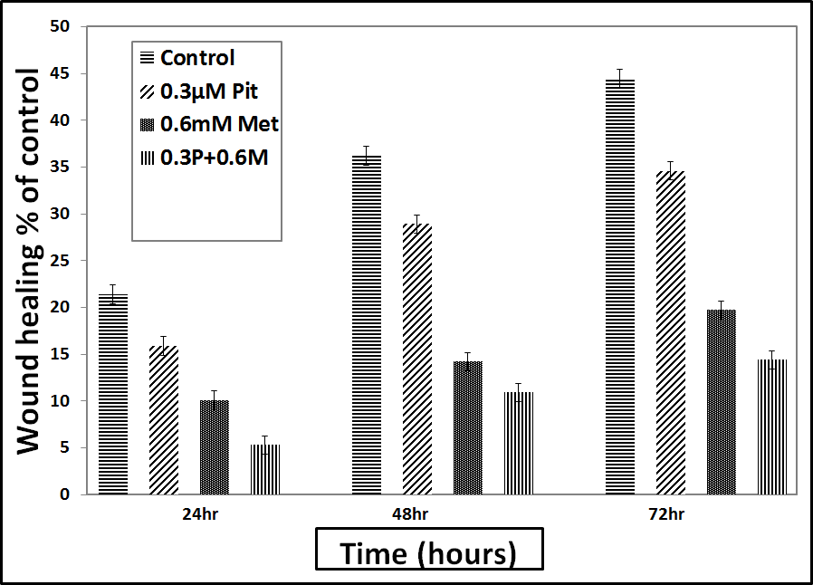
Supplementary Figure (3): The effect of Metformin and Pitavastatin (alone or in combination) on cell migration of MDA-MB-468 breast cancer cell line
Figure 8 shows how well MDA-MB-468 cells treated with the drugs Metformin and Pitavastatin could move. The cells were treated with 0.6mM Metformin and 0.3μM Pitavastatin separately, and then the two drugs were mixed together and given to the cells for 24, 48, and 72 hours. The cells' ability to move was shown by how well they could close the wound.

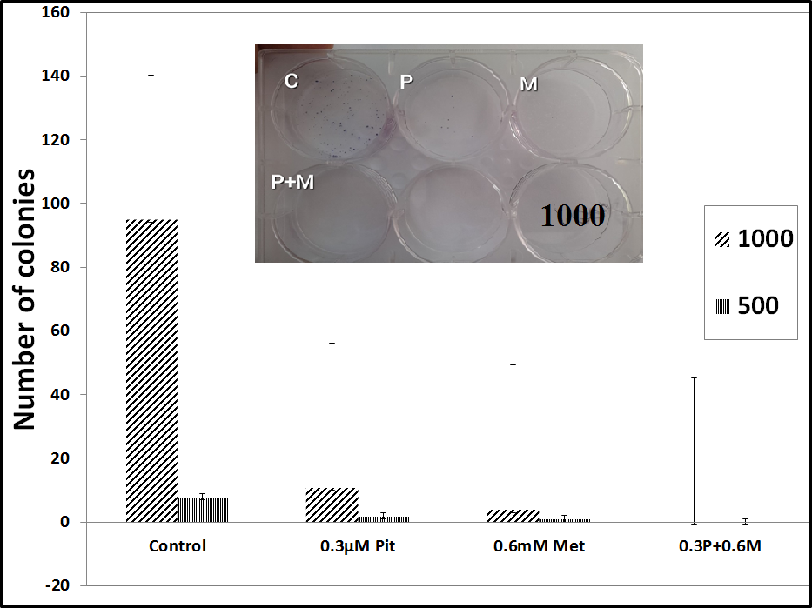
Supplementary Figure (4): Synergistic effect of Metformin and Pitavastatin to inhibit colony formation on MDA-MB-468 cells.

