Supplementary Table 1. Correlation analysis between studied miRNAs and other variables
Variable | Group | miRNA-375  (r) | miRNA-375 (p value) | miRNA-182  (r) | miRNA-182  (p value )
Age (years) | Controls | 0.203 | 0.157 | 0.156 | 0.279
Age (years) | POLYPs | -0.235 | 0.101 | -0.250 | 0.080
Age (years) | CRC | -0.181 | 0.210 | 0.161 | 0.265
BMI(Kg/m²) | Controls | . | . | . | .
BMI(Kg/m²) | POLYPs | 0.096 | 0.507 | -0.175 | 0.225
BMI(Kg/m²) | CRC | -0.270 | 0.058 | 0.229 | 0.110
Waist circumference  (Cm) | Controls | . | . | . | .
Waist circumference  (Cm) | POLYPs | 0.179 | 0.213 | -0.186 | 0.195
Waist circumference  (Cm) | CRC | -0.266 | 0.062 | 0.364 | 0.009
Waist-to-hip ratio | Controls | . | . | . | .
Waist-to-hip ratio | POLYPs | 0.080 | 0.580 | -0.219 | 0.127
Waist-to-hip ratio | CRC | -0.242 | 0.091 | 0.330 | 0.019
Cholesterol (mg/dL) | Controls | 0.123 | 0.395 | 0.266 | 0.061
Cholesterol (mg/dL) | POLYPs | -0.167 | 0.246 | -0.137 | 0.341
Cholesterol (mg/dL) | CRC | -0.087 | 0.546 | 0.331 | 0.019
HDL-C (mg/dL) | Controls | 0.077 | 0.595 | -0.212 | 0.140
HDL-C (mg/dL) | POLYPs | 0.271 | 0.057 | 0.096 | 0.506
HDL-C (mg/dL) | CRC | 0.048 | 0.741 | -0.282 | 0.048
Triglycerides (mg/dL) | Controls | -0.065 | 0.655 | 0.388 | 0.005
Triglycerides (mg/dL) | POLYPs | -0.084 | 0.564 | -0.265 | 0.063
Triglycerides (mg/dL) | CRC | -0.021 | 0.888 | 0.270 | 0.058
LDL-C (mg/dL) | Controls | 0.136 | 0.347 | 0.168 | 0.243
LDL-C (mg/dL) | POLYPs | -0.155 | 0.282 | 0.012 | 0.934
LDL-C (mg/dL) | CRC | -0.104 | 0.472 | 0.327 | 0.020

Supplementary Figure 1: Correlation of miR-182 with waist circumference in CRC group
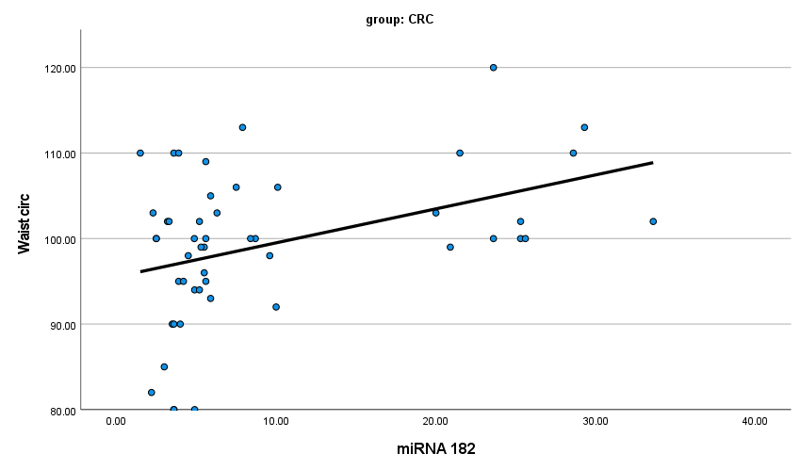
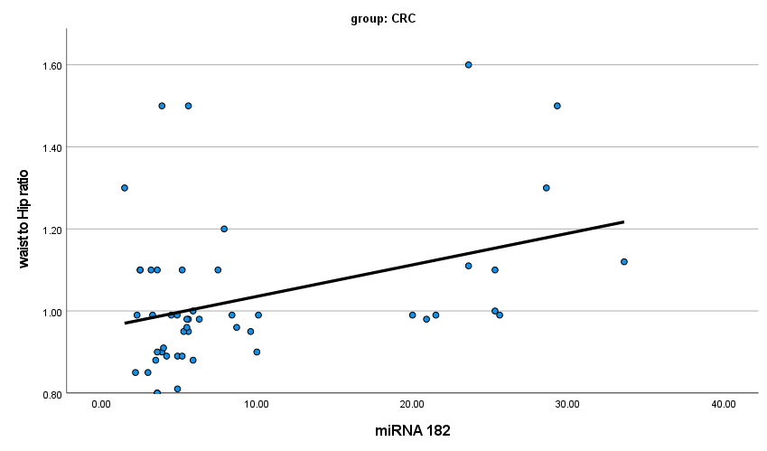  Supplementary Figure 2: Correlation of miR-182 with waist to hip ratio in CRC group | 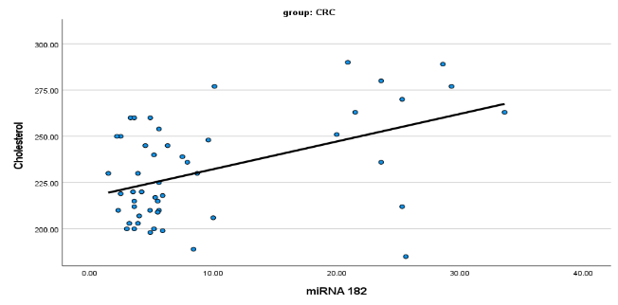 Supplementary Figure 3: Correlation of miR-182 with cholesterol in CRC group
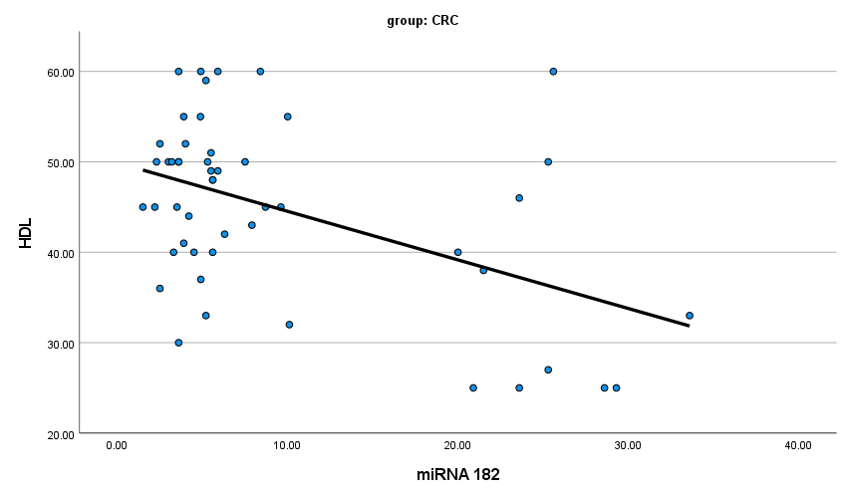  Supplementary Figure 4: Correlation of miR-182 with HDL in CRC group | 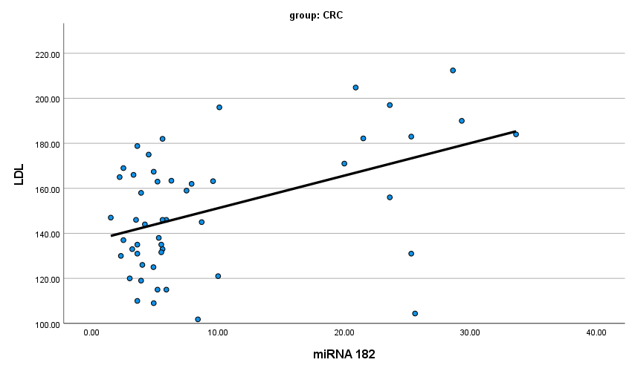  Supplementary Figure 5: Correlation of miR-182 with LDL in CRC group
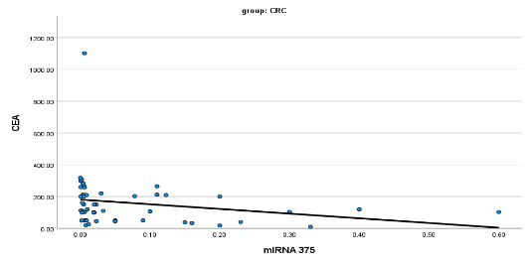  Supplementary Figure 6: Correlation of miR-375 with CEA in CRC group | 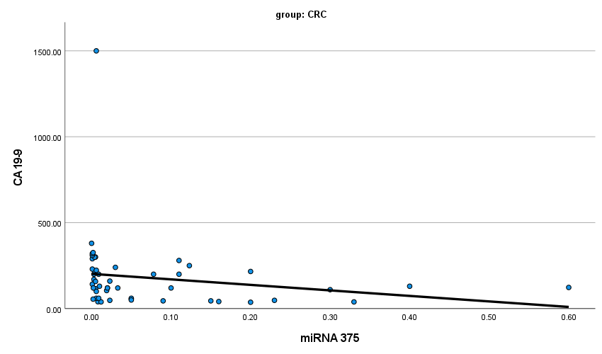  Supplementary Figure 7: Correlation of miR-375 with CA19-9 in CRC group  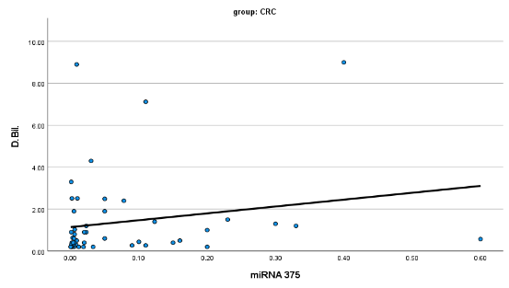  Supplementary Figure 8: Correlation of miR-375 with serum direct bilirubin in CRC group

Supplementary Table 2. Sex-based distribution of circulating miRNA levels in CRC patients
Parameter | Sex | Mean | SD | p value
miRNA-375 | Male | 0.08 | 0.13
miRNA-375 | Female | 0.06 | 0.10 | 0.983
miRNA-182 | Male | 11.34 | 9.64
miRNA-182 | Female | 5.57 | 5.14 | 0.011
Expression of micro-RNAs is represented as fold regulation
Supplementary Table 3. Diagnostic performance of miRNAs and tumour markers using ROC curve analysis
Biomarker | Comparison | AUC (95% CI) | Cut-off | Sensitivity (%) | Specificity (%) | PPV (%) | NPV (%) | p value
miRNA-375 | CRC vs Controls | 0.998 (0.992–1.000) | ≤0.74 | 100 | 98 | 96.1 | 97.9 | <0.001
miRNA-182 | CRC vs Controls | 0.996 (0.988–0.999) | >2.1 | 98 | 98 | 94.1 | 95.9 | <0.001
miRNA-182 | CRC vs Polyps | 0.927 (0.880–0.974) | >0.995 | 88 | 90 | — | — | <0.001
miRNA-182 | Polyps vs Controls | 0.970 (0.937-1.002) | > 1.525 | 94 | 92 | — | — | <0.001
miRNA-375 | CRC vs Polyps | 0.907 (0.851–0.963) | < 0.0545 | 70 | 98 | — | — | <0.001
Expression of micro-RNAs is represented as fold regulation

Supplementary Table 4. ROC for differentiation between CRC and Polyps using miRNA-182, CEA and CA 19-9
 | Area Under the Curve | p value | 95% Confidence Interval
 | Area Under the Curve | p value | Lower Bound | Upper Bound | Cut off | Sensitivity % | Specificity %
miRNA 182  (Fold regulation) | 0.927 | < 0.001 | 0.874 | 0.981 | > 3.15 | 88 | 90
CEA (ng/mL) | 0.986 | < 0.001 | 0.965 | 1.007 | > 14 ng/ml | 98 | 94
CA 19-9 (U/mL) | 0.976 | < 0.001 | 0.951 | 1.002 | > 40.5 U/ml | 92 | 92
Abbreviations: AUC, area under the curve; CI, confidence interval; PPV, positive predictive value; NPV, negative predictive value; CEA, carcinoembryonic antigen.
Footnote: ROC curves were constructed to discriminate CRC patients from non-CRC participants (polyps + controls). Optimal cut-off values were determined using the Youden index.
Supplementary Table 5. miRNA and Caspase expression with tumour characteristics in CRC patients
 |  | GRADE |  |  |  |  |  |  |  |  |  | p value
 |  | Well differentiated |  |  |  |  |  | Moderately differentiated |  |  |  | p value
miRNA-375* |  | 0.11± 0.12 |  |  |  |  |  | 0.06±0.12 |  |  |  | 0.049
miRNA-182* |  | 10.89± 11.09 |  |  |  |  |  | 9.14± 8.31 |  |  |  | 0.495
 |  | T (TUMOR) |  |  |  |  |  |  |  |  |  | p value
 |  | T2 |  |  | T3 |  |  |  | T4 |  |  | p value
 |  | Count | % |  | Count | % |  |  | Count |  | % | p value
CASPASE** | Positive | 1 | 10.0% |  | 30 | 33.3% |  |  | 0 |  | 0.0% | 0.046
CASPASE** | Negative | 29 | 90.0% |  | 60 | 66.7% |  |  | 30 |  | 100.0% | 0.046
 |  | N (NODES)
 |  | N0 |  |  |  |  | N2 |  |  |  |  | p value
 |  | Count |  | % |  |  | Count |  |  | %
CASPASE** | Positive | 10 |  | 6.7% |  |  | 67 |  |  | 45.0% |  | 0.004
*Data expressed as mean ±2 SD.
** Data expressed as Number and percentage

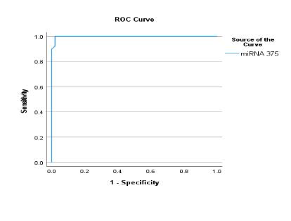  Supplementary Figure 9: ROC for differentiation between CRC and Controls using miRNA-375 | 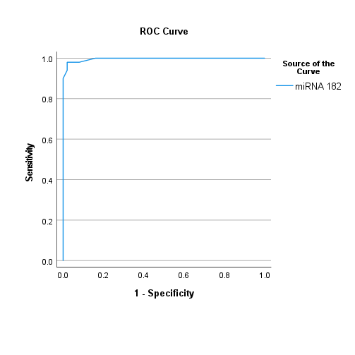  Supplementary Figure 10: ROC for differentiation between CRC and Controls using miRNA-182 | 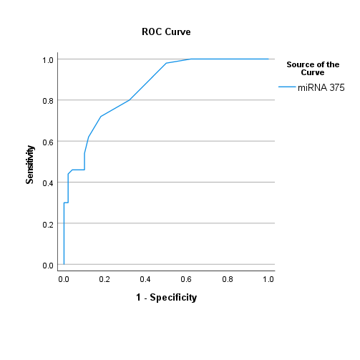  Supplementary Figure 11: ROC for differentiation between Polyps and Controls using miRNA-375
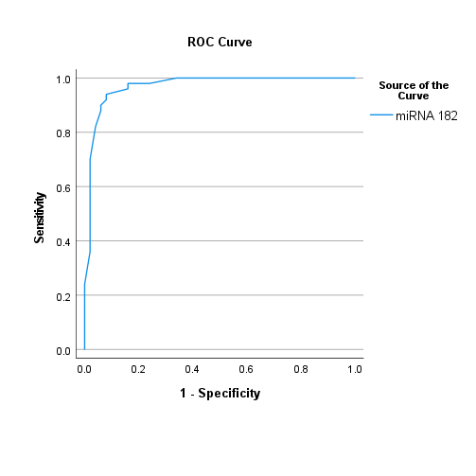 Supplementary Figure 12: ROC for differentiation between Polyps and Controls using miRNA-182 | 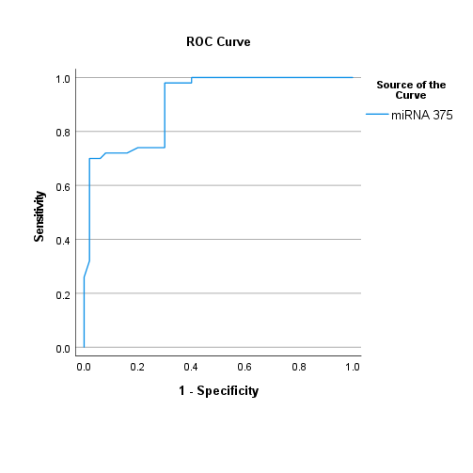  Supplementary Figure 13: ROC for differentiation between CRC and Polyps using miRNA-375 | 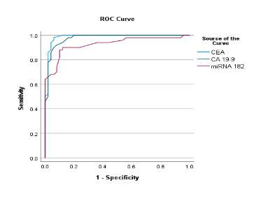  Supplementary Figure 14: ROC for differentiation between CRC and Polyps using miRNA-182, CEA and CA 19-9 as a panel.

Supplementary Table 6. Logistic regression analysis for prediction of lymph node (LN) positivity in colorectal cancer patients
Predictor | B | SE | Wald | Df | p value | OR | 95% CI (Lower) | 95% CI (Upper)
miR-375 | -1.444 | 2.747 | 0.276 | 1 | 0.599 | 0.236 | 0.001 | 51.413
miR-182 | 0.009 | 0.037 | 0.064 | 1 | 0.801 | 1.009 | 0.939 | 1.085
Caspase-3 positive | 2.488 | 0.876 | 8.072 | 1 | 0.004 | 12.038 | 2.163 | 66.984
B = regression coefficient; SE = standard error; OR = odds ratio; CI = confidence interval. Caspase-3 positivity was a significant independent predictor of LN metastasis (p < 0.01), whereas miR-375 and miR-182 were not.
Expression of micro-RNAs is represented as fold regulation

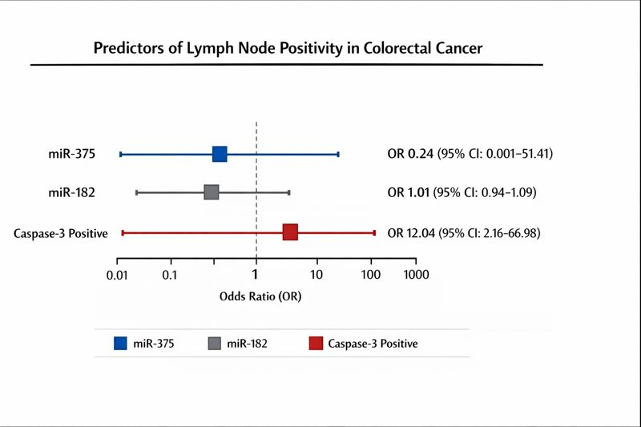
Supplementary Figure 15 Forest plot depicting the odds ratios (OR) and 95% confidence intervals (CI) for predictors of lymph node (LN) positivity in colorectal cancer patients. Predictors included miR-375, miR-182, and Caspase-3 positivity. Squares represent the point estimates of ORs, and horizontal lines indicate the 95% CIs. The vertical dashed line represents the reference OR of 1. Caspase-3 positivity was identified as a significant independent predictor of LN metastasis, whereas miR-375 and miR-182 showed no significant association.
Supplementary Table 7. Logistic regression models for CRC prediction and disease severity

Predictor | B | SE | Wald | df | P value | OR | 95% CI (Lower–Upper)
miRNA-375 | -5.974 | 1.905 | 9.831 | 1 | 0.002 | 0.003 | 0.000–0.107
miRNA-182 | 2.111 | 0.646 | 10.660 | 1 | 0.001 | 8.254 | 2.325–29.302
Constant | -5.124 | 1.684 | 9.262 | 1 | 0.002 | 0.006 | —
Abbreviations: OR, odds ratio; CI, confidence interval. Variables with P < 0.10 in univariate analysis were entered into the multivariate logistic regression model. Results are expressed as ORs with 95% confidence intervals. A P value < 0.05 was considered statistically significant.
Expression of micro-RNAs is represented as fold regulation

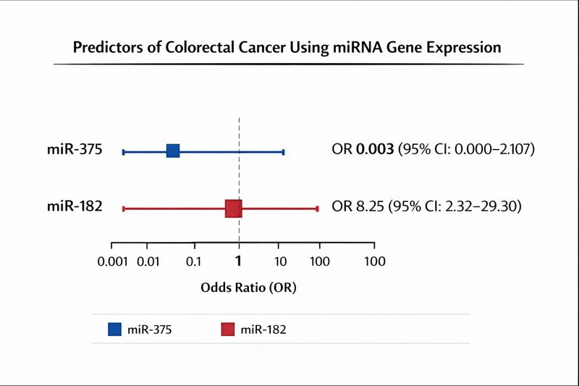

Supplementary Figure 16 Forest plot illustrating the odds ratios (ORs) and 95% confidence intervals (CIs) for circulating miRNA predictors of colorectal cancer derived from multivariate logistic regression analysis. miR-375 exhibited a strong inverse association with colorectal cancer risk, whereas miR-182 showed a significant positive association. Squares represent point estimates of ORs and horizontal lines denote 95% CIs. The vertical dashed line indicates the reference value (OR = 1). Odds ratios are displayed on a logarithmic scale.

