Supplementary Table 1: Range of scores used for AVQ, GQS, mDISCERN and VIQI
Audio-visual quality (AVQ)
3 | Excellent | Clear, professional editing (Videos which include clear visuals, text, professional graphics or effects, and where there was no difficulty in understanding spoken words and music, were rated as good)
2 | Average | Non-professional editing (while home videos, videos with average quality and text clarity, speech that was difficult to understand, distracting audio or background sounds, were rated as moderate)
1 | Poor | Blurry, out of focus, unintelligible videos (which had blurry, grainy, or difficult to understand visuals)
0 | Very poor | Unable to view and no audio
Global Quality Score (GQS)
1 | Poor quality; very unlikely to be any use to patients
2 | Poor quality but some information to the patient
3 | Moderate quality, suboptimal flow, some information covered but important topics missing, somewhat useful to the patient.
4 | Good quality and flow, most important topics covered, useful to the patients
5 | Excellent Quality and flow; highly useful to the patients
Modified DISCERN Tool (mDISCERN)
0-1 | Are the aims clear and achieved?
0-1 | Are reliable sources of information used? (i.e., the publication cited or speaker is a board-certified gynaecologist)
0-1 | Is the information presented balanced and unbiased?
0-1 | Are additional sources of information listed for patient reference?
0-1 | Are areas of uncertainty mentioned?
Video Information and Quality Index (VIQI)
1-5 | Flow of information
1-5 | Information Accuracy
1-5 | Quality (one point each for the use of still images, animation, interview with individuals in the community, Video captions and a report summary)
1-5 | Precision (level of coherence between video title and content)

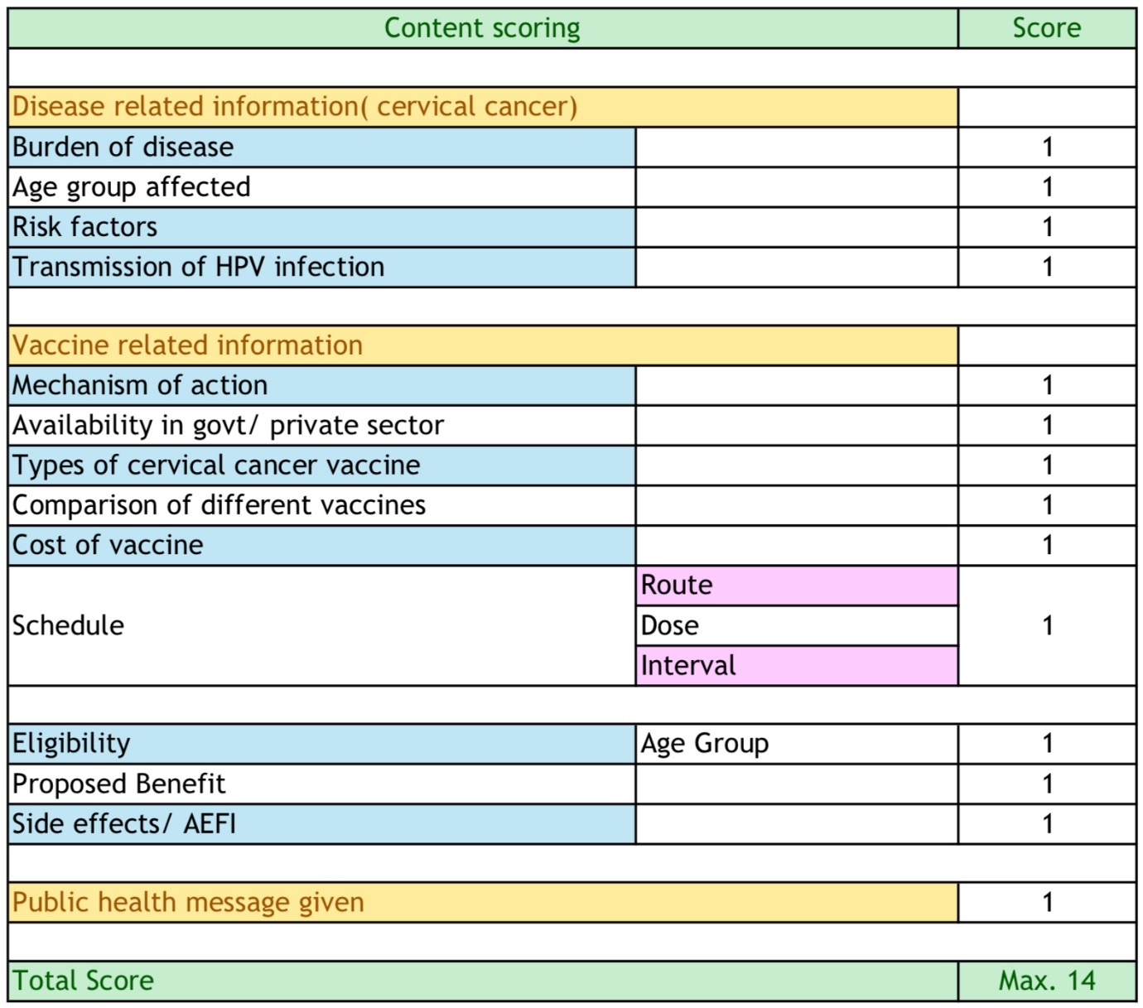
Supplementary Figure 1: Parameters used in CSCCV

