Supplementary figure
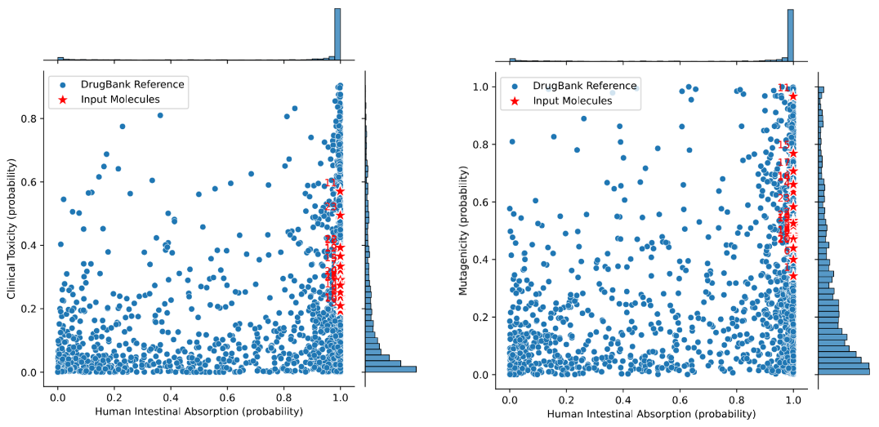
Figure S1. Toxicity probability and predicted human intestinal absorption (HIA) of Micheliolide derivatives compared with DrugBank reference compounds.
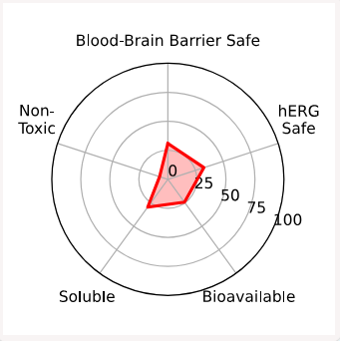
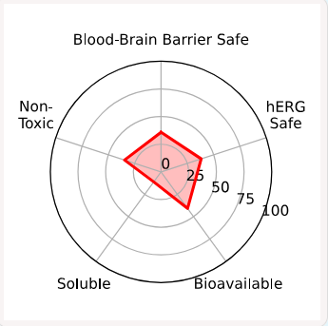
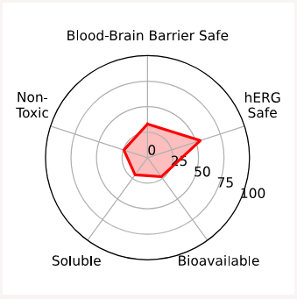
33
113
203

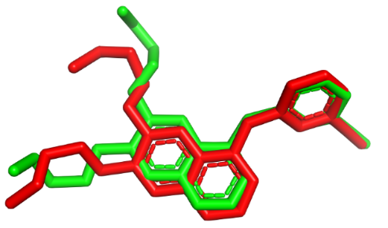
Figure S2. Overal ADMET properties of compounds 3, 11, and 20.

Figure S3. Native ligand (Erlotinib) before and after re-docking process.

