Supplementary Material.

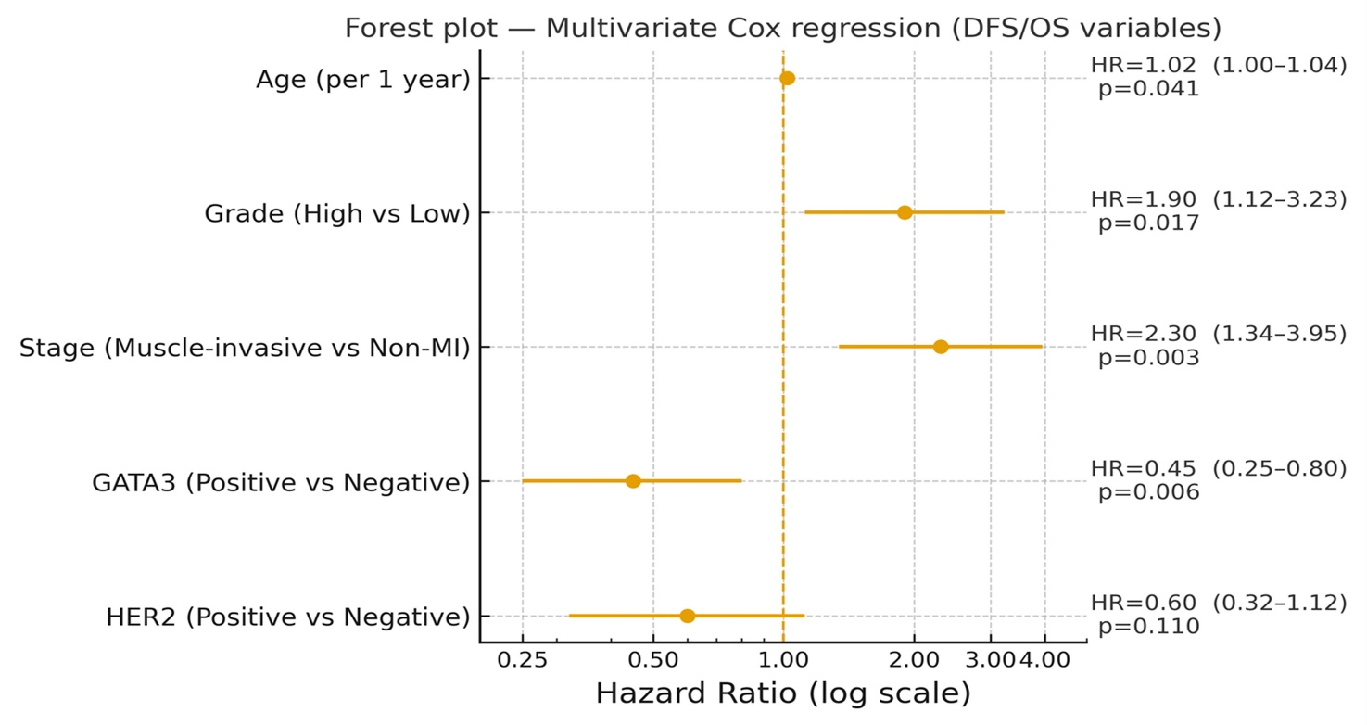

Supplementary Figure 1. Forest plots of the Cox regression model summarizing independent predictors of disease-free and overall survival. High tumor grade and muscle-invasive stage are associated with poorer outcomes, whereas GATA3 positivity correlates with improved prognosis. HER2 demonstrates a non-significant but favorable trend.

