Supplemental Table S1. Frequencies and percentages of patients classified by tumour type and age group (n=371)

Tumour type | AGE
Tumour type | 0-4 Years  (Column%) | 5-9 Years  (Column%) | 10-14 Years  (Column%)
III. CNS and miscellaneous intracranial and intraspinal neoplasms | 34 (21.8) | 35 (40.2) | 34 (26.6)
IV. Neuroblastoma and other peripheral nervous cell tumours | 29 (18.6) | 8 (9.2) | 2 (1.6)
V. Retinoblastoma | 30 (19.2) | 1 (1.1) | 0 (0.0)
VI. Renal tumours | 17 (10.9) | 2 (2.3) | 2 (1.6)
VII. Hepatic tumours | 15 (9.6) | 2 (2.3) | 4 (3.1)
VIII. Malignant bone tumours | 2 (1.3) | 8 (9.2) | 16 (12.5)
IX. Soft tissue and other extraosseous sarcomas | 11 (7.1) | 6 (6.9) | 12 (9.4)
X. Germ cell tumours, trophoblastic tumours, and neoplasms of gonads | 11 (7.1) | 11 (12.6) | 28 (21.9)
XI. Other malignant epithelial neoplasms and malignant melanomas | 0 (0.0) | 10 (11.5) | 25 (19.5)
XII. Other and unspecified malignant neoplasms | 7 (4.5) | 4 (4.6) | 5 (3.9)
Total | 156 | 87 | 128

Supplemental Table S2. Frequencies and percentages of patients classified by disease stage and age group (n=124)

Stage of disease | AGE
Stage of disease | 0-4 Years  (Column%) | 5-9 Years  (Column%) | 10-14 Years  (Column%)
Early stage (stage I-II) | 17 (28.8) | 5 (19.2) | 16 (41.0)
Advance stage (stage III-IV) | 42 (71.2) | 21 (80.8) | 23 (59.0)
Total | 59 | 26 | 39

Supplemental Table S3. Frequencies and percentages classified by disease stage and distance from the treatment centre (n=124)

Stage of disease | Distance from treatment centre
Stage of disease | Short & Intermediate distance  (Column%) | Long distance  (Column%)
Early stage (stage I-II) | 28 (33.3) | 10 (25.0)
Advance stage (stage III-IV) | 56 (66.7) | 30 (75.0)
Total | 84 | 40

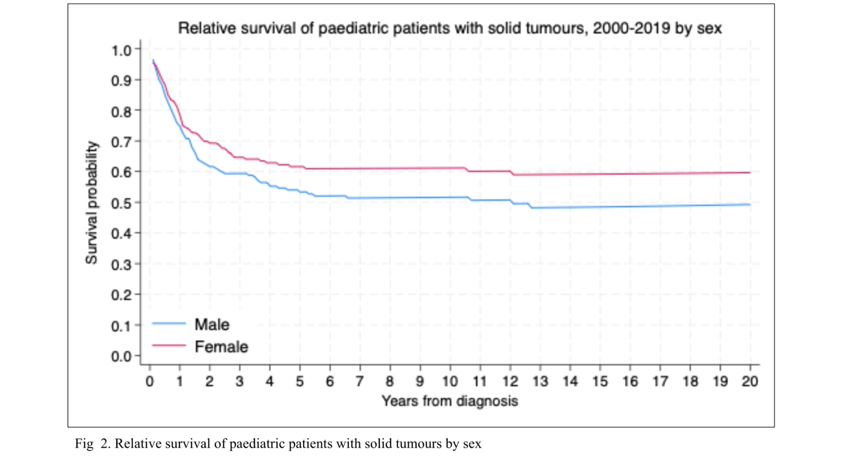
Supplemental Figure S1. Relative survival of pediatric patients with solid tumours by sex
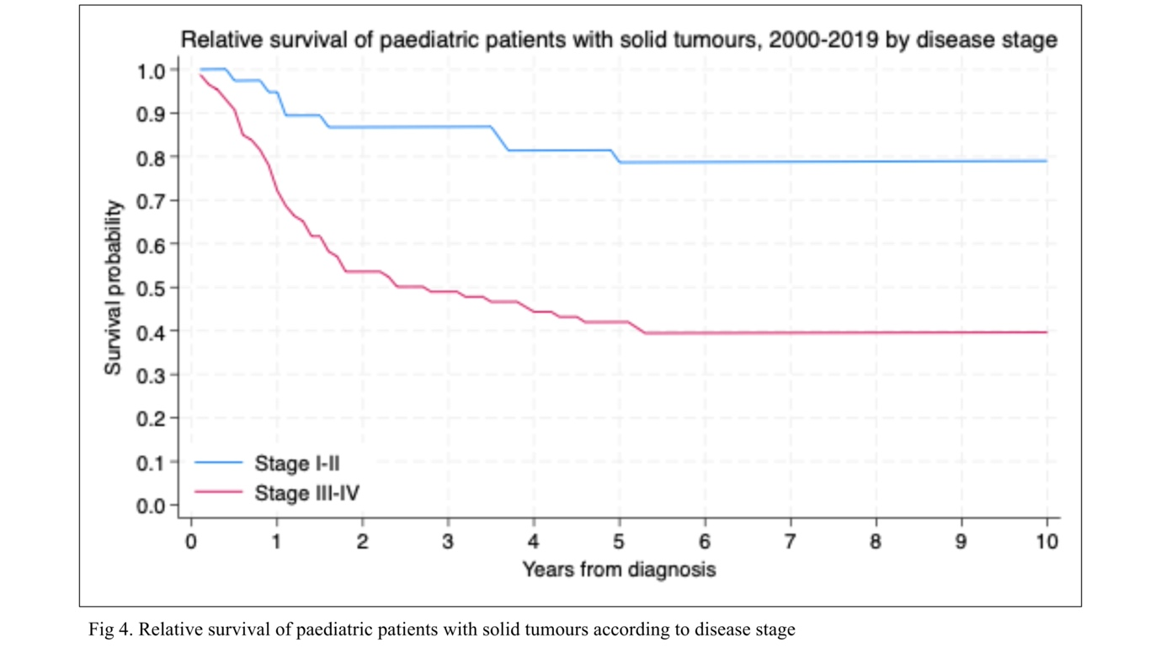 Supplemental Figure S2. Relative survival of pediatric patients with solid tumours according to disease stage

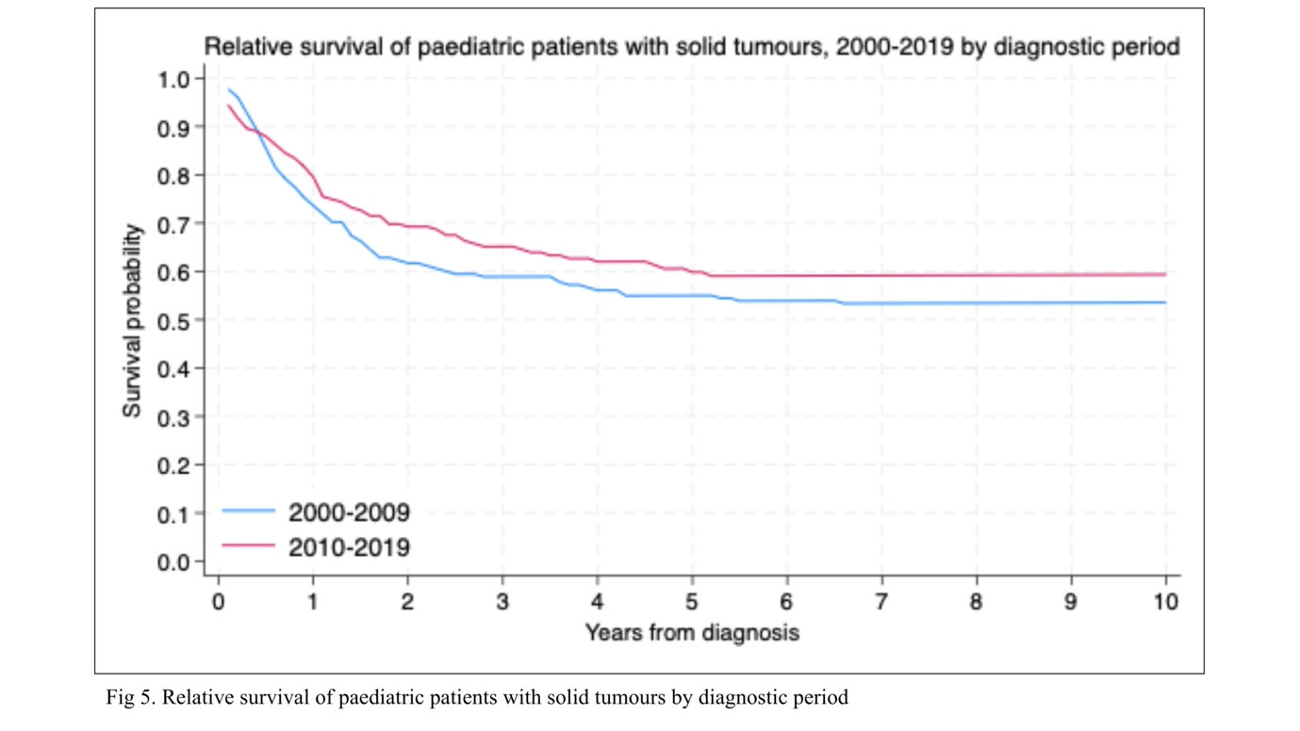 Supplemental Figure S3. Relative survival of pediatric patients with solid tumours by diagnostic period

