Table S1. Burden of multiple myeloma among females in Iran, 2021. Includes province-level estimates of incidence, prevalence, mortality, and disability-adjusted life years (DALYs), reported as both absolute counts and age-standardized rates (ASRs) per 100,000 population. Values are presented with 95% uncertainty intervals.
Province | Mortality |  | DALY |  | Prevalence |  | Incidence
 | Count | ASMR | Count | ASDR | Count | ASPR | Count | ASIR
Iran | 243.13 (133.83–320.47) | 0.64 (0.36–0.84) | 6551.06 (3534.64–8545.15) | 15.89 (8.65–20.8) | 866.16 (441.44–1201.82) | 2.06 (1.06–2.85) | 321.25 (175.79–431.11) | 0.81 (0.45–1.07)
East Azarbayejan | 11.23 (6.97–16.74) | 0.57 (0.36–0.86) | 300.41 (183.92–443.21) | 13.99 (8.59–20.62) | 35.22 (20.63–58.72) | 1.59 (0.96–2.66) | 14.13 (8.64–21.11) | 0.69 (0.43–1.02)
Isfahan | 15.85 (8.03–24.39) | 0.61 (0.32–0.93) | 422.53 (203.35–648.25) | 14.9 (7.27–22.83) | 56.17 (25.98–90.14) | 1.93 (0.91–3.02) | 20.85 (10.54–32.49) | 0.76 (0.39–1.17)
Semnan | 2.04 (1.04–3.1) | 0.57 (0.3–0.87) | 54.75 (27.13–83.36) | 14.35 (7.18–21.83) | 6.91 (3.36–11.38) | 1.79 (0.88–2.9) | 2.65 (1.38–4.11) | 0.72 (0.38–1.09)
Kerman | 5.99 (3.72–9.73) | 0.47 (0.3–0.77) | 166.87 (105.22–264.55) | 11.74 (7.44–18.82) | 18.79 (11.02–31.9) | 1.29 (0.77–2.18) | 7.53 (4.77–11.94) | 0.56 (0.35–0.91)
Gilan | 6.94 (4.23–13.63) | 0.44 (0.26–0.85) | 183.39 (113.46–354.5) | 10.84 (6.76–20.98) | 24.71 (13.65–47.95) | 1.42 (0.79–2.78) | 9.2 (5.4–18.1) | 0.56 (0.33–1.08)
Khorasan-e-Razavi | 14.56 (9.27–22.12) | 0.52 (0.33–0.79) | 400.81 (250.35–594.78) | 13.14 (8.32–19.85) | 44.54 (27.07–68.71) | 1.43 (0.87–2.2) | 18.17 (11.56–27.65) | 0.62 (0.39–0.95)
West Azarbayejan | 6.74 (4.62–10.59) | 0.48 (0.33–0.75) | 186.33 (127.4–290.74) | 11.82 (8.15–18.62) | 21.35 (13.03–35.39) | 1.32 (0.81–2.18) | 8.54 (5.67–13.31) | 0.57 (0.38–0.89)
Lorestan | 8.04 (2.2–12.91) | 0.98 (0.27–1.58) | 223.83 (59.94–359.68) | 25.24 (6.84–40.44) | 29.72 (8.12–55.89) | 3.3 (0.93–5.91) | 10.81 (3.14–18.13) | 1.26 (0.37–2.11)
South Khorasan | 2.17 (1.11–3.07) | 0.56 (0.29–0.8) | 57.71 (28.4–80.68) | 14.46 (7.18–20.37) | 6.64 (3.34–9.95) | 1.65 (0.85–2.48) | 2.7 (1.38–3.85) | 0.69 (0.36–0.98)
Bushehr | 1.64 (0.93–3.51) | 0.37 (0.21–0.79) | 46.85 (26.86–97.77) | 9.36 (5.31–19.88) | 6.09 (3.05–12.74) | 1.18 (0.6–2.54) | 2.21 (1.21–4.66) | 0.47 (0.25–1.01)
Sistan and Baluchistan | 3.32 (2.14–4.82) | 0.43 (0.28–0.65) | 102.97 (61.93–152.97) | 11.75 (7.61–17.06) | 8.74 (4.94–14.08) | 1 (0.61–1.59) | 3.93 (2.47–6.01) | 0.49 (0.32–0.73)
Alborz | 9.06 (4.54–13.97) | 0.77 (0.4–1.18) | 251.99 (119.31–388.44) | 18.21 (9.02–28.08) | 35.8 (15.48–60.38) | 2.47 (1.17–4.14) | 12.54 (6.09–19.84) | 0.97 (0.49–1.54)
Khuzestan | 11.83 (7.02–16.45) | 0.63 (0.38–0.88) | 337.28 (190.05–476.26) | 16.34 (9.5–22.96) | 40.18 (21.65–63.59) | 1.91 (1.07–3) | 15.42 (8.89–23.42) | 0.79 (0.47–1.16)
Ilam | 1.11 (0.72–2.18) | 0.42 (0.27–0.83) | 31.45 (20.85–59.86) | 10.78 (7.05–20.93) | 3.96 (2.21–7.69) | 1.33 (0.76–2.6) | 1.48 (0.91–2.81) | 0.53 (0.33–1.01)
Ardebil | 2.58 (1.64–4.9) | 0.41 (0.26–0.79) | 70.51 (46.13–128.16) | 10.6 (6.93–19.61) | 8.57 (5.04–15.18) | 1.27 (0.75–2.26) | 3.32 (2.04–6) | 0.51 (0.32–0.95)
Yazd | 4.13 (1.4–6.59) | 0.89 (0.31–1.43) | 107.33 (34.39–170.39) | 21.56 (7.08–34.2) | 13.74 (4.14–24.31) | 2.71 (0.84–4.7) | 5.31 (1.72–8.58) | 1.11 (0.37–1.8)
Kermanshah | 5.81 (3.59–8.56) | 0.57 (0.36–0.84) | 158.98 (95.64–231.04) | 14.48 (8.73–21.01) | 18.28 (10.18–29.95) | 1.63 (0.93–2.69) | 7.33 (4.53–10.86) | 0.69 (0.43–1.03)
Markazi | 4.84 (2.41–6.83) | 0.61 (0.31–0.86) | 124.46 (59.87–179.22) | 15.44 (7.46–22.26) | 15.25 (7.17–23.87) | 1.88 (0.9–2.9) | 6.08 (3.06–9.21) | 0.76 (0.39–1.13)
Golestan | 3.52 (2.22–6.74) | 0.42 (0.26–0.82) | 102.26 (66.31–185.25) | 10.99 (6.98–20.52) | 10.9 (6.05–20.77) | 1.15 (0.64–2.21) | 4.44 (2.66–8.45) | 0.5 (0.3–0.98)
Chahar Mahaal and Bakhtiari | 1.32 (0.65–3.15) | 0.29 (0.14–0.7) | 36.56 (18.18–84.67) | 7.58 (3.79–17.84) | 5.4 (2.4–12.9) | 1.1 (0.5–2.7) | 1.84 (0.9–4.37) | 0.39 (0.19–0.95)
Kohgiluyeh and Boyer-Ahmad | 1.07 (0.66–1.93) | 0.39 (0.24–0.72) | 32.02 (19.89–54.65) | 10.31 (6.34–18.52) | 4.3 (2.34–8.15) | 1.37 (0.76–2.62) | 1.48 (0.89–2.74) | 0.51 (0.3–0.97)
North Khorasan | 1.54 (0.99–2.87) | 0.42 (0.27–0.8) | 43.26 (28.69–76.83) | 10.82 (7.1–19.59) | 4.64 (2.71–8.16) | 1.14 (0.67–2.04) | 1.92 (1.21–3.5) | 0.5 (0.31–0.93)
Fars | 11.37 (6.81–20.74) | 0.48 (0.29–0.88) | 314.56 (191.09–543.72) | 12.14 (7.28–21.32) | 39.1 (21.56–70.34) | 1.48 (0.83–2.66) | 14.85 (8.66–26.67) | 0.6 (0.35–1.07)
Hamadan | 5.75 (3.09–8.08) | 0.63 (0.34–0.88) | 152.89 (79.29–212.71) | 16.05 (8.41–22.2) | 17.36 (8.79–26.67) | 1.8 (0.93–2.7) | 7.13 (3.79–10.19) | 0.76 (0.41–1.09)
Mazandaran | 8.76 (5.51–16.92) | 0.45 (0.29–0.88) | 236.68 (149.67–444.19) | 11.41 (7.25–21.49) | 33.42 (18.84–64.98) | 1.57 (0.9–3.02) | 11.95 (7.15–22.69) | 0.59 (0.36–1.12)
Tehran | 75.89 (19.73–118.07) | 1.06 (0.28–1.66) | 1961.96 (502.76–3082.91) | 25.49 (6.58–39.58) | 301.84 (80.41–502.87) | 3.82 (1.02–6.24) | 104.65 (27.55–171.79) | 1.4 (0.37–2.3)
Zanjan | 1.77 (0.99–3.7) | 0.33 (0.18–0.71) | 47.9 (27.93–97.14) | 8.57 (4.96–17.6) | 6.13 (3.05–12.65) | 1.08 (0.54–2.25) | 2.31 (1.24–4.95) | 0.42 (0.22–0.9)
Kurdistan | 5.01 (2.45–7.35) | 0.64 (0.32–0.93) | 136.98 (64.13–201.75) | 16.2 (7.7–23.6) | 16.37 (7.39–26.98) | 1.91 (0.87–3.07) | 6.41 (3.04–9.89) | 0.79 (0.38–1.17)
Hormozgan | 2.43 (1.44–4.56) | 0.39 (0.23–0.76) | 71.17 (43.25–127.75) | 10.09 (6.05–18.81) | 8.06 (4.52–14.7) | 1.12 (0.64–2.1) | 3.12 (1.91–5.83) | 0.47 (0.28–0.91)
Qazvin | 3.13 (1.89–4.69) | 0.52 (0.32–0.79) | 86.59 (51.12–130.45) | 13.25 (7.87–19.92) | 10.96 (5.81–18.51) | 1.64 (0.89–2.73) | 4.1 (2.34–6.47) | 0.65 (0.38–1.03)
Qom | 3.68 (1.84–5.18) | 0.71 (0.36–1) | 99.77 (47.61–141.7) | 17.01 (8.39–24.12) | 13.02 (6.16–21.02) | 2.15 (1.06–3.35) | 4.86 (2.39–7.22) | 0.88 (0.45–1.29)

Table S2. Burden of multiple myeloma among males in Iran, 2021. Provides province-specific data on incidence, prevalence, mortality, and DALYs for males, including both absolute counts and age-standardized rates (ASRs). All estimates include 95% uncertainty intervals.
Province | Mortality |  | DALY |  | Prevalence |  | Incidence
 | Count | ASMR | Count | ASDR | Count | ASPR | Count | ASIR
Iran (Islamic Republic of) | 350.31 (209.69–446.69) | 0.94 (0.56–1.21) | 9322.19 (5546.92–11432.31) | 22.88 (13.7–28.57) | 1139.79 (622.01–1532.27) | 2.76 (1.51–3.65) | 445.46 (256.4–581.28) | 1.15 (0.67–1.48)
East Azarbayejan | 17.85 (11.08–25.36) | 0.93 (0.58–1.33) | 481.94 (291.6–679.8) | 22.52 (13.81–31.95) | 52.19 (30.89–75.55) | 2.38 (1.39–3.43) | 21.93 (13.44–30.82) | 1.08 (0.67–1.53)
Isfahan | 21.99 (12.89–31.96) | 0.81 (0.48–1.18) | 596.43 (339.14–854.91) | 20.34 (11.67–29.21) | 73.35 (39.4–111.15) | 2.46 (1.34–3.7) | 28.29 (16.06–41.68) | 1 (0.58–1.49)
Semnan | 3.19 (1.75–4.48) | 0.94 (0.52–1.34) | 84.67 (44.88–117.92) | 22.84 (12.3–31.83) | 9.83 (4.89–14.45) | 2.61 (1.32–3.78) | 4 (2.07–5.73) | 1.14 (0.6–1.62)
Kerman | 9.66 (5.65–14.34) | 0.77 (0.46–1.16) | 274.76 (159.11–410.66) | 19.13 (11.08–28.13) | 28.45 (16.28–42.38) | 1.95 (1.12–2.92) | 11.9 (7–17.69) | 0.89 (0.52–1.35)
Gilan | 8.19 (4.67–18.42) | 0.53 (0.3–1.21) | 216.66 (125.72–478.47) | 13.2 (7.61–29.09) | 26.92 (15.23–56.48) | 1.61 (0.91–3.36) | 10.53 (5.98–22.63) | 0.66 (0.37–1.44)
Khorasan-e-Razavi | 20.66 (14.33–31.36) | 0.76 (0.53–1.18) | 573.24 (392.61–841.35) | 19.21 (13.14–28.7) | 58.99 (37.85–92.06) | 1.95 (1.27–3.06) | 25.17 (16.85–37.65) | 0.89 (0.6–1.35)
West Azarbayejan | 8.78 (5.84–14.71) | 0.67 (0.43–1.14) | 244.85 (160.53–401.06) | 16.09 (10.71–26.88) | 25.93 (16.8–43) | 1.66 (1.11–2.82) | 10.85 (7.06–17.72) | 0.77 (0.51–1.3)
Lorestan | 12.4 (3.64–18.69) | 1.79 (0.54–2.7) | 347.84 (98.98–527.92) | 44.44 (12.91–67.02) | 42.3 (11.37–71.08) | 5.28 (1.47–8.56) | 16.21 (4.65–25.37) | 2.21 (0.65–3.39)
South Khorasan | 2.32 (1.34–3.89) | 0.64 (0.37–1.08) | 60.84 (33.95–97.57) | 16.02 (9–26.13) | 6.44 (3.62–10.26) | 1.69 (0.95–2.75) | 2.78 (1.64–4.56) | 0.75 (0.44–1.26)
Bushehr | 2.33 (1.36–4.76) | 0.54 (0.32–1.13) | 65.41 (38.22–133.4) | 13.15 (7.65–26.83) | 7.7 (4.17–16.28) | 1.51 (0.84–3.18) | 3 (1.72–6.28) | 0.65 (0.37–1.4)
Sistan and Baluchistan | 4.62 (2.86–6.93) | 0.6 (0.37–0.95) | 142.29 (85.33–202.1) | 16.28 (10.01–24.3) | 11.21 (6.68–17.17) | 1.31 (0.79–2) | 5.32 (3.17–8.06) | 0.67 (0.4–1.07)
Alborz | 13.15 (7.7–18.33) | 1.02 (0.61–1.43) | 370.55 (210.04–521.48) | 25.11 (14.5–35.06) | 48.74 (26.25–72.84) | 3.22 (1.77–4.74) | 17.71 (10.17–25.76) | 1.28 (0.75–1.82)
Khuzestan | 15.83 (10.1–23.02) | 0.86 (0.56–1.28) | 455.58 (287.73–649.59) | 22.16 (13.93–32.1) | 49.81 (30.24–72.67) | 2.39 (1.46–3.4) | 20.02 (12.72–28.61) | 1.04 (0.66–1.49)
Ilam | 1.72 (1.12–2.83) | 0.72 (0.47–1.22) | 48.15 (31.64–77.5) | 17.8 (11.66–28.92) | 5.53 (3.39–9.14) | 2.01 (1.24–3.34) | 2.19 (1.4–3.61) | 0.87 (0.56–1.45)
Ardebil | 3.57 (2.22–6.71) | 0.65 (0.4–1.22) | 97.51 (61.91–179.61) | 15.89 (9.9–29.47) | 10.82 (6.54–20.42) | 1.73 (1.06–3.25) | 4.47 (2.81–8.39) | 0.77 (0.48–1.46)
Yazd | 6.71 (2.23–10.52) | 1.41 (0.49–2.21) | 179.65 (58.57–281.67) | 34.12 (11.25–53.54) | 21.45 (6.86–35.13) | 4 (1.32–6.43) | 8.51 (2.83–13.41) | 1.71 (0.58–2.7)
Kermanshah | 7.4 (4.94–10.94) | 0.76 (0.51–1.14) | 205.71 (133.82–286.38) | 19.67 (12.84–27.6) | 21.88 (13.9–32.4) | 2.07 (1.33–3.06) | 9.14 (5.91–13.58) | 0.91 (0.59–1.37)
Markazi | 5.33 (3.27–8.33) | 0.7 (0.43–1.11) | 143.17 (87.12–212.28) | 18.07 (11.06–27.33) | 16.36 (9.66–24.59) | 2.05 (1.23–3.12) | 6.62 (4.07–10.17) | 0.86 (0.53–1.33)
Golestan | 5.29 (3.47–9.28) | 0.7 (0.46–1.27) | 154.1 (103.52–264.47) | 18.13 (11.96–31.31) | 14.95 (9.4–26.23) | 1.73 (1.09–3.04) | 6.47 (4.19–11.45) | 0.82 (0.51–1.47)
Chahar Mahaal and Bakhtiari | 2.6 (1.74–4.19) | 0.64 (0.43–1.04) | 71.71 (48.01–112.03) | 15.87 (10.58–25.22) | 9.73 (6.12–16.46) | 2.1 (1.35–3.51) | 3.51 (2.3–5.67) | 0.82 (0.54–1.33)
Kohgiluyeh and Boyer-Ahmad | 2.07 (1.12–3.01) | 0.71 (0.39–1.03) | 60.52 (31.41–89.01) | 18.74 (9.84–27.4) | 7.42 (3.93–11.48) | 2.3 (1.26–3.49) | 2.74 (1.5–4.15) | 0.9 (0.5–1.37)
North Khorasan | 1.97 (1.25–3.95) | 0.54 (0.34–1.1) | 54.54 (35.5–104.15) | 14.04 (9.04–27.33) | 5.39 (3.41–10.22) | 1.38 (0.87–2.65) | 2.36 (1.48–4.61) | 0.64 (0.4–1.27)
Fars | 16.39 (10.55–29.14) | 0.71 (0.45–1.27) | 463.88 (302.78–804.32) | 18.1 (11.73–31.87) | 53.27 (33.09–93.61) | 2.05 (1.27–3.64) | 20.95 (13.32–36.55) | 0.86 (0.55–1.54)
Hamadan | 8.16 (4.85–11.57) | 0.89 (0.53–1.28) | 226.91 (131.08–320.73) | 23.71 (13.89–33.45) | 23.93 (12.83–35.78) | 2.48 (1.34–3.67) | 10.01 (5.72–14.71) | 1.07 (0.63–1.58)
Mazandaran | 11.61 (7.27–22.54) | 0.62 (0.38–1.21) | 314.2 (199.54–594.86) | 15.6 (9.94–29.68) | 40.84 (25.18–80.91) | 1.99 (1.23–3.87) | 15.26 (9.28–28.33) | 0.79 (0.48–1.47)
Tehran | 113.44 (45.28–165.81) | 1.51 (0.61–2.19) | 2747.42 (1066.59–4108.57) | 34.97 (13.59–52.13) | 393.75 (143.74–624.07) | 4.97 (1.84–7.69) | 146.43 (55.38–218.97) | 1.91 (0.74–2.82)
Zanjan | 2.1 (1.11–4.98) | 0.43 (0.23–1.03) | 55.61 (30.85–131.48) | 10.61 (5.74–25.22) | 6.46 (3.44–15.32) | 1.22 (0.64–2.92) | 2.63 (1.38–6.22) | 0.52 (0.27–1.26)
Kurdistan | 6.92 (3.38–10.11) | 0.91 (0.45–1.31) | 189.31 (89.57–279.92) | 23.09 (11.11–33.66) | 20.75 (9.44–32.27) | 2.51 (1.16–3.89) | 8.56 (4.17–12.75) | 1.09 (0.54–1.6)
Hormozgan | 2.88 (1.6–6.41) | 0.48 (0.26–1.09) | 85.65 (48.44–181.6) | 12.19 (6.8–26.81) | 8.83 (4.63–19.09) | 1.25 (0.65–2.7) | 3.6 (1.97–7.96) | 0.56 (0.3–1.26)
Qazvin | 5.49 (3.53–7.44) | 0.99 (0.65–1.32) | 151.22 (93.87–204.93) | 24.05 (15.29–32.26) | 17.45 (10.42–25.5) | 2.71 (1.7–3.83) | 6.97 (4.28–9.61) | 1.18 (0.75–1.61)
Qom | 5.67 (2.68–8.05) | 1.02 (0.49–1.44) | 157.85 (72.82–223.8) | 25.31 (11.85–36.08) | 19.1 (8.46–29.9) | 3.01 (1.39–4.68) | 7.32 (3.39–10.49) | 1.25 (0.6–1.8)

Table S3. ARIMAX model parameters for temporal trend analysis of multiple myeloma burden in Iran.
Measure | Model Number | Sex | ar1 (SE) | ar2 (SE) | intercept (SE) | Calender year (SE) | pandemic (SE)
Deaths | 1 | Both | 1.6466 (0.1124) | -0.7775 (0.1147) | 0.4926 (0.0146) | 0.0121 (0.0009) | -0.0593 (0.0045)
Deaths | 2 | Female | 1.6548 (0.1109) | -0.7671 (0.1131) | 0.3833 (0.0128) | 0.0099 (0.0008) | -0.0432 (0.0035)
Deaths | 3 | Male | 1.6421 (0.1131) | -0.7714 (0.1158) | 0.5974 (0.0188) | 0.0141 (0.0011) | -0.0759 (0.0057)
Incidence | 4 | Both | 1.7051 (0.1082) | -0.7975 (0.1110) | 0.5091 (0.0214) | 0.0173 (0.0012) | -0.0796 (0.0047)
Incidence | 5 | Female | 1.7229 (0.1045) | -0.8017 (0.1075) | 0.3993 (0.0194) | 0.0146 (0.0011) | -0.0609 (0.0037)
Incidence | 6 | Male | 1.6901 (0.1106) | -0.7849 (0.1137) | 0.6126 (0.0267) | 0.0201 (0.0015) | -0.0989 (0.0060)
DALYs | 7 | Both | 1.6392 (0.1133) | -0.7578 (0.1158) | 12.3939 (0.3580) | 0.2852 (0.0205) | -1.6202 (0.1027)
DALYs | 8 | Female | 1.6445 (0.1129) | -0.7497 (0.1150) | 9.7793 (0.3073) | 0.2400 (0.0172) | -1.2416 (0.0816)
DALYs | 9 | Male | 1.6374 (0.1136) | -0.7552 (0.1165) | 14.8096 (0.4678) | 0.3357 (0.0268) | -2.0104 (0.1320)
Prevalence | 10 | Both | 1.8375 (0.0717) | -0.9025 (0.0754) | 0.8425 (0.0672) | 0.0522 (0.0037) | -0.2189 (0.0096)
Prevalence | 11 | Female | 1.8433 (0.0691) | -0.9051 (0.0727) | 0.6771 (0.0591) | 0.0453 (0.0032) | -0.1768 (0.0081)
Prevalence | 12 | Male | 1.8195 (0.0802) | -0.8844 (0.0845) | 0.9941 (0.0831) | 0.0596 (0.0045) | -0.2621 (0.0120)

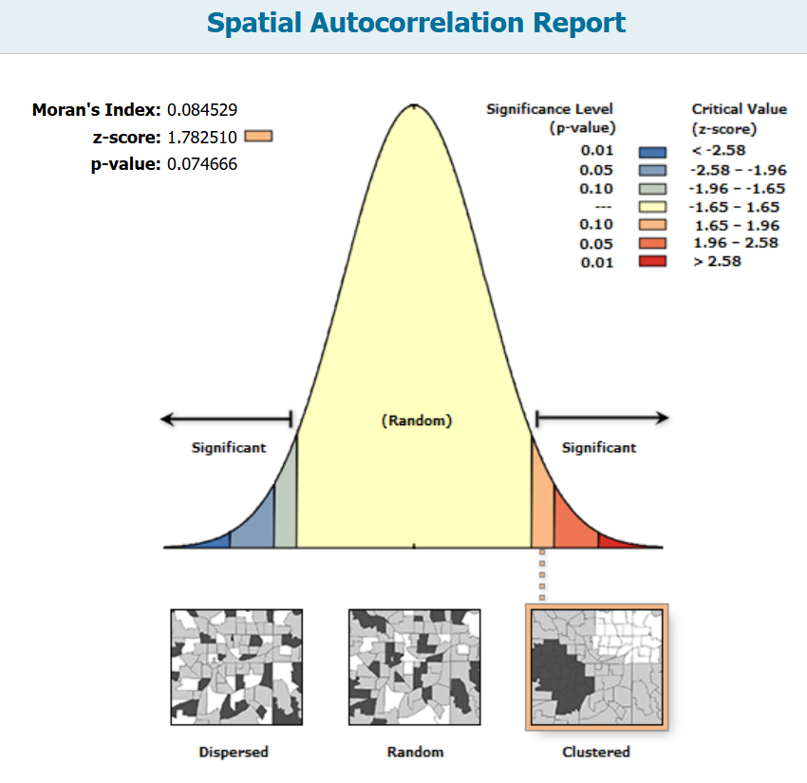
Figure S1. Global Moran’s I statistic for the spatial autocorrelation of age-standardized prevalence of multiple myeloma in Iran, 2021

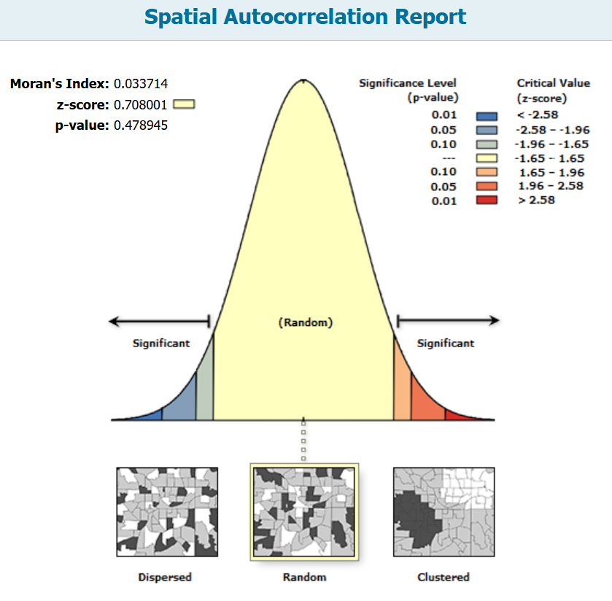
Figure S2. Global Moran’s I statistic for the spatial autocorrelation of age-standardized incidence of multiple myeloma in Iran, 2021

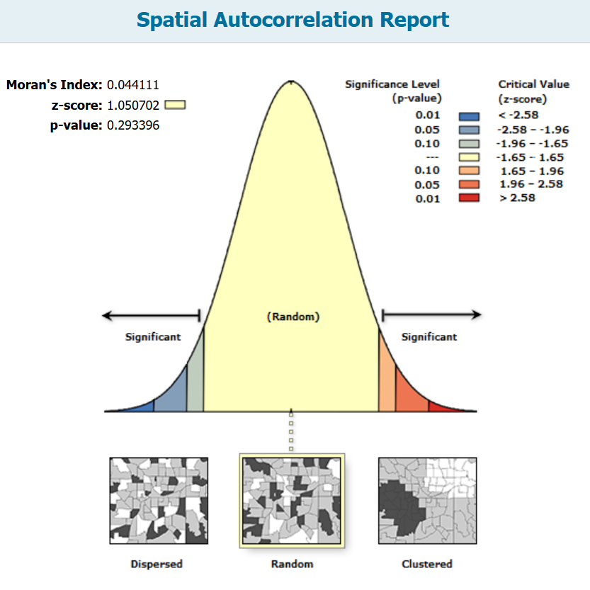
Figure S3. Global Moran’s I statistic for the spatial autocorrelation of age-standardized mortality rate of multiple myeloma in Iran, 2021

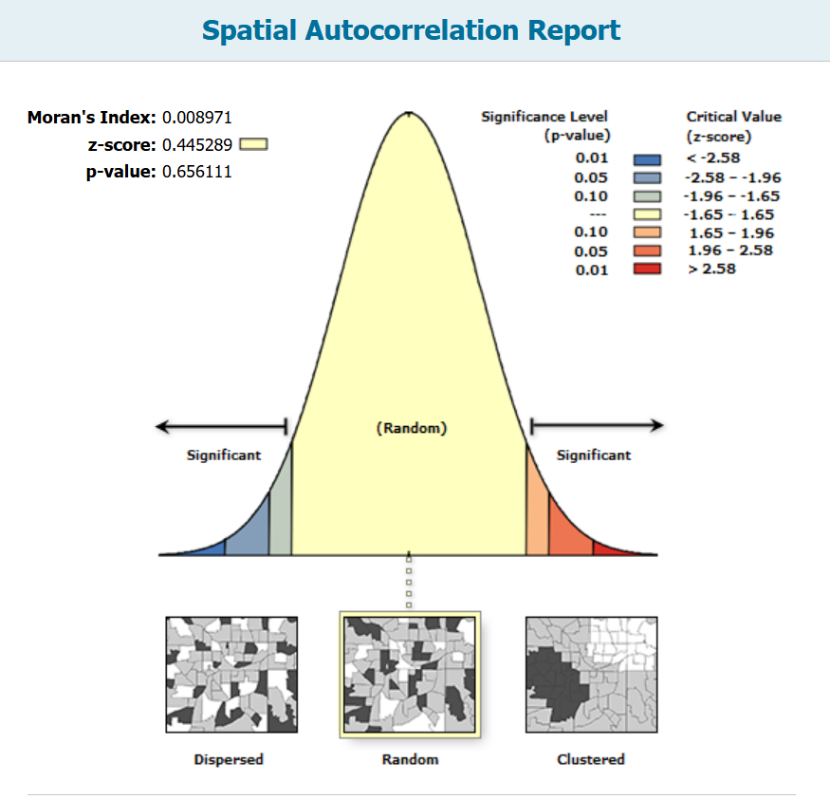
Figure S4. Global Moran’s I statistic for the spatial autocorrelation of age-standardized DALYs rate due to multiple myeloma in Iran, 2021

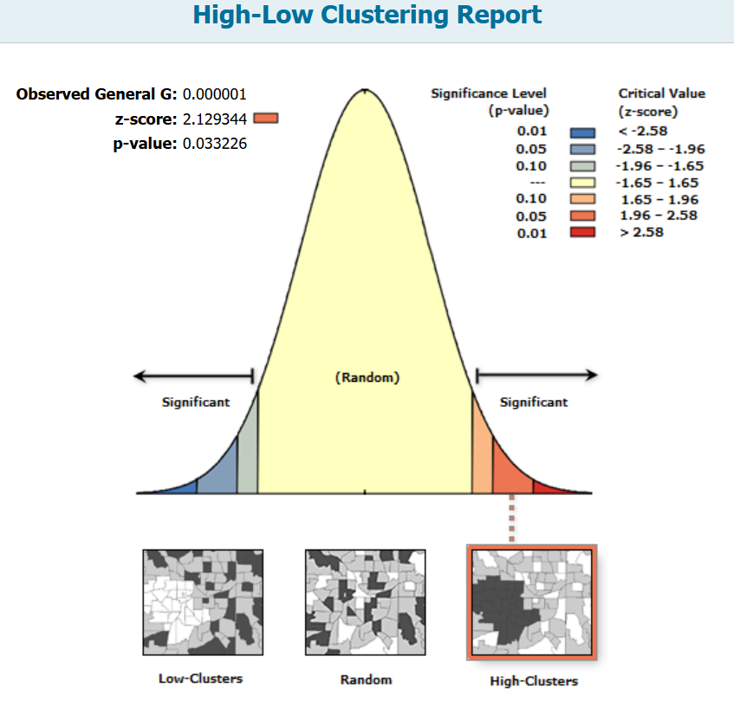
Figure S5. Getis–Ord Gi* hot spot analysis for age-standardized incidence of multiple myeloma in Iran, 2021 (Z = 2.12, p < 0.03), indicating statistically significant spatial clustering of high-incidence areas.

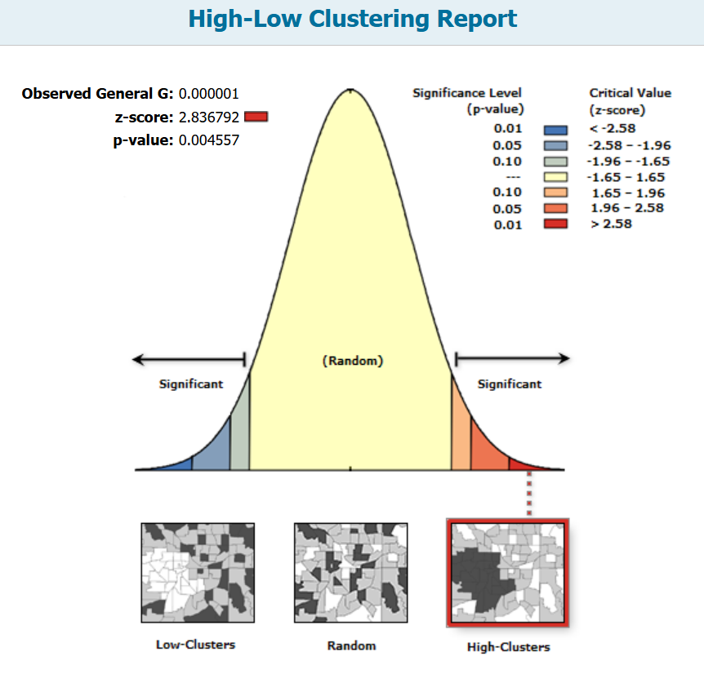
Figure S6. Getis–Ord Gi* hot spot analysis for age-standardized prevalence of multiple myeloma in Iran, 2021 (Z = 2.83, p < 0.01), confirming significant clustering of high-prevalence provinces.

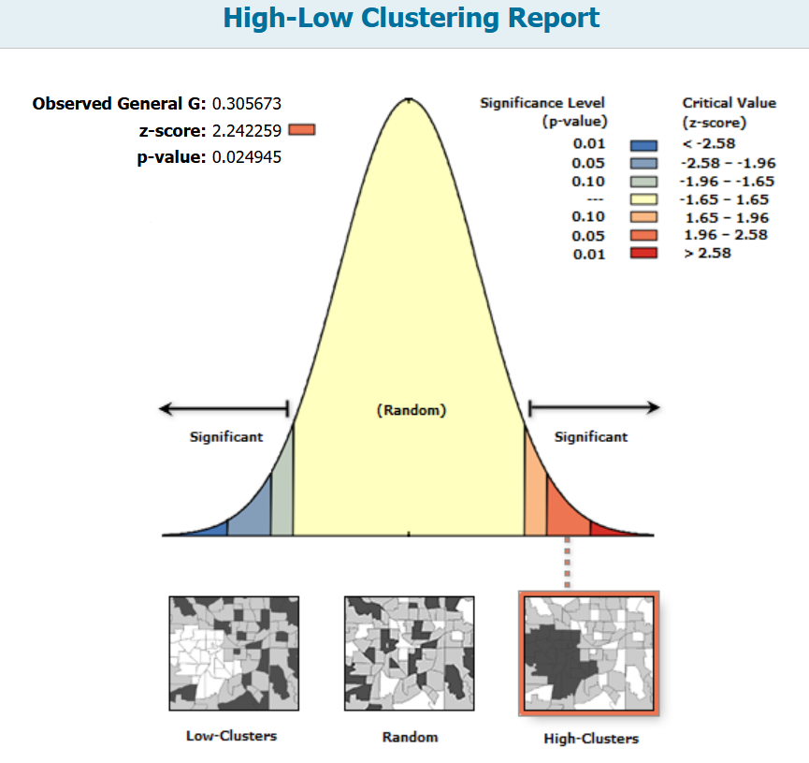
Figure S7. Getis–Ord Gi* hot spot analysis for age-standardized mortality rate of multiple myeloma in Iran, 2021 (Z ≈ 2.24, p < 0.05), suggesting moderate clustering of high-mortality areas at the 95% confidence level.
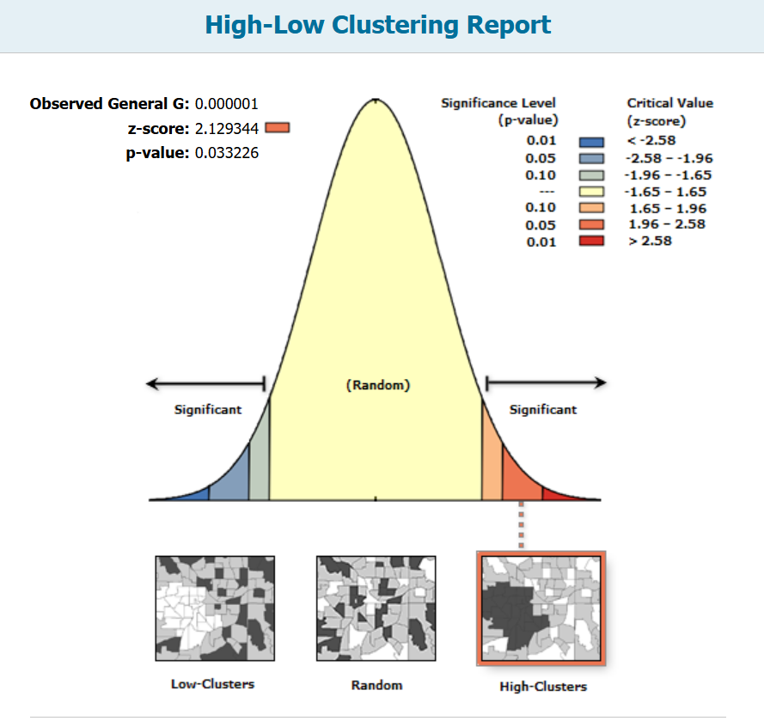
Figure S8. Getis–Ord Gi* hot spot analysis for age-standardized DALYs rate due to multiple myeloma in Iran, 2021 (Z ≈ 2.12, p < 0.05), indicating moderate clustering of high-burden areas, though below conventional 95% significance thresholds.

