APPENDIX B

Table 1: All Cancers
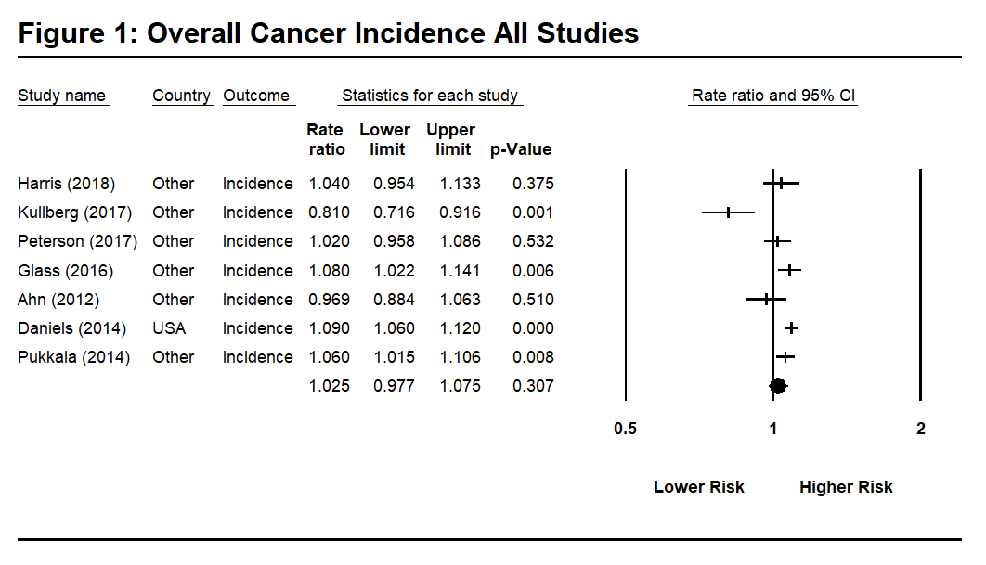
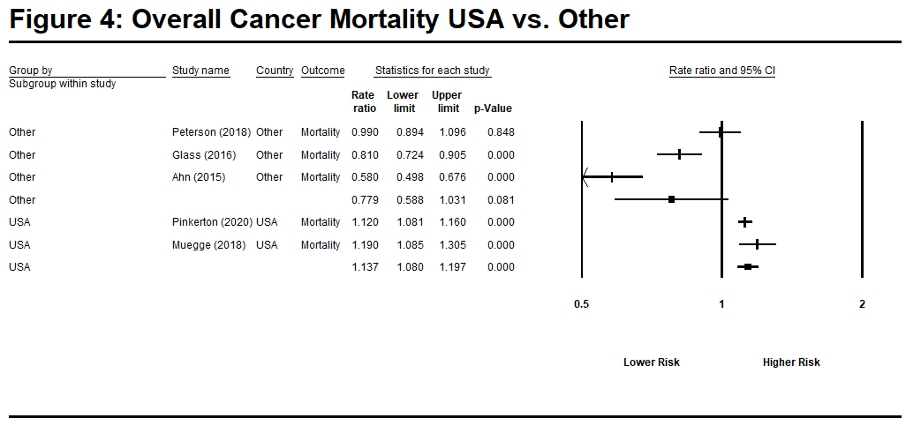
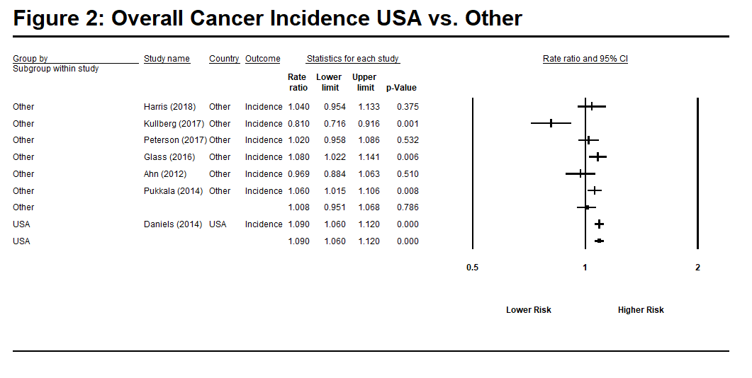
Study | Country | Outcome | Rate Ratio (log) | Std Error (log) | Rate Ratio
Pinkerton et al (2020) | US | Mortality | 0.113 | 0.018 | 1.12
Muegge et al (2018) | US | Mortality | 0.174 | 0.047 | 1.19
Peterson et al (2018) | Denmark | Mortality | -0.010 | 0.052 | 0.99
Harris et al (2018) | Canada | Incidence | 0.039 | 0.044 | 1.04
Kulberg et al (2017) | Sweden | Incidence | -0.211 | 0.063 | 0.810
Petersen et al (2017) | Denmark | Incidence | 0.020 | 0.032 | 1.02
Glass, et al (2016) | Australia | Incidence  Mortality | 0.077  -0.211 | 0.028  0.057 | 1.08  0.81
Ahn et al (2015) | Korea | Mortality | -0.545 | 0.078 | 0.580
Ahn et al (2012) | Korea | Incidence | -0.031 | 0.047 | 0.97
Daniels, et al (2014) | US | Incidence | 0.086 | 0.014 | 1.09
Pukkala et al (2014) | Nordic | Incidence | 0.058 | 0.022 | 1.06
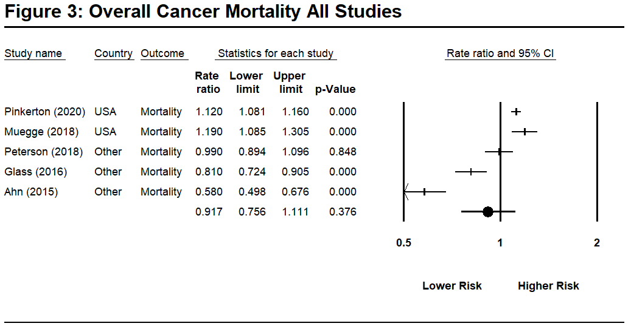

Table 2: Bladder Cancer
Table 2: Detailed Analysis of Bladder Cancer Rates in Firefighters
Study | Country | Outcome | Rate Ratio (log) | Std Error (log) | Rate Ratio
Pinkerton et al (2020) | US | Mortality | -0.020 | 0.099 | 0.98
Lee et al (2020). | US | Incidence | -0.094 | 0.098 | 0.91
Harris et al (2018) | Canada | Incidence | -0.117 | 0.203 | 0.89
Kulberg et al (2017) | Sweden | Incidence | -0.329 | 0.268 | 0.72
Petersen et al (2017) | Denmark | Incidence | 0.086 | 0.106 | 1.09
Glass, et al (2016) | Australia | Incidence | -0.248 | 0.198 | 0.78
Tsai et al (2015) | US | Incidence | -0.010 | 0.122 | 0.99
Brice, et al (2015) | French | Mortality | -0.315 | 0.276 | 0.73
Ahn et al (2012) | Korea | Incidence | 0.470 | 0.237 | 1.60
Daniels, et al (2014) | US | Incidence | 0.113 | 0.057 | 1.12
Pukkala et al (2014) | Nordic | Incidence | 0.104 | 0.073 | 1.11
Kang et al (2008) | US | Incidence | 0.174 | 0.125 | 1.19
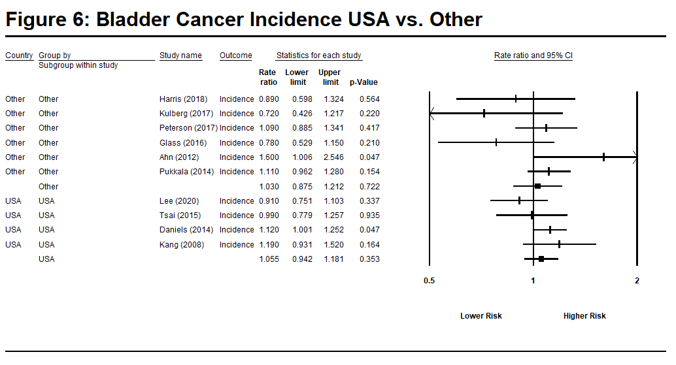
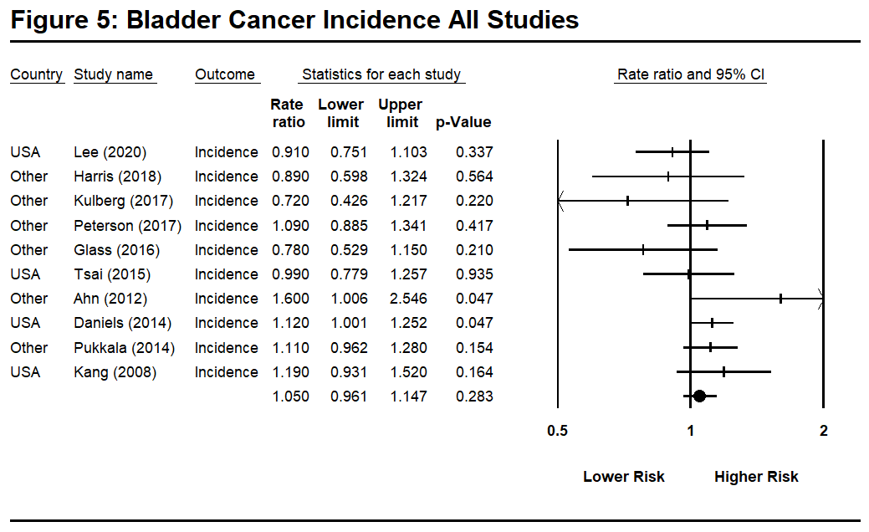
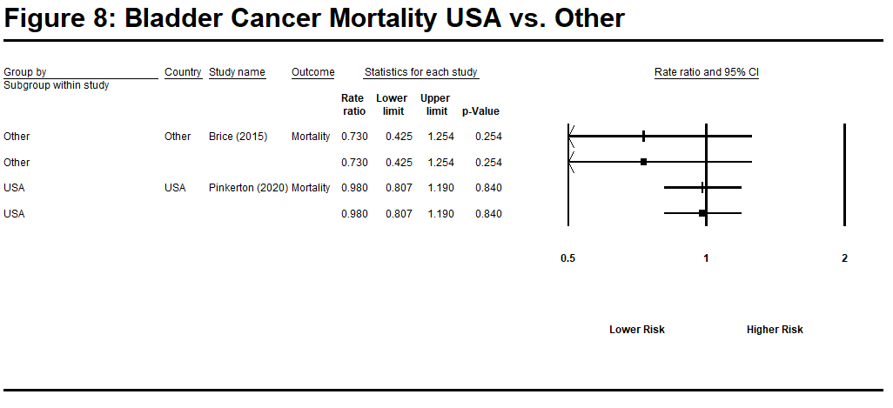
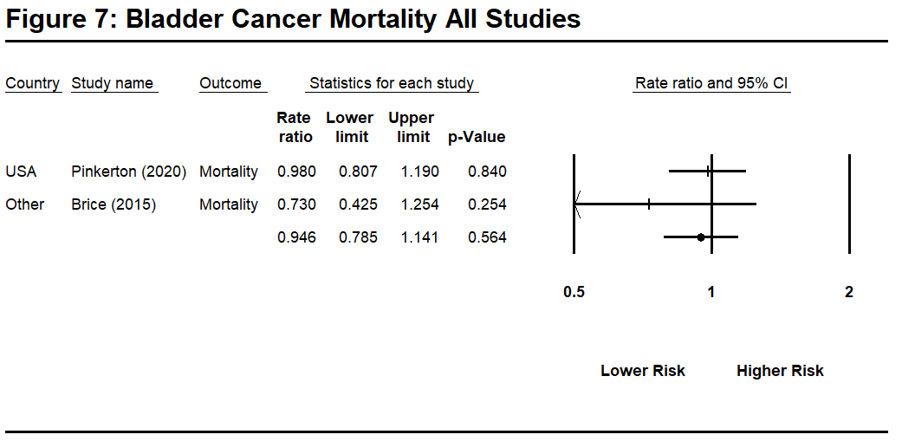

Table 3: Bone Cancer

Study | Country | Outcome | Rate Ratio (log) | Std Error (log) | Rate Ratio
Lee et al (2020). | US | Incidence | -0.329 | 0.354 | 0.72
Kulberg et al (2017) | Sweden | Incidence | 0.445 | 0.677 | 1.56
Petersen et al (2017) | Denmark | Incidence | 0.223 | 0.580 | 1.25
Ahn et al (2012) | Korea | Incidence | 0.683 | 0.576 | 1.98
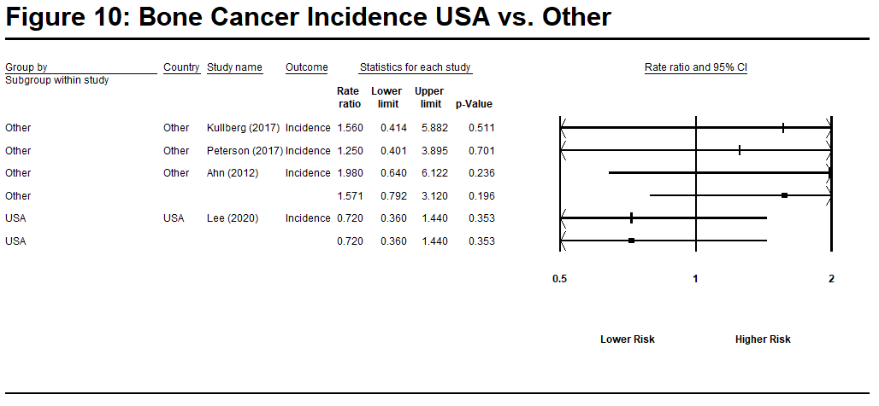
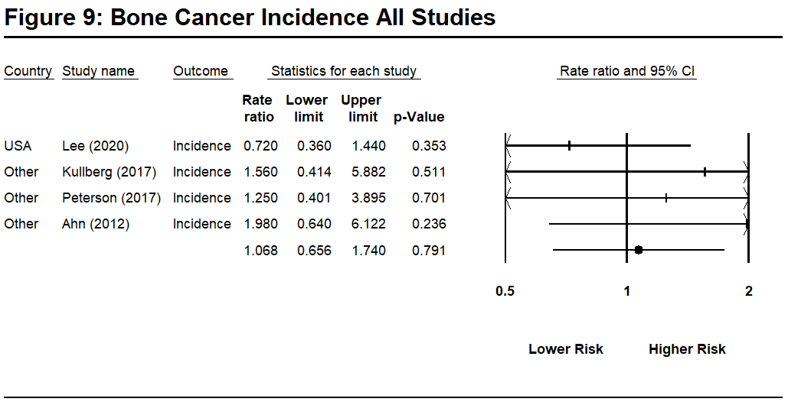

Table 4: Brain Cancer

Study | Country | Outcome | Rate Ratio (log) | Std Error (log) | Rate Ratio
Pinkerton et al (2020) | US | Mortality | -0.010 | 0.113 | 0.99
Lee et al (2020). | US | Incidence | 0.030 | 0.120 | 1.03
Muegge et al (2018) | US | Mortality | 0.683 | 0.237 | 1.98
Harris et al (2018) | Canada | Incidence | 0.104 | 0.304 | 1.11
Kulberg et al (2017) | Sweden | Incidence | 0.148 | 0.387 | 1.16
Petersen et al (2017) | Denmark | Incidence  Meninges  Brain  Other CNS | 0.199  -0.062  0.329 | 0.332  0.175  0.289 | 1.22  0.94  1.39
Glass, et al (2016) | Australia | Incidence  Other CNS  Brain | -0.041  -0.274 | 0.190  0.264 | 0.96  0.76
Tsai et al (2015) | US | Incidence | 0.432 | 0.132 | 1.54
Ahn et al (2012) | Korea | Incidence | -0.635 | 0.580 | 0.53
Daniels, et al (2014) | US | Incidence | 0.020 | 0.145 | 1.02
Pukkala et al (2014) | Nordic | Incidence | -0.151 | 0.130 | 0.86
Kang et al (2008) | US | Incidence | 0.307 | 0.227 | 1.36
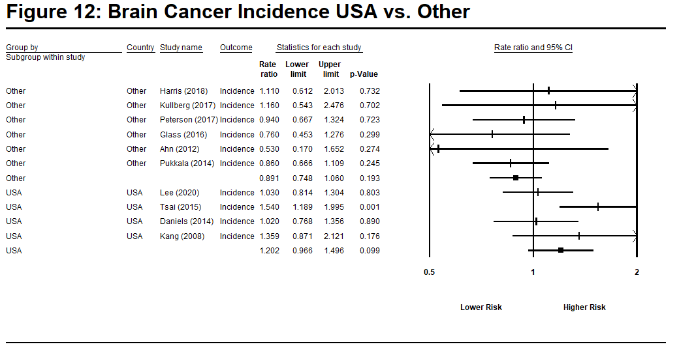
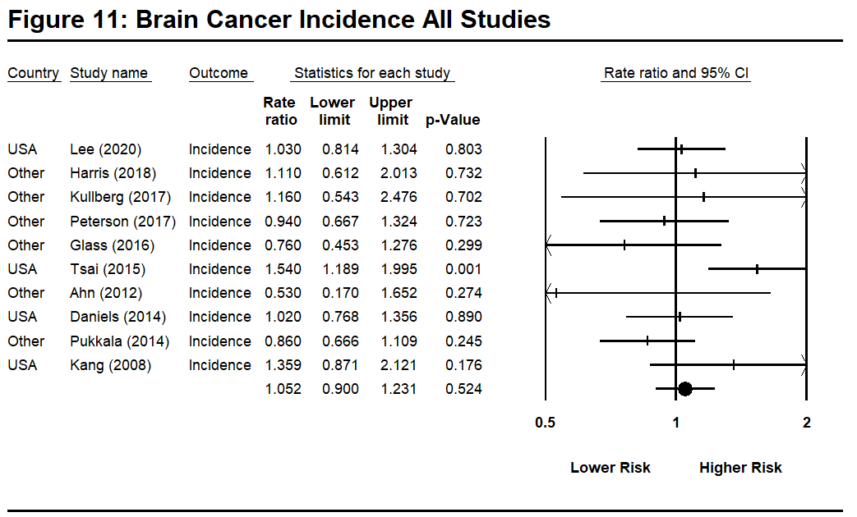
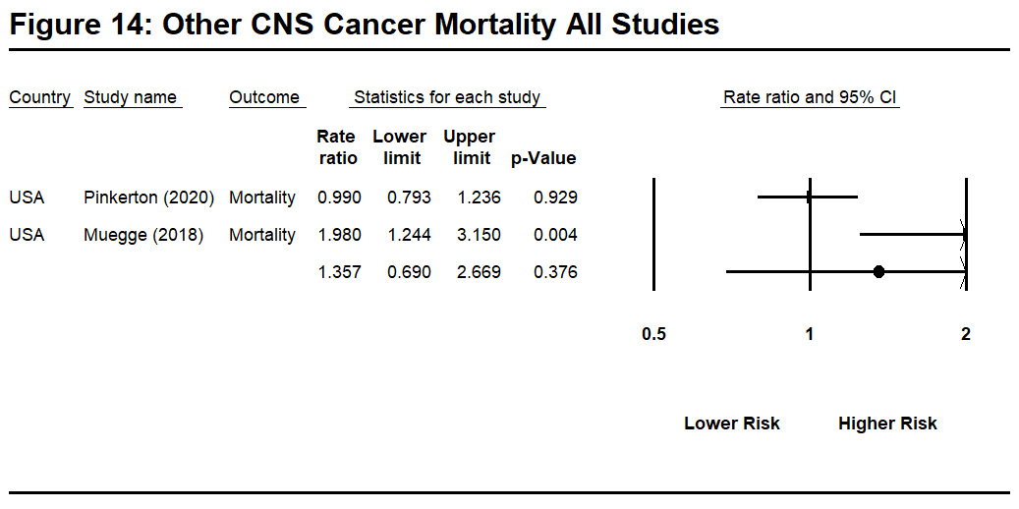
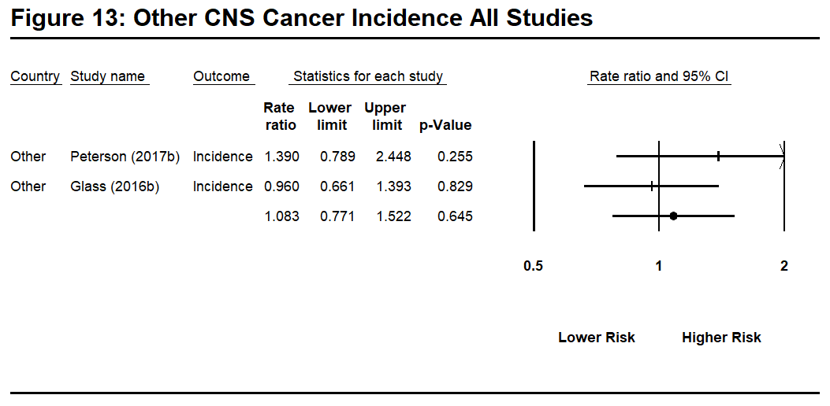
Note: Meninges cancer not shown given there was only a single study reporting on this cancer type.

Table 5: Breast Cancer

Study | Country | Outcome | Rate Ratio (log) | Std Error (log) | Rate Ratio
Pinkerton et al (2020) | US | Mortality | 0.215 | 0.344 | 1.24
Lee et al (2020). | US | Incidence | -0.315 | 0.169 | 0.73
Glass, et al (2016) | Australia | Incidence | 0.775 | 0.453 | 2.17
Brice, et al (2015) | French | Mortality | -0.274 | 1.366 | 0.76
Daniels, et al (2014) | US | Incidence | 0.231 | 0.2087 | 1.26
Kang et al (2008) | US | Incidence | 0.247 | 0.510 | 1.28
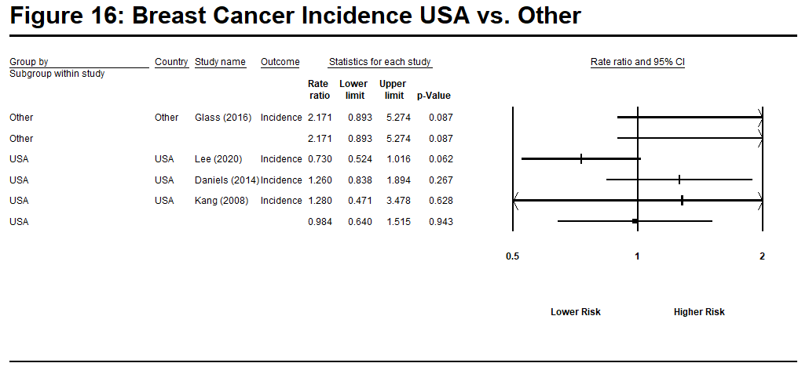
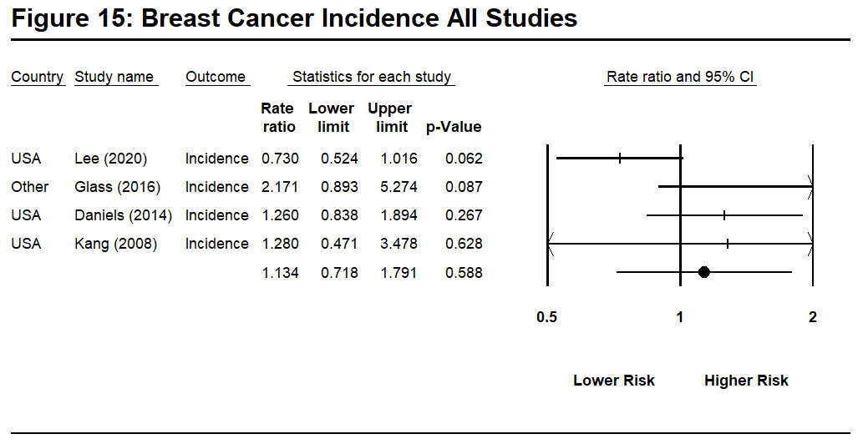
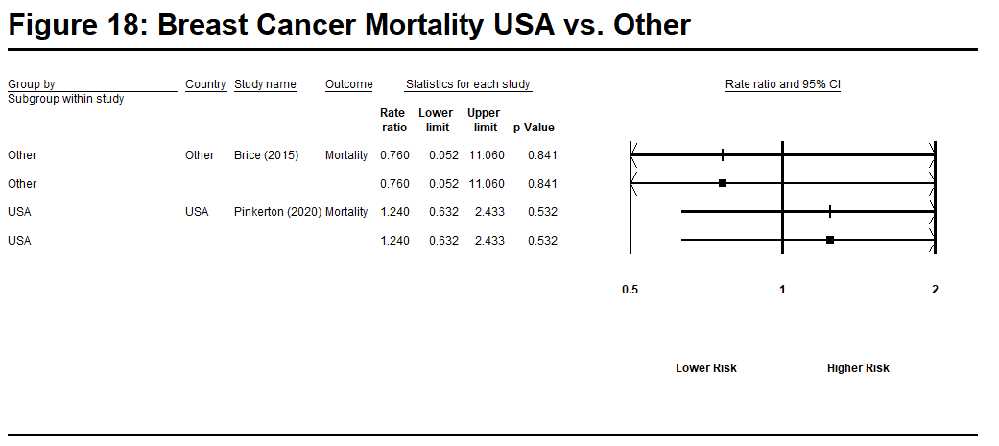
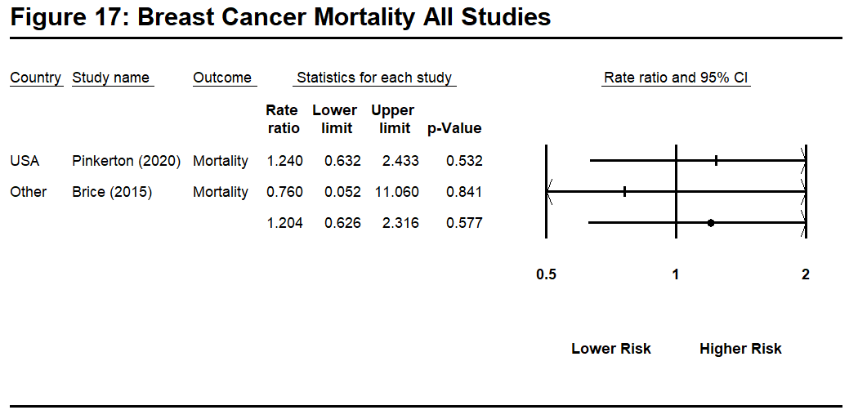

Table 6: Buccal Cavity and Pharynx

Study | Country | Outcome | Rate Ratio (log) | Std Error (log) | Risk Ratio
Lee, et al (2020) | US | Incidence  Oral Cavity and pharynx | -0.163 | 0.081 | 0.85
Muegge, et al (2018) | US | Mortality  Buccal cavity and pharynx  Other Parts Buccal Cavity  Pharynx | 0.765  1.386  0.815 | 0.296  0.673  0.380 | 2.149  4.00  2.26
Peterson, et al (2018) | Denmark | Mortality  Oral Cavity and esophagus | 1.27 | 0.239 | 0.204
Harris, et al (2018) | Canada | Mortality  Lip  Oral | 0.737  0.010 | 0.449  0.241 | 2.09  1.01
Kulberg, et al (2017) | Sweden | Incidence  Lip | 0.372 | 0.861 | 1.45
Petersen, et al (2017) | Denmark | Incidence  Lip  Tongue  Mouth  Salivary  Pharynx | 0.039  0.419  -0.511  0.582  -0.094 | 0.501  0.290  0.382  0.501  0.222 | 1.04  1.52  0.60  1.79  0.91
Glass, et al (2016) | Australia | Incidence  Lip, Oral Cavity, and Pharynx | -0.051 | 0.14 | 0.95
Tsai, et al (2015) | US | Incidence  Lip  Tongue  Salivary gland  Mouth/Oral  Pharyngeal | 0.365  0.166  0.262  0.068  0.058 | 0.246  0.186  0.280  0.279  0.177 | 1.44  1.18  1.30  1.07  1.06
Brice, et al (2015) | French | Mortality  Lip, Oral Cavity, and Pharynx | 0.140 | 0.126 | 1.15
Ahn, et al (2012) | Korea | Mortality  Salivary Gland | 0.85 | 0.683 | 2.34
Pukkala, et al (2014) | Nordic | Incidence  Lip  Tongue  Salivary glands  Oral Cavity  Pharynx | -0.223  0.039  0.525  -0.223  0.000 | 0.261  0.329  0.343  0.325  0.245 | 0.80  1.04  1.69  0.80  1.00
Paget-Bailly, et al (2013) | France | Incidence  Oral Cavity  Oropharynx  Hypopharynx | 2.322  0.642  1.131 | 0.611  0.819  0.855 | 10.2  1.9  3.1
Kang, et al (2008) | US | Incidence  Lip  Buccal Cavity  Nasopharynx | 0.049  -0.416  0.270 | 0.587  0.242  0.717 | 1.05  0.66  1.31
Langevin, et al (2020) | US | Incidence  Head and Neck | -0.083 | 0.043 | 0.920
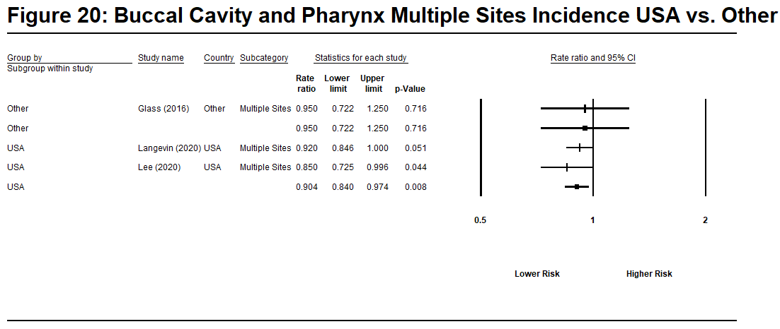
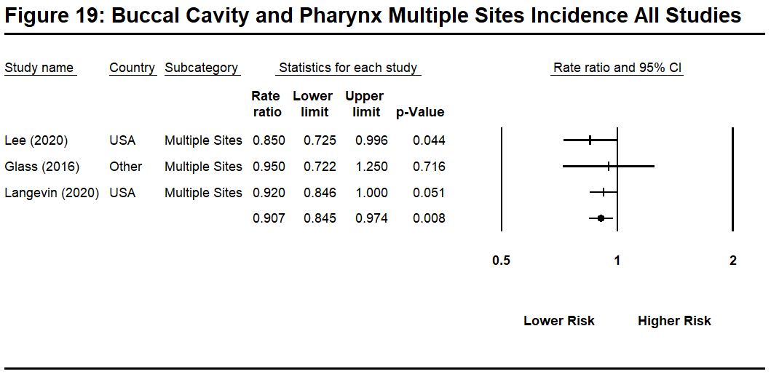

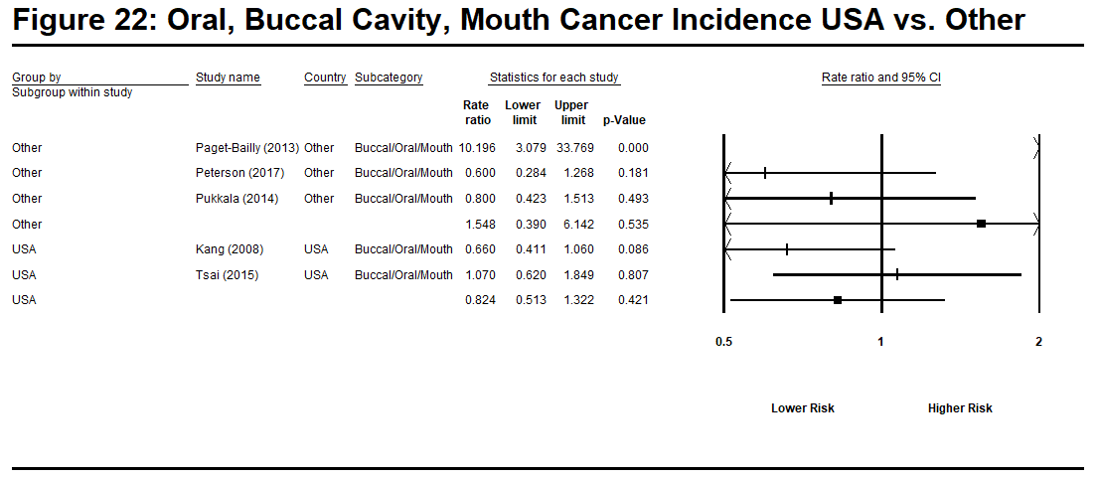
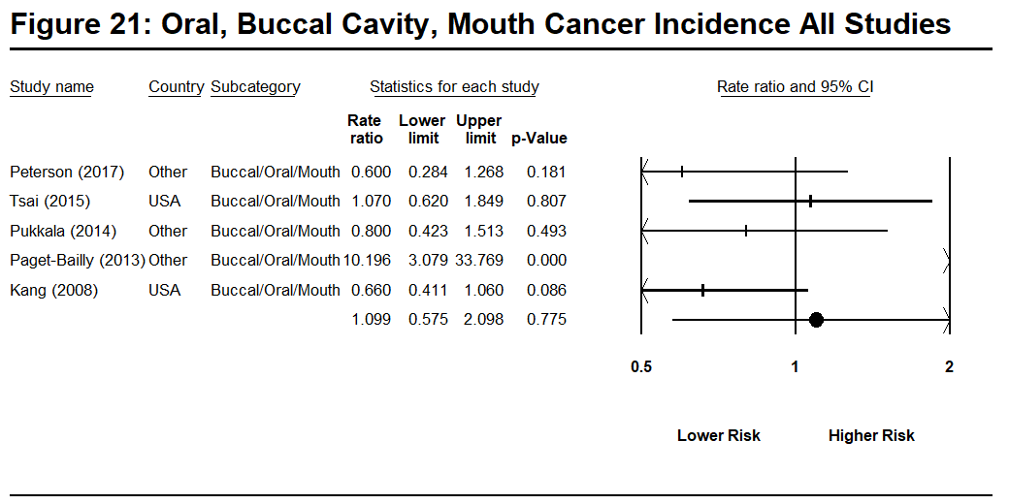
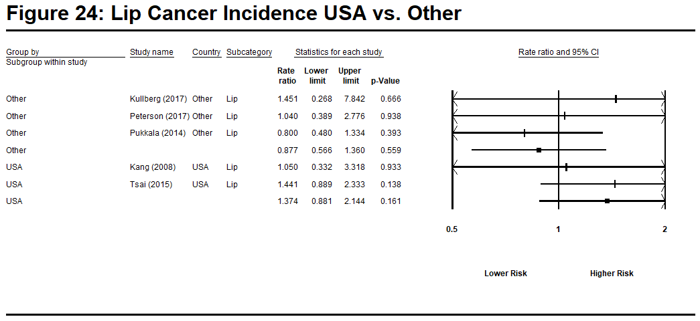
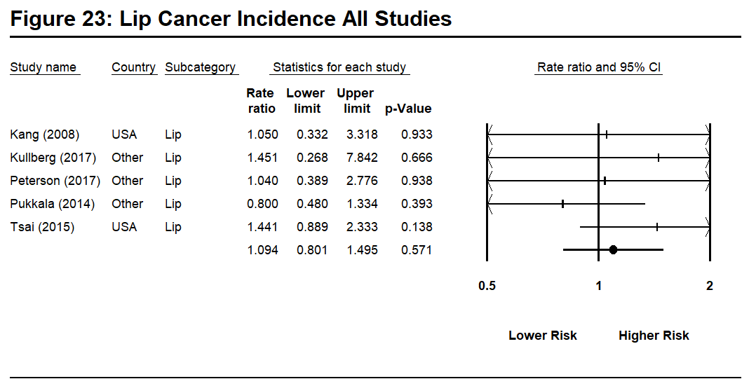

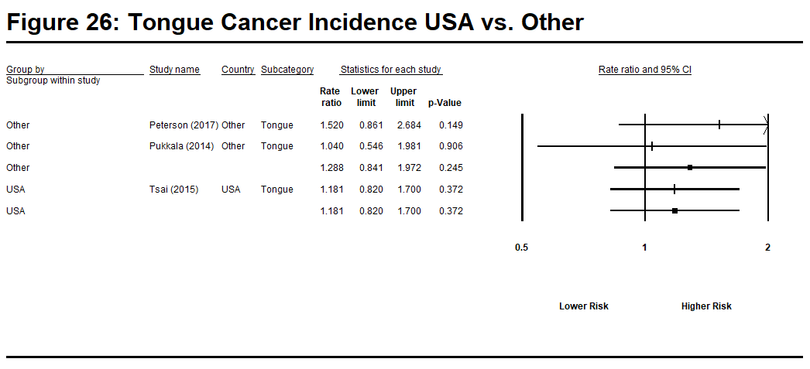
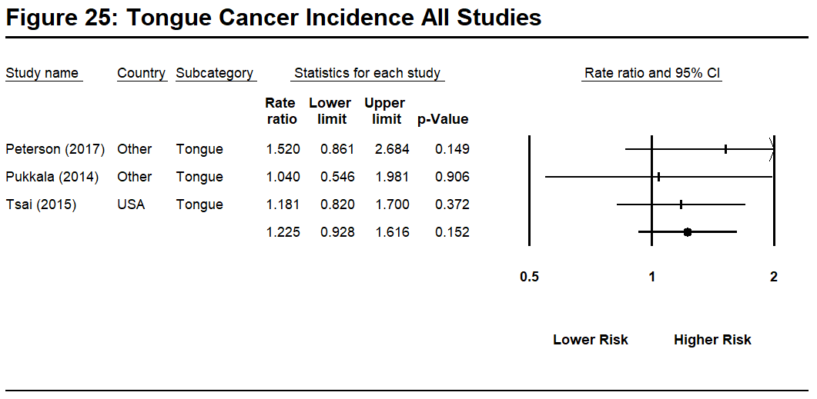
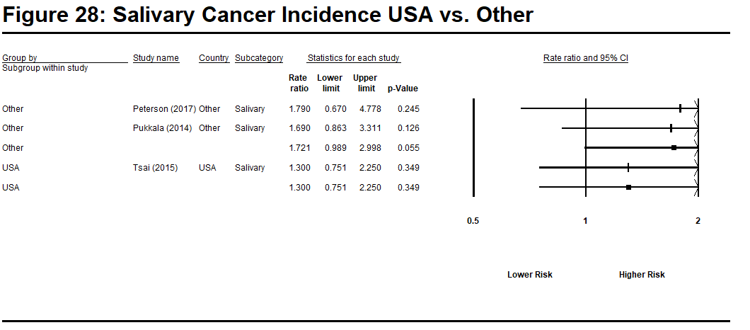
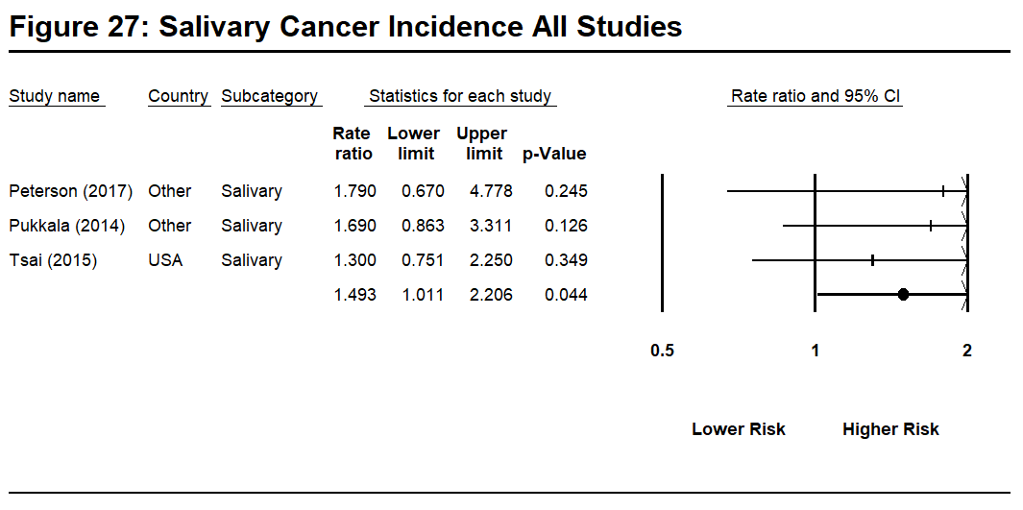

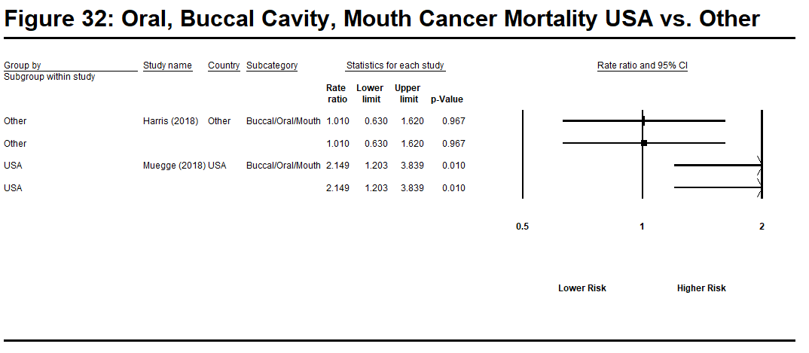
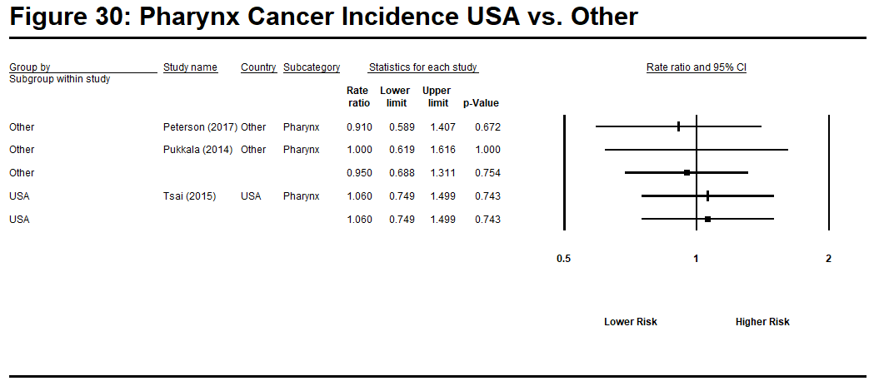
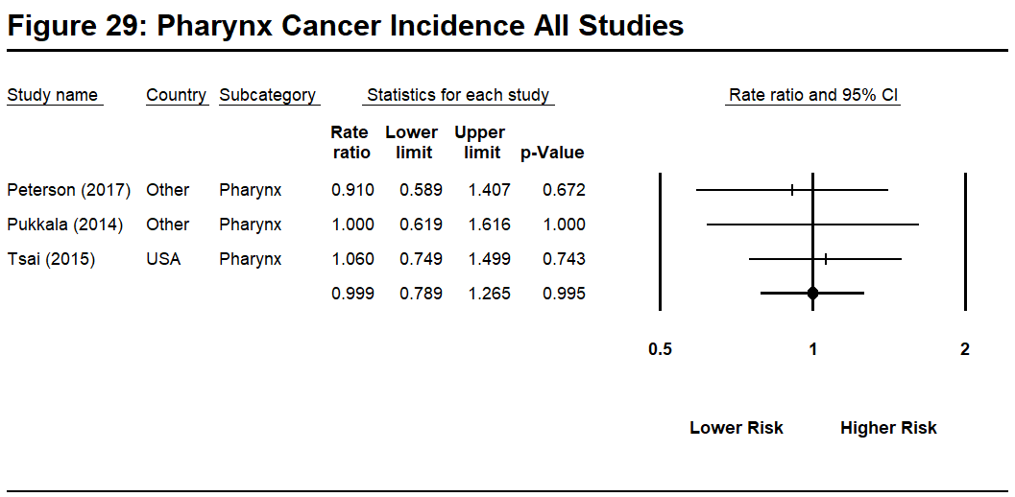
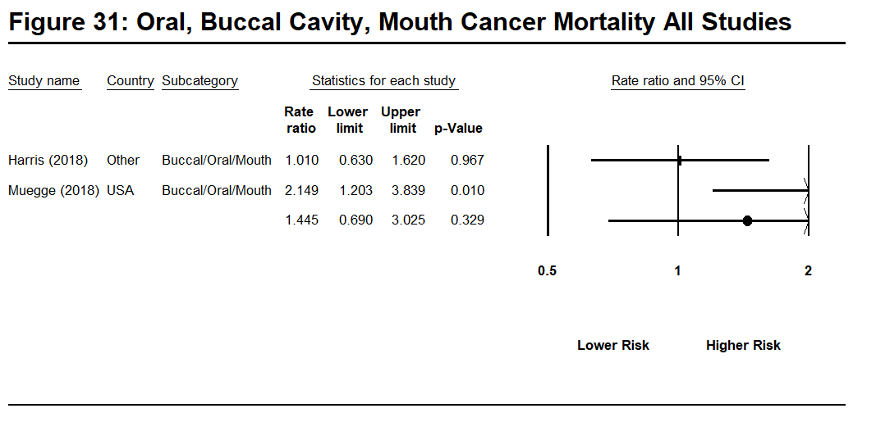
Note: The remaining subcategories of Buccal Cavity and Pharynx cancer not shown given there was only a single study reporting mortality this cancer type.

Table 7: Colon Cancer

Study | Country | Outcome | Rate Ratio (log) | Std Error (log) | Rate Ratio
Pinkerton et al (2020) | US | Mortality | 0.239 | 0.052 | 1.27
Lee et al (2020 | US | Incidence | 0.010 | 0.068 | 1.01
Peterson et al (2018) | Denmark | Mortality | 0.104 | 0.200 | 1.11
Harris et al (2018) | Canada | Incidence | -0.105 | 0.153 | 0.90
Kulberg et al (2017) | Sweden | Incidence | -0.151 | 0.237 | 0.86
Petersen et al (2017) | Denmark | Incidence | -0.315 | 0.130 | 0.73
Glass, et al (2016) | Australia | Incidence | 0.068 | 0.093 | 1.07
Tsai et al (2015) | US | Incidence | 0.095 | 0.087 | 1.10
Brice, et al (2015) | French | Mortality | -0.315 | 0.219 | 0.73
Ahn et al (2015) | Korea | Mortality | -0.431 | 0.309 | 0.65
Ahn et al (2012) | Korea | Incidence | 0.239 | 0.116 | 1.27
Daniels, et al (2014) | US | Incidence  Mortality | 0.191  0.262 | 0.051  0.055 | 1.21  1.30
Kang et al (2008) | US | Incidence | 0.140 | 0.110 | 1.15

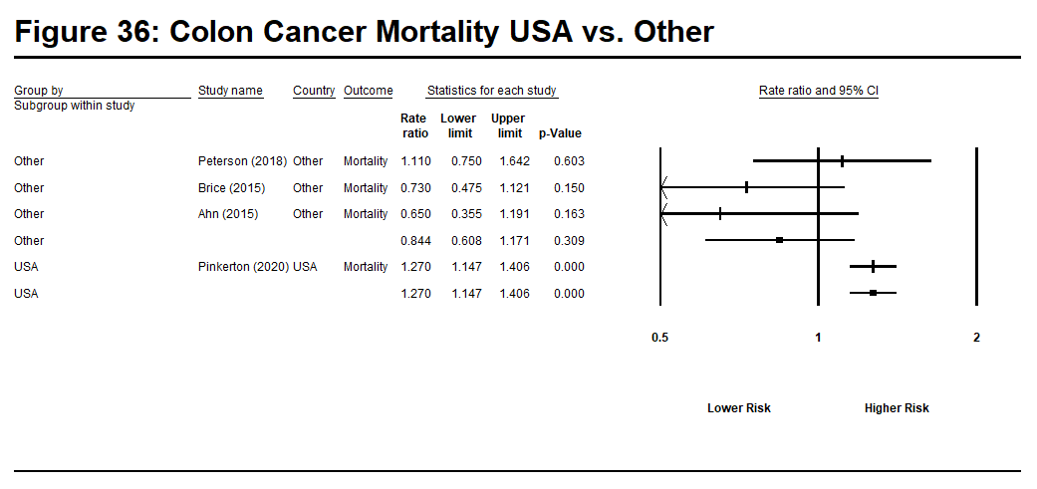
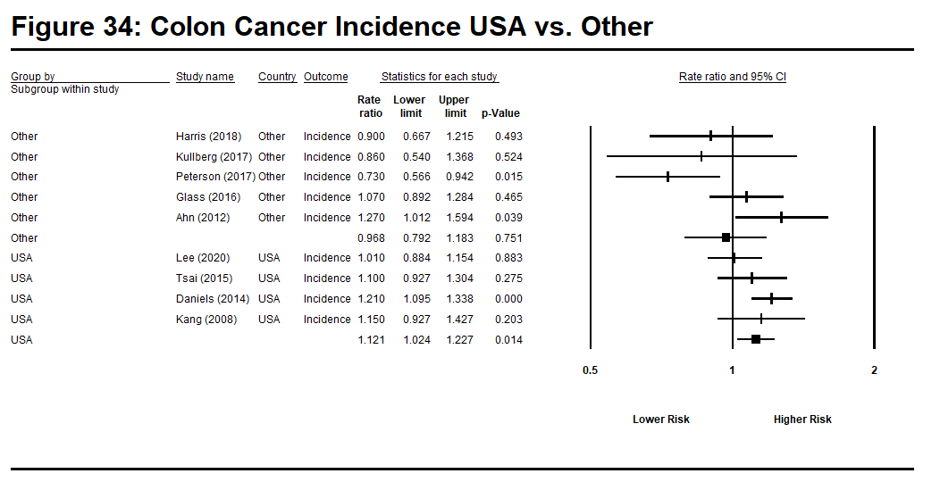
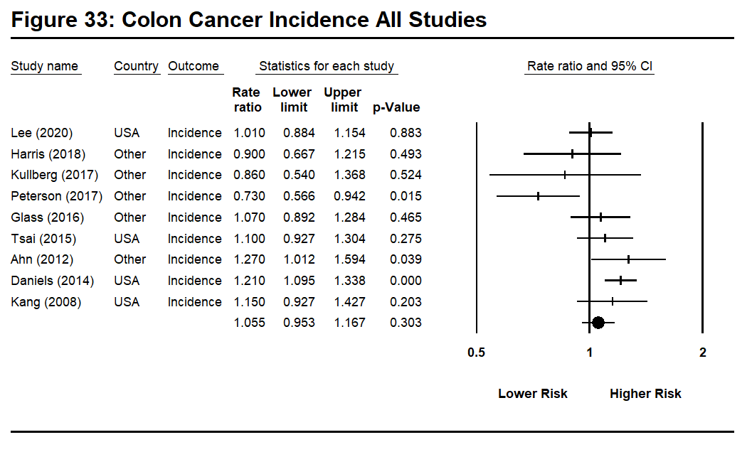
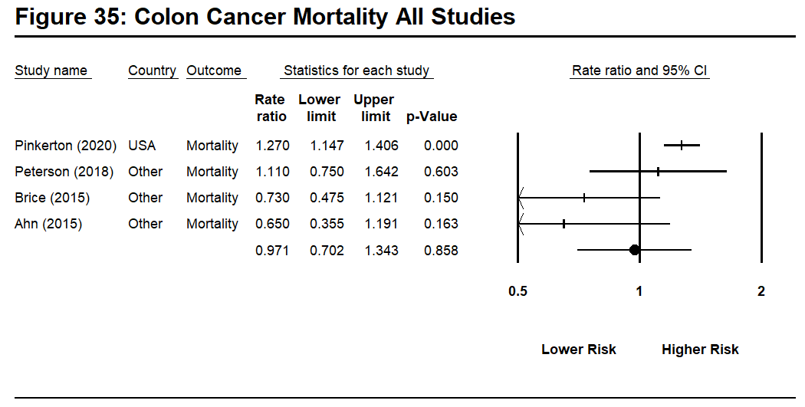

Table 8: Esophagus Cancer

Study | Country | Outcome | Rate Ratio (log) | Std Error (log) | Rate Ratio
Pinkerton et al (2020) | US | Mortality | 0.270 | 0.087 | 1.31
Lee et al (2019) | US | Incidence | -0.094 | 0.139 | 0.91
Harris et al (2018) | Canada | Mortality | 0.270 | 0.333 | 1.31
Kulberg et al (2017) | Sweden | Incidence | -0.010 | 0.503 | 0.99
Petersen et al (2017) | Denmark | Incidence | -0.01 | 0.218 | 0.99
Glass, et al (2016) | Australia | Incidence | -0.274 | 0.313 | 0.76
Tsai, et al (2015) | US | Incidence | 0.464 | 0.142 | 1.59
Brice, et al (2015) | French | Mortality | -0.073 | 0.163 | 0.93
Ahn et al (2012) | Korea | Incidence | -0.288 | 0.451 | 0.75
Daniels, et al (2014) | US | Incidence | 0.482 | 0.108 | 1.62
Pukkala et al (2014) | Nordic | Incidence | -0.020 | 0.190 | 0.98
Kang et al (2008) | US | Incidence | -0.446 | 0.157 | 0.64
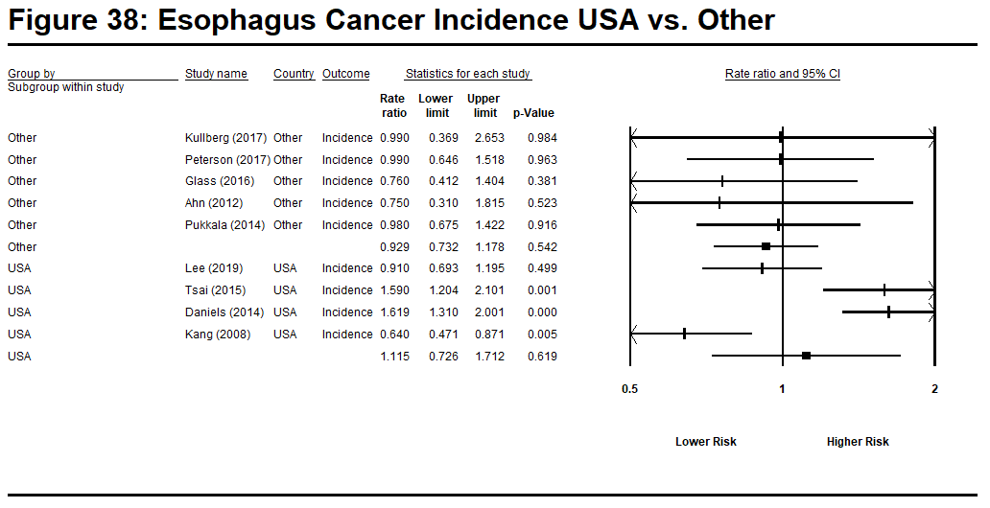
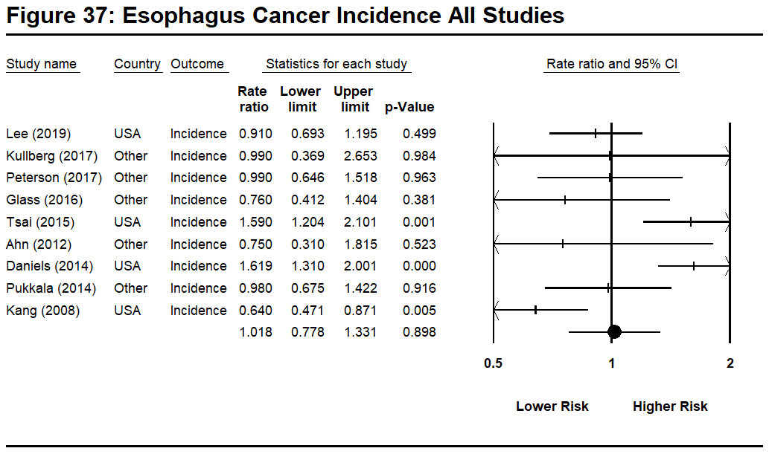
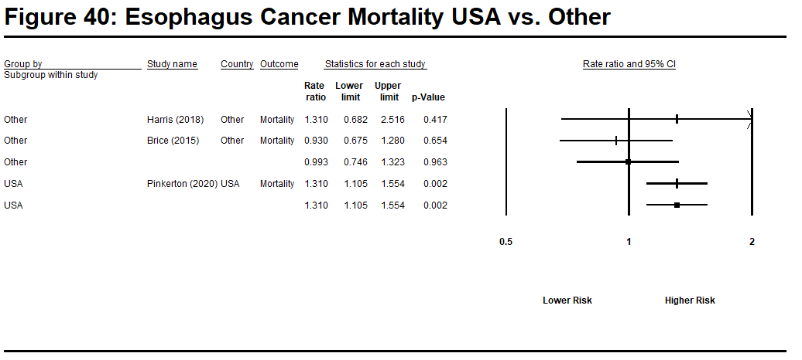
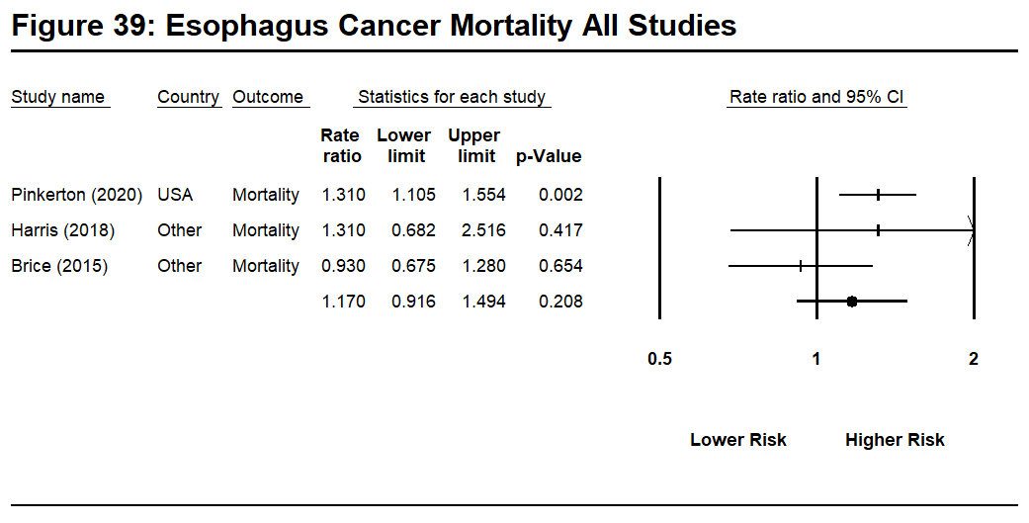

Table 9: Eye Cancer

Study | Country | Outcome | Rate Ratio (log) | Std Error (log) | Rate Ratio
Lee et al (2020). | US | Incidence | -0.128 | 0.378 | 0.88
Petersen et al (2017) | Denmark | Incidence | -0.128 | 0.582 | 0.88
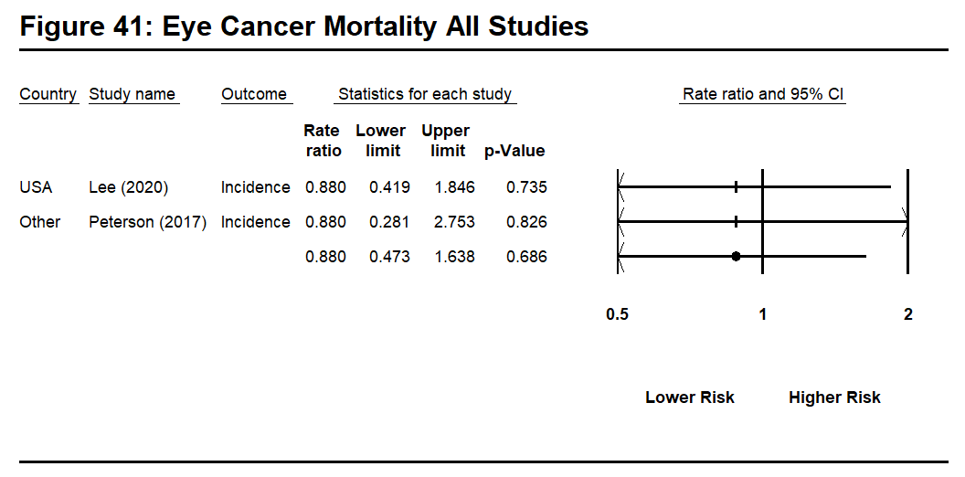
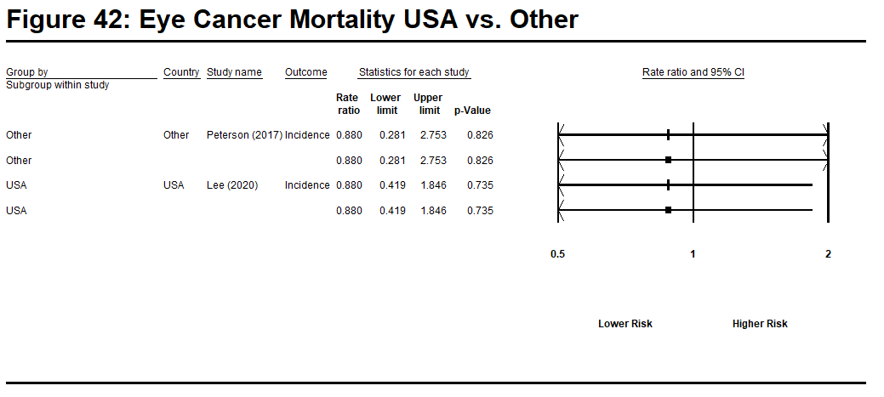

Table 10: Hodgkin’s Disease

Study | Country | Outcome | Rate Ratio (log) | Std Error (log) | Rate Ratio
Lee et al (2020). | US | Incidence | -0.163 | 0.179 | 0.85
Harris et al (2018) | Canada | Incidence | 1.061 | 0.411 | 2.89
Kulberg et al (2017) | Sweden | Incidence | 0.329 | 0.863 | 1.39
Petersen et al (2017) | Denmark | Incidence | 0.495 | 0.278 | 1.64
Glass, et al (2016) | Australia | Incidence | -0.010 | 0.340 | 0.99
Tsai et al (2015) | US | Incidence | 0.140 | 0.238 | 1.15
Kang et al (2008) | US | Incidence | 0.445 | 0.402 | 1.56
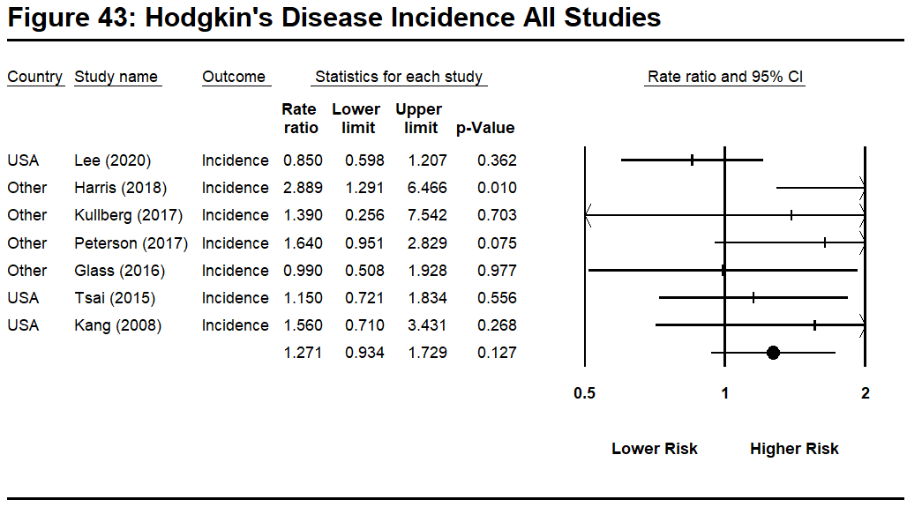
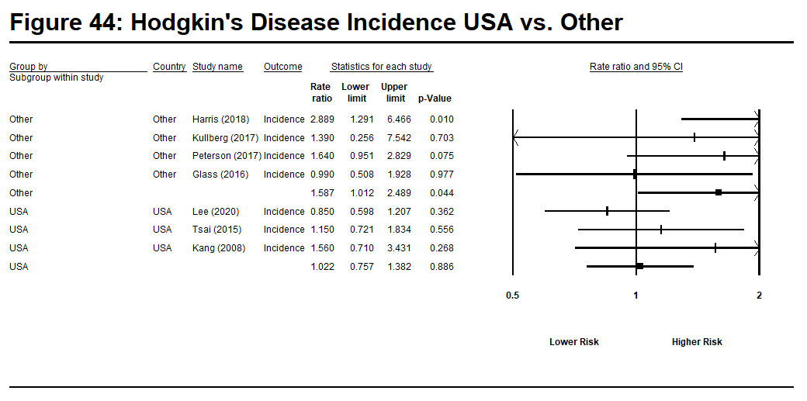

Table 11: Kidney Cancer
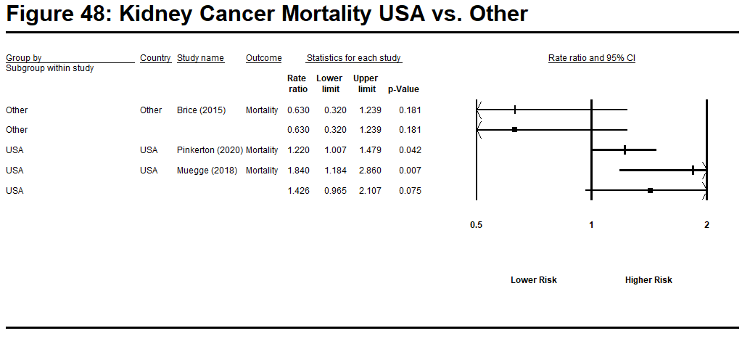
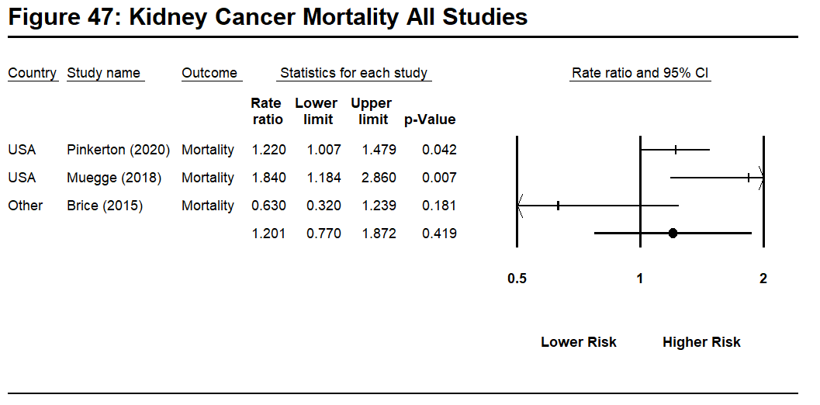
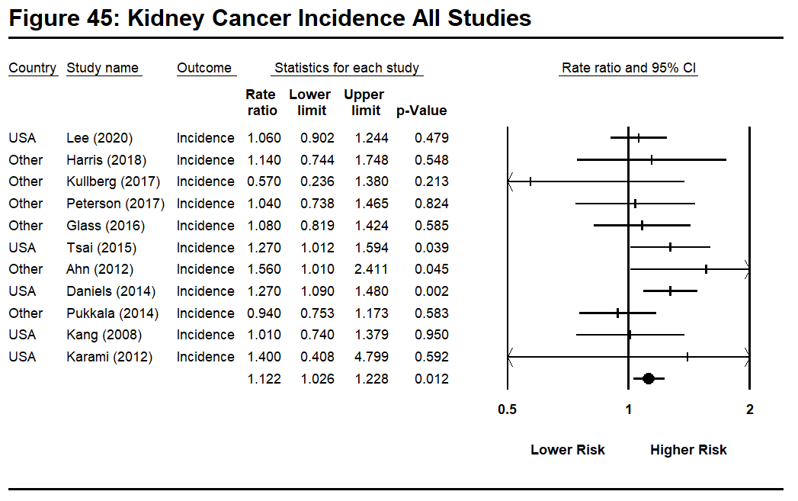
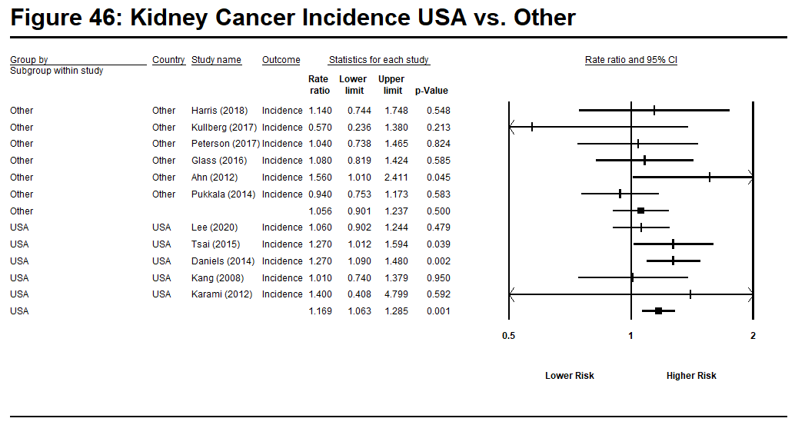
Study | Country | Outcome | Rate Ratio (log) | Std Error (log) | Rate Ratio
Pinkerton et al (2020) | US | Mortality | 0.199 | 0.098 | 1.22
Lee et al (2020) | US | Incidence | 0.058 | 0.082 | 1.06
Muegge et al (2018) | US | Mortality | 0.610 | 0.225 | 1.84
Harris et al (2018) | Canada | Incidence | 0.131 | 0.218 | 1.14
Kulberg et al (2017) | Sweden | Incidence | -0.562 | 0.451 | 0.57
Petersen et al (2017) | Denmark | Incidence  Kidney  Renal pelvis | 0.039  0.378 | 0.175  0.315 | 1.04  1.46
Glass, et al (2016) | Australia | Incidence | 0.077 | 0.141 | 1.08
Tsai et al (2015) | US | Incidence | 0.239 | 0.116 | 1.27
Brice, et al (2015) | French | Mortality | -0.462 | 0.345 | 0.63
Ahn et al (2012) | Korea | Incidence | 0.445 | 0.222 | 1.56
Daniels, et al (2014) | US | Incidence | 0.239 | 0.078 | 1.27
Pukkala et al (2014) | Nordic | Incidence | -0.062 | 0.113 | 0.94
Kang et al (2008) | US | Incidence | 0.010 | 0.159 | 1.01
Karami (2012) | US | Incidence | 0.336 | 0.629 | 1.400

Note: Renal Pelvis cancer rates not shown given only one study reported on this cancer type.
Table 12: Large Intestine Cancer

Study | Country | Outcome | Rate Ratio (log) | Std Error (log) | Rate Ratio
Daniels, et al (2014) | US | Incidence  Mortality | 0.191  0.270 | 0.053  0.062 | 1.21  1.31
Pukkala et al (2014) | Nordic | Incidence | 0.131 | 0.071 | 1.14
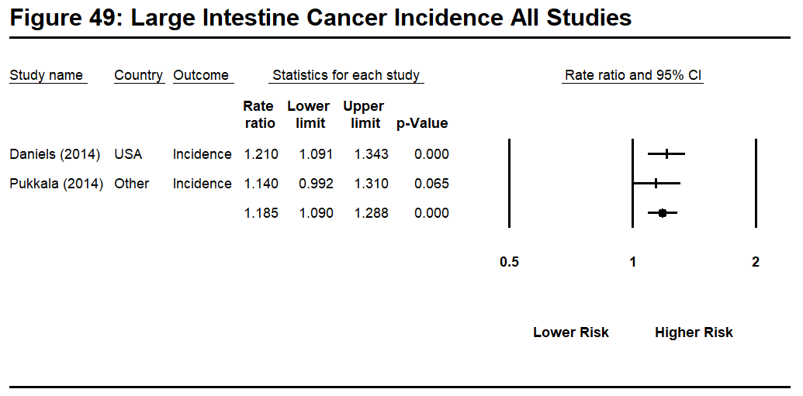
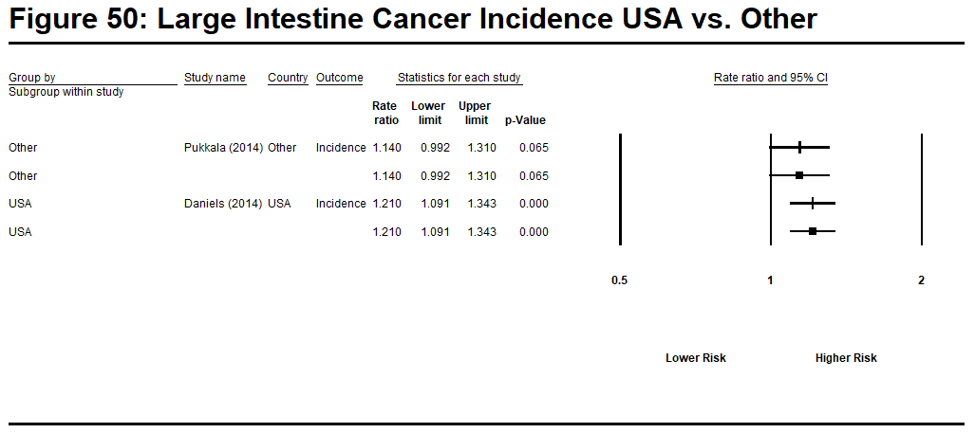

Note: only one study provides data for large intestine cancer mortality.

Table 13: Larynx Cancer

Study | Country | Outcome | Rate Ratio (log) | Std Error (log) | Rate Ratio
Lee et al (2020) | US | Incidence | -0.734 | 0.173 | 0.48
Petersen et al (2017) | Denmark | Incidence | -0.083 | 0.251 | 0.92
Glass, et al (2016) | Australia | Incidence | -0.357 | 0.311 | 0.70
Tsai et al (2015) | US | Incidence | -0.528 | 0.210 | 0.59
Brice, et al (2015) | French | Mortality | 0.095 | 0.199 | 1.10
Ahn et al (2012) | Korea | Incidence | -0.562 | 0.694 | 0.57
Pukkala et al (2014) | Nordic | Incidence | 0.058 | 0.187 | 1.06
Kang et al (2008) | US | Incidence | -0.211 | 0.181 | 0.81
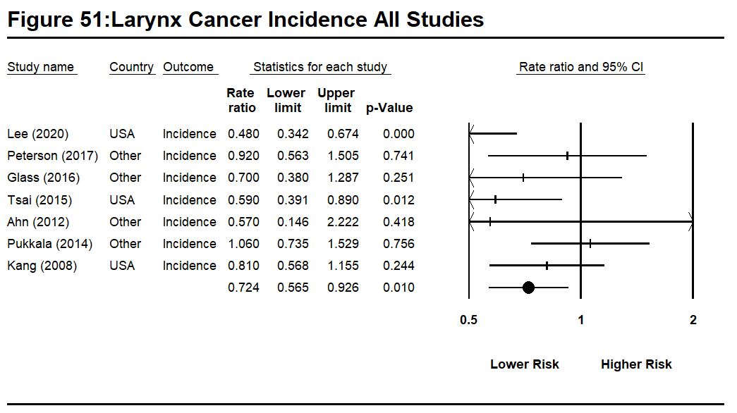
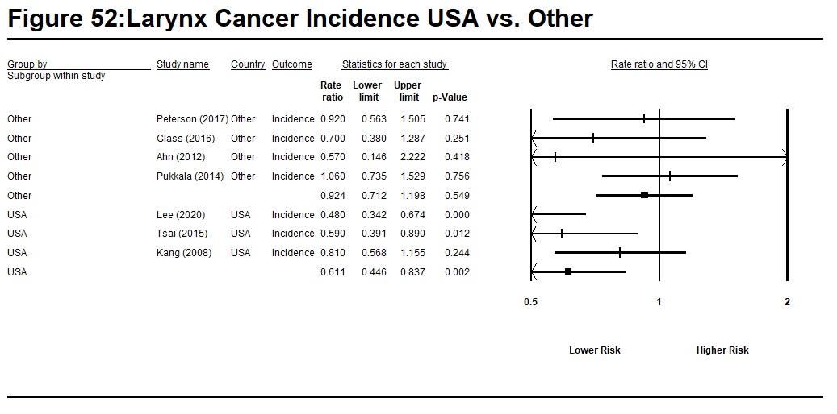

Note: Only one study reported data on larynx cancer mortality.

Table 14: Leukemia

Study | Country | Outcome | Rate Ratio (log) | Std Error (log) | Rate Ratio
Pinkerton et al (2020) | US | Mortality | 0.104 | 0.085 | 1.11
Lee et al (2020). | US | Incidence | -0.673 | 1.003 | 0.51
Harris et al (2018) | Canada | Incidence | -0.073 | 0.269 | 0.93
Kulberg et al (2017) | Sweden | Incidence | -0.968 | 0.669 | 0.38
Petersen et al (2017) | Denmark | Incidence  Lymphatic  Myeloid | -0.094  -0.274 | 0.258  0.330 | 0.91  0.76
Glass, et al (2016) | Australia | Incidence | 0.000 | 0.157 | 1.00
Tsai et al (2015) | US | Incidence | 0.278 | 0.117 | 1.32
Ahn et al (2015) | Korea | Mortality | -0.416 | 0.457 | 0.66
Ahn et al (2012) | Korea | Incidence | 0.049 | 0.296 | 1.05
Daniels, et al (2014) | US | Incidence | -0.062 | 0.102 | 0.94
Pukkala et al (2014) | Nordic | Incidence | -0.062 | 0.138 | 0.94
Kang et al (2008) | US | Incidence | -0.020 | 0.179 | 0.98
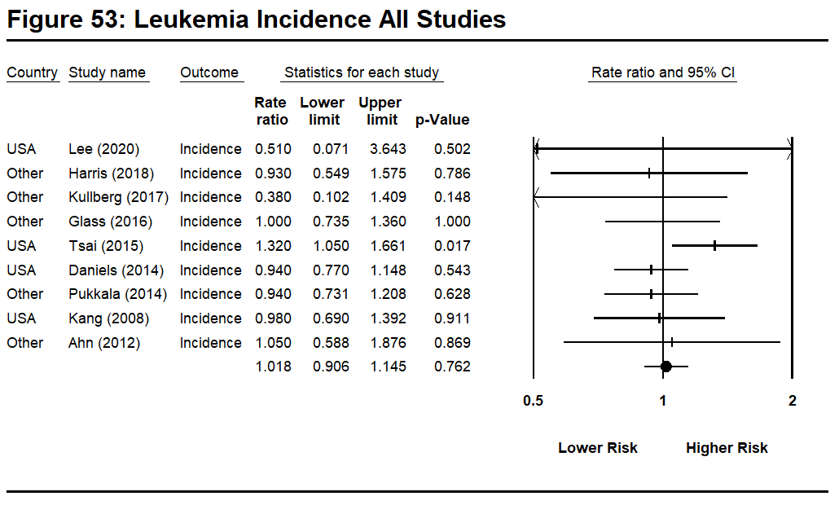
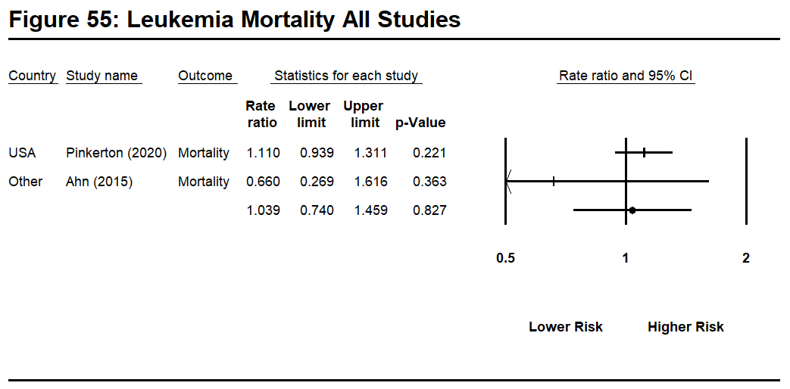
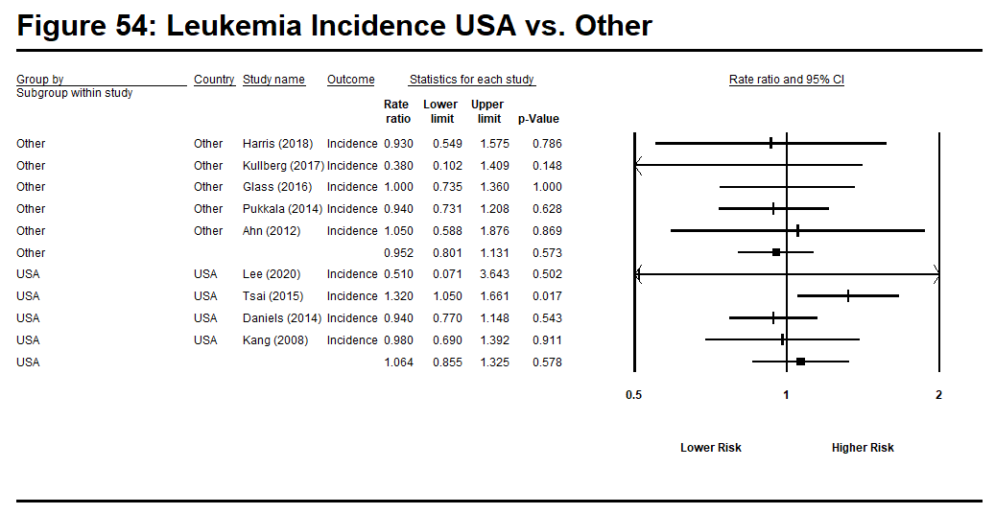
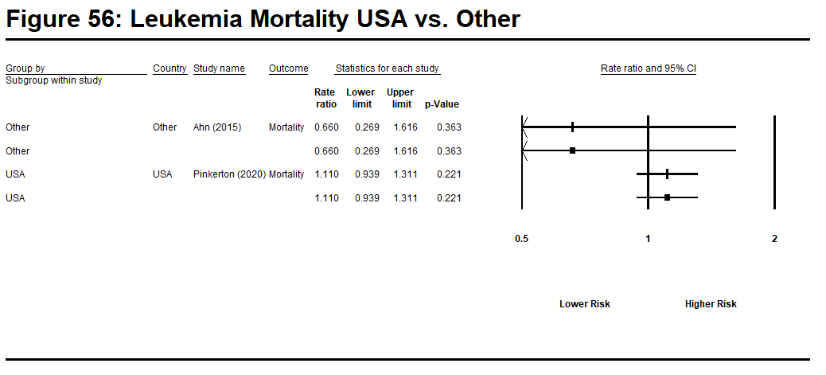
Note: only one study each provided data on Lymphatic and Myeloid cancer.

Table 15: Liver/Gallbladder Cancer

Study | Country | Outcome | Rate Ratio (log) | Std Error (log) | Rate Ratio
Lee et al (2020) | US | Incidence | -0.357 | 0.136 | 0.70
Harris et al (2018) | Canada | Incidence | -0.616 | 0.444 | 0.54
Kulberg et al (2017) | Sweden | Incidence | -0.236 | 0.415 | 0.79
Petersen et al (2017) | Denmark | Incidence  Liver  Gallbladder | -0.030  -0.010 | 0.265  0.448 | 0.97  0.99
Glass, et al (2016) | Australia | Incidence | -0.580 | 0.308 | 0.56
Tsai et al (2015) | US | Incidence | 0.068 | 0.182 | 1.07
Brice, et al (2015) | French | Mortality | 0.095 | 0.153 | 1.10
Ahn et al (2015) | Korea | Mortality | -0.598 | 0.147 | 0.55
Ahn et al (2012) | Korea | Incidence  Liver  Gallbladder) | -0.174  -0.198 | 0.121  0.418 | 0.84  0.82
Pukkala et al (2014) | Nordic | Incidence  Liver  Gallbladder | -0.094  0.372 | 0.209  0.250 | 0.91  1.45
Kang et al (2008) | US | Incidence | 0.174 | 0.279 | 1.19
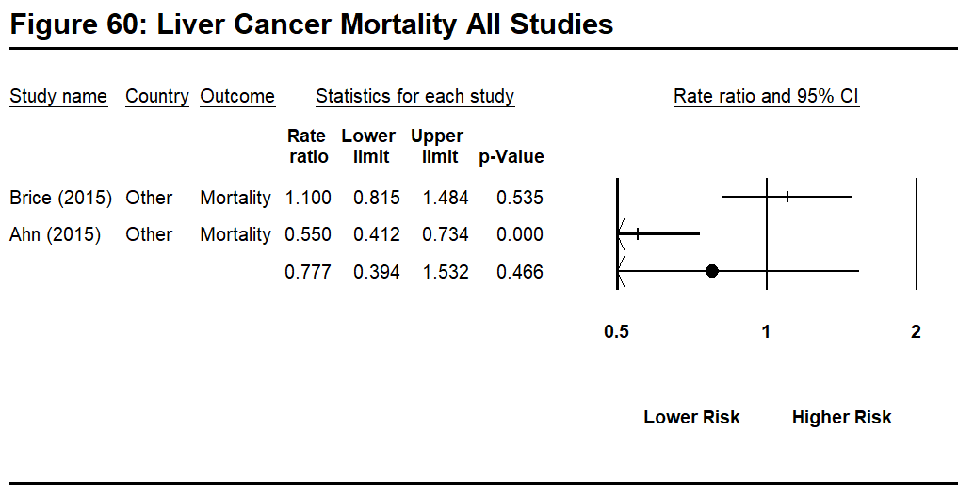
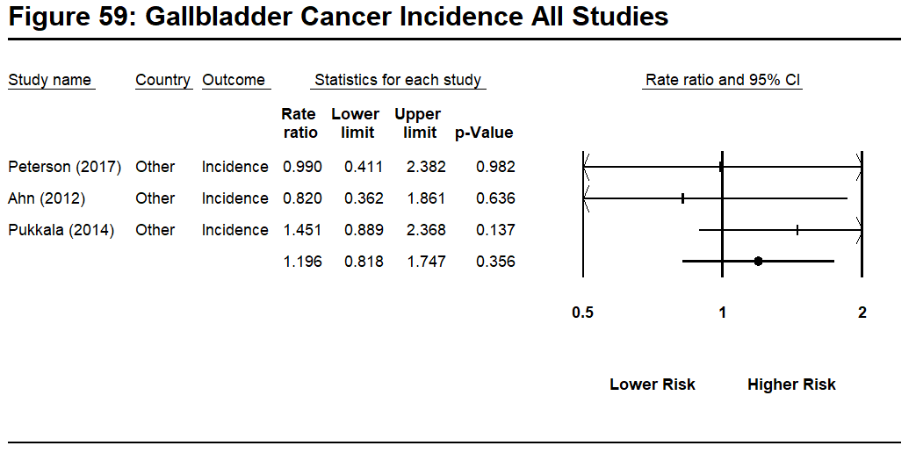
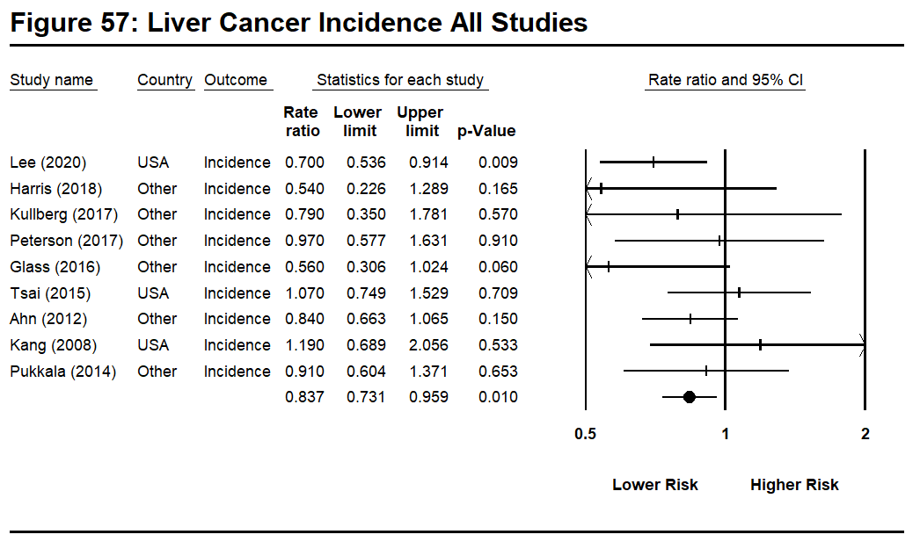
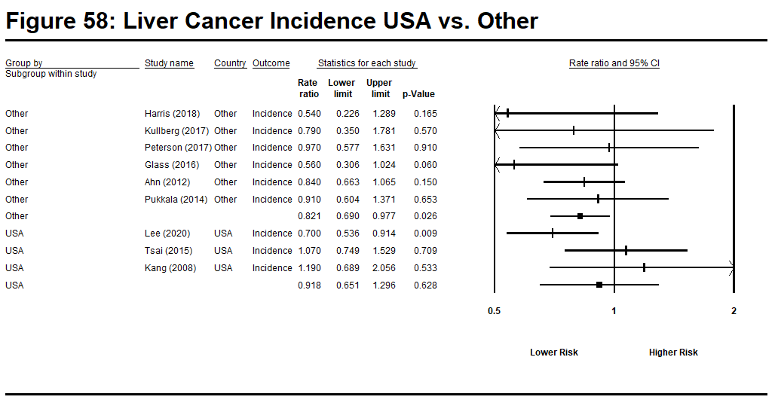
Note: Studies not providing separate outcomes for liver and gallbladder examined liver cancer only. No US studies provided risk estimates for gallbladder cancer. Only US studies provided liver cancer mortality risk estimates.

Table 16: Lung Cancer
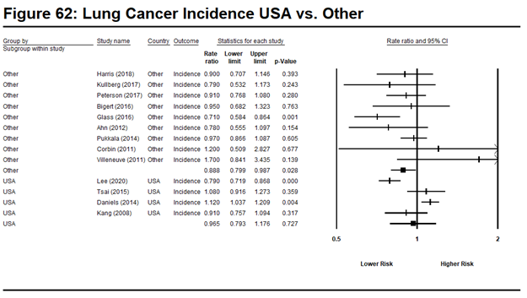
Study | Country | Outcome | Rate Ratio (log) | Std Error (log) | Rate Ratio
Pinkerton et al (2020) | US | Mortality | 0.077 | 0.031 | 1.08
Lee et al (2020) | US | Incidence | -0.236 | 0.048 | 0.79
Harris et al (2018) | Canada | Incidence | -0.105 | 0.123 | 0.90
Kullberg et al (2017) | Sweden | Incidence | -0.236 | 0.202 | 0.79
Petersen et al (2017) | Denmark | Incidence | -0.094 | 0.087 | 0.91
Bigert et al (2016) | Europe, Canada,  New Zealand, China | Incidence | -0.051 | 0.169 | 0.95
Glass, et al (2016) | Australia | Incidence | -0.342 | 0.100 | 0.71
Tsai et al (2015) | US | Incidence | 0.077 | 0.084 | 1.08
Brice, et al (2015) | French | Mortality | -0.151 | 0.074 | 0.86
Ahn et al (2015) | Korea | Mortality | -0.545 | 0.202 | 0.58
Ahn et al (2012) | Korea | Incidence | -0.248 | 0.174 | 0.78
Daniels, et al (2014) | US | Incidence | 0.113 | 0.039 | 1.12
Pukkala et al (2014) | Nordic | Incidence | -0.030 | 0.058 | 0.97
Kang et al (2008) | US | Incidence | -0.094 | 0.094 | 0.91
Corbin (2011) | New Zealand | Incidence | 0.182 | 0.437 | 1.20
Villeneuve (2011) | Canada | Incidence | 0.531 | 0.359 | 1.70
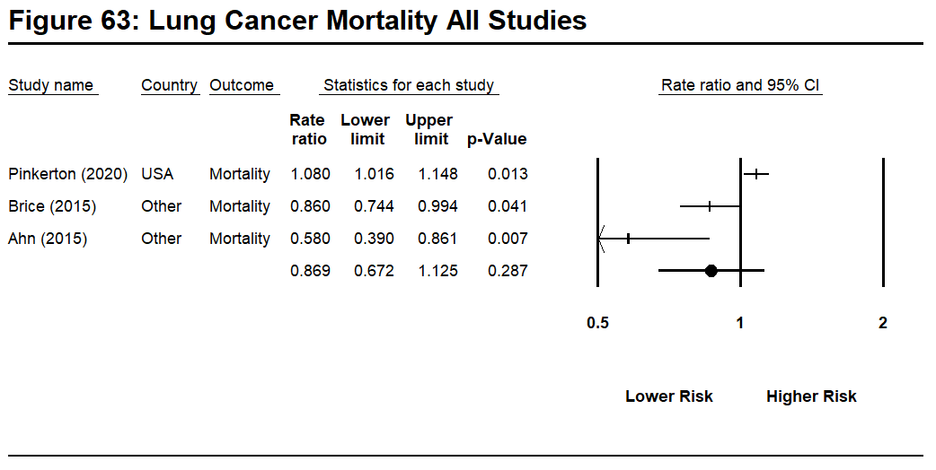
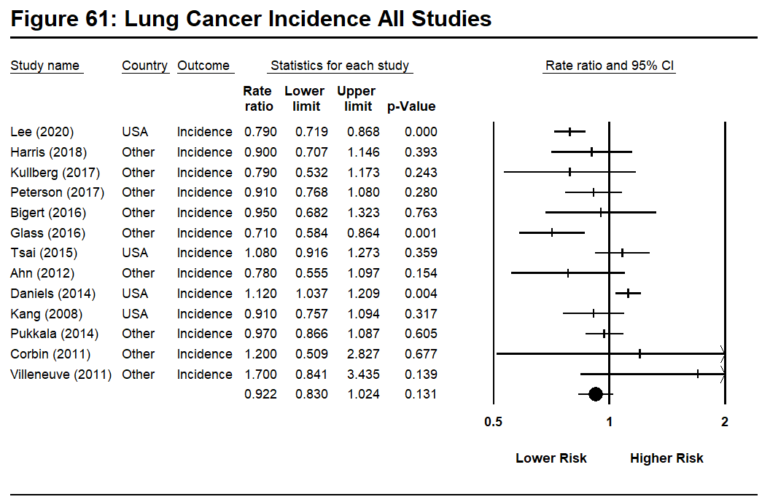
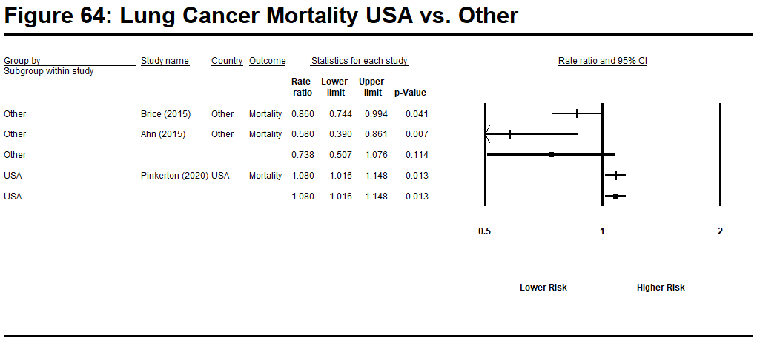
Table 17: Multiple Myeloma

Study | Country | Outcome | Rate Ratio (log) | Std Error (log) | Rate Ratio
Pinkerton et al (2020) | US | Mortality | -0.073 | 0.140 | 0.93
Lee et al (2020) | US | Incidence | -0.223 | 0.159 | 0.80
Harris et al (2018) | Canada | Incidence | 0.419 | 0.317 | 1.52
Kulberg et al (2017) | Sweden | Incidence | 0.166 | 0.505 | 1.18
Petersen et al (2017) | Denmark | Incidence | -0.478 | 0.354 | 0.62
Glass, et al (2016) | Australia | Incidence | 0.000 | 0.251 | 1.00
Tsai et al (2015) | US | Incidence | 0.300 | 0.153 | 1.35
Daniels, et al (2014) | US | Incidence | -0.329 | 0.174 | 0.72
Pukkala et al (2014) | Nordic | Incidence | 0.122 | 0.162 | 1.13
Kang et al (2008) | US | Incidence | -0.083 | 0.237 | 0.92
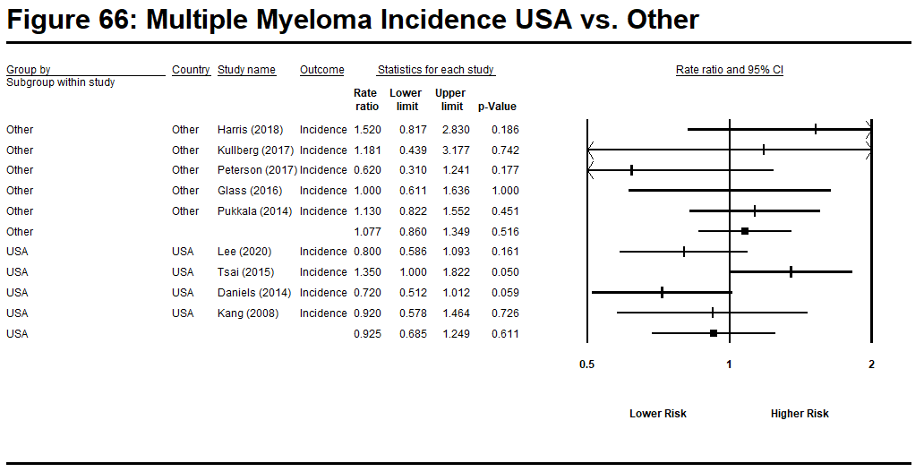
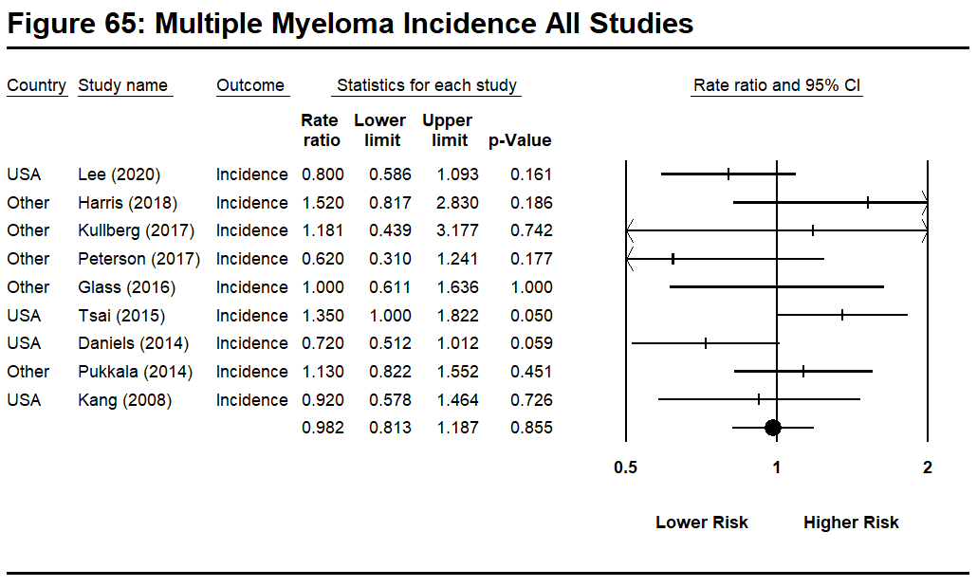

Note: Only one study provided estimates for multiple myeloma mortality

Table 18: Non-Hodgkin’s Lymphoma

Study | Country | Outcome | Rate Ratio (log) | Std Error (log) | Rate Ratio
Pinkerton et al (2020) | US | Mortality | 0.191 | 0.082 | 1.21
Lee et al (2020) | US | Incidence | -0.128 | 0.081 | 0.88
Harris et al (2018) | Canada | Incidence | 0.000 | 0.175 | 1.00
Kulberg et al (2017) | Sweden | Incidence | -0.386 | 0.454 | 0.68
Petersen et al (2017) | Denmark | Incidence | -0.041 | 0.165 | 0.96
Glass, et al (2016) | Australia | Incidence | -0.030 | 0.128 | 0.97
Tsai et al (2015) | US | Incidence | 0.199 | 0.103 | 1.22
Ahn et al (2012) | Korea | Incidence | 0.525 | 0.248 | 1.69
Daniels, et al (2014) | US | Incidence | -0.010 | 0.077 | 0.99
Pukkala et al (2014) | Nordic | Incidence | 0.039 | 0.112 | 1.04
Kang et al (2008) | US | Incidence | 0.095 | 0.327 | 1.10
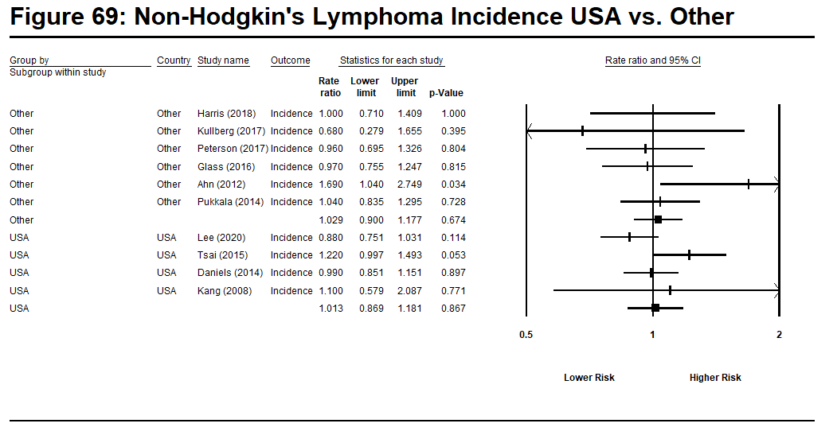
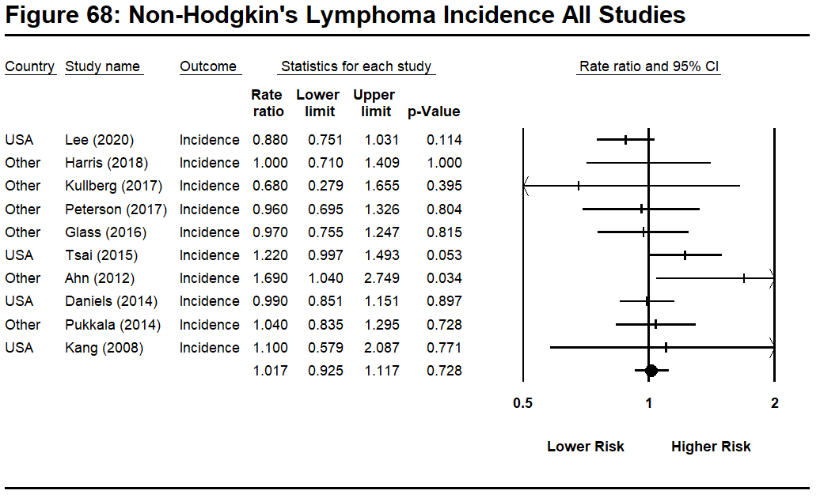

Note: Only one study reported estimates for Non-Hodgkin’s Lymphoma mortality

Table 19: Other Male Genital Cancer

Study | Country | Outcome | Rate Ratio (log) | Std Error (log) | Rate Ratio
Pinkerton et al (2020) | US | Mortality | -0.942 | 0.563 | 0.39
Lee et al (2020) | US | Incidence | -0.236 | 0.447 | 0.79
Petersen et al (2017) | Denmark | Incidence | -0.248 | 0.578 | 0.78
Daniels, et al (2014) | US | Incidence | -0.478 | 0.258 | 0.62
Pukkala et al (2014) | Nordic | Incidence | 0.425 | 0.311 | 1.53
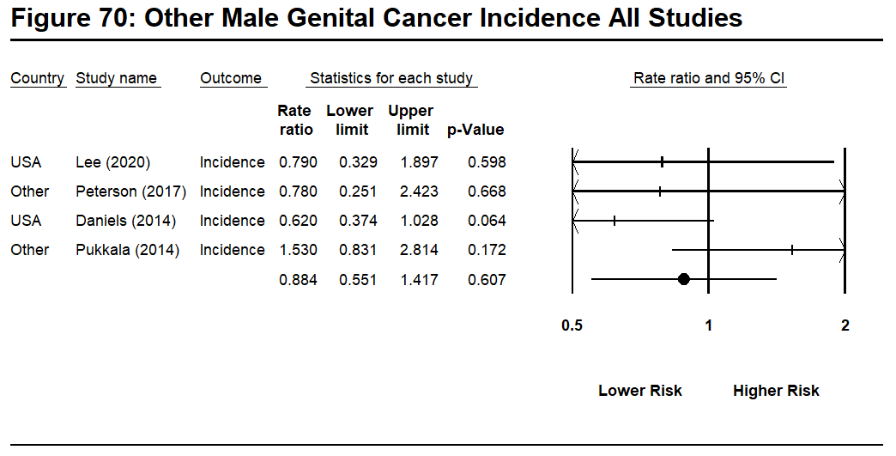
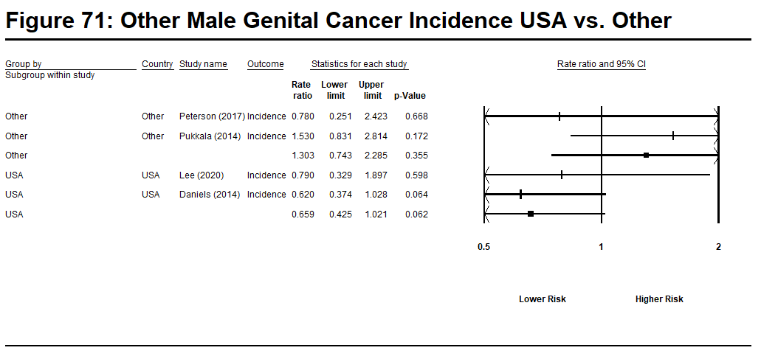

Note: Only one study provides estimates for Other Male Genital Cancer mortality.

Table 20: Pancreas Cancer

Study | Country | Outcome | Rate Ratio (log) | Std Error (log) | Rate Ratio
Lee et al (2020) | US | Incidence | -0.163 | 0.118 | 0.85
Muegge et al (2018) | US | Mortality | 0.372 | 0.182 | 1.45
Harris et al (2018) | Canada | Incidence | 0.332 | 0.259 | 1.38
Kullberg et al (2017) | Sweden | Incidence | 0.058 | 0.341 | 1.06
Petersen et al (2017) | Denmark | Incidence | 0.182 | 0.171 | 1.20
Glass, et al (2016) | Australia | Incidence | 0.030 | 0.195 | 1.03
Tsai et al (2015) | US | Incidence | 0.095 | 0.144 | 1.10
Brice, et al (2015) | French | Mortality | 0.239 | 0.160 | 1.27
Ahn et al (2012) | Korea | Incidence | -0.051 | 0.361 | 0.95
Pukkala et al (2014) | Nordic | Incidence | 0.157 | 0.111 | 1.17
Kang et al (2008) | US | Incidence | -0.174 | 0.190 | 0.84
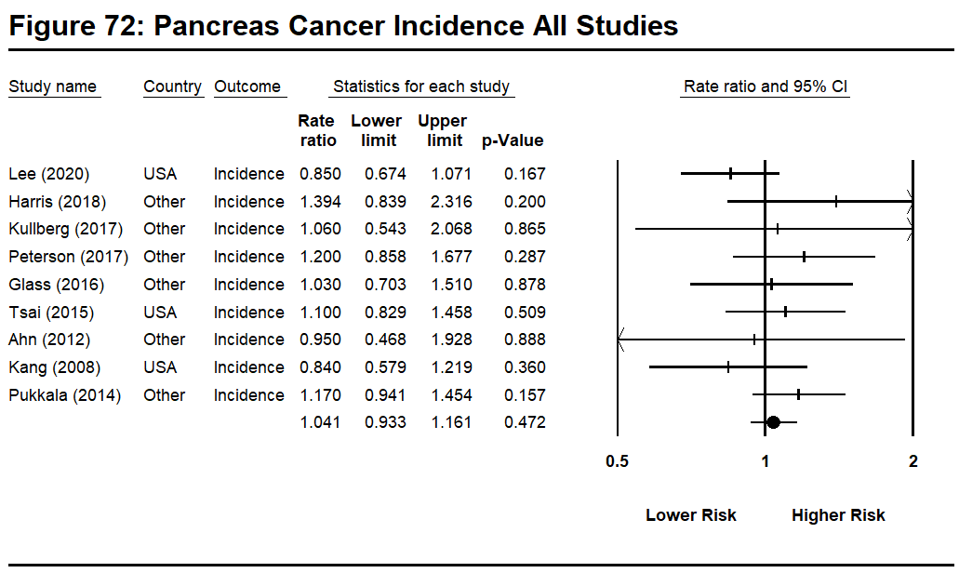
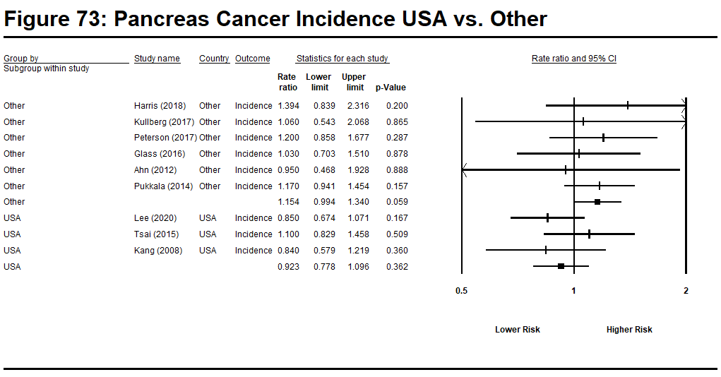
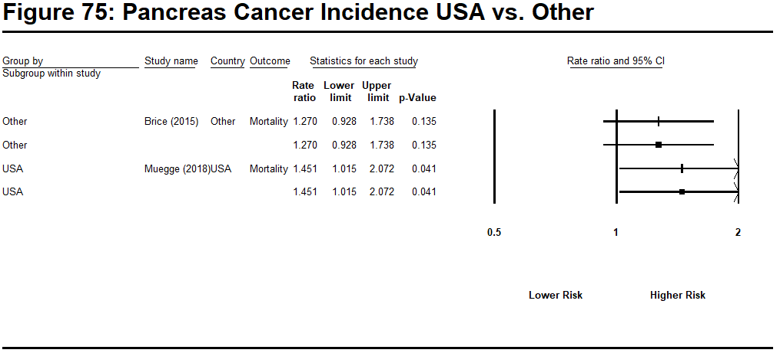
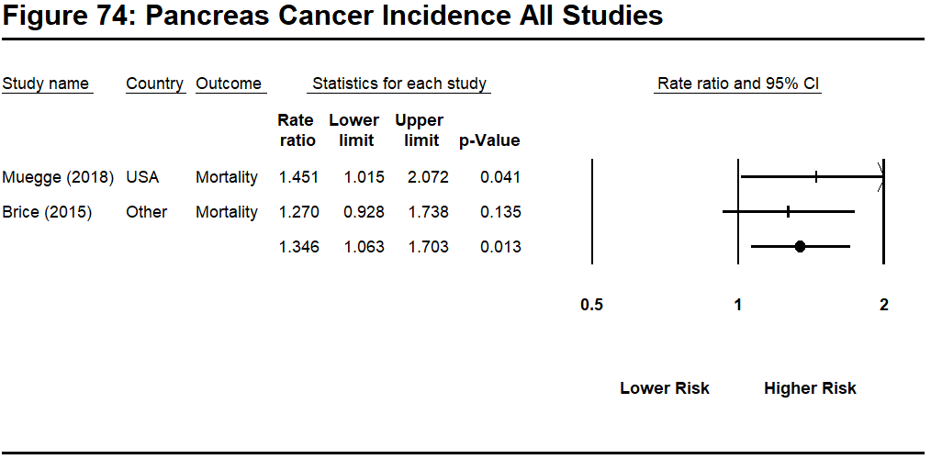

Table 21: Pleura (Mesothelioma)

Study | Country | Outcome | Rate Ratio (log) | Std Error (log) | Rate Ratio
Pinkerton et al (2020) | US | Mortality | 0.621 | 0.251 | 1.86
Lee et al (2020) | US | Incidence | 0.231 | 0.302 | 1.26
Kulberg et al (2017) | Sweden | Incidence | 0.880 | 0.868 | 2.41
Petersen et al (2017) | Denmark | Incidence | -0.431 | 0.504 | 0.65
Glass, et al (2016) | Australia | Incidence | 0.293 | 0.276 | 1.34
Tsai et al (2015) | US | Incidence | 0.336 | 0.232 | 1.40
Daniels, et al (2014) | US | Incidence | 0.829 | 0.176 | 2.29
Pukkala et al (2014) | Nordic | Incidence | 0.438 | 0.259 | 1.55
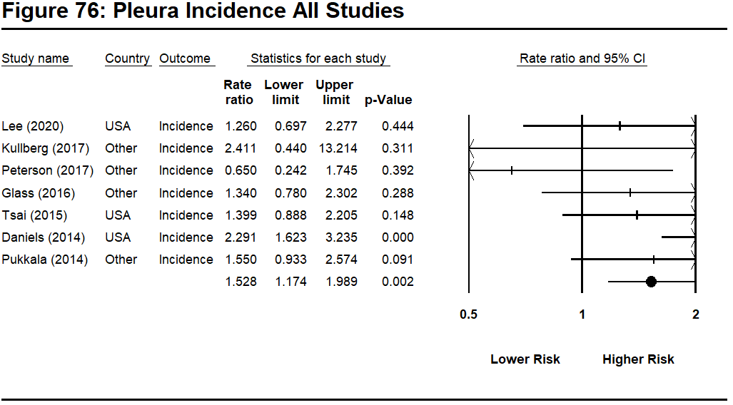
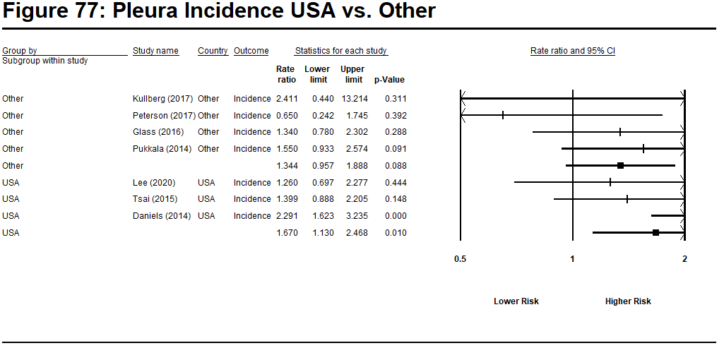

Note: Only one study provided estimates for Pleura mortality

Table 22: Prostate Cancer

Study | Country | Outcome | Rate Ratio (log) | Std Error (log) | Rate Ratio
Pinkerton et al (2020) | US | Mortality | 0.077 | 0.054 | 1.08
Lee et al (2020) | US | Incidence | 0.307 | 0.036 | 1.36
Sritharan et al (2018) | Canada | Incidence | 0.157 | 0.076 | 1.17
Peterson et al (2018) | Denmark | Mortality | -0.416 | 0.251 | 0.66
Harris et al (2018) | Canada | Incidence | 0.166 | 0.078 | 1.18
Kulberg et al (2017) | Sweden | Incidence | -0.386 | 0.131 | 0.68
Petersen et al (2017) | Denmark | Incidence | 0.095 | 0.072 | 1.10
Glass, et al (2016) | Australia | Incidence | 0.270 | 0.047 | 1.31
Tsai et al (2015) | US | Incidence | 0.372 | 0.077 | 1.45
Brice, et al (2015) | French | Mortality | -0.616 | 0.260 | 0.54
Ahn et al (2012) | Korea | Incidence | 0.278 | 0.365 | 1.32
Daniels, et al (2014) | US | Incidence | 0.030 | 0.027 | 1.03
Pukkala et al (2014) | Nordic | Incidence | 0.122 | 0.038 | 1.13
Kang et al (2008) | US | Incidence | 0.049 | 0.087 | 1.05
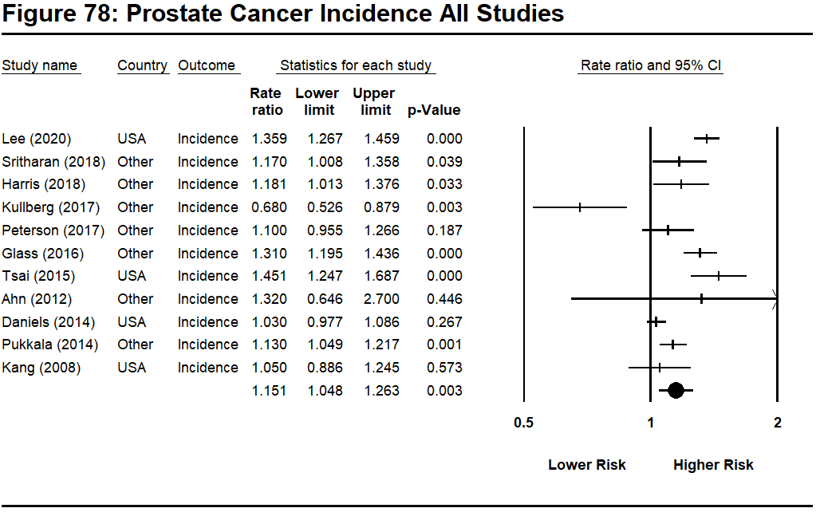
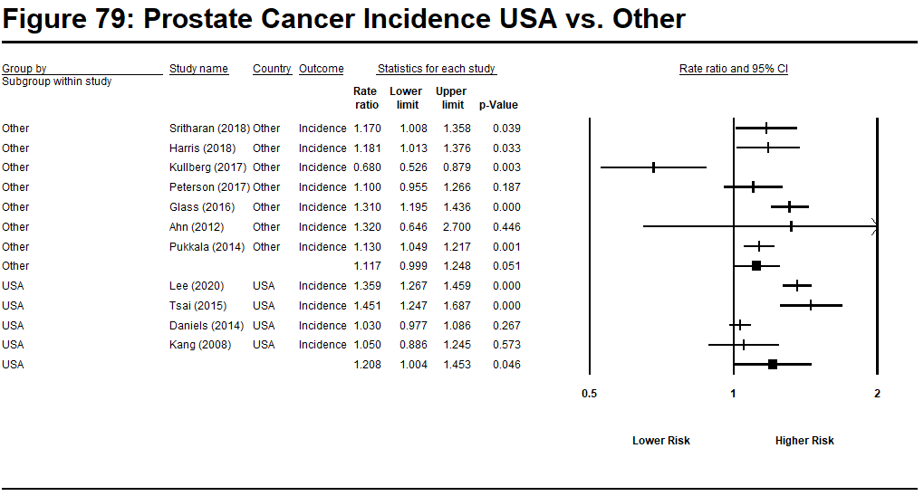
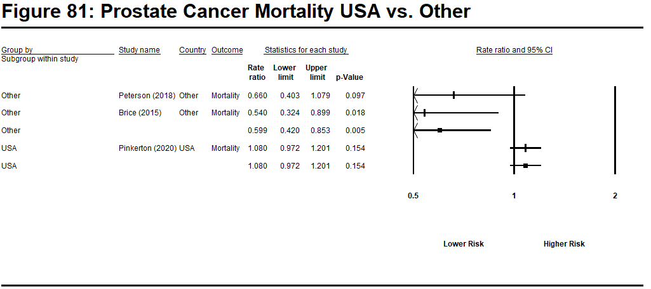
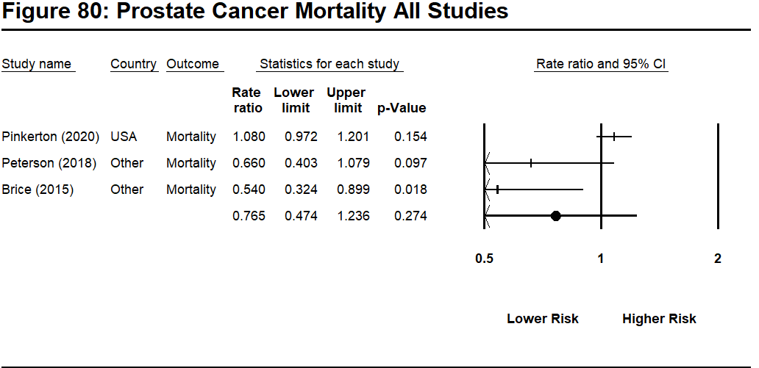

Table 23: Rectum Cancer

Study | Country | Outcome | Rate Ratio (log) | Std Error (log) | Rate Ratio
Pinkerton et al (2020) | US | Mortality | 0.278 | 0.104 | 1.32
Lee et al (2020) | US | Incidence | -0.030 | 0.097 | 0.97
Peterson et al (2018) | Denmark | Mortality | 0.039 | 0.289 | 1.04
Harris et al (2018) | Canada | Incidence | -0.128 | 0.187 | 0.88
Kulberg et al (2017) | Sweden | Incidence | 0.223 | 0.251 | 1.25
Petersen et al (2017) | Denmark | Incidence | 0.199 | 0.125 | 1.22
Glass, et al (2016) | Australia | Incidence | 0.166 | 0.119 | 1.18
Brice, et al (2015) | French | Mortality | 0.307 | 0.220 | 1.36
Daniels, et al (2014) | US | Incidence | 0.104 | 0.080 | 1.11
Pukkala et al (2014) | Nordic | Incidence | -0.010 | 0.095 | 0.99
Kang et al (2008) | US | Incidence | 0.030 | 0.149 | 1.03
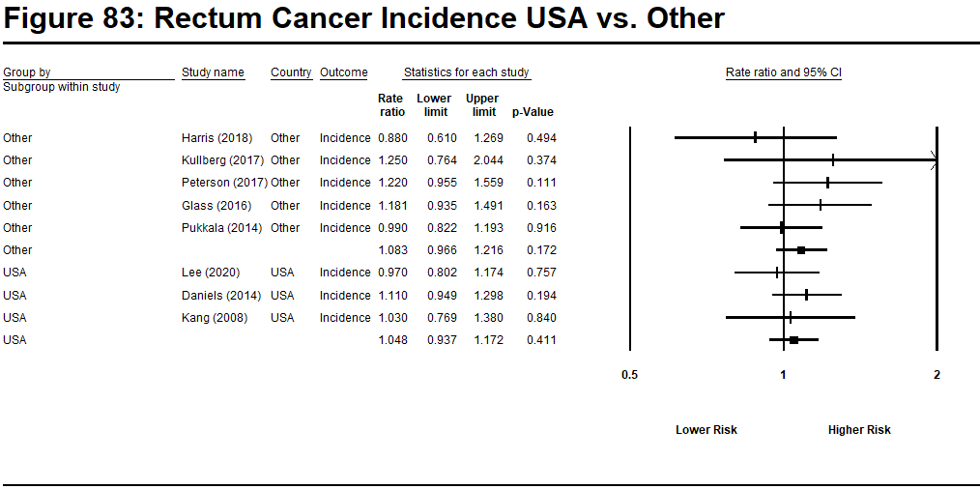
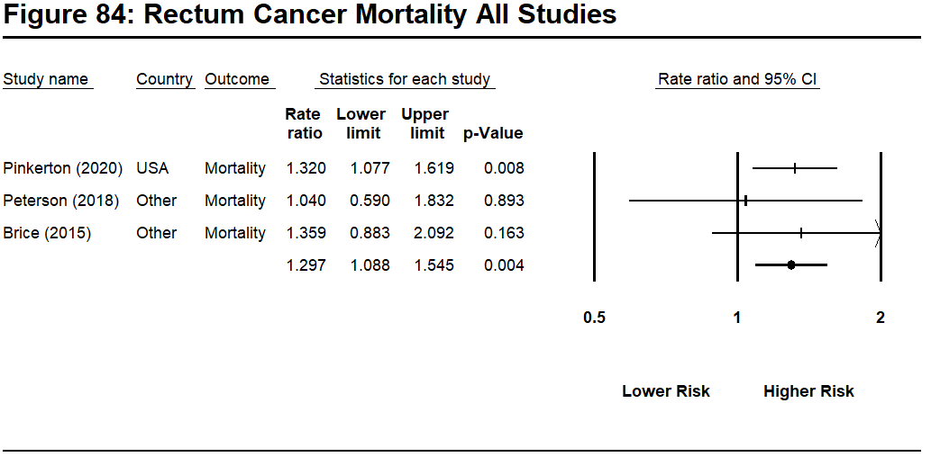
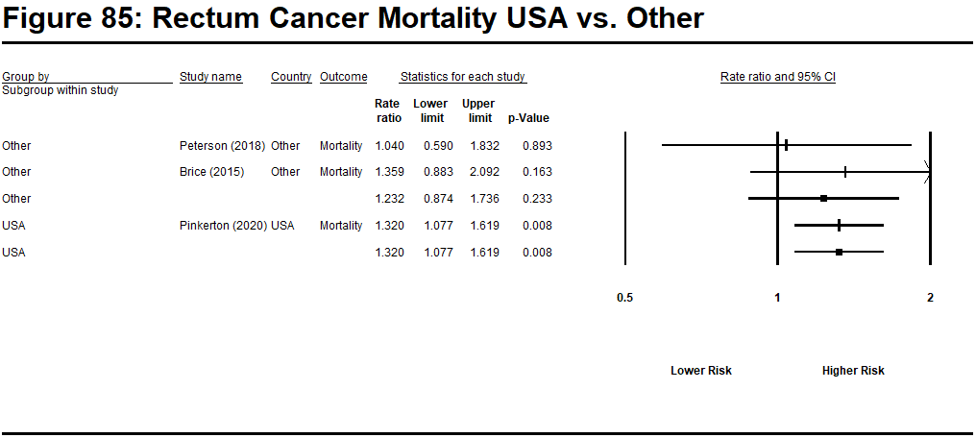
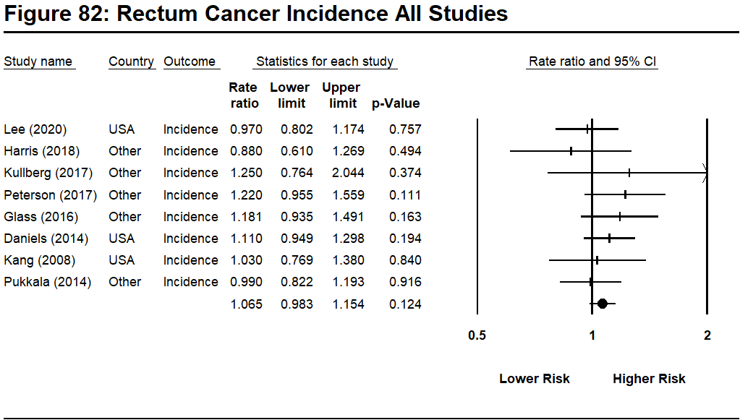

Table 24: Skin Cancer/Malignant Melanoma
Table 24.1: Skin Cancer
Study | Country | Outcome | Rate Ratio (log) | Std Error (log) | Rate Ratio
Pinkerton et al (2020) | US | Mortality | 0.049 | 0.116 | 1.05
Kulberg et al (2017) | Sweden | Incidence | -0.163 | 0.259 | 0.85
Petersen et al (2017) | Denmark | Incidence | 0.000 | 0.056 | 1.00
Brice, et al (2015) | French | Mortality | -0.431 | 0.503 | 0.65
Pukkala et al (2014) | Nordic | Incidence | 0.285 | 0.094 | 1.33
Kang et al (2008) | US | Incidence | 0.039 | 0.156 | 1.04

Table 24.2: Malignant Melanoma
Study | Country | Outcome | Rate Ratio (log) | Std Error (log) | Rate Ratio
Lee et al (2020) | US | Incidence | 0.445 | 0.060 | 1.56
Harris et al (2018) | Canada | Incidence | 0.513 | 0.180 | 1.67
Kulberg et al (2017) | Sweden | Incidence | -1.204 | 0.685 | 0.30
Petersen et al (2017) | Denmark | Incidence | 0.215 | 0.120 | 1.24
Glass, et al (2016) | Australia | Incidence | 0.365 | 0.060 | 1.44
Tsai et al (2015) | US | Incidence | 0.560 | 0.100 | 1.75
Pukkala et al (2014) | Nordic | Incidence | 0.223 | 0.098 | 1.25
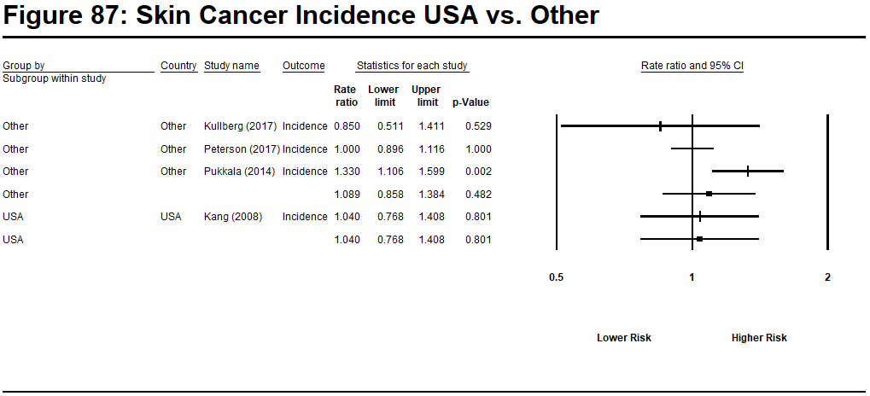
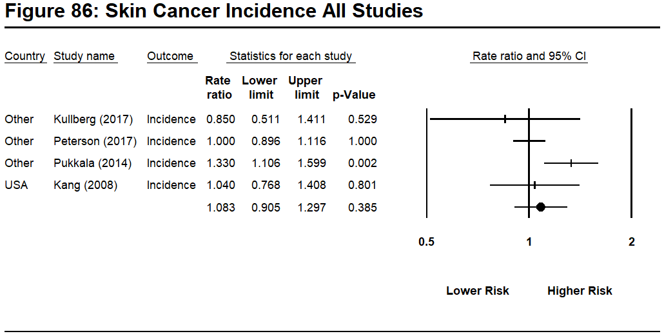

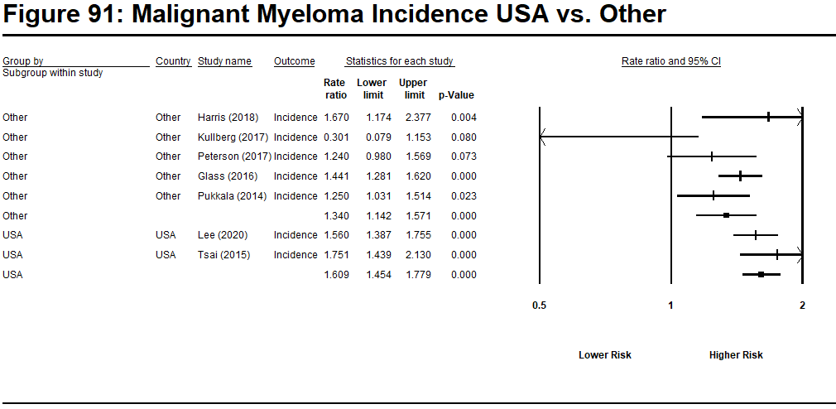
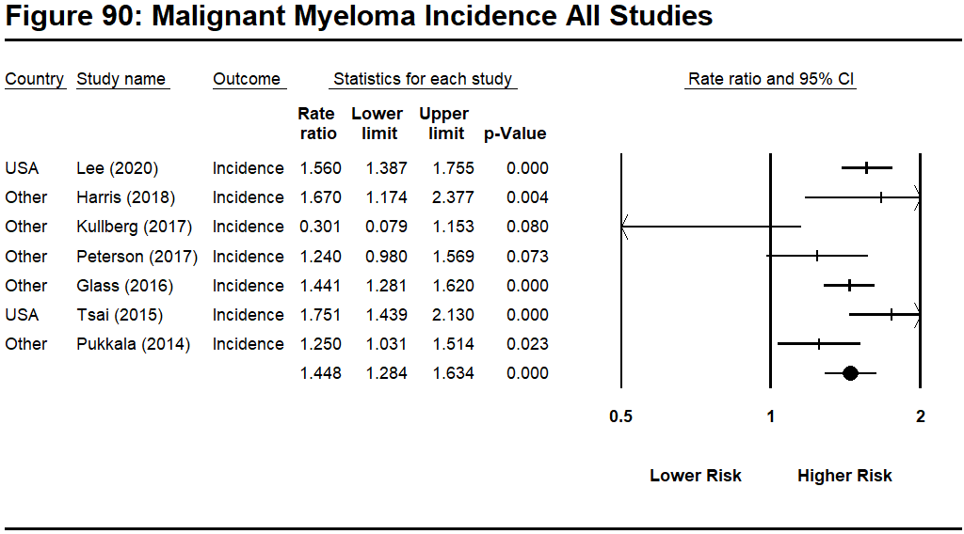
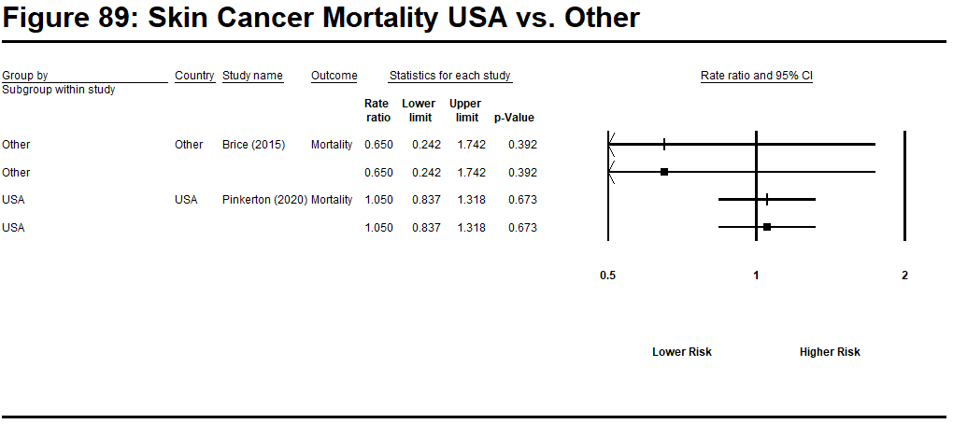
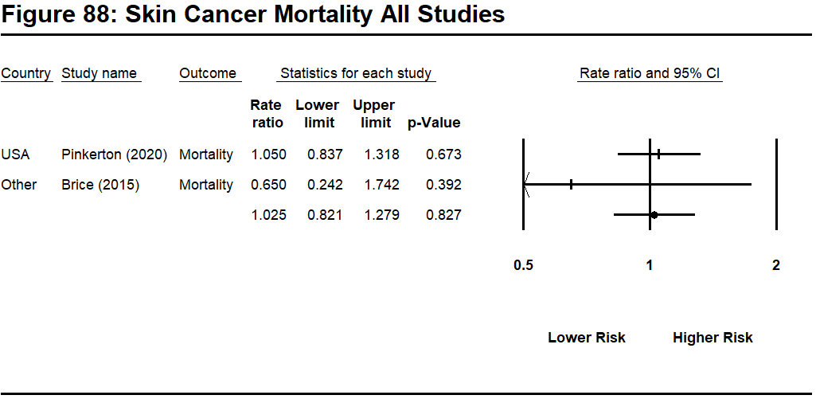

Note: No study provided estimates for Malignant Myeloma Mortality.

Table 25: Small Intestine Cancer

Study | Country | Outcome | Rate Ratio (log) | Std Error (log) | Rate Ratio
Ahn et al (2012) | Korea | Incidence | 0.900 | 0.506 | 2.46
Daniels, et al (2014) | US | Incidence  Mortality | 0.140  0.507 | 0.259  0.386 | 1.15  1.66
Pukkala et al (2014) | Nordic | Incidence | 0.140 | 0.299 | 1.15
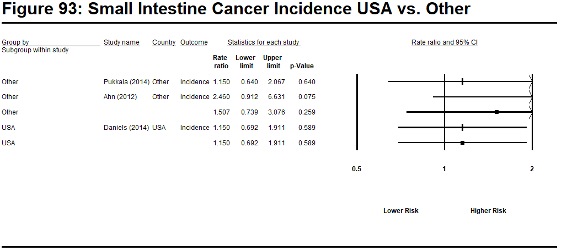
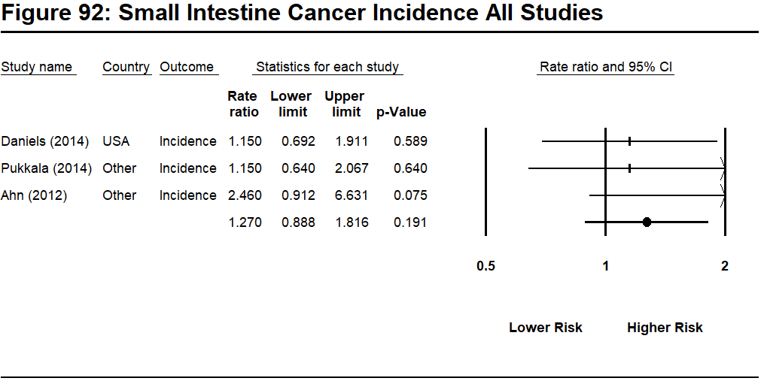

Note: Only one study provided estimates for Small Intestine Cancer Mortality

Table 26: Soft Tissue Sarcoma

Study | Country | Outcome | Rate Ratio (log) | Std Error (log) | Rate Ratio
Lee et al (2020) | US | Incidence | -0.073 | 0.185 | 0.93
Muegge et al (2018) | US | Mortality | 0.916 | 0.449 | 2.50
Petersen et al (2017) | Denmark | Incidence | -0.174 | 0.378 | 0.84
Tsai et al (2015) | US | Incidence | 0.148 | 0.216 | 1.16
Pukkala et al (2014) | Nordic | Incidence | 0.148 | 0.250 | 1.16
Kang et al (2008) | US | Incidence | 0.058 | 0.300 | 1.06
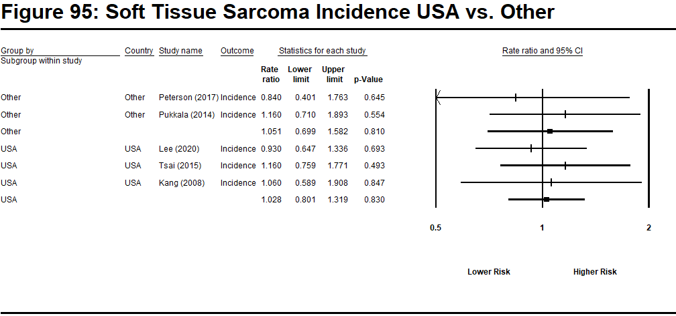
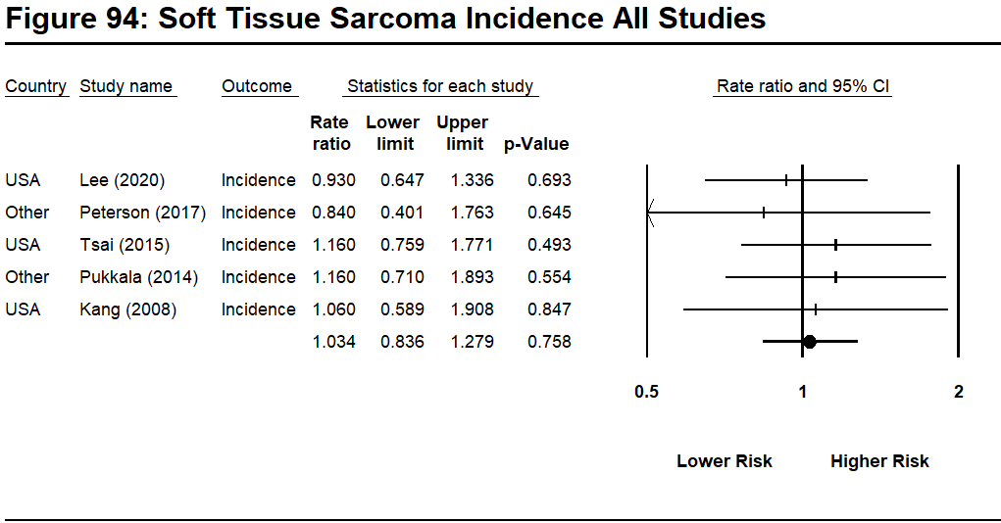

Note: Only one study provided estimates for Soft Tissue Sarcoma Mortality.

Table 27: Stomach Cancer

Study | Country | Outcome | Rate Ratio (log) | Std Error (log) | Rate Ratio
Pinkerton et al (2020) | US | Mortality | 0.058 | 0.094 | 1.06
Lee et al (2019) | US | Incidence | -0.248 | 0.147 | 0.78
Peterson et al (2018) | Denmark | Mortality | 0.673 | 0.243 | 1.96
Harris et al (2018) | Canada | Incidence | -0.446 | 0.354 | 0.64
Kulberg et al (2017) | Sweden | Incidence | 0.637 | 0.201 | 1.89
Petersen et al (2017) | Denmark | Incidence | 0.086 | 0.192 | 1.09
Glass, et al (2016) | Australia | Incidence | -0.010 | 0.182 | 0.99
Tsai et al (2015) | US | Incidence | -0.211 | 0.161 | 0.81
Brice, et al (2015) | French | Mortality | 0.140 | 0.194 | 1.15
Ahn et al (2015) | Korea | Mortality | -0.462 | 0.183 | 0.63
Ahn et al (2012) | Korea | Incidence | -0.073 | 0.101 | 0.93
Daniels, et al (2014) | US | Incidence | 0.140 | 0.104 | 1.15
Pukkala et al (2014) | Nordic | Incidence | 0.086 | 0.091 | 1.09
Kang et al (2008) | US | Incidence | -0.030 | 0.171 | 0.97
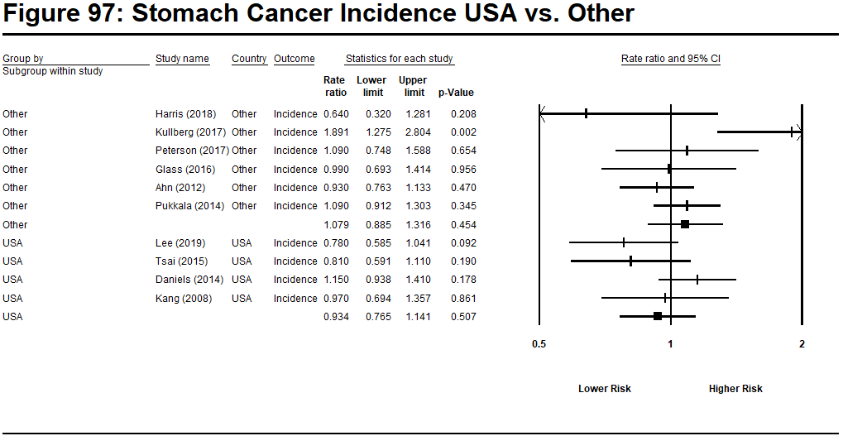
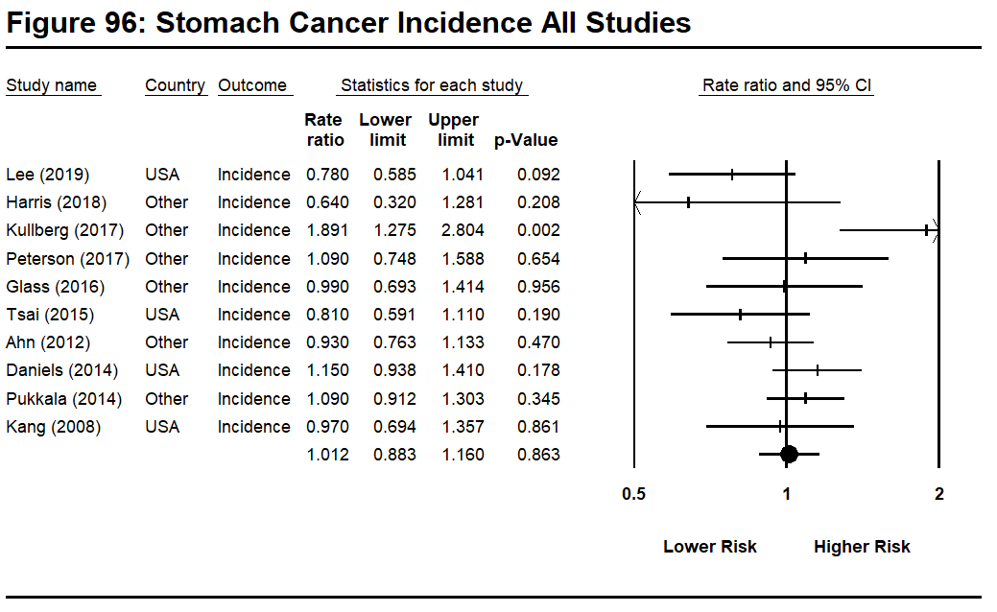
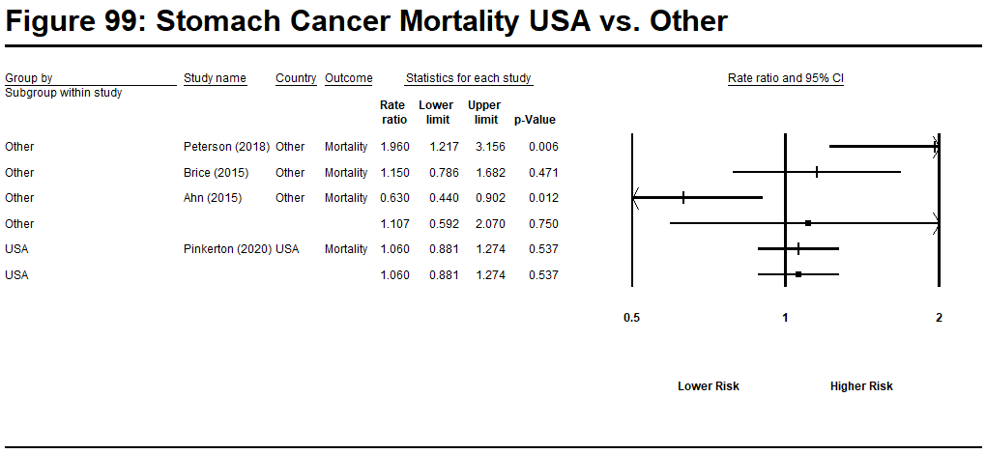
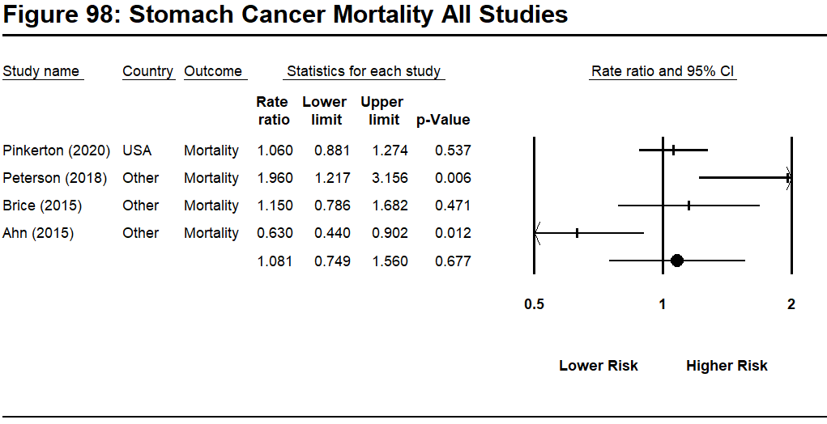

Table 28: Testis Cancer

Study | Country | Outcome | Rate Ratio (log) | Std Error (log) | Rate Ratio
Lee et al (2020) | US | Incidence | 0.507 | 0.111 | 1.66
Harris et al (2018) | Canada | Incidence | 0.588 | 0.381 | 1.80
Petersen et al (2017) | Denmark | Incidence | 0.262 | 0.148 | 1.30
Glass, et al (2016) | Australia | Incidence | 0.223 | 0.158 | 1.25
Tsai et al (2015) | US | Incidence | 0.095 | 0.210 | 1.10
Daniels, et al (2014) | US | Incidence  Morality | -0.288  -0.315 | 0.276  0.678 | 0.75  0.73
Pukkala et al (2014) | Nordic | Incidence | -0.673 | 0.370 | 0.51
Kang et al (2008) | US | Incidence | 0.392 | 0.264 | 1.48
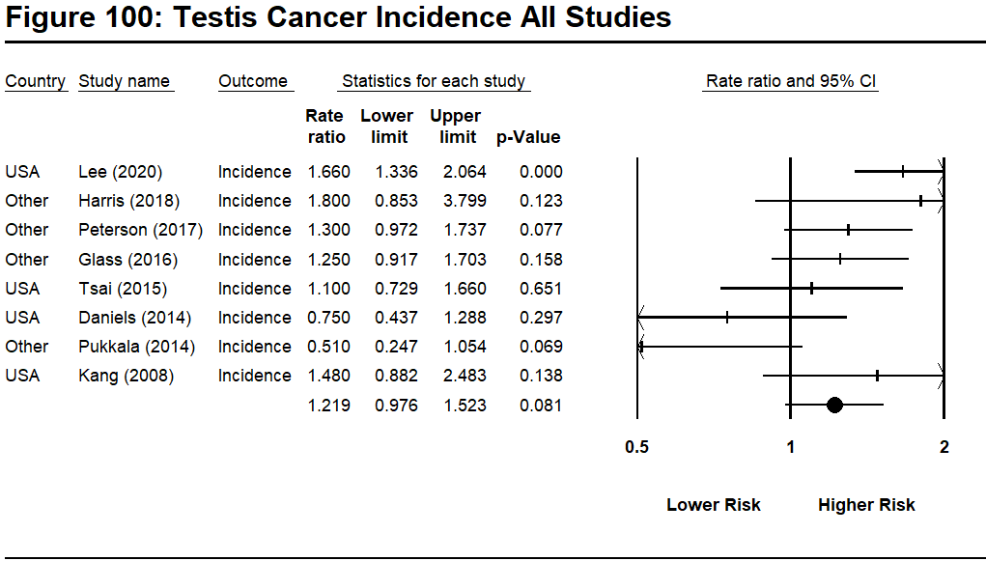
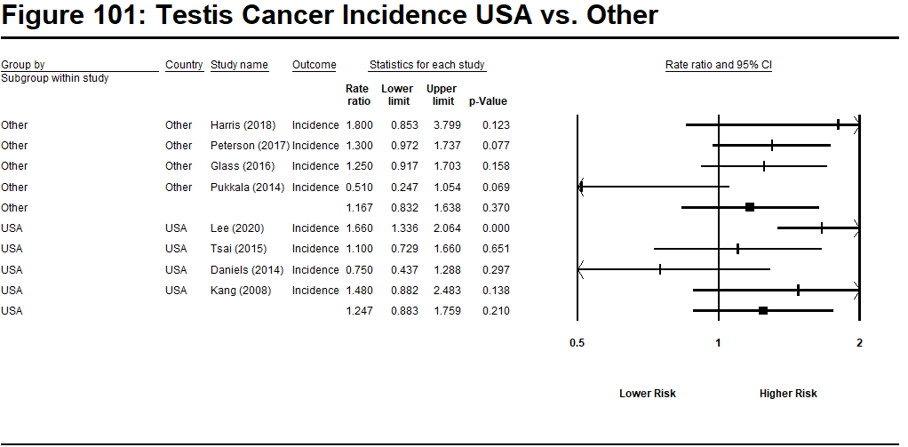
Note: only one study provided estimates for testicular cancer mortality.

Table 29: Thyroid Cancer

Study | Country | Outcome | Rate Ratio (log) | Std Error (log) | Rate Ratio
Lee et al (2020) | US | Incidence | 0.775 | 0.102 | 2.17
Harris et al (2018) | Canada | Incidence | 0.300 | 0.408 | 1.35
Petersen et al (2017) | Denmark | Incidence | 0.191 | 0.410 | 1.21
Glass, et al (2016) | Australia | Incidence | 0.182 | 0.235 | 1.20
Tsai et al (2015) | US | Incidence | 0.239 | 0.188 | 1.27
Ahn et al (2012) | Korea | Incidence | 0.000 | 0.244 | 1.00
Pukkala et al (2014) | Nordic | Incidence | 0.247 | 0.257 | 1.28
Kang et al (2008) 3 | US | Incidence | -0.211 | 0.346 | 0.81
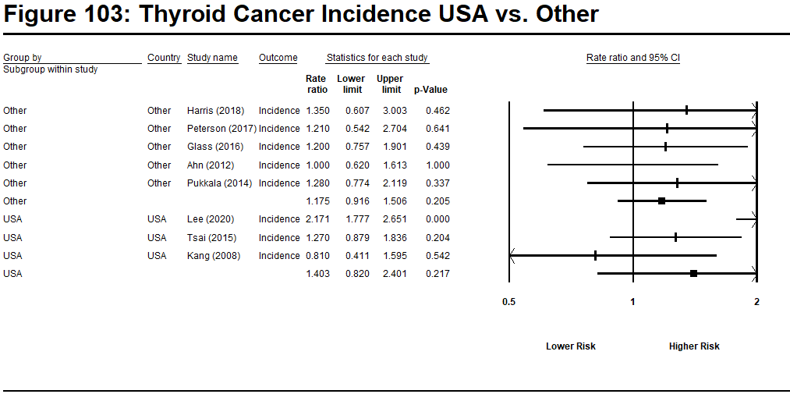
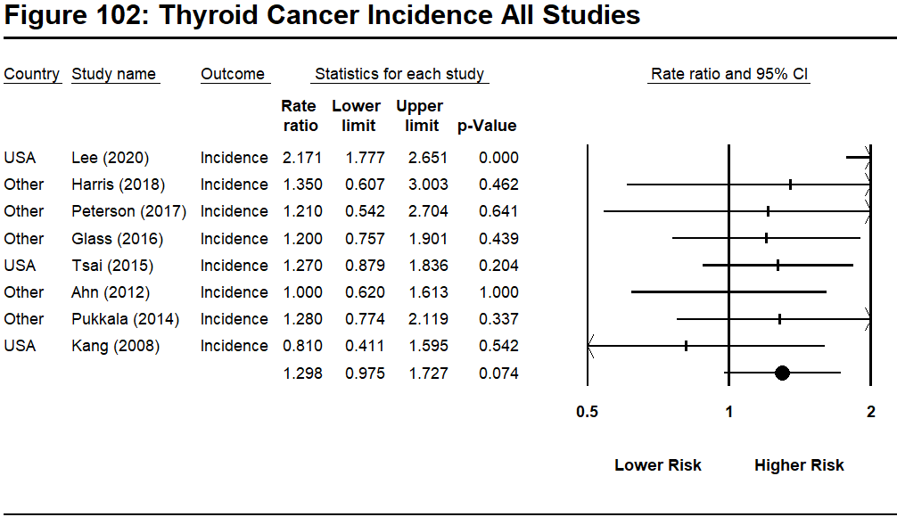

Table 30: Additional outcomes for Swedish cohort of the NOCCA study (Bigert et al., 2020 Swedish subsample)

Cancer Type | Risk Ratio | 95% Confidence Interval
All cancers | 1.03 | 0.97-1.09
Buccal Cavity and Pharynx | 1.04 | 0.55-1.78
Esophagus | 0.71 | 0.38-1.21
Stomach | 1.08 | 0.83-1.39
Colon | 1.01 | 0.82-1.23
Rectum | 0.89 | 0.69-1.14
Liver/Gallbladder | 0.89 | 0.50-1.47
Pancreas | 1.17 | 0.85-1.58
Larynx | 0.92 | 0.48-1.61
Lung | 0.87 | 0.72-1.05
Pleura (mesothelioma) | 1.11 | 0.45-2.29
Soft Tissue Sarcoma | 1.46 | 0.82-2.41
Malignant Melanoma | 1.22 | 0.95-1.54
Skin | 1.48 | 1.20-1.80
Prostate | 1.06 | 0.96-1.16
Testis | 0.39 | 0.11-1.01
Bladder | 1.08 | 0.89-1.31
Brain | 0.89 | 0.63-1.23
Multiple Myeloma | 1.25 | 0.82-1.83
Leukemia | 0.94 | 0.65-1.33
Note: Participants were 8136 Swedish male firefighters. These firefighters were part of the larger NOCCA cohort presented in Pukkala et al, 2014

