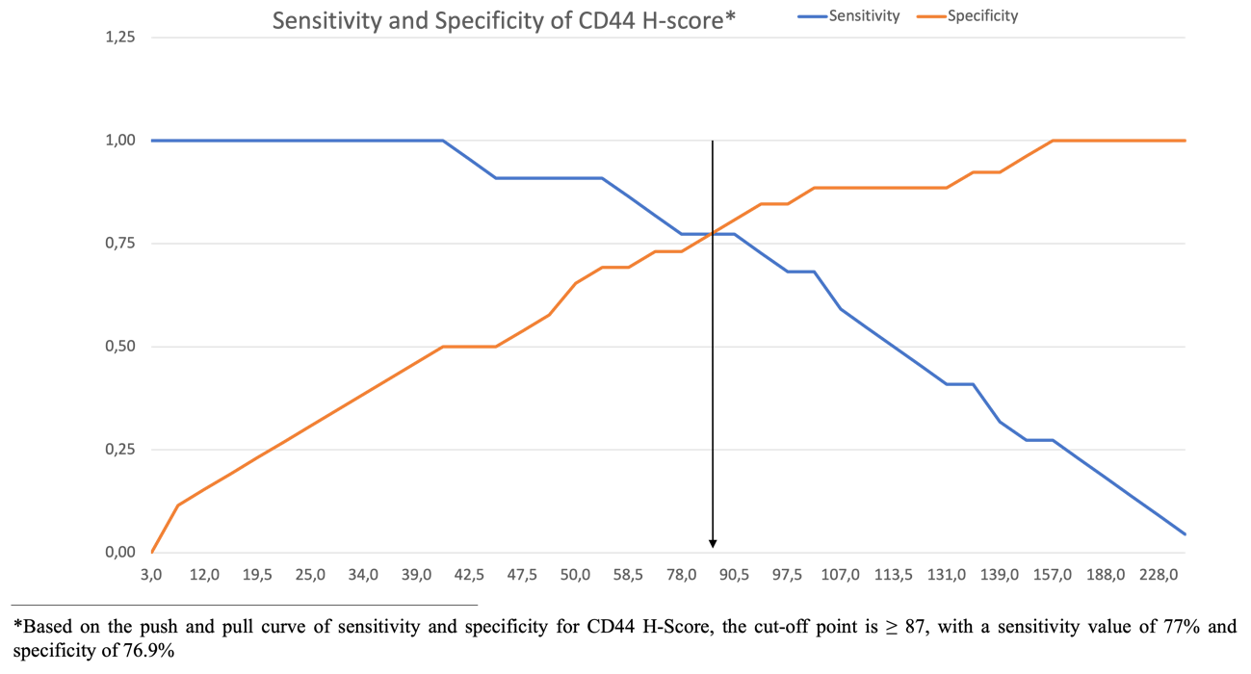

Supplementary Figure 1. Push and Pull Curve of Sensitivity and Specificity for CD44 H-score
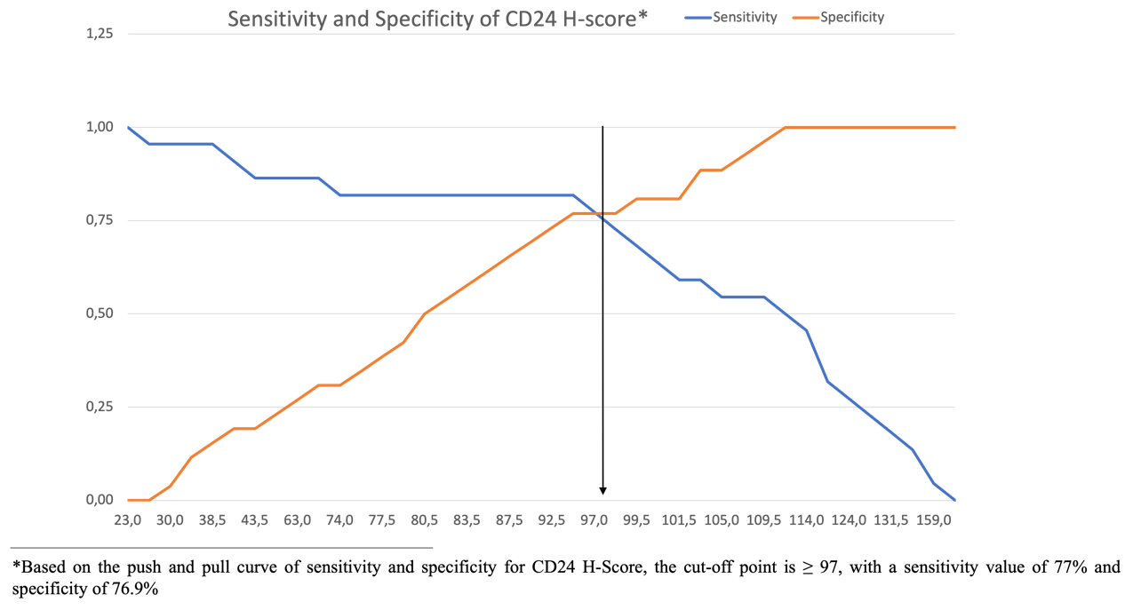

Supplementary Figure 2. Push and Pull Curve of Sensitivity and Specificity for CD24 H-score

Supplementary Table 1. Area Under Curve (AUC) value for CD44 and CD24 H-Score
Variable | AUC Value | P
H-Score CD44 (500 cells) | 0,859 | 0,000
H-Score CD24 (500 cells) | 0,795 | 0,000

Supplementary Table 2. Mean Survival in CD44 Expression
CD44 Expression | Total | Event | Mean Survival (months) | Median (months) | HR | CI 95%
High | 23 | 17 | 13.2 ± 1.8 | 11 | 5.05 | 1.84-13.85
Low | 25 | 5 | 35.4 ± 3

Supplementary Table 3. Mean Survival in CD24 Expression
CD24 Expression | Total | Event | Mean survival (months) | Median (months) | HR | CI 95%
High | 24 | 18 | 13.5 ± 2.4 | 7 | 7.73 | 1.84-13.85
Low | 24 | 4 | 37.4 ± 2.5

Supplementary Table 4. Mean Survival in CD24 Expression
Variable | N (%)
CD44^{high}/CD24 ^{high} | 15 (31.3%)
CD44^{high}/CD24^{low} | 10 (20.8%)
CD44^{low}/CD24^{high} | 7 (14.6%)
CD44^{low}/CD24^{low} | 16 (33.3%)
Total | 48 (100%)

Supplementary Table 5. The Combination of CD44 and CD24 Expression in Relation to 2-Year Recurrence
Variable | Recurrence Within 2 Years
 | Yes  N (%) | No  N (%)
CD44^{high}/CD24 ^{high} | 13 (86.7%) | 2 (13.3%)
CD44^{high}/CD24^{low} | 5 (50%) | 5 (50%)
CD44^{low}/CD24^{high} | 4 (57.1%) | 3 (42.9%)
CD44^{low}/CD24^{low} | 0 (0%) | 16 (100%)

Supplementary Table 6. The Combination of CD44 and/or CD24 in Relation to 2-Year Recurrence
Variable | Recurrence Within 2 Years |  | Total | p
 | Yes | No
CD44^{high}/CD24 ^{high} | 13 (86.7%) | 2 (13.3%) | 15 | 0,000*
Either CD^{high} | 9 (52.9%) | 8 (47.1%) | 17
CD44^{low}/CD24^{low} | 0 (0%) | 16 (100%) | 16

* Kruskall-Wallis test; mean rank CD44^{high}/CD24^{high} 34.45; mean rank of either of CD^{high} 26.21; mean rank CD44^{low}/CD24^{low} 13.5

Supplementary Table 7. The Combination of CD44 and CD24 expression in relation to Disease-free Survival
Variable | Mean ± SD  (months) | Median  (months)
CD44^{high}/CD24 ^{high} | 10.44 ± 1.88 | 7
Only one of CD^{high} | 18.94 ± 3.18 | 12

