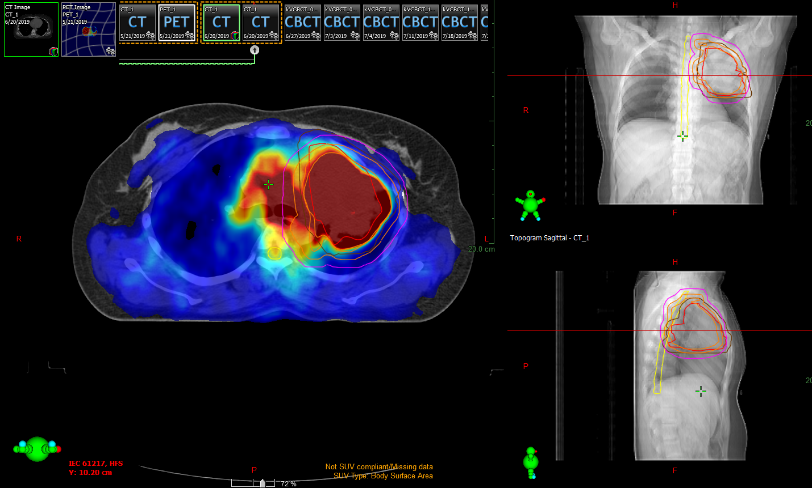
Figure 6: Contouring on PET-CT & planning CECT fused image
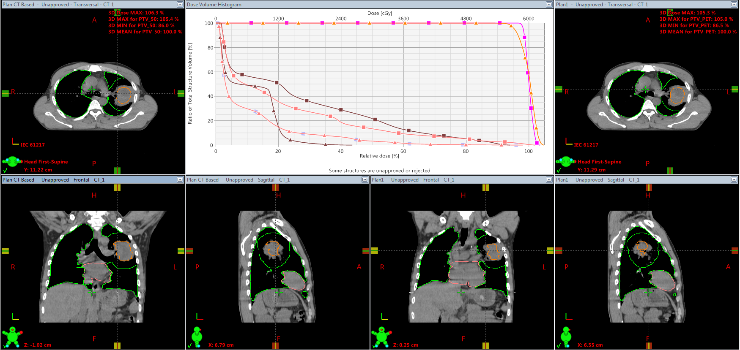
Figure 7: Dose Volume Histogram (DVH) & contouring of tumor at different sections
CECT Based Plan
PET Based Plan

≡ PTV coverage ≡ PTV coverage
≡ Dose on Esophagus ≡ Dose on Esophagus
≡ Dose on Heart ≡ Dose on Heart
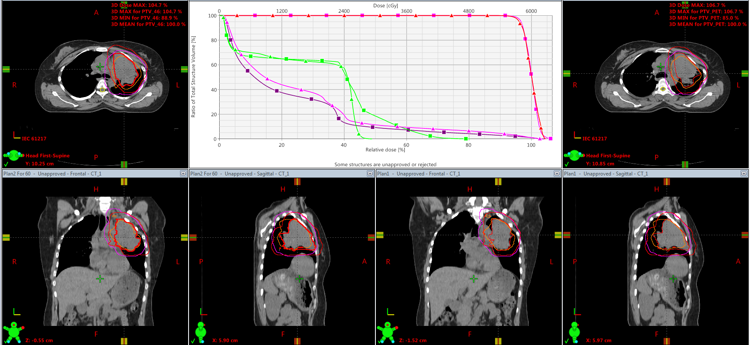
Figure 8: DVH & contouring of tumor at different sections
PET Based Plan

CECT Based Plan

≡ Dose on Spinal cord ≡ Dose on Spinal cord
≡ Dose on Heart ≡ Dose on Heart
≡ PTV coverage ≡ PTV coverage
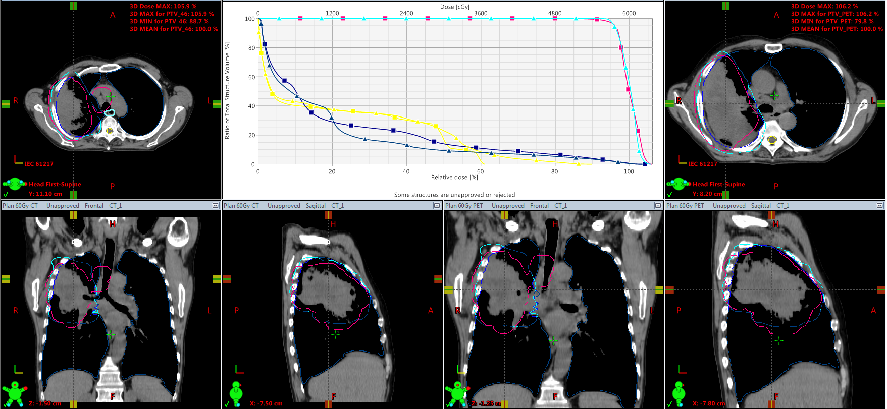
Figure 9: DVH & contouring of tumor at different sections
PET Based Plan
CT Based Plan

≡ PTV coverage ≡ PTV coverage
≡ Dose on contralateral lung ≡ Dose on contralateral lung
≡ Dose on Spinal cord ≡ Dose on Spinal cord
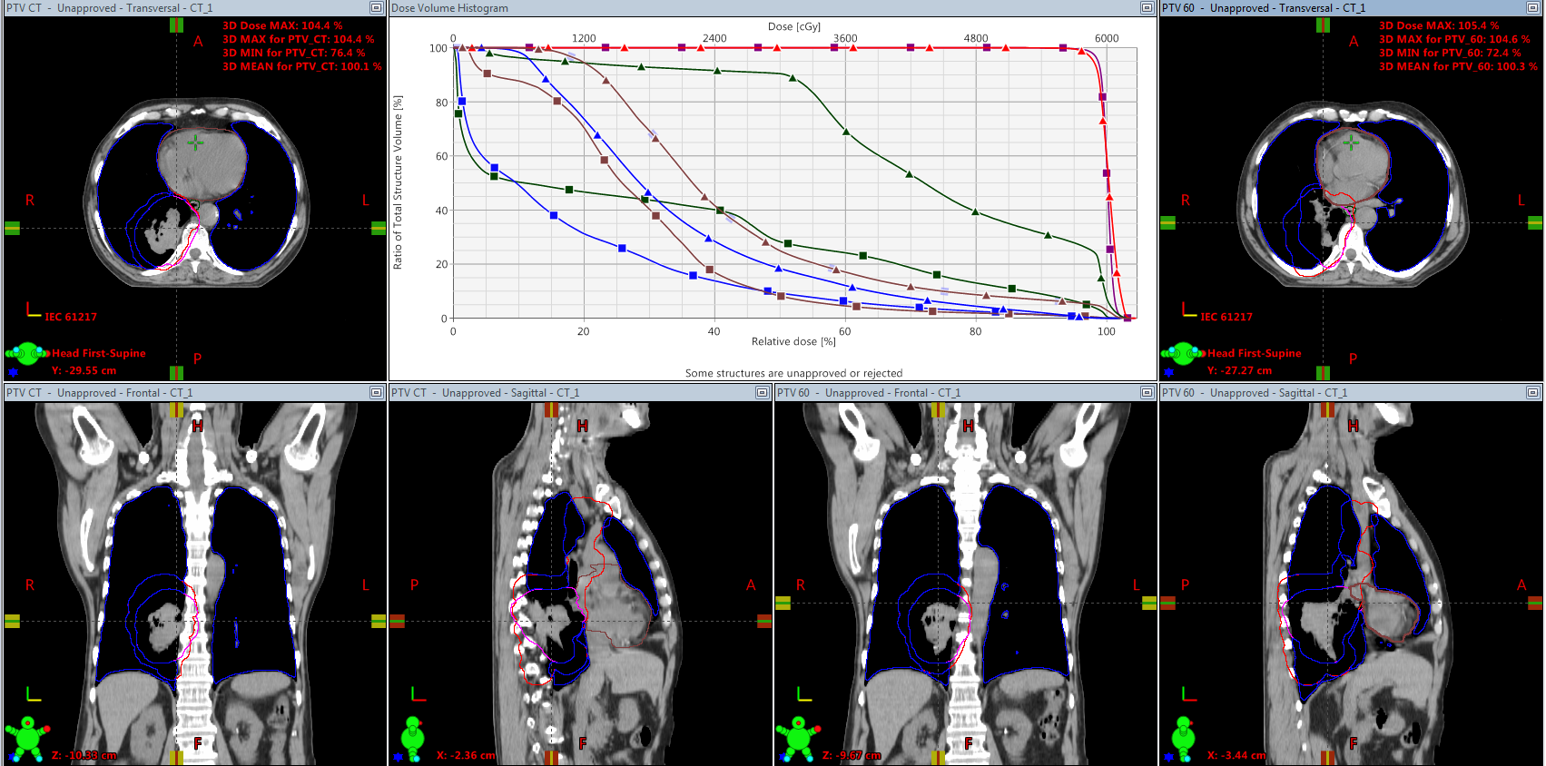
Figure 10: DVH & contouring of tumor at different sections
CECT Based Plan
PET Based Plan

≡ PTV coverage ≡ PTV coverage
≡ Dose on Eshophagus ≡ Dose on Esophagus
≡ Dose on Heart ≡ Dose on Heart
≡ Mean lung dose ≡ Mean lung dose

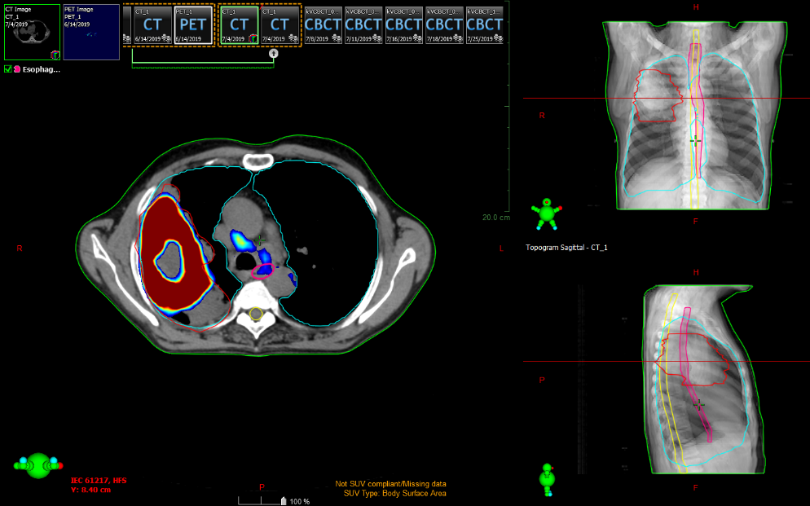
Figure 11: Planning CECT & PET–CT fused image showing GTV and atelectasis inside tumor
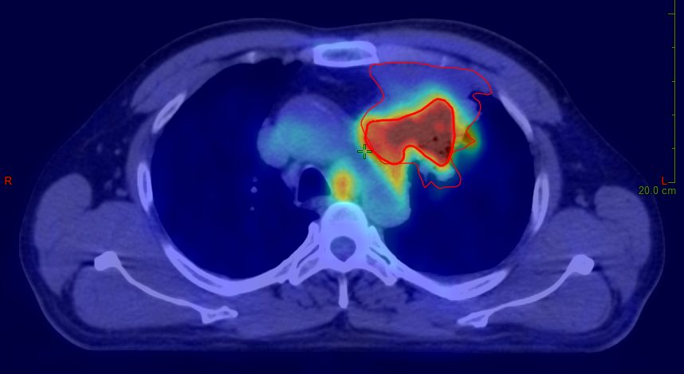
Figure 12: Planning CECT, PET-CT & fusion image shows Gross tumor volume

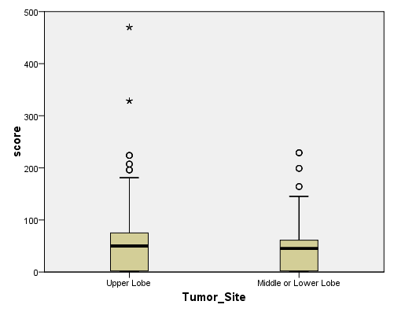
Figure 13: Box-Whisker plot showing comparison of parameters based on Tumor sites

Figure 14: Bar diagram showing demographic characteristics of study population

Figure 15: Pie chart showing distribution of tumor staging

Figure 16: Pie chart showing distribution of nodal staging

