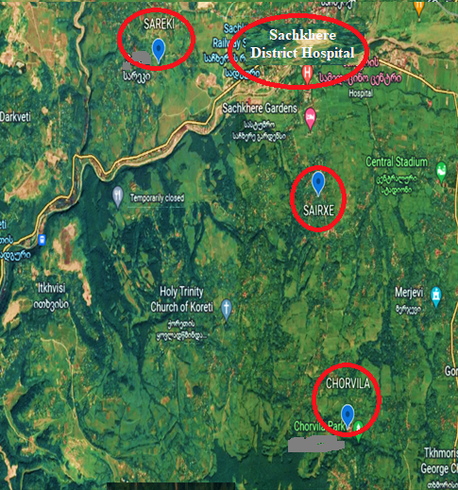
Figure 1. Map of the rural area of Sachkhere District

