Supplementary Figure 1. Risk of bias within studies. A) Were the two groups similar and recruited from the same population? B) Were the exposures measured similarly to assign people to both exposed and unexposed groups? C) Was the exposure measured in a valid and reliable way? D) Were confounding factors identified? E) Were strategies to deal with confounding factors stated? F) Were the groups/participants free of the outcome at the start of the study (or at the moment of exposure)? G) Were the outcomes measured in a valid and reliable way? H) Was the follow up time reported and sufficient to belong enough for outcomes to occur? I) Was follow up complete, and if not, were the reasons to loss to follow up described and explored? J) Were strategies to address incomplete follow up utilized? K) Was appropriate statistical analysis used?

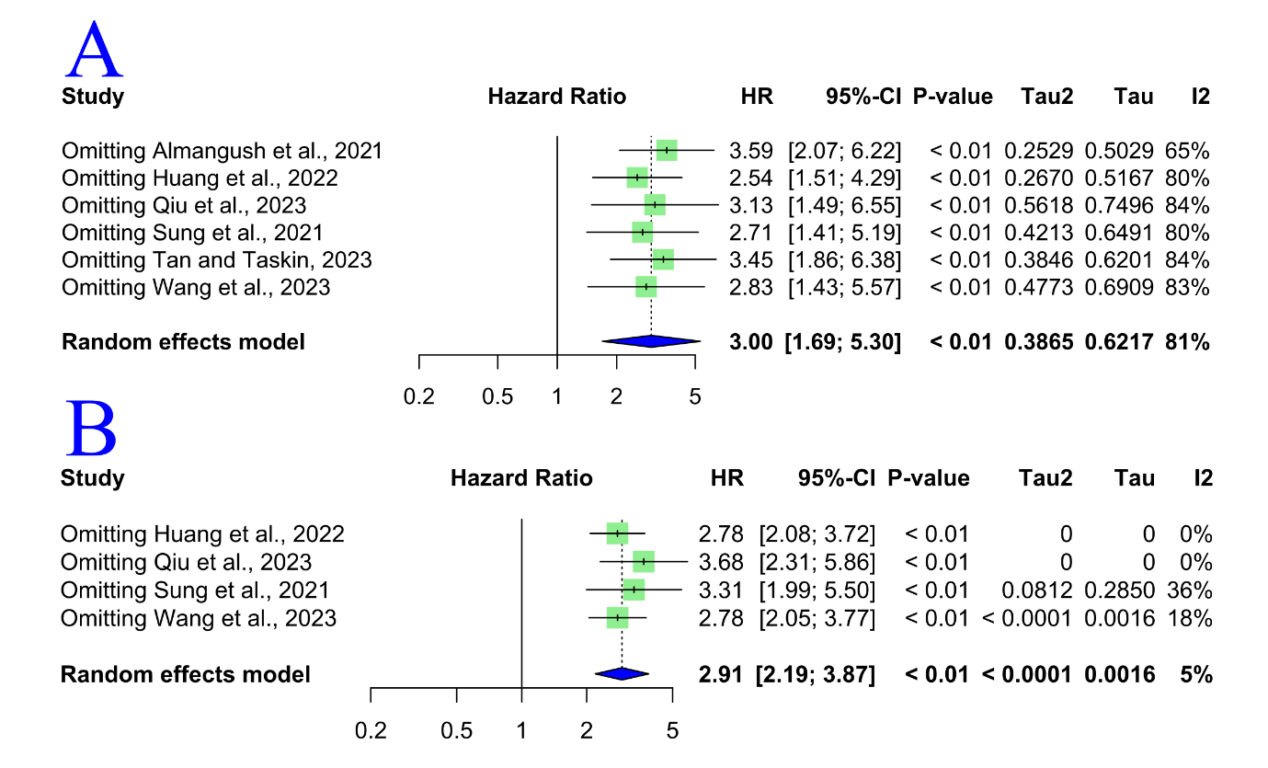

Supplementary Figure 2. Sensitivity analysis for the overall survival meta-analyses. (A) univariate analysis, (B) multivariate analysis

Supplementary Figure 3. Sensitivity analysis for the disease-specific survival meta-analyses. (A) univariate analysis, (B) multivariate analysis

Supplementary Figure 4. Sensitivity analysis for the disease-free survival meta-analyses. (A) univariate analysis, (B) multivariate analysis

Supplementary Table 1. Data search strategy

|  |  |  |
| --- | --- | --- |
| Database | Search | Number of records |
| **PubMed** | (“Mouth Neoplasms”[Mesh] OR “Mouth Neoplasms” OR “Mouth Neoplasm” OR “Oral Neoplasm” OR “Oral Neoplasms” OR “Cancer of Mouth” OR “Mouth Cancers” OR “Oral Cancer” OR “Oral Cancers” OR “Cancer of the Mouth” OR “Mouth Cancer” OR “Oral Squamous Cell Carcinoma” OR “Oral Tongue Squamous Cell Carcinoma” OR “Oral Cavity Squamous Cell Carcinoma” OR “Oral Squamous Cell Carcinomas” OR “Squamous Cell Carcinoma of the Mouth”) AND (“Tumor-stroma Ratio” OR “Carcinoma-stroma Ratio” OR “TSR” OR “Stromas” OR “Stroma” OR “Stromal Ratio” OR “Tumour-stroma” OR “Tumor Stroma” OR “Tumour Stroma”) AND (“Survival”[Mesh] OR “Survival” OR “Prognosis”[Mesh] OR “Prognosis” OR “Prognoses” OR “Prognostic Factors” OR “Prognostic Factor” OR “overall survival” OR “hazard ratio” OR “disease-free survival” OR “disease-specific survival” OR “Cancer-specific survival”) | 291 |
| **EMBASE** | #1“Mouth Neoplasms” OR “Mouth Neoplasm” OR “Oral Neoplasm” OR “Oral Neoplasms” OR “Cancer of Mouth” OR “Mouth Cancers” OR “Oral Cancer” OR “Oral Cancers” OR “Cancer of the Mouth” OR “Mouth Cancer” OR “Oral Squamous Cell Carcinoma” OR “Oral Tongue Squamous Cell Carcinoma” OR “Oral Cavity Squamous Cell Carcinoma” OR “Oral Squamous Cell Carcinomas” OR “Squamous Cell Carcinoma of the Mouth”  #2 “Tumor-stroma Ratio” OR “Carcinoma-stroma Ratio” OR TSR OR Stromas OR Stroma OR “Stromal Ratio” OR “Tumour-stroma” OR “Tumor Stroma” OR “Tumour Stroma”  #3 “Survival” OR Prognosis OR Prognoses OR “Prognostic Factors” OR “Prognostic Factor” OR “overall survival” OR “hazard ratio” OR “disease-free survival” OR “disease-specific survival” OR “Cancer-specific survival”  #1 AND #2 AND #3 | 596 |
| **SCOPUS** | TITLE-ABS-KEY ( "Mouth Neoplasms" OR "Mouth Neoplasm" OR "Oral Neoplasm" OR "Oral Neoplasms" OR "Cancer of Mouth" OR "Mouth Cancers" OR "Oral Cancer" OR "Oral Cancers" OR "Cancer of the Mouth" OR "Mouth Cancer" OR "Oral Squamous Cell Carcinoma" OR "Oral Tongue Squamous Cell Carcinoma" OR "Oral Cavity Squamous Cell Carcinoma" OR "Oral Squamous Cell Carcinomas" OR "Squamous Cell Carcinoma of the Mouth" ) AND TITLE-ABS-KEY ( "Tumor-stroma Ratio" OR "Carcinoma-stroma Ratio" OR tsr OR stromas OR stroma OR "Stromal Ratio" OR "Tumour-stroma" OR "Tumor Stroma" OR "Tumour Stroma" ) AND TITLE-ABS-KEY ( "Survival" OR prognosis OR prognoses OR "Prognostic Factors" OR "Prognostic Factor" OR "overall survival" OR "hazard ratio" OR "disease-free survival" OR "disease-specific survival" OR "Cancer-specific survival" ) | 272 |
| **LIVIVO** | (“Mouth Neoplasms” OR “Mouth Neoplasm” OR “Oral Neoplasm” OR “Oral Neoplasms” OR “Cancer of Mouth” OR “Mouth Cancers” OR “Oral Cancer” OR “Oral Cancers” OR “Cancer of the Mouth” OR “Mouth Cancer” OR “Oral Squamous Cell Carcinoma” OR “Oral Tongue Squamous Cell Carcinoma” OR “Oral Cavity Squamous Cell Carcinoma” OR “Oral Squamous Cell Carcinomas” OR “Squamous Cell Carcinoma of the Mouth”) AND (“Tumor-stroma Ratio” OR “Carcinoma-stroma Ratio” OR TSR OR Stromas OR Stroma OR “Stromal Ratio” OR “Tumour-stroma” OR “Tumor Stroma” OR “Tumour Stroma”)  [by title] | 128 |
| Web of Science | (“Mouth Neoplasms” OR “Mouth Neoplasm” OR “Oral Neoplasm” OR “Oral Neoplasms” OR “Cancer of Mouth” OR “Mouth Cancers” OR “Oral Cancer” OR “Oral Cancers” OR “Cancer of the Mouth” OR “Mouth Cancer” OR “Oral Squamous Cell Carcinoma” OR “Oral Tongue Squamous Cell Carcinoma” OR “Oral Cavity Squamous Cell Carcinoma” OR “Oral Squamous Cell Carcinomas” OR “Squamous Cell Carcinoma of the Mouth”) AND (“Tumor-stroma Ratio” OR “Carcinoma-stroma Ratio” OR TSR OR Stromas OR Stroma OR “Stromal Ratio” OR “Tumour-stroma” OR “Tumor Stroma” OR “Tumour Stroma”) AND (“Survival” OR Prognosis OR Prognoses OR “Prognostic Factors” OR “Prognostic Factor” OR “overall survival” OR “hazard ratio” OR “disease-free survival” OR “disease-specific survival” OR “Cancer-specific survival”) | 196 |
| **Google Scholar** | (“Oral Neoplasm” OR “Oral Neoplasms” OR “Cancer of Mouth” OR “Oral Cancer” OR “Oral Cancers” OR “Mouth Cancer” OR “Oral Squamous Cell Carcinoma”) AND “Tumor-stroma Ratio” AND Survival | 100 |

Supplementary Table 2. Pooled estimates for demographic and clinicopathological feature of patients

|  |  |  |  |  |
| --- | --- | --- | --- | --- |
| Characteristics | Effect size (%) | 95% CI | Heterogeneity | |
| I2 (%) | p |
| Age (years) | 57.51* | [52.38; 62.64] | 96 | <0.01 |
| Follow-up (months) | 51.34* | [40.19; 62.49] | 99 | <0.01 |
| Gender |  |  |  |  |
| Male | 61.28 | [56.04; 66.53] | 81 | <0.01 |
| Female | 38.72 | [33.47; 43.96] | 81 | <0.01 |
| Site |  |  |  |  |
| Tongue | 80.12 | [67.13; 93.12] | 99 | <0.01 |
| Other | 19.88 | [6.88; 32.87] | 99 | <0.01 |
| Tumor |  |  |  |  |
| T1 | 33.89 | [29.90; 37.88] | 56 | 0.05 |
| T2 | 48.85 | [37.36; 60.34] | 95 | <0.01 |
| T3 | 11.91 | [2.40; 21.41] | 98 | <0.01 |
| T4 | 4.08 | [0.06; 8.10] | 94 | <0.01 |
| Lymph node |  |  |  |  |
| N0 | 79.96 | [63.08; 96.83] | 99 | <0.01 |
| N1 | 6.06 | [0.43; 11.68] | 97 | <0.01 |
| N2 | 9.29 | [0.00; 18.76] | 97 | <0.01 |
| N3 | 3.87 | [0.00; 10.03] | 93 | <0.01 |
| Histologic grade |  |  |  |  |
| Well-differentiated | 32.07 | [22.71; 41.44] | 92 | <0.01 |
| Moderately differentiated | 57.58 | [46.89; 68.28] | 94 | <0.01 |
| Poorly differentiated | 10.06 | [4.79; 15.34] | 92 | <0.01 |
| Stages |  |  |  |  |
| Early | 65.12 | [48.76; 81.48] | 99 | 0 |
| Advanced | 34.60 | [18.41; 50.79] | 99 | <0.01 |
| Tumor-stroma ratio |  |  |  |  |
| Stroma-poor | 52.10 | [45.66; 58.54] | 88 | <0.01 |
| Stroma-rich | 47.90 | [41.46; 54.34] | 88 | <0.01 |

*Mean; CI, confidence interval.

Supplementary Table 3. Subgroup analyses for overall survival (univariate analysis)

|  |  |  |  |
| --- | --- | --- | --- |
| Subgroup | HR (95% CI) | Heterogeneity | |
|  |  | I2 (%) | p |
| Asia | 3.59 (2.07-6.22) | 65 | 0.02 |
| China | 4.21 (2.14-8.28) | 62 | 0.07 |

CI, confidence interval; HR, hazard ratio.

Supplementary Table 4. Subgroup analyses for disease-specific survival

|  |  |  |  |
| --- | --- | --- | --- |
| Univariate analysis | | | |
| Subgroup | HR (95% CI) | Heterogeneity | |
|  |  | I2 (%) | p |
| China | 2.89 (2.07-4.02) | 0 | 0.44 |
| Multivariate analysis | | | |
| China | 2.80 (1.90-4.13) | 10 | 0.29 |

CI, confidence interval; HR, hazard ratio.

Supplementary Table 5. Subgroup analyses for disease-free survival

|  |  |  |  |
| --- | --- | --- | --- |
| Univariate analysis | | | |
| Subgroup | HR (95% CI) | Heterogeneity | |
|  |  | I2 (%) | p |
| Asia | 2.86 (2.19-3.73) | 20 | 0.28 |
| China | 2.45 (1.93-3.10) | 0 | 0.75 |
| Tongue | 1.97 (1.43-2.73) | 0 | 0.42 |
| Multivariate analysis | | | |
| Asia | 2.20 (1.77-2.75) | 0 | 0.83 |
| China | 2.08 (1.63-2.65) | 0 | 0.98 |
| Tongue | 1.82 (1.19-2.79) | 0 | 0.63 |

CI, confidence interval; HR, hazard ratio.

Supplementary Table 6. Excluded articles and reasons for exclusion (n = 8)

|  |  |
| --- | --- |
| Author | Reasons for exclusion |
| [1-2] | The sample reported in another included study |
| [3-8] | Hazard ratio was not reported |

**References**

1. Almangush A, Heikkinen I, Bakhti N, Mäkinen LK, Kauppila JH, Pukkila M, et al. Prognostic impact of tumour–stroma ratio in early‐stage oral tongue cancers. Histopathology. 2018;72(7):1128–35. https://doi.org/10.1111/his.13481.

2. Silva GVD, Da Silva Dolens E, Paranaíba LMR, Ayroza ALC, Gurgel Rocha CA, Almangush A, et al. Exploring the combination of tumor‐stroma ratio, tumor‐infiltrating lymphocytes, and tumor budding with WHO histopathological grading on early‐stage oral squamous cell carcinoma prognosis. J Oral Pathol Med. 2023;52(5):402–9. https://doi.org/10.1111/jop.13359.

3. Singh P, Somani K, Poduwal S, Singh G. A Study of Histological and Clinical Parameters and Their Correlation With Lymph Node Metastasis and Two-Year Survival in 50 Cases of Oral Squamous Cell Carcinoma. Cureus. 2024;16(4):1–21. https://doi.org/10.7759/cureus.59045.

4. Guo J, Liu X, Zeng Y, Liang T, Tang K, Guo J, et al. Comprehensive Analysis of the Effects of Genetic Ancestry and Genetic Characteristics on the Clinical Evolution of Oral Squamous Cell Carcinoma. Front Cell Dev Biol. 2021;9:1–14. https://doi.org/10.3389/fcell.2021.678464.

5. Hyytiäinen A, Mroueh R, Peltonen J, Wennerstrand P, Mäkitie A, Al‐Samadi A, et al. Prognostic histological markers in oral tongue squamous cell carcinoma patients treated with (chemo)radiotherapy. APMIS. 2023;131(4):142–51. https://doi.org/10.1111/apm.13298.

6. Niranjan KC, Sarathy NA. Prognostic impact of tumor-stroma ratio in oral squamous cell carcinoma - A pilot study. Ann Diagn Pathol. 2018;35:56–61. https://doi.org/10.1016/j.anndiagpath.2018.05.005.

7. Grawish ME, Denewar M, Ahmed RA, Abouzid A, Esmaeil DA, Mourad MI. Tumor stroma ratio as a parameter for prognosis and clinicopathological behavior of oral squamous cell carcinoma: A retrospective cohort study. J Solid Tumors. 2021;10(2):36–42. https://doi.org/10.5430/jst.v10n2p36.

8. Knief J, Herber K, Muenscher A, Thorns C, Moeckelmann N. Tumor-stroma ratio in preoperative biopsies and matched surgical specimens in oral squamous cell carcinoma: Concordance and impact on recurrence-free and overall survival. Pathol - Res Pract. 2024;255:1–5. https://doi.org/10.1016/j.prp.2024.155211.