SUPPLEMENTAL MATERIAL:
Industry Strategies for Attracting Youth to Cigarettes, E-cigarettes, and HTPs: Retailer Density and Marketing at Points-of-Sale in Vietnam and the Philippines

TABLE OF CONTENTS
FIGURE S1. Sample selection in Vietnam and the Philippines 2
TABLE S1. TAPS policies in areas without sales restrictions (i.e., greater than 100m from a youth-oriented center such as a school) in Vietnam and the Philippines 3
TABLE S2. Retailer types in areas with and without sales restrictions, by country and product type 4
Table S3. Retailer marketing tactics in areas with (i.e., within 100m of schools) and without (VT: within 100m of post offices; PH: 100-200m from schools) sales restrictions in Vietnamª and the Philippines and compliance with TAPS regulations in areas without sales restrictions 5
FIGURE S2. Example photos of marketing tactics observed in Vietnam and the Philippines 6
APPENDIX 1. OBSERVATION FORM (VIETNAM) 7
APPENDIX 2. OBSERVATION FORM (THE PHILIPPINES) 16

FIGURE S1. Sample selection in Vietnam and the Philippines
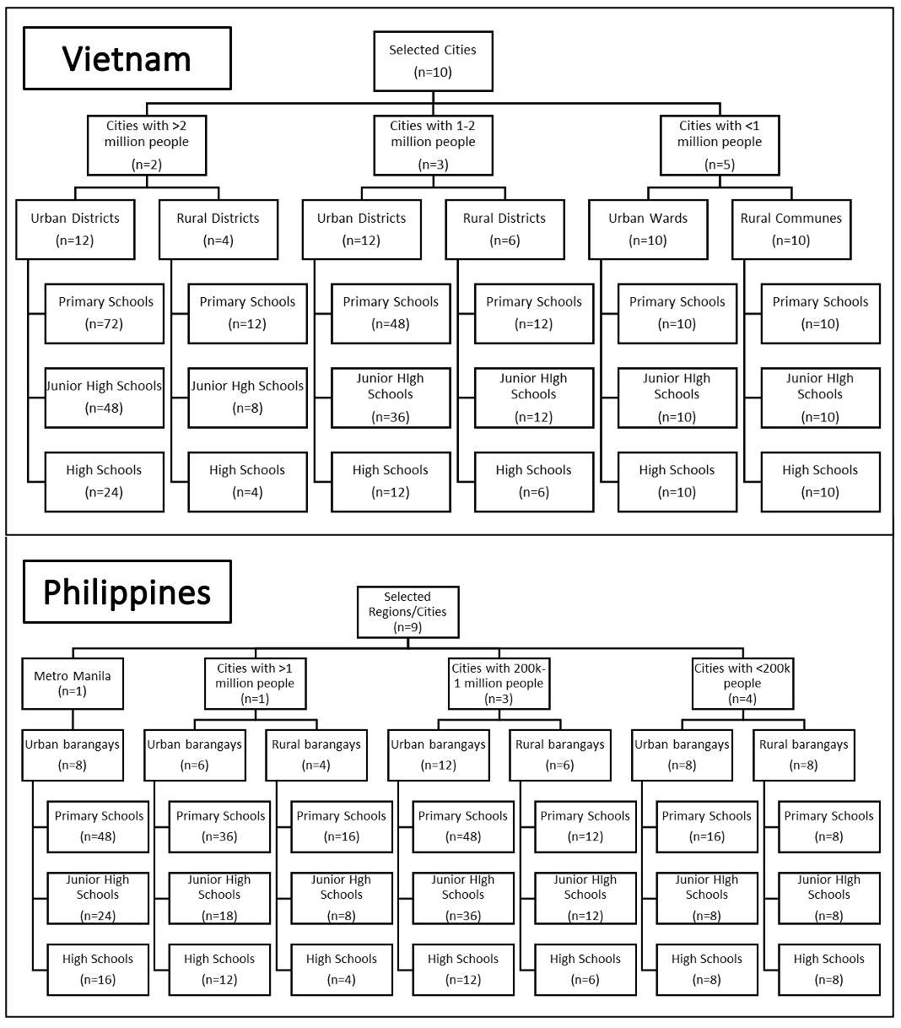
TABLE S1. TAPS policies in areas without sales restrictions (i.e., greater than 100m from a youth-oriented center such as a school) in Vietnam and the Philippines^{24,25}
 | Vietnamª |  | Philippines
 | Cigarettes | E-cigarettes &  HTPs | Cigarettes | E-cigarette &  HTPs
Single stick sales | Permitted | NA | Permitted | NA
Flavored product sales | Permitted | Unregulated | Permitted | Banned
Displays | Limited to one package per brand | Unregulated | Permitted | Permitted
Advertising | Banned | Unregulated | Permitted | Permitted
Promotion | Banned | Unregulated | Permitted | Permitted
Age sales restriction signage | Required | Required | Required | Required
ª Vietnam has no law regulating ENDS and HTPs, meaning sales and marketing are presumed to be allowed; however, these products can only be imported by Vietnam Tobacco Corporation, which it has not done yet.

TABLE S2. Retailer types in areas with and without sales restrictions, by country and product type
 |  | Vietnam |  | Philippines
 |  | Areas with sales restrictions | Areas without sales restrictions | Areas with sales restrictions | Areas without sales restrictions
Cigarettes |  | n=712 | n=751 | n=2070 | n=4496
 | Grocery/Convenience Store | 387 (54.4%) | 377 (50.2%) | 70 (3.4%) | 105 (2.3%)
 | Prepared Food/Beverage | 129 (18.1%) | 126 (16.8%) | 82 (4.0%) | 147 (3.3%)
 | Sari-Sari | NA | NA | 1779 (85.9%) | 4039 (89.8%)
 | Street Vendor | 171 (24%) | 212 (28.2%) | 132 (6.4%) | 185 (4.1%)
 | Tobacco Specialty Store | 11 (1.5%) | 6 (0.8%) | 0 (0%) | 2 (0.04%)
 | Other* | 14 (2.0%) | 30 (4.0%) | 7 (0.3%) | 18 (0.4%)
E-cigarettes |  | n=9 | n=3 | n=43 | n=69
 | Grocery/Convenience Store | 0 (0%) | 0 (0%) | 19 (44.2%) | 30 (43.5%)
 | Prepared Food | 0 (0%) | 0 (0%) | 1 (2.3%) | 1 (1.4%)
 | Sari-Sari | NA | NA | 6 (14.0%) | 4 (5.8%)
 | Street Vendor | 1 (11.1%) | 1 (33.3%) | 0 (0%) | 0 (0%)
 | Tobacco Specialty Store | 8 (88.8%) | 2 (66.6%) | 12 (27.9%) | 22 (31.9%)
 | Other* | 0 (0%) | 0 (0%) | 5 (11.6%) | 12 (17.4%)
HTPs |  | n=0 | n=0 | n=33 | n=90
 | Grocery/Convenience Store | NA | NA | 12 (36.4%) | 33 (36.7%)
 | Prepared Food | NA | NA | 0 (0) | 0 (0%)
 | Sari-Sari | NA | NA | 20 (60.6%) | 55 (61.1%)
 | Street Vendor | NA | NA | 0 (0%) | 0 (0%)
 | Tobacco Specialty Store | NA | NA | 1 (3.0%) | 0 (0%)
 | Other* | NA | NA | 0 (0%) | 2 (2.2%)
*The ‘other’ category included a variety of retailers, such as cellphone accessory stores, laundromats, pet shops, car washes, barber shops, etc.

Table S3. Retailer marketing tactics in areas with (i.e., within 100m of schools) and without (VT: within 100m of post offices; PH: 100-200m from schools) sales restrictions in Vietnamª and the Philippines and compliance with TAPS regulations in areas without sales restrictions
 |  |  | Vietnam | Philippines
 |  |  | Cigarettes | Cigarettes | E-cigarettes | HTPs
Areas with sales restrictions |  |  | n=712 | n=2070 | n=43 | n=33
 | Flavored product sales |  | 248 (34.8%) | 1798 (86.9%) | 43 (100%) | 31 (93.9%)
 | Displays |  | 514 (72.2%) | 133 (6.4%) | 33 (76.7%) | 10 (30.3%)
 | Indoor advertisements |  | 164 (23.0%) | 34 (1.6%) | 8 (18.6%) | 7 (21.2%)
 | Outdoor advertisements |  | 242 (34.0%) | 573 (27.7%) | 7 (16.3%) | 17 (51.5%)
 | Promotions |  | 14 (2.0%) | 263 (12.7%) | 1 (2.3%) | 0 (0%)
 | Single stick sales |  | 371 (52.1%) | 2030 (98.1%) | NA | NA
 | No sales age restriction signage w/ specific age |  | 642 (90.2%) | 1850 (89.4%) | 31 (72.1%) | 18 (54.5%)
Areas without sales restrictions |  |  | n=751 | n=4496 | n=69 | n=90
 | Non-compliance with at least one TAPS regulation |  | 751 (100%) | 4011 (89.2%) | 69 (100%) | 90 (100%)
 | Flavored product sales |  | 300 (39.9%) | 4079 (90.7%) | 67 (97.1%)* | 90 (100%)*
 | Displays |  | 564 (75.1%) | 330 (7.3%) | 47 (68.1%) | 28 (31.1%)
 |  | Display with >1 package/brand | 530 (70.6%)* | NA | NA | NA
 | Indoor advertisements |  | 197 (26.2%)* | 64 (1.4%) | 19 (27.5%) | 24 (26.7%)
 | Outdoor advertisements |  | 291 (38.7%)* | 1502 (33.4%) | 16 (23.2%) | 50 (55.6%)
 | Promotions |  | 38 (5.1%)* | 719 (16%) | 5 (7.2%) | 3 (3.3%)
 | Single stick sales |  | 389 (51.8%) | 4422 (98.4%) | NA | NA
 | No sales age restriction signage w/ specific age |  | 648 (86.3%)* | 4011 (89.2%)* | 37 (53.6%)* | 45 (50%)*
*Indicates non-compliance with TAPS regulations for areas without sales restrictions in the given country
ªE-cigarette retailers in Vietnam (n=12) were omitted from this table given the low number of retailers identified

FIGURE S2. Example photos of marketing tactics observed in Vietnam and the Philippines
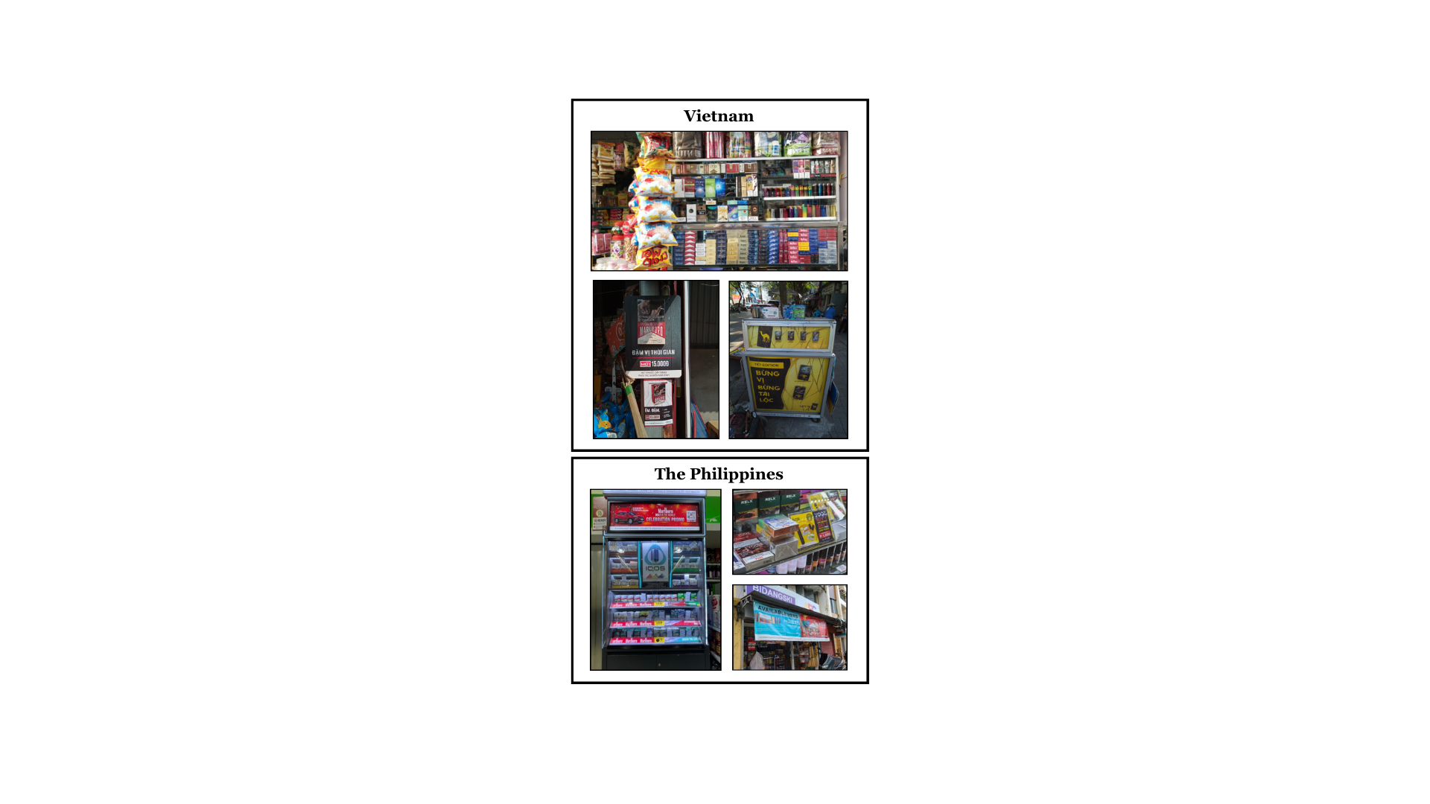

APPENDIX 1. OBSERVATION FORM (VIETNAM)
BEFORE ENTERING THE STORE:
- Observed Outlet ID
  - Input into the Hub ID and the ordinal number of the observed outlet of the hub (3 digit)

- Date
  - Text box; formatted to dd-mm-yyyy

- City
  - 1- Ho Chi Minh City
  - 2- Ha Noi
  - 3- Da Nang
  - 4- Hai Phong
  - 5- Can Tho
  - 6- Ha Tinh
  - 7- Cam Pha
  - 8- Tay Ninh
  - 9- Hoa Binh
  - 10- Buon Ho

- District/Wards/ Commune
  - Drop-down menu showing only district/ward/commune of city selected in Q3

- Hub type
  - 1 – School
  - 2 - Post-Office

- Hub ID
  - Drop-down menu showing only options from school selected in Q4

[Hint]: Select the ID obtained from project coordinator.

[If Q5 = 1]: School level
  - 1 - Primary
  - 2 – Secondary
  - 3 - High school

- Geo-coordinates of retailer
  - GPS field

[Hint]: Click the “GPS” button. On the new screen that appears, click “Save location”.

- Retailer Street Address (if available)
  - Text box

[Hint]: Enter street and number of the venue as that from the venue list. If the address of the venue cannot be found, please enter “NF”.
- Retailer Type
  - 1- Tobacco and Alcohol Specialty Store
  - 2- Vape Shop
  - 3- HTP Shop
  - 4- Convenience Store/Mini Mart (e.g., Circle K, Family Mart)
  - 5- Independent Small Grocer
  - 6- Street vendor
  - 7 – Café/ Beverage/ Smoothies
  - 8 – Restaurant/ Rice/ Food store
  - 9 – Small family business (other than small grocer, e.g. laundromat)
  - 10 – Tobacco Specialty Store (no alcohol)
  - 9971 - Other: text box

[If Q9 != 6]: ENTER THE STORE/RETAILER.

10a. [If Q9 != 6]: Are you allowed to enter the facility?
  - 1- Yes
  - 2- No, this venue is outdoor only
  - 3- No due to COVID precautions
  - 4- No for reason other than COVID

10b. [If Q10a = 3 or 4]: Can you see inside from outside and able to make observations on product display and advertisements?
  - 1- Yes (Continue questionnaire and select ‘unknown’ if you cannot see inside)
  - 2- No [Show Q11, then skip to Q31]

[If Q9 != 6 and Q10a = 1]: STEP INSIDE THE STORE

PRODUCT PLACEMENT/DISPLAY
- What types of tobacco and/or nicotine products does the retailer sell (select all that apply)?
  - 1- Cigarettes
  - 2- E-cigarettes
  - 3- Heated tobacco products (HTPs)
  - 4- Tobacco products sold besides cigarettes, e-cigarettes, HTPs
  - 9998- No tobacco products are sold here [Skip to Q40]

- [If Q9 = 7]: How are tobacco and/or nicotine products being promoted (select all that apply)?

 | Yes | No
a. Only available on request | 1 | 2
b. PGs (promotion girls) | 1 | 2
c. Product display | 1 | 2
d. Advertisements | 1 | 2

[If (Q12a and/or Q12b = 1) AND (Q12c and Q12d = 2)]: Skip to Q33.
[If Q12c or Q12d = 1]: Continue with questionnaire.
For the following questions, power wall refers to a display of tobacco products with multiple shelves and multiple packs.

- Are types of tobacco and/or nicotine products displayed on a power wall?

 |  | Yes | No | Unknown
[If Q11 = 1]: | a. Cigarettes | 1 | 2 | 99
[If Q11 = 2]: | b. E-cigarettes | 1 | 2 | 99
[If Q11 = 3]: | c. Heated tobacco products (HTPs) | 1 | 2 | 99

- [If Q13a = 1]: Are the health warning labels on the cigarettes visible?
  - 1- Yes
  - 2- No
  - 99 - Unknown

For the following questions, product display refers to the prominent and intentional arrangement of a tobacco product(s) that is visible to customers or potential customers. This can be located anywhere throughout the retailer. For the purposes of the following three questions, please exclude power walls.

- Are there any product displays for cigarettes/ e-cigarettes/ HTPs (excluding power walls)?

 |  | Yes | No | Unknown
[If Q11 = 1]: | a. Cigarettes | 1 | 2 | 99
[If Q11 = 2]: | b. E-cigarettes | 1 | 2 | 99
[If Q11 = 3]: | c. Heated tobacco products (HTPs) | 1 | 2 | 99

For question 13, cashier zone refers to the area surrounding the cash register (on the counter, in front of the counter, within 30 cm to the left or right of the cash register). These can be located anywhere within the store. If there is no cashier zone, select ‘N/A’.

- Are cigarettes/ e-cigarettes/ HTPs displayed in the cashier zone (excluding the power wall)?

 |  | Yes | No | N/A | Unknown
[If Q11 = 1]: | a. Cigarettes | 1 | 2 | 98 | 99
[If Q11 = 2]: | b. E-cigarettes | 1 | 2 | 98 | 99
[If Q11 = 3]: | c. Heated tobacco products (HTPs) | 1 | 2 | 98 | 99

- Are cigarettes/ e-cigarettes/ HTPs accessible to the consumer without help from a cashier or store attendant?

 |  | Yes | No | Unknown
[If Q11 = 1]: | a. Cigarettes | 1 | 2 | 99
[If Q11 = 2]: | b. E-cigarettes | 1 | 2 | 99
[If Q11 = 3]: | c. Heated tobacco products (HTPs) | 1 | 2 | 99

- Are cigarettes/ e-cigarettes/ HTPs that are accessible to the consumer without help placed within 1 meter from the floor?
 |  | Yes | No | Unknown
[If Q11 = 1]: | a. Cigarettes | 1 | 2 | 99
[If Q11 = 2]: | b. E-cigarettes | 1 | 2 | 99
[If Q11 = 3]: | c. Heated tobacco products (HTPs) | 1 | 2 | 99

- [If Q11 = 1]: Is more than one cigarette pack displayed per brand?
  - 1- Yes
  - 2- No
  - 99 - Unknown

- Are lights used to illuminate cigarettes/ e-cigarettes/ HTPs?

 |  | Yes | No | Unknown
[If Q11 = 1]: | a. Cigarettes | 1 | 2 | 99
[If Q11 = 2]: | b. E-cigarettes | 1 | 2 | 99
[If Q11 = 3]: | c. Heated tobacco products (HTPs) | 1 | 2 | 99

- Are cigarettes/ e-cigarettes/ HTPs placed within 30 cm (estimate using your leg or body) of candy, beverages or snacks?

 |  | Yes | No | Unknown
[If Q11 = 1]: | a. Cigarettes | 1 | 2 | 99
[If Q11 = 2]: | b. E-cigarettes | 1 | 2 | 99
[If Q11 = 3]: | c. Heated tobacco products (HTPs) | 1 | 2 | 99

For the following questions, advertising refers to branded print and/or digital/electronic signage such as posters, banners, flyers, or shelf liners.

PRODUCT PROMOTIONS & ADVERTISEMENTS

- How are the cigarettes/ e-cigarettes/ HTPs advertised (select all that apply)?

 | [If Q11 = 1]:  a. Cigarettes | [If Q11 = 2]:  b.  E-cigarettes | [If Q11 = 3]:  c. Heated tobacco products (HTPs)
Print signage (posters, banners, flyers, etc.), apart from a product display | 1 | 1 | 1
Print signage inside/as part of a product display (backgrounds, shelf liners) | 2 | 2 | 2
Digital signage (video or electronic screen) | 3 | 3 | 3
Electronically illuminated advertisements | 4 | 4 | 4
Three-dimensional signage | 5 | 5 | 5
None of the above | 9998 | 9998 | 9998
Unknown | 9999 | 9999 | 9999

- Are any advertisements for cigarettes/ e-cigarettes/ HTPs placed within 1 meter from the floor?

 |  | Yes | No | Unknown
[If Q22a != 9998 or 9999]: | a. Cigarettes | 1 | 2 | 99
[If Q22b != 9998 or 9999]: | b. E-cigarettes | 1 | 2 | 99
[If Q22c != 9998 or 9999]: | c. Heated tobacco products (HTPs) | 1 | 2 | 99

- Do any advertisements for cigarettes/ e-cigarettes/ HTPs use cartoon characters?

 |  | Yes | No | Unknown
[If Q22a != 9998 or 9999]: | a. Cigarettes | 1 | 2 | 99
[If Q22b != 9998 or 9999]: | b. E-cigarettes | 1 | 2 | 99
[If Q22c != 9998 or 9999]: | c. Heated tobacco products (HTPs) | 1 | 2 | 99

- Do advertisements for cigarettes/ e-cigarettes/ HTPs include any of the following messages (select all that apply)?

 | [If Q22a != 9998 or 9999]:  a. Cigarettes | [If Q22b != 9998 or 9999]:  b. E-cigarettes | [If Q22c != 9998 or 9999]:  c. Heated tobacco products (HTPs)
Can be used for smoking cessation |  | 1 | 1
Healthier than cigarettes |  | 2 | 2
Prevent and/or limit the effects of COVID-19 | 3 | 3 | 3
Help you cope with the COVID-19 pandemic | 4 | 4 | 4
Other messaging about the COVID-19 pandemic | 5 | 5 | 5
None of the above | 9998 | 9998 | 9998
Unknown | 9999 | 9999 | 9999

For the following questions, promotion refers to special or limited time offer that are intended to result in the purchase of a tobacco product.

- Are cigarettes/ e-cigarettes/ HTPs promoted in any of the following ways (select all that apply)?

 | [If Q11 = 1]:  a. Cigarettes | [If Q11 = 2]:  b. E-cigarettes | [If Q11 = 3]:  c. Heated tobacco products (HTPs)
Price discounts (e.g. sales, coupons, limited time offer, multi pack discounts) | 1 | 1 | 1
Free cigarettes (with or without the purchase of other goods) | 2
Free e-cigarettes and/or e-liquids (with or without the purchase of other goods) |  | 3
Free HTPs and/or HTP sticks (with or without the purchase of other goods) |  |  | 4
Cigarette pack/lighter exchanges |  | 5 | 5
Gifts other than the product (free or with purchase) unrelated to COVID-19 (e.g., carrying case) | 6 | 6 | 6
Gifts other than the product (free or with purchase) related to COVID-19 (e.g. face masks, sanitizer) | 7 | 7 | 7
A tobacco brand sponsored event, activity, or cause | 8 | 8 | 8
Contests or competitions | 9 | 9 | 9
Loyalty/rewards scheme | 10 | 10 | 10
Presence of brand representative | 11 | 11 | 11
Direction to social media channel | 12 | 12 | 12
QR code to website | 13 | 13 | 13
None of the above | 9998 | 9998 | 9998
Unknown | 9999 | 9999 | 9999

- What type of social media channels are being used to promote cigarettes/ e-cigarettes/ HTPs via advertisements (select all that apply)?

 | [If Q24a = 12]:  Cigarettes | [If Q24b = 12]:  E-cigarettes | [If Q24c = 12]:  Heated tobacco products (HTPs)
Facebook | 1 | 1 | 1
Zalo | 2 | 2 | 2
Instagram | 3 | 3 | 3
Youtube | 4 | 4 | 4
Tiktok | 5 | 5 | 5
Pinterest | 6 | 6 | 6
Twitter | 7 | 7 | 7
Other: text box | 9971 | 9971 | 9971
None of the above | 9999 | 9999 | 9999
Unknown | 9998 | 9998 | 9998

- Do you see any cigarettes/ e-cigarettes/ HTPs branding on non-tobacco products in the store (e.g., clocks, hats, t-shirts, mirrors, carry bags, cigarette lighters, counter mats)?

 |  | Yes | No | Unknown
[If Q22a != 9998 or 9999]: | a. Cigarettes | 1 | 2 | 99
[If Q22b != 9998 or 9999]: | b. E-cigarettes | 1 | 2 | 99
[If Q22c != 9998 or 9999]: | c. Heated tobacco products (HTPs) | 1 | 2 | 99

FLAVORS

- [If Q11 = 1]: Does the store sell any flavored cigarettes? (e.g.,mint, strawberry, etc)?
      - 1- Yes
      - 2- No
      - 9999- Unknown

- [If Q11 = 2]: What flavors are available for e-cigarettes in the store?
      - 1- Tobacco
      - 2- Other flavors (e.g., mint, fruity, candy)
      - 9999- Unknown

- [If Q11 = 3]: Does the store sell any flavored HTPs (e.g.,menthol, strawberry)?
  - Yes
- 2- No
- 99- Unknown

OTHER SIGNAGE

- [If Q11 = 1]: Is there a sign that says the cigarettes can only be sold to adults (select all that apply)?
- 1-Yes: a sign saying sales are prohibited with a specific age indicated (e.g., “sales are prohibited to youth under 18”)
- 2-Yes: a sign saying sales are prohibited with no specific age indicated (e.g., “sales are prohibited to youth”)
- 9998-No

SINGLE STICK SALES

- [If Q11 = 1]: Does the retailer sell single sticks of cigarettes?
  - 1- Yes
  - 2- No
  - 99- Unknown

[If Q9 != and Q10a != 2]: EXIT RETAILER AND VIEW FROM OUTSIDE
[If Q9 != and Q10a != 2]: OUTSIDE THE STORE: PRODUCT ADVERTISEMENTS

- Are there any advertisements for cigarettes/ e-cigarettes/ HTPs on the façade of the retailer?

 |  | Yes | No
[If Q11 = 1 and Q9 != 6 and Q10a != 2] | a. Cigarettes | 1 | 2
[If Q11 = 2 and Q9 != 6 and Q10a != 2] | b. E-cigarettes | 1 | 2
[If Q11 = 3 and Q9 != 6 and Q10a != 2] | c. Heated tobacco products (HTPs) | 1 | 2

- How are the cigarettes/ e-cigarettes/ HTPs advertised (select all that apply)?

 | [If Q34a = 1]:  a. Cigarettes | [If Q34b = 2]:  b. E-cigarettes | [If Q34c =1]:  c. Heated tobacco products (HTPs)
Print signage (posters, banners, flyers, etc.), apart from a product display | 1 | 1 | 1
Backlit or illuminated advertisements | 2 | 2 | 2
Three-dimensional signage | 3 | 3 | 3

- Are any of the following items related to cigarettes/ e-cigarettes/ HTPs that are inside the store visible from outside the store (through a window, door, or storefront)?

 | [If Q11 = 1 and Q9 != 6 and Q10a != 2]:  a. Cigarettes | [If Q11 = 2 and Q9 != 6 and Q10a != 2]:  b. E-cigarettes | [If Q11 = 3 and Q9 != 6 and Q10a != 2]:  c. Heated tobacco products (HTPs)
Display of products (including power wall) | 1 | 1 | 1
Advertising | 2 | 2 | 2
None of the above | 9998 | 9998 | 9998
Not applicable | 9999 | 9999 | 9999

COMPLETION OF OBSERVATION
- If you can take a picture without drawing unwanted attention, please take a picture of the outside of the store.
  - Picture field

- Do you have any additional notes on your observations in this store?
  - Open-ended

- [If Q3 = 1 or 2]: Would you recommend this vendor for professional photography?
  - 1- Yes
  - 0- No

- Result of observation
  - 1- Observation completed
  - 2- Observation not completed

- [If Q40 = 2]: If observation not completed, why?
  - 1-Data collectors are not allowed to enter the survey site
  - 2- Data collector asked to leave venue
  - 3- Data collector not comfortable inside venue
  - 4- Retailer out of business
  - 5- Retailer not open
  - 9971- Other: text box

APPENDIX 2. OBSERVATION FORM (THE PHILIPPINES)

School Observation Form
- Observer ID
  - Drop-down menu

- City
  - 1- Metro Manila
  - 2- Davao
  - 3- Cebu
  - 4- Pagadian, Zamboanga del Sur
  - 5- Naga (Camarines Sur)
  - 6- Roxas, Capiz
  - 7- Alaminos, Pangasinan
  - 8- Catbalogan, Samar
  - 9- Cabadbaran, Agusan del Norte

- School ID (5-digit)
  - Drop-down menu showing hub IDs only for the city selected in Q2

[Hint]: Enter the school ID obtained from project coordinator.

- School Name
  - Text box

- School type (select all that apply)
  - 1- Elementary school
  - 2- Junior high school
  - 3- Senior high school

- School geo-coordinates
- GPS field

[Hint]: Click the button with the small circle above the map to the right.

Completion of Observation

- Result of observation
- 1- Observation completed
- 2- Observation not completed

- [If Q7 = 2]: If observation not completed, why?
- 1- Hub does not exist/is not at the specified location
- 2- Other

- [If Q8 = 2]: Please specify.
- Text box
Retailer Observation Form
BEFORE ENTERING THE STORE:
- Observer ID
  - Drop-down menu

- City
  - 1- Metro Manila
  - 2- Davao
  - 3- Cebu
  - 4- Pagadian, Zamboanga del Sur
  - 5- Naga (Camarines Sur)
  - 6- Roxas, Capiz
  - 7- Alaminos, Pangasinan
  - 8- Catbalogan, Samar
  - 9- Cabadbaran, Agusan del Norte

- School ID
  - Drop-down menu

- Retailer ID
  - Text box

[Hint]: Input the ordinal number of the observed retailer of the hub (3 digit; e.g., “004”, “024”, 103”)

- Geo-coordinates of retailer
  - GPS field

[Hint]: Click the button with the small circle above the map to the right.

- Retailer Street Address (if available)
  - Text box

[Hint]: Enter street and number of the venue as that from the venue list. If the address of the venue cannot be found, please enter “NF”.

- Are you entering the following?
  - 1- Shopping Mall
  - 2- Public Market
  - 3- Neither

- Retailer Type
  - 1- Tobacco and Alcohol Specialty Store
  - 2- Tobacco Specialty Store (no alcohol)
  - 3- Vape Shop
  - 4- HTP Shop
  - 5- Convenience Store
  - 6- Mini Mart
  - 7- Supermarket
  - 8- Street Vendor
  - 9- Carinderia
  - 10- Sari-Sari Store
  - 11- Bakery
  - 12- Food Stall
  - 13- Carinderia and Sari-Sari Store
  - 14- Bakery and Sari-Sari Store
  - 15- Kiosk (within mall)
  - 16- Grocery
  - 17- Other

- [If Q8 = 17]: Please specify the type of retailer.
  - Text box

- Are you able to enter the store?
  - 1- Yes
  - 0- No

[If Q10 = 1]: ENTER THE STORE/RETAILER.

- What types of tobacco and/or nicotine products does the retailer sell (select all that apply)?
  - 1- Cigarettes
  - 2- E-cigarettes
  - 3- Heated tobacco products (HTPs)
  - 4- Nicotine pouches
  - 98- None of the above [SKIP TO Q27]

- [If Q8 = 3, 4, 15, or 17]: Does the retailer sell only one brand of tobacco and/or nicotine products?
  - 1- Yes
  - 0- No

- [If Q12 = 1]: Please specify the brand:
  - Text box

PRODUCT PLACEMENT/DISPLAY

For the questions 14-17, please use the following definitions:
Power wall: a display of tobacco and/or nicotine products with multiple shelves and multiple packs
Product display: the prominent and intentional arrangement of a tobacco and/or nicotine product(s) that is visible to customers or potential customers. This can be located anywhere throughout the retailer.
Cashier zone: the area surrounding the cash register (on the counter, in front of the counter, within 30 cm to the left or right of the cash register). This can be located anywhere within the store. If there is no cashier zone, select ‘N/A’.

- How are the following tobacco and/or nicotine products displayed (select all that apply)?

 | [If Q11 = 1]:  Cigarettes | [If Q11 = 2]:  E-cigarettes | [If Q11 = 3]:  HTPs | [If Q11 = 4]:  Nicotine pouches | None of the above | NA (no cashier zone present)
a. Power wall | 1 | 2 | 3 | 4 | 98
b. Product displays (excluding power walls) | 1 | 2 | 3 | 4 | 98
c. In the cashier zone | [If Q14a or Q14b = 1]: 1 | [If Q14a or Q14b = 2]: 2 | [If Q14a or Q14b = 3]: 3 | [If Q14a or Q14b = 4]: 4 | 98 | 97
d. With lights used to illuminate the products | [If Q14a or Q14b = 1]: 1 | [If Q14a or Q14b = 2]: 2 | [If Q14a or Q14b = 3]: 3 | [If Q14a or Q14b = 4]: 4 | 98
e. Within 30 cm of candy, beverages or snacks | [If Q14a or Q14b = 1]: 1 | [If Q14a or Q14b = 2]: 2 | [If Q14a or Q14b = 3]: 3 | [If Q14a or Q14b = 4]: 4 | 98

- [If Q14 power wall or display = 1, 2, 3, or 4]: Are the health warning labels on any of the following tobacco and/or nicotine products visible?
  - [If Q14 power wall or display = 1]: 1- Cigarettes
  - [If Q14 power wall or display = 2]: 2- E-cigarettes
  - [If Q14 power wall or display = 3]: 3- Heated tobacco products (HTPs)
  - [If Q14 power wall or display = 4]: 4- Nicotine pouches
  - 98- None of the above

- Are the following tobacco and/or nicotine products accessible to the consumer without help from a cashier or store attendant?
  - [If Q11 = 1]: 1- Cigarettes
  - [If Q11 = 2]: 2- E-cigarettes
  - [If Q11 = 3]: 3- Heated tobacco products (HTPs)
  - [If Q11 = 4]: 4- Nicotine pouches
  - 98- None of the above

- [If Q16 = 1, 2, 3, or 4]: Are the following tobacco and/or nicotine products that are accessible to the consumer without help placed within 1 meter from the floor?
  - [If Q11 = 1]: 1- Cigarettes
  - [If Q11 = 2]: 2- E-cigarettes
  - [If Q11 = 3]: 3- Heated tobacco products (HTPs)
  - [If Q11 = 4]: 4- Nicotine pouches
  - 98- None of the above

PRODUCT PROMOTIONS & ADVERTISEMENTS

For the following questions, advertising refers to branded print and/or digital/electronic signage such as posters, banners, flyers, or shelf liners.

- How are the following tobacco and/or nicotine products advertised (select all that apply)?

 | [If Q11 = 1]:  Cigarettes | [If Q11 = 2]:  E-cigarettes | [If Q11 = 3]:  HTPs | [If Q11 = 4]:  Nicotine pouches | None of the above
a. Print signage (posters, banners, flyers, etc.), apart from a product display or power wall | 1 | 2 | 3 | 4 | 98
b. Print signage inside/as part of a product display or power wall (backgrounds, shelf liners) | [If Q14a or Q14b =1]: 1 | [If Q14a or Q14b = 2]: 2 | [If Q14a or Q14b = 3]: 3 | [If Q14a or Q14b = 4]: 4 | 98
c. Digital signage (video or electronic screen) | 1 | 2 | 3 | 4 | 98
d. Electronically illuminated advertisements | 1 | 2 | 3 | 4 | 98

- Are any advertisements for the following tobacco and/or nicotine products placed within 1 meter from the floor?
  - [If Q11 = 1]: 1- Cigarettes
  - [If Q11 = 2]: 2- E-cigarettes
  - [If Q11 = 3]: 3- Heated tobacco products (HTPs)
  - [If Q11 = 4]: 4- Nicotine pouches
  - 98- None of the above

For the following questions, promotion refers to special or limited time offers that are intended to result in the purchase of a tobacco product.

- Are the following tobacco/nicotine products promoted in any of the following ways (select all that apply)?

 | [If Q11 = 1]:  Cigarettes | [If Q11 = 2]:  E-cigarettes | [If Q11 = 3]:  HTPs | [If Q11 = 4]:  Nicotine pouches | None of the above
a. Price discounts (e.g. sales, coupons, limited time offer, multi pack discounts) | 1 | 2 | 3 | 4 | 98
b. Free product (with or without the purchase of other goods) | 1 | 2 | 3 | 4 | 98
d. Cigarette pack/lighter exchanges |  | 2 | 3 | 4 | 98
e. Gifts other than the product (free or with purchase) (e.g., carrying case) | 1 | 2 | 3 | 4 | 98
f. A tobacco brand sponsored event, activity, or cause | 1 | 2 | 3 | 4 | 98
g. Contests or competitions | 1 | 2 | 3 | 4 | 98
h. Loyalty/rewards scheme | 1 | 2 | 3 | 4 | 98
i. Presence of brand representative | 1 | 2 | 3 | 4 | 98

- Do you see any of the following tobacco and/or nicotine product branding on non-tobacco products in the store (e.g., clocks, hats, t-shirts, mirrors, carry bags, cigarette lighters, counter mats)?
  - [If Q11 = 1]: 1- Cigarettes
  - [If Q11 = 2]: 2- E-cigarettes
  - [If Q11 = 3]: 3- Heated tobacco products (HTPs)
  - [If Q11 = 4]: 4- Nicotine pouches
  - 98- None of the above

FLAVORS

- What flavors are available for the following tobacco/nicotine products (select all that apply)?

 | [If Q11 = 1]:  Cigarettes | [If Q11 = 2]:  E-cigarettes | [If Q11 = 3]:  HTPs | [If Q11 = 4]:  Nicotine pouches
a. Tobacco | 1 | 2 | 3 | 4
b. Other flavors (e.g., menthol, fruit, dessert) | 1 | 2 | 3 | 4
c. NA (only device is being sold, no e-cigarette liquid or HTP sticks) |  | 2 | 3
d. Unknown | 1 | 2 | 3 | 4

OTHER SIGNAGE

- Is there a sign that says any of the following tobacco/nicotine products can only be sold to adults (select all that apply)?

 | [If Q11 = 1]:  Cigarettes | [If Q11 = 2]:  E-cigarettes | [If Q11 = 3]:  HTPs | [If Q11 = 4]:  Nicotine pouches
Yes: a sign saying sales are prohibited with a specific age indicated (e.g., “sales are prohibited to youth under 21”) | 1 | 2 | 3 | 4
Yes: a sign saying sales are prohibited with no specific age indicated (e.g., “sales are prohibited to youth”) | 1 | 2 | 3 | 4
No | 1 | 2 | 3 | 4

SINGLE STICK SALES

- [If Q11 = 1]: Does the retailer sell single sticks of cigarettes?
  - 1- Yes
  - 0- No
  - 99- Unknown

[If Q10 = 1]: EXIT RETAILER AND VIEW FROM OUTSIDE
[If Q10 = 1]: OUTSIDE THE STORE: PRODUCT ADVERTISEMENTS

- [Q10 = 1]: Are there any advertisements (e.g., print signage, backlit/illuminated ads, 3-D signage) outside of the retailer for the following tobacco and/or nicotine products?
  - [If Q11 = 1]: 1- Cigarettes
  - [If Q11 = 2]: 2- E-cigarettes
  - [If Q11 = 3]: 3- Heated tobacco products (HTPs)
  - [If Q11 = 4]: 4- Nicotine pouches
  - 98- None of the above

- [If Q10 = 1]: Are any of the following items that are inside the store visible from outside the store (through a window, door, or storefront), for each type of tobacco/nicotine product?

 | [If Q11 = 1]:  Cigarettes | [If Q11 = 2]:  E-cigarettes | [If Q11 = 3]:  HTPs | [If Q11 = 4]:  Nicotine pouches | None of the above
a. Display of products (including power wall) | 1 | 2 | 3 | 4 | 98
b. Advertising | 1 | 2 | 3 | 4 | 98
c. Promotions | 1 | 2 | 3 | 4 | 98

COMPLETION OF OBSERVATION
- If you can take a picture without drawing unwanted attention, please take a picture of the outside of the store and/or any product displays, advertisements, or promotions.
  - Picture field

- If you can take a picture without drawing unwanted attention, please take a picture of the outside of the store and/or any product displays, advertisements, or promotions.
  - Picture field

- If you can take a picture without drawing unwanted attention, please take a picture of the outside of the store and/or any product displays, advertisements, or promotions.
  - Picture field
- Do you have any additional notes on your observations in this store?
  - Open-ended

- Result of observation
  - 1- Observation completed
  - 0- Observation not completed

- [If Q31 = 0]: If observation not completed, why?
  - 1- Data collectors are not allowed to enter the venue
  - 2- Data collector asked to leave venue
  - 3- Data collector not comfortable inside venue
  - 4- Retailer out of business
  - 5- Retailer not open
  - 6- Other

- [If Q32 = 6]: Please specify the reason the observation was not completed.
  - Text box

