**Supplementary Table 1.** Standardized mean differences for baseline covariates after propensity score matching

|  |  |  |  |
| --- | --- | --- | --- |
| Variable | After PSM | | |
| **Upfront surgery** | **NAT** | **SMD** |
| ***n* = 152 (%)** | ***n* = 152 (%)** |
| Age |  |  |  |
| < 50 years | 15 (9.9) | 16 (10.5) | 0.099 |
| 50 - 64 years | 67 (44.1) | 65 (42.8) |
| 65 - 74 years | 54 (35.5) | 50 (32.9) |
| ≥ 75 years | 16 (10.5) | 21 (13.8) |
| Sex |  |  |  |
| Female | 72 (47.4) | 76 (50.0) | 0.053 |
| Male | 80 (52.6) | 76 (50.0) |
| Year of diagnosis |  |  |  |
| 2004 - 2009 | 50 (32.9) | 43 (28.3) | 0.100 |
| 2010 - 2015 | 102 (67.1) | 109 (71.7) |
| Median household income (inflation adjust to 2022) |  |  |  |
| < $40,000 - $59,999 | 26 (17.1) | 26 (17.1) | 0.089 |
| $60,000 - $89,999 | 74 (48.7) | 80 (52.6) |
| ≥ $90,000 | 52 (34.2) | 46 (30.3) |
| Tumor site |  |  |  |
| Head | 97 (63.8) | 94 (61.8) | 0.068 |
| Body/Tail | 29 (19.1) | 28 (18.4) |
| Overlapping/Other | 26 (17.1) | 30 (19.7) |
| Grade |  |  |  |
| I: Well differentiated | 15 (9.9) | 14 (9.2) | 0.099 |
| II: Moderately differentiated | 57 (37.5) | 56 (36.8) |
| III: Poorly differentiated | 36 (23.7) | 38 (25.0) |
| IV: Undifferentiated | 1 (0.7) | 0 (0.0) |
| Unknown | 43 (28.3) | 44 (28.9) |
| N stage |  |  |  |
| N0 | 68 (44.7) | 58 (38.2) | 0.098 |
| N1 | 84 (55.3) | 93 (61.2) |
| NX | 0 (0.0) | 1 (0.7) |
| AT | 90 (59.2) | 89 (58.6) | 0.013 |

Categorical variables were presented as n (%).

NAT; neoadjuvant therapy; AT, adjuvant therapy; PSM, propensity score matching; SMD, standardized mean difference

**Supplementary Table 2.** Comparison of baseline characteristics and survival probabilities between neoadjuvant chemotherapy and neoadjuvant chemoradiation therapy for T4 pancreatic ductal adenocarcinoma patients

|  |  |  |  |
| --- | --- | --- | --- |
| Variable | NAC | NACRT | *P* value |
| ***n* = 83 (%)** | ***n* = 158 (%)** |
| Age |  |  |  |
| < 50 years | 9 (10.8) | 17 (10.8) | 0.191 |
| 50 - 64 years | 33 (39.8) | 83 (52.5) |
| 65 - 74 years | 34 (41.0) | 44 (27.8) |
| ≥ 75 years | 7 (8.4) | 14 (8.9) |
| Sex |  |  |  |
| Female | 44 (53.0) | 71 (44.9) | 0.291 |
| Male | 39 (47.0) | 87 (55.1) |
| Year of diagnosis |  |  |  |
| 2004 - 2009 | 9 (10.8) | 36 (22.8) | **0.037** |
| 2010 - 2015 | 74 (89.2) | 122 (77.2) |
| Median household income (inflation adjust to 2022) |  |  |  |
| < $40,000 - $59,999 | 10 (12.0) | 28 (17.7) | 0.504 |
| $60,000 - $89,999 | 46 (55.4) | 84 (53.2) |
| ≥ $90,000 | 27 (32.5) | 46 (29.1) |
| Tumor site |  |  |  |
| Head | 51 (61.4) | 98 (62.0) | 0.944 |
| Body/Tail | 17 (20.5) | 34 (21.5) |
| Overlapping/Other | 15 (18.1) | 26 (16.5) |
| Grade |  |  |  |
| I: Well differentiated | 6 (7.2) | 15 (9.5) | 0.642 |
| II: Moderately differentiated | 24 (28.9) | 48 (30.4) |
| III: Poorly differentiated | 12 (14.5) | 30 (19.0) |
| IV: Undifferentiated | 0 (0.0) | 1 (0.6) |
| Unknown | 41 (49.4) | 64 (40.5) |
| N stage |  |  |  |
| N0 | 36 (43.4) | 76 (48.1) | 0.573 |
| N1 | 47 (56.6) | 82 (51.9) |
| NX | 0 (0.0) | 0 (0.0) |
| AT | 32 (38.6) | 68 (43.0) | 0.594 |
| Median survival duration (month, range) | 26 [3, 103] | 27 [3, 117] | 0.579 |
| 1-year survival probability (95% CI) | 0.830 [0.753, 0.915] | 0.867 [0.816, 0.922] | - |
| 2-year survival probability (95% CI) | 0.537 [0.439, 0.657] | 0.588 [0.516, 0.700] | - |
| 3-year survival probability (95% CI) | 0.354 [0.264, 0.474] | 0.403 [0.333, 0.487] | - |
| 4-year survival probability (95% CI) | 0.281 [0.198, 0.397] | 0.281 [0.219, 0.361] | - |
| 5-year survival probability (95% CI) | 0.195 [0.126, 0.303] | 0.198 [0.145, 0.271] | - |

Continuous variables were presented as median [range]; Categorical variables were presented as n (%); Survival probabilities were presented with 95% CI.

*P* values of categorical variables were calculated by χ2 or Fisher’s exact test; *P* values of median follow-up duration were calculated by Log-rank test. Bold values indicate statistical significance at the *P* < 0.05 level.

NAC, neoadjuvant chemotherapy; NACRT, neoadjuvant chemoradiotherapy; AT, adjuvant therapy; CI, confidence interval

**Supplementary Table 3.** Comparison of baseline characteristics and survival probabilities between neoadjuvant therapy with and without adjuvant therapy for T4 pancreatic ductal adenocarcinoma patients

|  |  |  |  |
| --- | --- | --- | --- |
| Variable | NAT without AT | NAT with AT | *P* value |
| ***n* = 141 (%)** | ***n* = 100 (%)** |
| Age |  |  |  |
| < 50 years | 12 (8.5) | 14 (14.0) | 0.479 |
| 50 - 64 years | 72 (51.1) | 44 (44.0) |
| 65 - 74 years | 44 (31.2) | 34 (34.0) |
| ≥ 75 years | 13 (9.2) | 8 (8.0) |
| Sex |  |  |  |
| Female | 67 (47.5) | 48 (48.0) | 1.000 |
| Male | 74 (52.5) | 52 (52.0) |
| Year of diagnosis |  |  |  |
| 2004 - 2009 | 20 (14.2) | 25 (25.0) | 0.051 |
| 2010 - 2015 | 121 (85.8) | 75 (75.0) |
| Median household income (inflation adjust to 2022) |  |  |  |
| < $40,000 - $59,999 | 25 (17.7) | 13 (13.0) | 0.442 |
| $60,000 - $89,999 | 77 (54.6) | 53 (53.0) |
| ≥ $90,000 | 39 (27.7) | 34 (34.0) |
| Tumor site |  |  |  |
| Head | 90 (63.8) | 59 (59.0) | 0.213 |
| Body/Tail | 32 (22.7) | 19 (19.0) |
| Overlapping/Other | 19 (13.5) | 22 (22.0) |
| Grade |  |  |  |
| I: Well differentiated | 11 (7.8) | 10 (10.0) | 0.299 |
| II: Moderately differentiated | 36 (25.5) | 36 (36.0) |
| III: Poorly differentiated | 25 (17.7) | 17 (17.0) |
| IV: Undifferentiated | 1 (0.7) | 0 (0.0) |
| Unknown | 68 (48.2) | 37 (37.0) |
| N stage |  |  |  |
| N0 | 71 (50.4) | 41 (41.0) | 0.192 |
| N1 | 70 (49.6) | 59 (59.0) |
| NX | 0 (0.0) | 0 (0.0) |
| NAT modality |  |  |  |
| NAC | 51 (36.2) | 32 (32.0) | 0.594 |
| NACRT | 90 (63.8) | 68 (68.0) |
| Median survival duration (month, range) | 27 [3, 106] | 27 [6, 117] | 0.524 |
| 1-year survival probability (95% CI) | 0.865 [0.810, 0.923] | 0.840 [0.771, 0.915] | - |
| 2-year survival probability (95% CI) | 0.572 [0.495, 0.660] | 0.569 [0.480, 0.675] | - |
| 3-year survival probability (95% CI) | 0.414 [0.340, 0.505] | 0.346 [0.263, 0.453] | - |
| 4-year survival probability (95% CI) | 0.293 [0.226, 0.379] | 0.264 [0.190, 0.367] | - |
| 5-year survival probability (95% CI) | 0.214 [0.156, 0.294] | 0.173 [0.112, 0.266] | - |

Continuous variables were presented as median [range]; Categorical variables were presented as n (%); Survival probabilities were presented with 95% CI.

*P* values of categorical variables were calculated by χ2 or Fisher’s exact test; *P* values of median follow-up duration were calculated by Log-rank test. Bold values indicate statistical significance at the *P* < 0.05 level.

NAC, neoadjuvant chemotherapy; NACRT, neoadjuvant chemoradiotherapy; AT, adjuvant therapy; CI, confidence interval

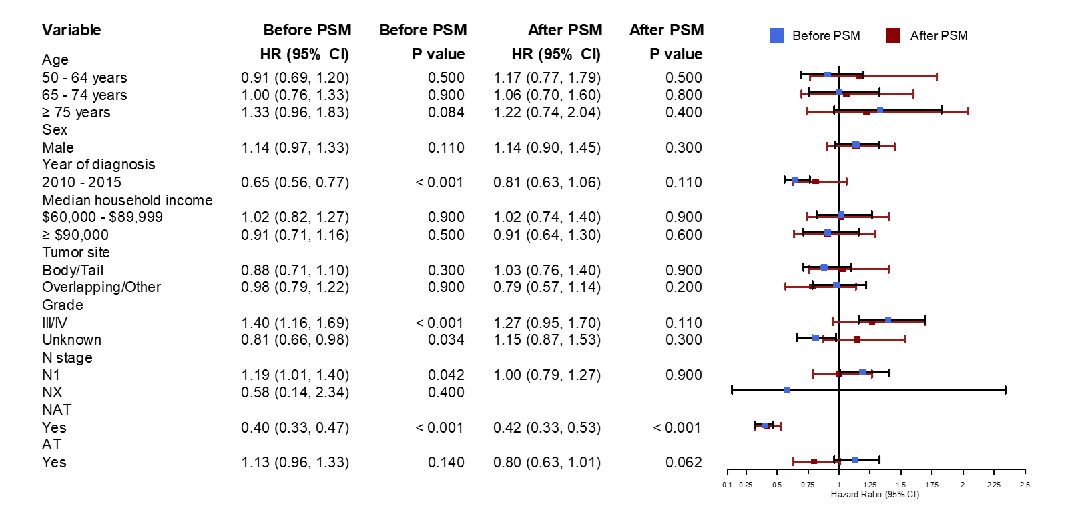

**Supplementary Figure 1**. Forest plot of covariate associations with overall survival in T4 pancreatic ductal adenocarcinoma (AT, adjuvant therapy; NAT, neoadjuvant therapy; PSM, propensity score matching; HR, hazard ratio; CI, confidence interval).