Supplementary data

**Table 1: Baseline parameters of patients**

|  |  |  |  |
| --- | --- | --- | --- |
| Parameter | Range | Mean | Mean SD |
| Age (Years) | *16-73* | 46.15 | 13.67 |
| WBC (x 109) | 0.5-359.5 | 46.61 | 67.88 |
| Hemoglobin (g/L) | 4.9-13.6 | 8.44 | 1.90 |
| Platelet (x 109) | 1.3-373 | 66.69 | 64.94 |
| LDH(u/L) | 127-9097 | 881.41 | 1127.3 |
| Bone marrow blast (%) | 20-99 | 64.52 | 23.16 |

**OS subgroup analysis**

**Table 2.WT1 mut status within FLT3-ITD+/NPM1 mut**

|  |  |  |  |  |  |
| --- | --- | --- | --- | --- | --- |
| Time (Years) | wildtype | | Mutated | | P-value |
| Surv Prob % | SE % | Surv Prob % | SE % |
| 2 | 44.4 | 18.9 | 66.7 | 27.2 | 0.655 |

**Figure 1**

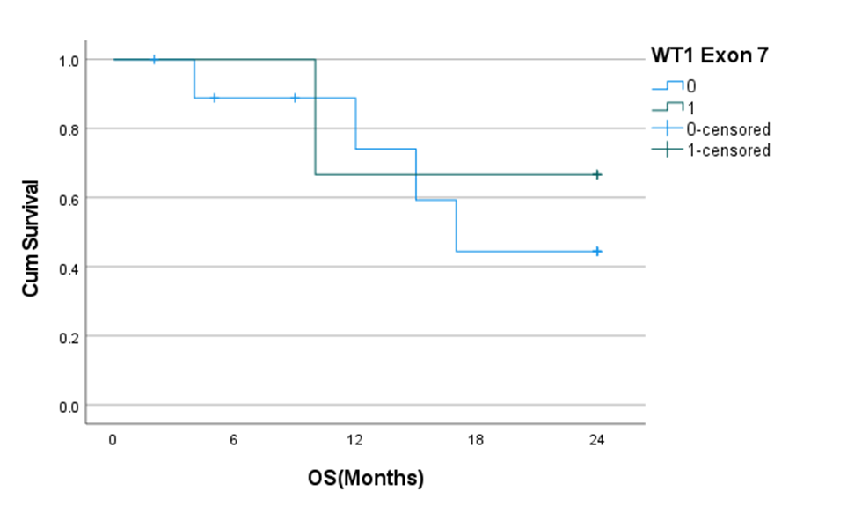

**Table 3.Within FLT3-ITD+/NPM1 wt**

|  |  |  |  |  |  |
| --- | --- | --- | --- | --- | --- |
| Time (Years) | Wildtype | | Mutated | | P-value |
| Surv Prob % | SE % | Surv Prob % | SE % |
| 2 | 24.4 | 11.9 | 26.7 | 22.6 | 0.327 |

**Figure 2**

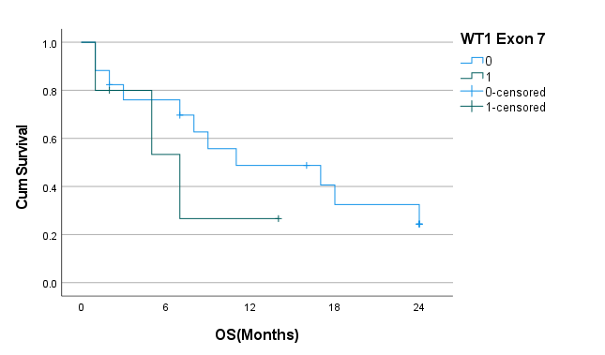

**Table 4.Within ITD-/NPM1 wt**

|  |  |  |  |  |  |
| --- | --- | --- | --- | --- | --- |
| Time (Years) | Wildtype | | Mutated | | P-value |
| Surv Prob % | SE % | Surv Prob % | SE % |
| 2 | 38.5 | 5.8 | 66.7 | 19.2 | 0.335 |

**Figure 3**

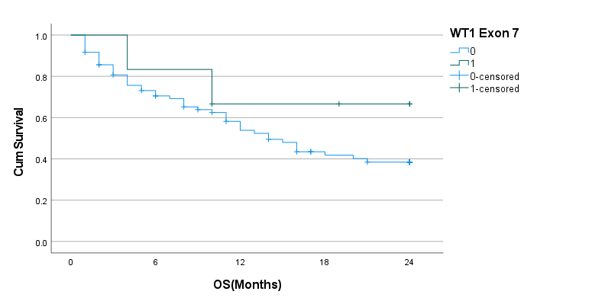**Table 5 .Within ITD-/NPM1 mut**

|  |  |  |  |  |  |
| --- | --- | --- | --- | --- | --- |
| Time (Years) | wildtype | | Mutated | | P-value |
| Surv Prob % | SE % | Surv Prob % | SE % |
| 2 | 63.3 | 11.2 | 30.0 | 23.9 | 0.394 |

**Figure 4**

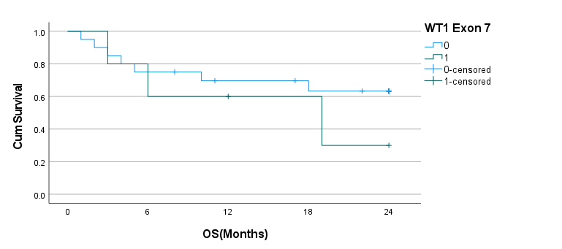

**DFS Subgroup Analysis**

**Table 6.WT1mut status Within ITD+/NPM1mut**

|  |  |  |  |  |  |
| --- | --- | --- | --- | --- | --- |
| Time (Years) | Wild type | | Mutated | | P-value |
| Surv Prob % | SE % | Surv Prob % | SE % |
| 2 | 35.6 | 18.6 | 100 | - | 0.139 |

**Figure 5.**

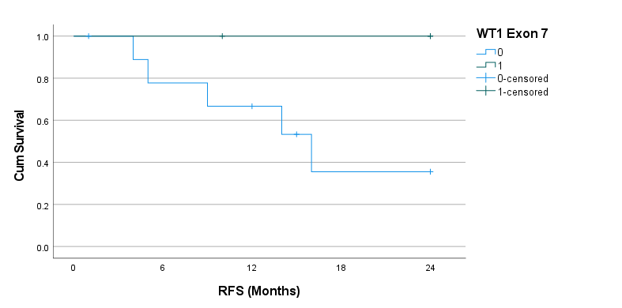

**Table 7.Within ITD+/NPM1wt**

|  |  |  |  |  |  |
| --- | --- | --- | --- | --- | --- |
| Time (Years) | wildtype | | Mutated | | P-value |
| Surv Prob % | SE % | Surv Prob % | SE % |
| 2 | 22.9 | 11.5 | 50.0 | 35.4 | 0.675 |

**Figure 6**

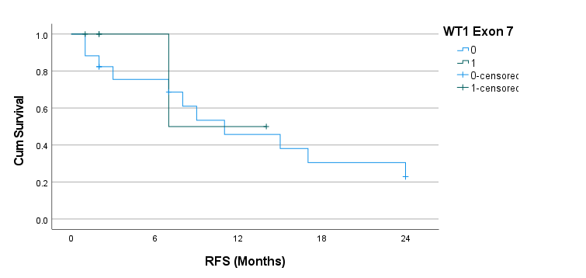

**Table 8.Within ITD-/NPM1wt**

|  |  |  |  |  |  |
| --- | --- | --- | --- | --- | --- |
| Time (Years) | Wildtype | | Mutated | | P-value |
| Surv Prob % | SE % | Surv Prob % | SE % |
| 2 | 26.8 | 5.8 | 50.0 | 35.4 | 0.133 |

**Figure 7.**

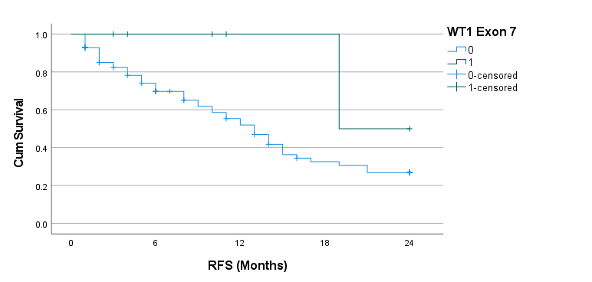

**Table 9. Within ITD-/NPM1+**

|  |  |  |  |  |  |
| --- | --- | --- | --- | --- | --- |
| Time (Years) | wildtype | | Mutated | | P-value |
| Surv Prob % | SE % | Surv Prob % | SE % |
| 2 | 45.5 | 11.7 | 25.0 | 21.7 | 0.780 |

**Figure 8**

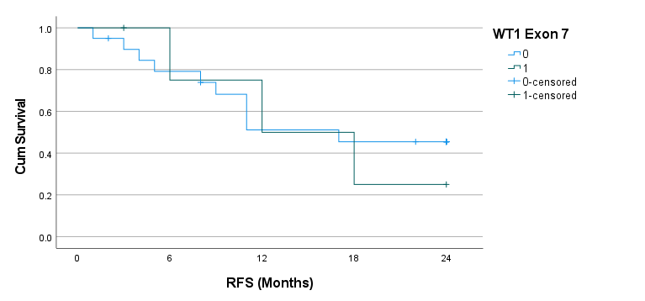

**RFS Subgroup analysis**

**Table 10.WT1 mutation status within ITD+/NPM1-**

|  |  |  |  |  |  |
| --- | --- | --- | --- | --- | --- |
| Time (Years) | wildtype | | Mutated | | P-value |
| Surv prob % | SE % | Surv prob % | SE % |  |
| 2 | 22.9 | 11.5 | 49.4 | 16.8 | 0.675 |

**Figure 9**

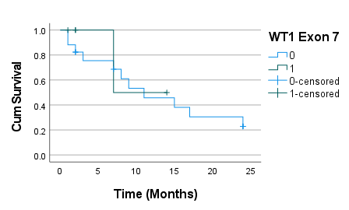**Table 11.Within ITD-/NPM1 mut**

|  |  |  |  |  |  |
| --- | --- | --- | --- | --- | --- |
| Time (Years) | wildtype | | Mutated | | P-value |
| Surv prob % | SE % | Surv prob % | SE % |  |
| 2 | 45.5 | 11.7 | 25.0 | 21.7 | 0.780 |

**Figure 10.**

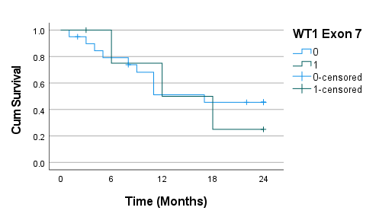

**Table 12.Within ITD-/NPM1wt**

|  |  |  |  |  |  |
| --- | --- | --- | --- | --- | --- |
| Time (Years) | wildtype | | Mutated | | P-value |
| Surv prob % | SE % | Surv prob % | SE % |  |
| 2 | 26.8 | 5.8 | 50.0 | 35.4 | 0.133 |

**Figure 11.**

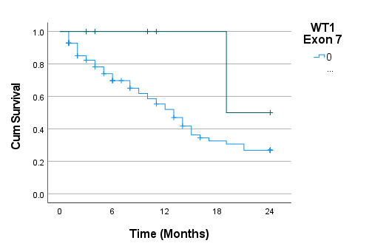

**Table 13.Within ITD+/NPM1 mut**

|  |  |  |  |  |  |
| --- | --- | --- | --- | --- | --- |
| Time (Years) | wildtype | | Mutated | | P-value |
| Surv prob % | SE % | Surv prob % | SE % |  |
| 2 | 35.6 | 18.6 | 100 | - | 0.139 |

**Figure 12**

