Supp. Table: The Docking score (∆G) kcal/mol of synthesized compounds (5, 7, and 8) against selected proteins.
Amino acids | Type of interactions |  | RMSD | Score kcal/mol | Comp.
 | Pi | H.B
Lys 53, Glu 71 | - | 2 | 0.85 | 6.33- | 5 | MAP kinase P38  (ID: 2EWA)
Gly170, Asp 168, Met 109 | - | 3 | 1.80 | 5.83- | 7
Asp 112, Asn 115 | - | 2 | 1.90 | -7.32 | 8
Lys 152 | - | 1 | 1.21 | -6.17 | Ligand (code: SB2)
Ser 155 | - | 1 | 1.69 | -6.59 | 5 | JNK kinase (ID: 3PZE)
Lys 55, Gly35, Ser 34, Gly 33, Ser 155, IIe 32 | 1 | 7 | 1.28 | -6.49 | 7
Ala 36, Arg 69, IIe 32 | 1 | 2 | 1.29 | -7.05 | 8
Met 111, Glu 109, Met 108 | - | 4 | 0.79 | -6.11 | Ligand (code: CFK)
Val 228, Lys 101, Phe213 | 1 | 4 | 0.90 | -7.67 | 5 | MEK-2 (ID: 1S9I)
Lys 101, Phe 213, Val 131 | - | 4 | 0.76 | -8.49 | 7
Asp 194, Phe213, Lys101 | 1 | 4 | 1.31 | -8.68 | 8
Asp 194, Gly 81, Val 131 | - | 3 | 1.21 | -8.11 | Ligand (code: 5EA)

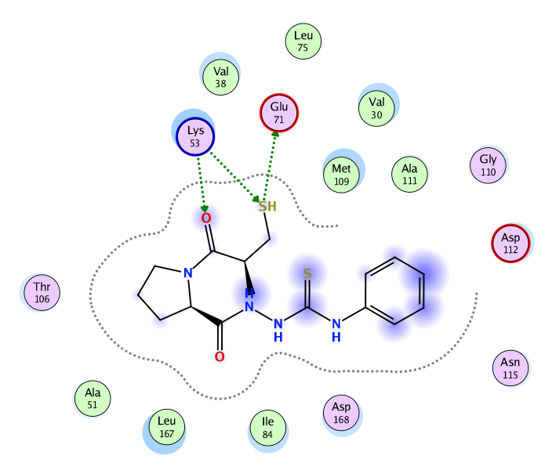  Comp.7  Comp.5 | 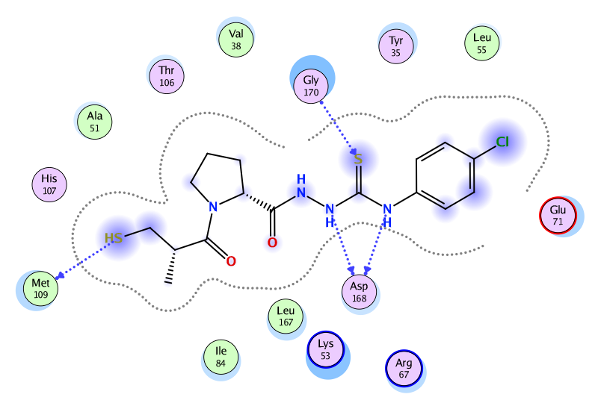
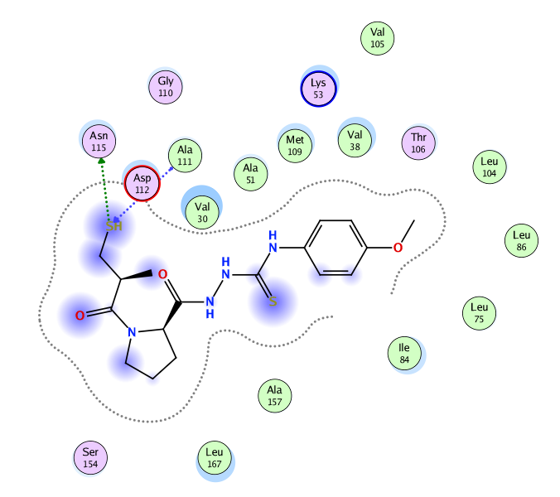  Comp. 8 | 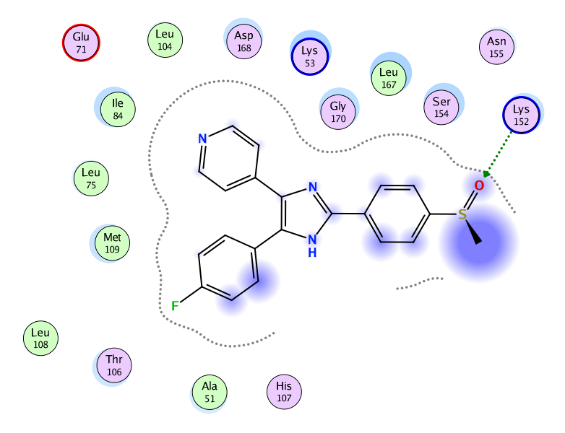  Ligand
Supp. Figure A: 2D interaction mode of synthesized compounds (5,7, and 8) and original ligand (2SB) in active site of MAP kinase P38.

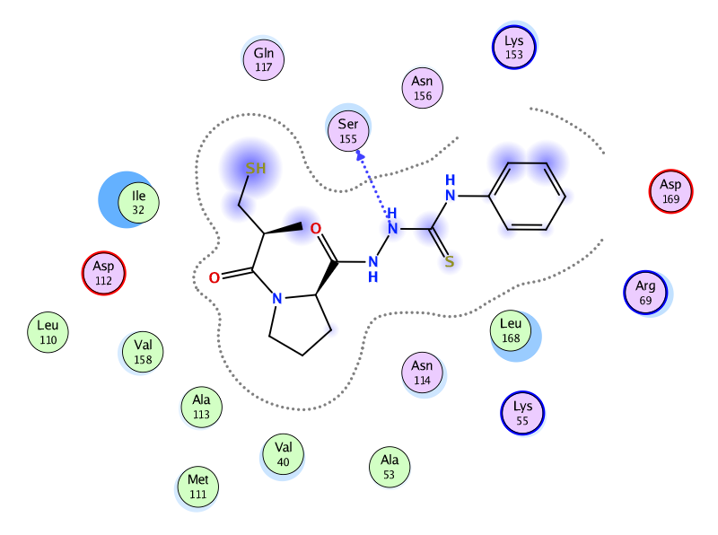  Comp. 5 | 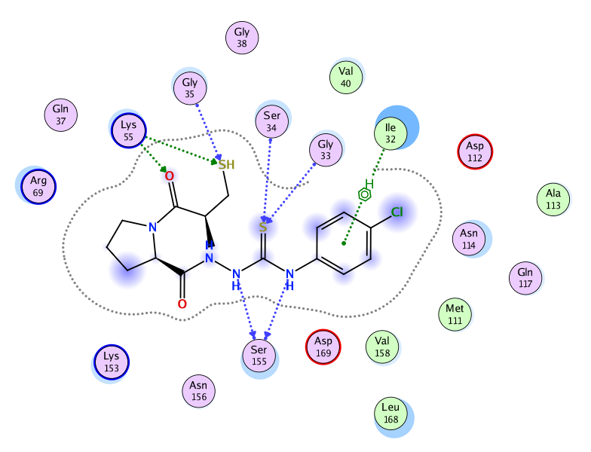  Comp. 7
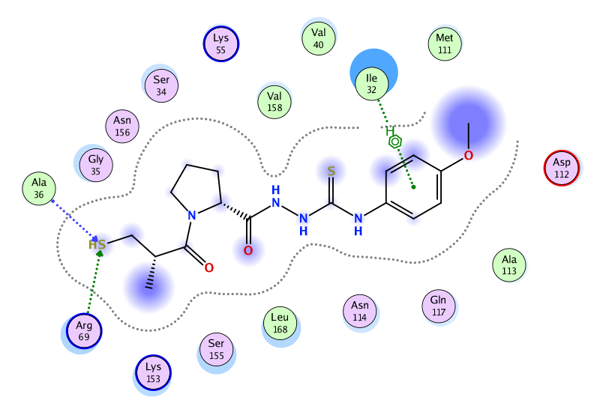  Comp. 8 | 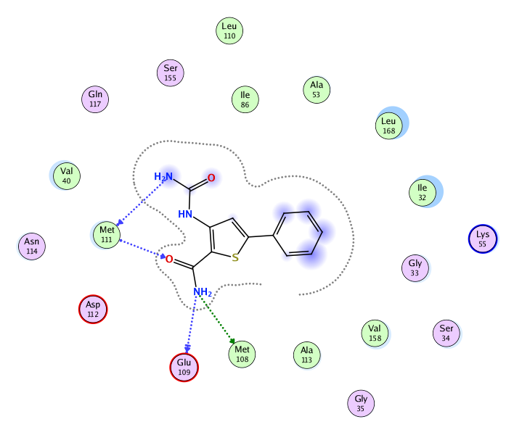  Ligand
Supp. Figure B: 2D interaction mode of synthesized compounds (5,7, and 8) and original ligand (CFK) in active site of JNK kinase.

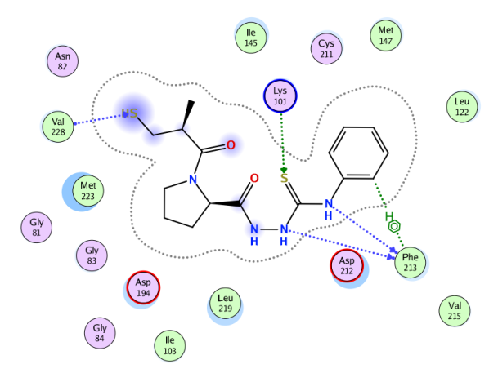  Comp. 5 | 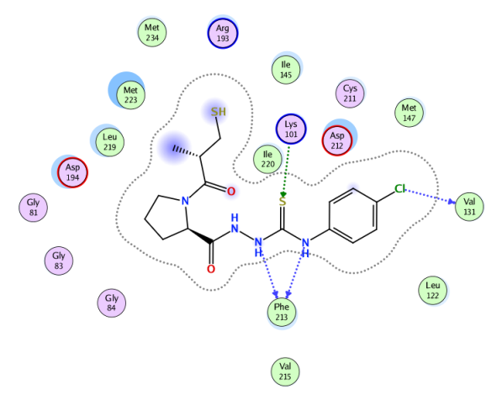  Comp. 7
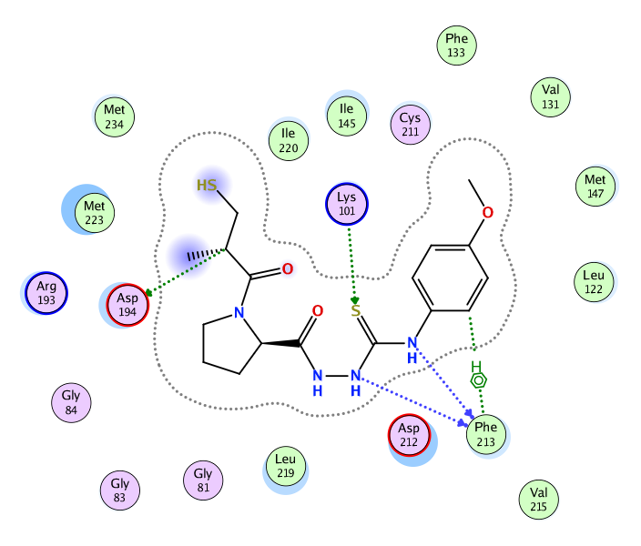  Comp. 8 | 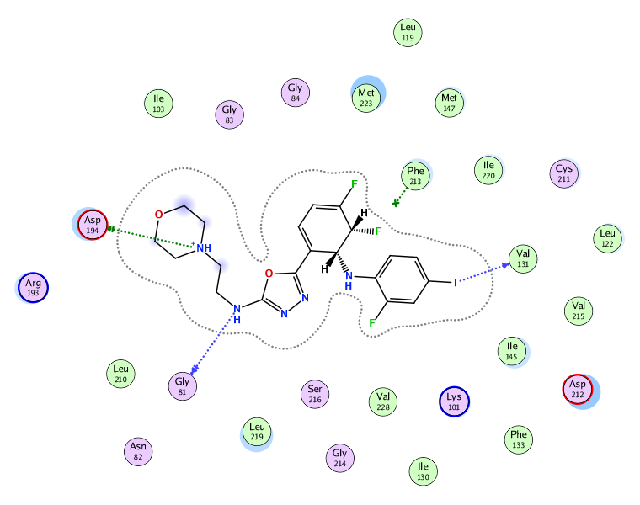  Ligand

Supp. Figure C: 2D interaction mode of synthesized compounds (5,7, and 8) and original ligand (5EA) in active site of MEK-2.

